HI-ACE-III Administration Instructions

Materials needed for administration: answer / score sheet, pen, pencil with eraser, blank sheet of paper and timer (while the slides are timed, it is helpful to still have a timer with you)
The PowerPoint works when it is viewed as a slideshow. Please ensure that you are viewing the PowerPoint on a device that is big enough, in particular when displaying the pictures. Before administering the HI-ACE-III, the tester should be trained in administration and read the administration instructions.
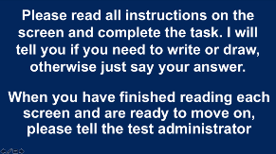

Instruction Screen
The participant should read the displayed instructions. Blank slides will appear between most test slides. Once the participant has informed you that they are ready to begin, move to the blank slide. This is to prevent the participant from referring back to instructions several times.
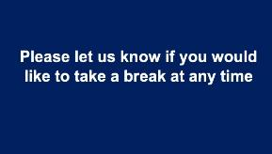
Attention - Orientation
The questions on the next slide will appear one at a time with a blank screen in between. Please press the enter key to continue once the client has given their answer and record the answer on the answer sheet.

Please use the symbol to view a prompt. If no prompt is needed, then press the symbol/

Prompt: If the participant says the month in numbers e.g. 14th of the 8th then use the name of the month prompt. When the season is changing (e.g., at the end of August) and the participant says, “Autumn” then use the “could it be another season?” prompt. If the answer is “Summer”, give 1 point since the two seasons are in transition. Do not give 1 point if the answer is “Winter” or “Spring”.

The next slide will ask you to select the hyperlink corresponding to the appropriate setting. Please select the option that will take you to the appropriate set of questions

Option 1: In the private home. Please press the enter key to continue through each element of the address once the client has given their answer and record the answer on the answer sheet. After the last question, the symbol will appear. Click on this to proceed to the next task.
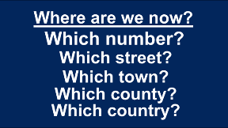

Option 2: In a hospital setting: Please press the enter key to continue through each element of the address once the client has given their answer and record the answer on the answer sheet.
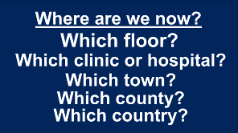

Attention - Registration of 3 items This slide is timed, once you click and the instructions have disappeared, each word will appear automatically and will be displayed for 2 seconds to represent the length of time the word would be presented verbally. If the individual does not say the words, press the symbol after the last word disappears to give instruction to repeat the words.
You can repeat this slide up to 3 times if they are unable to remember all three on the first trial. You do this by pressing backspace and enter. Only the first trial is scored, record the number of trials it takes to learn all 3 words and record any incorrect items. Once finished, press the symbol in order to display the prompt to remember the words.

Attention - Serial 7 Subtraction
The instructions are shown in 2 parts. Only show the second part of the instruction (by clicking the mouse) once the client has provided their answer to ‘Could you take 7 away from 100?’. The blank screen should be displayed while the client provides their answers. Record all responses and do not stop the client if they make a mistake. Stop the client after 5 subtractions by clicking from the blank screen to the ‘stop’ screen.
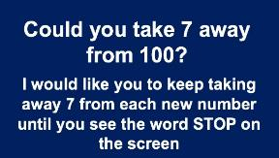

Memory – Recall of 3 Items

Show the screen below until the participant has had time to take in the instruction. Then click to the blank screen. This should be presented while the participant provides their answers. Record responses verbatim and score 1 point for each correct item. Do not prompt the participants for the items.

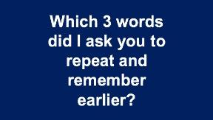

Verbal Fluency – Letter and Category

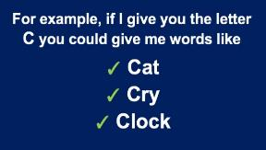
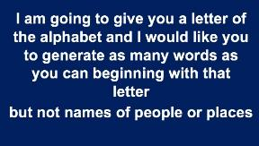

The slide below is timed, after the instructions have disappeared on clicking the P will automatically appear for 3 seconds before a blank screen will be displayed. It will automatically move to the stop screen after a minute has passed. Any answers given after the minute has passed should not be counted. Record each word that the participant generates on the answer sheet in 15 second intervals. Do not include any answers given after stop has appeared.

The slide below is also timed, the blank slide will appear for 1 minute after ‘You have one minute’ has been displayed for 3.5 seconds. If the participant misunderstands the instructions and perseverates by naming animals beginning with “p” then click on the symbol to prompt the participant that they can name animals beginning with any letter.
(Address this issue by stopping your timer, display the prompt slide, then continue timing).
Record each word the participant generates on the answer sheet in 15 second intervals. Do not include any answers given after stop has appeared. Once finished, press the symbol in order to display the next task.
Memory – Anterograde Memory – Name and Address
The address slide is timed, the address will appear for 8 seconds before disappearing. It will appear 2 further times on click in order to represent the 3 learning trials. Prompt: If the participant starts reciting the address before it has disappeared, press the symbol to prompt them to wait until it has disappeared.
Record responses for each trial but only responses in the third trial contribute to the ACE-III score. Once finished, press the symbol in order to display the next task.

Memory – Retrograde Memory – Famous People
Record responses to these slides verbatim. Surnames are allowed. You may need to prompt by
- asking for the full name if only the first name is given using the symbol
- If there has been a recent change in leader and they do not know the name of the new leader, you may need to prompt for the name of the outgoing leader by using the symbol
If no prompt is needed then press the symbol
Optional prompts
Language – Comprehension
Please place a pencil and piece of paper side by side in front of the participant before presenting these slides.
This is a practice trial. If this is incorrectly performed, score 0 and do not continue any further with this item by pressing the symbol.
If correctly performed, go on to the next 3 slides. The slides with instructions are timed (8 seconds). When they have completed a task then click to the next instruction slide. Before beginning each trial, always place the pencil and piece of paper next to each other in front of the participant.

Language – Sentence Writing
For the next slide, please provide the participant with the answer sheet and a pen. The blank screen following the second slide should be displayed while the participant completes the task.
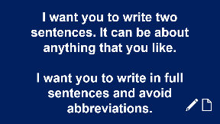
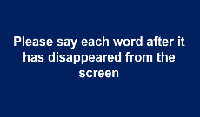
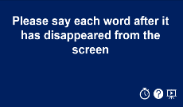
Language – Single Word Repetition
These slides are timed once the participant has read the instructions and you have pressed enter. Each word appears for 2.5 seconds with 3 seconds for the participant to say the word. There is no need to press enter until the blank screen appears after statistician. If the participant tries to say the word before it has disappeared, please use the symbol to prompt them to wait for it to disappear. If you need to use the prompt you can return to the task by using the backspace key. Once finished, press the symbol in order to display the next task.
Language – Proverb Repetition
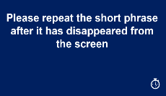
These slides are timed once the participant has read the instructions and you have pressed enter. Each proverb appears for 4 seconds with 4 seconds for the participant to repeat the proverb.
Language – Object Naming
These slides are not timed. The participant should be allowed enough time to name or attempt to name all the pictures in any order. Record responses verbatim.
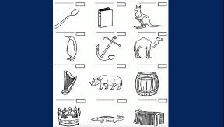

Language – Comprehension
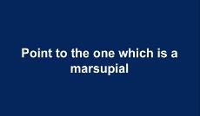
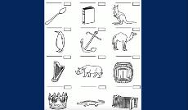
These slides are not timed, and you should proceed to the pictures once the participant has read the question. The participant should point to the picture on the screen or name the picture. Please do not provide any feedback regarding the word meaning. Self-corrections are allowed.

Language – Reading
These words will appear one at a time as you press the return key. Keep the words on the screen while the participant reads them. If possible, record the mistakes using the phonetic alphabet.
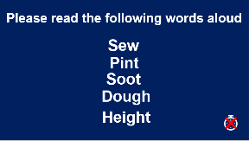

Visuospatial Ability – Intersecting Infinity Loops
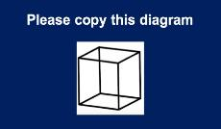
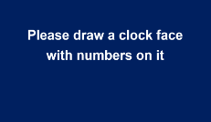
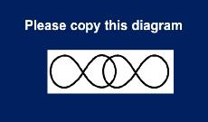
Please give the participant the answer sheet in order for them to complete the next three items. Please ensure that the answer sheet is folded so that the participant cannot see the other tasks. Please ensure that the diagram is displayed on the screen while the participant completes the task, not the instructions.
For the clock draw, switch to the blank slide once the client has begun drawing the clock. Once the participant has finished drawing, show the prompt to set the hands. Ensure that the blank screen is displayed while the participant draws the hands. Participants may correct any mistakes by erasing them while drawing.
If the participant does not like their first drawing and would like to do it again, you can allow for that by pressing the symbol to display the optional prompt. You should score the second clock.
Once finished, take the answer sheet back from the participant and press the symbol in order to display the next task.
Perceptual Abilities – Counting Dots
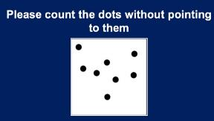
The instructions will disappear before the dots are presented. Please ensure that the clients are not pointing to the dots on the screen in order to count them. The dot counting slides are not timed.

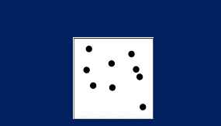

Perceptual Abilities – Identifying Letters
The instructions will disappear before the letters are presented. The participant is allowed to point. These slides are not timed.

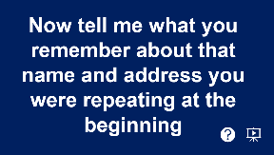
Memory – Recall of Name and Address

The blank screen should be displayed while the participant provides their answer. This is not timed. If the participant recalls the full name and address, press the symbol to conclude the test.
If the participant is not able to recall one or more details from the name or address, you are able to give them some hints by pressing the symbol. This gives the participant a chance to recognise items they could not recall.
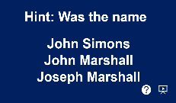
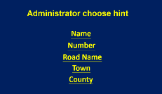
First, tick the correctly remembered items on the shaded column and then proceed with the hints. Pressing the symbol will return to the hint page to select the next hint, pressing the symbol will conclude the test.

