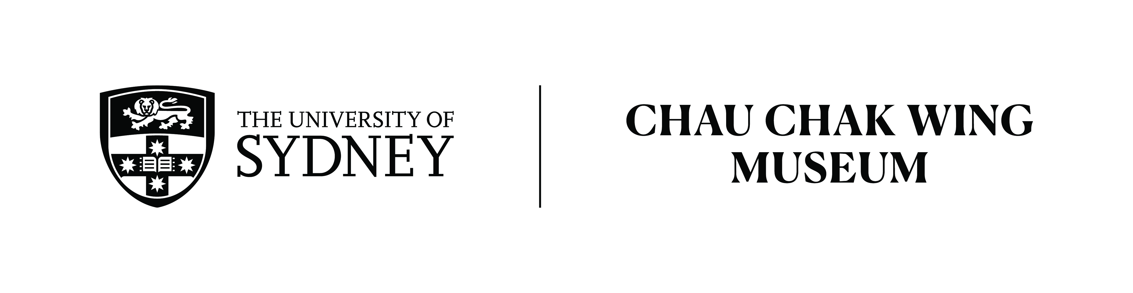

Listening Activity
Transport in the past - The Corso
Transcription
Spoken by: Dr Craig Barker
Duration: 2:15min

Today we look at a photograph from the Chau Chak Wing Museum collection, of a glass negative half-plate; it's a photograph of The Corso in Manly, taken in around about 1912. You'll see that it’s captioned on the plate by "Kerry and Co Sydney", this was a commercial photography studio of the early 20th century run by Charles Kerry. The Corso was a pedestrian promenade linking Manly Cove where the ferry jetty is located with Manly Beach a very popular Sydney landmark.

Named after the Via de Corso in Rome, it was first developed in the 1850s so more than 50 years before this photograph along a pre-existing track worn by the local Gamaragal people. This photograph was taken around 1912, about 10 years after the tramline was first opened in Manly in 1903. It provides an interesting insight into Australian social history from a century ago. We as historians can use this as a primary document and ask a number of questions about transport, clothing, the buildings and human behaviour. Firstly, what do you notice about transport? What types of transport are visible in the photograph? Although The Corso is a still a pedestrian avenue today, would the motorcar have a greater presence in a contemporary photograph taken from the same angle? How is the tram in the photograph visibly different from a modern light-rail? Now look at the buildings; is there a particular architectural style which may help us understand when these buildings were built? Were they brand-new at the time of the photograph or had they already been standing for some time? On the right of the photograph you can see the Wright Bros emporium building, this still stands. What was the building being used for at the time of the photograph? Can you see any signage? Look up how the building is being used today. From a social history perspective one of the most interesting aspects is the clothing.

This scene shows daily life for Australians in the years before world war one. What are the women wearing? What are the men wearing? Are these the type of clothes that modern Australians wear? What about things such as hats and gloves, are they noticeable in the photograph? A group of women can be seen on the left of the image, heading towards the direction of the beach. What are they carrying, what may have they have been doing on the day this photograph was captured? Can you find an image of The Corso as it looks today in the 21st century from a similar angle. What has changed and what has remained the same? Australia has complex heritage legislation which is designed by the government to protect and preserve some built heritage such as architecture and landscapes so some buildings would still be recognisable but obviously people change and the way that people use spaces change so a historic photograph such as this is a wonderful resource for an historian to use to understand life in the past.

Transcribed by Suzanne Kortlucke.

