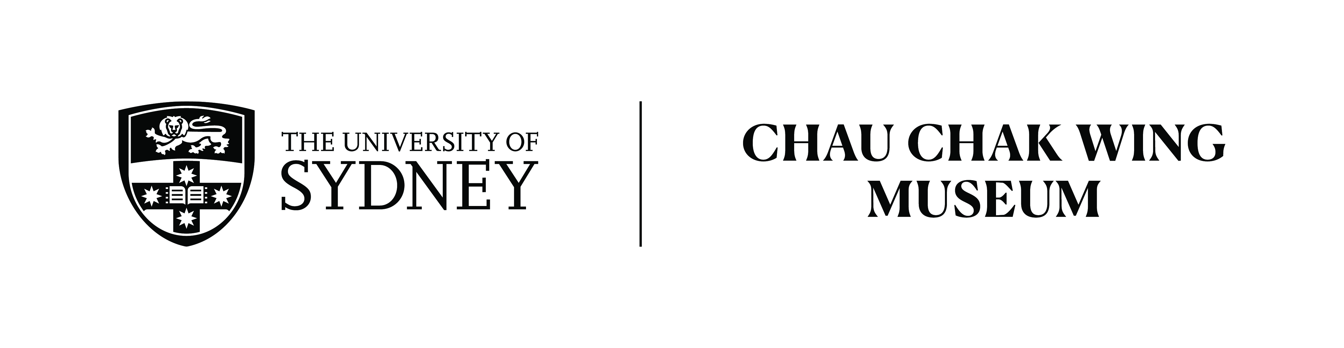

Primary Source Analysis
Cuneiform Inscribed Brick NM80.72
Transcription
Written and Spoken by: Sareeta Zaid
Duration: 1:50 Mins

This fragment of brick is inscribed in cuneiform, the ancient Sumerian writing that is the oldest recorded writing system. The brick is ceramic, made of clay, and is inscribed with multiple lines of cuneiform script. This artefact dates to the 3rd Dynasty of Ur, in the 21st century BCE. It is a receipt for a quantity of corn, likely by a temple official. The receipt is dated in cuneiform to the month of Siwan, on the 4th day, in the year of the destruction of the district of Simur of the reign of Sulqu in the 3rd Dynasty of Ur. Siwan was a month dedicated to the moon god, Nanna, and marked the summer solstice in June. These types of receipts were provided to those who fulfilled their contributions to a temple as a way of providing evidence of this donation.

The 3rd Dynasty of Ur occupied the cities of Isin, Larsa and Eshnunna, and reached into upper Mesopotamia. Following military unrest and conflict with neighbouring city states, the dynasty was founded by Ur-Nammu, who was originally a general and was known for killing the ruler of Lagash in battle. Ur-Nammu is also known for his law code. The Code of Ur-Nammu is the oldest surviving law code and is written in cuneiform on clay tablets. This law code sets out the punishments for various crimes, with some crimes requiring compensation in the monetary payment of fines, which shows progression from earlier punishments that involved bodily harm.

