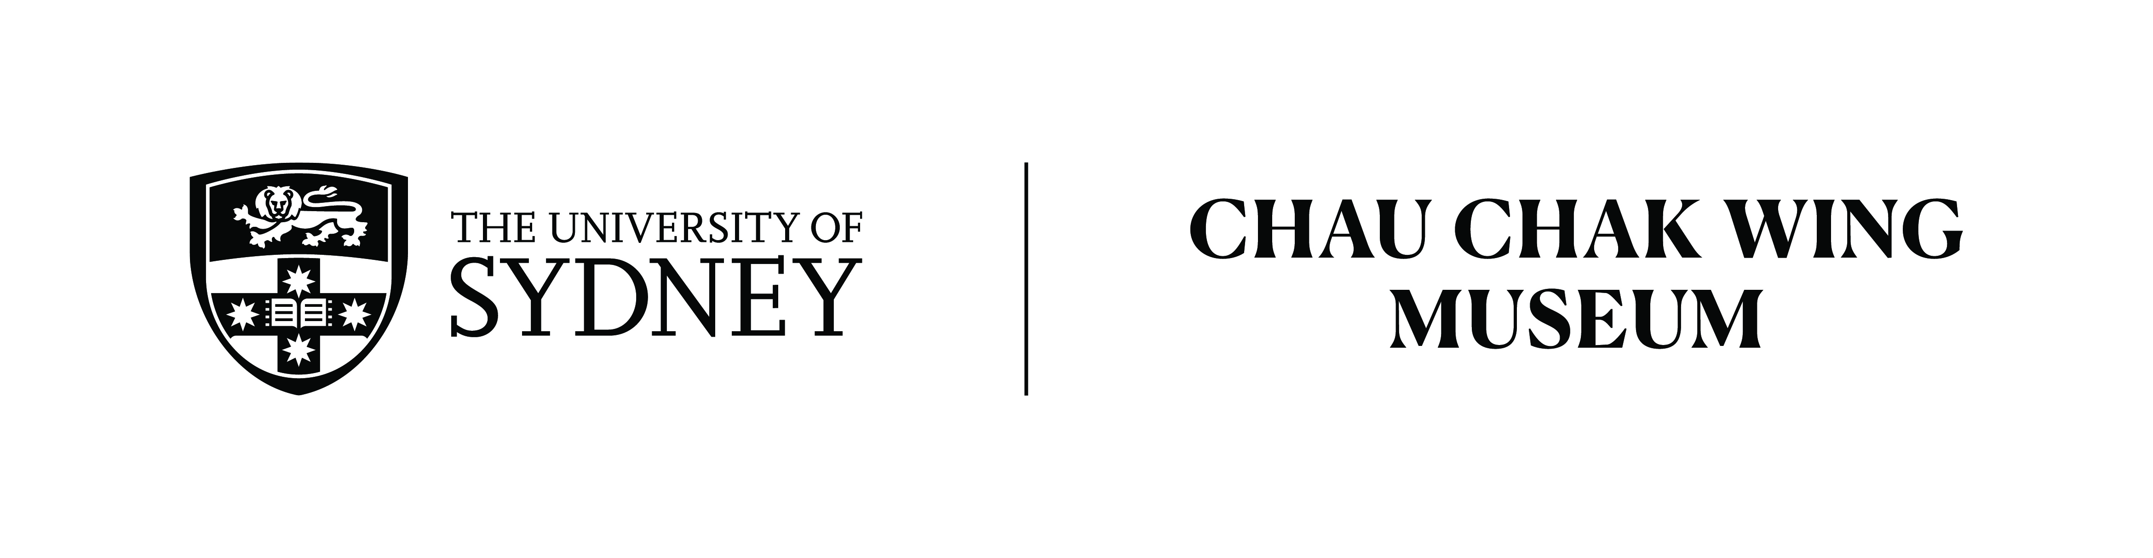

Primary Source Analysis
Cuneiform Inscribed Cone – NM60.5
Transcription
Written and Spoken by: Sareeta Zaid
Duration: 2:05 Mins

This ceramic cone is inscribed in cuneiform, the oldest form of writing. It bears a royal inscription of Gudea, the king of Lagash. Lagash was an ancient Sumerian city state in modern day Iraq. Gudea ruled from 2144 to 2124 BCE, and under his reign Lagash enjoyed prosperity. The inscription is a royal dedication to the god Nin-Dara, who was the consort and husband of the goddess Nanshe, the goddess of social justice, prophecy and fertility. Nindara was the local god of Lagash and a revered warrior. He has been described as the ‘tax collector of the sea’ in cuneiform inscriptions although the meaning of this is unclear.

This artefact was discovered in Tello, Iraq. Tello is the modern Arabic name for the ancient Sumerian city of Girsu, one of the earliest known cities in the world. Girsu was the religious centre of the Lagash city state. Tello was the first Sumerian site to be extensively excavated. Excavations here uncovered many artefacts and features of interest, including a bridge built of baked brick, which is thought to be the oldest bridge to be found in the world.

The writing on this artefact was translated as part of the Cuneiform in Australia and New Zealand Collections project. The inscribed cone reflects the focus on religion during Gudea’s reign. During his rule Gudea took part in a temple building regime dedicated to the important gods of Girsu. There are many statues of Gudea that have been found in ancient Girsu within temples to offer constant prayers on his behalf. These provide extremely realistic depictions of this ancient king.

