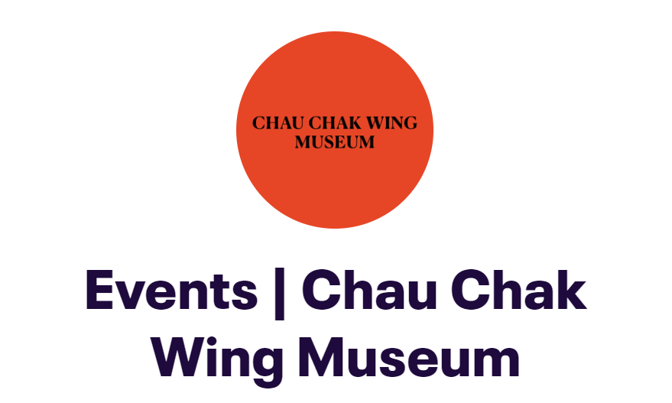

TALK TRANSCRIPT
TITLE: The Illustrated Handbook of Yolŋu Sign Language
DATE: Thursday 5 August 2021, 6.30-7.30pm AEST (approx.)
SPEAKER: Dr Bentley James (live from Darwin, Northern Territory)
Presented by the Chau Chak Wing Museum as a public program in association with the Yolŋu co-curated exhibition, Gululu dhuwala djalkiri: welcome to the Yolŋu foundations (November 2020 - 21 November 2021).
SUMMARY:
Linguistic anthropologist and educator Dr Bentley James works in Darwin and Arnhem Land preserving Indigenous languages. In this talk Dr James introduces an incredible project documenting over 500 hand signs used by the Yolŋu people across North East Arnhem Land. Directed by the Yolŋu signers and speakers of this rare, endangered language, the Illustrated Handbook of Yolŋu Sign Language of North East Arnhem Land was created over 25 years in the many homelands and communities of the region.
Dr James discusses the roots of the project to enhance the intergenerational transmission of ancestral knowledge and some of the ethno-linguistics of alternate sign language. A highly entertaining talk on an incredibly complex topic, he shares the who, what and where with illustrations, film excerpts and some of the five hundred signs of Yolŋu sign language collected from the east to the west of Yolŋu Country with his Yolŋu and non-Indigenous co-researchers.
For more on the project see: www.yolngusignlanguage.com.au/ ; www.facebook.com/SaveYSL/
Dr James affiliations: Centre for Australian Studies Universität zu Köln; APE Association of Philanthropic Ethnograpy; ALAA Applied Linguistics Association of Australia.
EVENT NOTES:
During promotion of the event, we received requests for AUSLAN translation and captioning on the part of prospective hard of hearing audience members. The Chau Chak Wing Museum is exploring various options to make our public programs more widely accessible but at the time of this event had yet to formally test or offer some of these services as part of online events.
The auto-translation/captioning service offered by the ZOOM interface is attuned to the American-English accent. In addition, it is our experience that is does not translate academic and specialist terminology accurately and it has no facility to translate words or terms in Yolŋu-matha (Yolŋu language). We have found that auto-captioning can be nonsensical, accidently offensive, and distracting rather than useful. We committed to record and provide an accurate transcription of the event after its staging, hence this document which can be read alongside the A/V recording posted on our YouTube channel. This is a verbatim transcript with the exception that some filler words (‘ums’ etc.) that have been edited out to aid reading flow.
With the support of the Office of the Indigenous Deputy Vice-Chancellor Strategy and Services, we were able to secure two AUSLAN interpreters for the public program staging at short notice and for which we were incredibly grateful.
The event was staged online in the early days of the 2021 Sydney Covid-19 lockdown. Due to some technical difficulties the event had a delayed start and was not presented as professionally as intended. Following an Acknowledgment of Country personalized to the event it became apparent that the AUSLAN interpreters were not visible to the audience. After some troubleshooting the solution was migration of the event from a ZOOM Webinar to a ZOOM Meeting format. The recording and talk transcription presented here starts at the commencement of the second ZOOM (Meeting format) in which the AUSLAN interpreters appear. The Acknowledgement of Country that happened in the first ZOOM (Webinar format) is summarized here and presented as a written introductory slide for the published recording.
Note: in the confusion of the early stages of the event various audience members had their videos and speakers on/off at different points during the presentation; the words of these speakers are not transcribed here.
Yolŋu diacritics:
ŋ = soft ‘ng’ as in song
SPEAKERS, PRESENTERS (in order of appearance)
Rebecca Conway, Curator ethnography Macleay Collections, Chau Chak Wing Museum
Dr Bentley James (Invited speaker; Linguistic anthropologist)
Amanda Galea, AUSLAN Interpreter 1 [on-screen]
Video voice-over for excerpt from the film, BIG BOSS The Last Leader of the Crocodile Islands https://youtu.be/Sx1koZAh1Lw Directed by Paul Sinclair
Rebecca Kent, AUSLAN Interpreter 2 [on-screen]
Voice of Laurie Baymarrwaŋa speaking in Yan-nhaŋu [translated on screen and transcribed below] in excerpt from the film, BIG BOSS – A Race Against Time https://youtu.be/FQ8Otktmfhc Crocodile Islands
Event coordinator:
Dr Craig Barker, Manager Education and Public Programs, Chau Chak Wing Museum

ACKNOWLEDGEMENT OF COUNTRY:
Many Aboriginal nations are acknowledged for this event:
…
Staged online during Sydney’s 2021 covid lockdown, Curator ethnography, Rebecca Conway [who introduces the speaker] acknowledged Country from her home office on Cammeraygal Country, Sydney
…
The event was organised as a public program in association with the exhibition,
Gululu dhuwala djalkiri: welcome to the Yolŋu foundations (Nov 2020- 21 Nov 2021)
at the Chau Chak Museum, on the Camperdown campus, land of the Gadigal clan of the Eora nation
…
The centrepiece of the Yolŋu co-curated exhibition and the lecture by Dr Bentley James is knowledge embedded in Country, the clan estates of the Yolŋu people in North East Arnhem Land* Northern Territory, and the lived culture of the Yolŋu nation
…
Dr Bentley James spoke to us from his Darwin office, on Larrakia Country, Northern Territory
…
*for the purposes of this talk we used the speakers preferred geographic reference, North East Arnhem Land. For the exhibition and other museum publications we have used eastern Arnhem Land. Both refer to the same general region and peoples.

TRANSCRIPT, from commencement of talking
00.21 Rebecca Conway
Okay, apologies for that very rough start. In the previous Zoom, we acknowledged Country and the Elders that we've been working, and a number of lands and nations across Australia, from North East Arnhem Land through to Sydney.
Without further ado, it's my pleasure to introduce Dr. Bentley James, a linguist and anthropologist who has lived in North East Arnhem Land for some 30 years, documenting and working with Yolŋu people there preserving their rare Indigenous languages. His interests include sign, ritual magics, social organization, archaeology, and material culture skills. And he revels really in creating projects that are in support of bilingual education; linguistic, cultural, and biological diversity for new generations, to continue the traditions of learning through new means and into the future. His collaboration with elderly regional knowledge holders building two-way knowledge systems is really giving a growing encouragement to a population of young people to access and continue these traditions. I really think without further ado, Bentley, he’s best to talk about the fabulous projects that he's been working on, and that he will be sharing with us tonight, particularly his project on Yolŋu Sign Language (YSL). Thanks Bentley.
01:48 Bentley James
Thank you, Rebecca. And thank you, everybody, for coming along. I hope that you're all comfortable and warm, and in a nice spot. Let's give a thought for those people living in North East Arnhem Land, and also in the 72 prescribed communities around the Northern Territory, who are living under the iron fist of ‘The Intervention’ [continuation of The NorthernTerritory National Emergency Response Act 2007], and who are living under the poverty line today.
It is really very lovely to be here. And I'm very grateful for you coming along, to listen to what I have to say about the Illustrated Handbook, and the project that made it possible.
02:24 [Amanda Galea, AUSLAN Interpreter 1 (on-screen)]
So, jumping along, this is Guti. He's a young man from North East Arnhem Land, who lives in Yirrkala. And he is deaf and has been from childhood yet is perfectly capable of being able to communicate with people throughout his community and more broadly in North East Arnhem Land, because he is a user of Yolŋu Sign Language (YSL). What is important is the difference between primary sign languages and alternate sign languages. An alternate sign language is the kind of language that we use in North East Arnhem Land.
03:16 Bentley James [new slide on screen]
Primary sign language have been developed over the last 100 years or so to facilitate communication among non-hearing people and with non-hearing people to hearing people. Whereas Yolŋu Sign Language (YSL) is a kind of alternate sign language. And that is a language that was developed in a hearing population, that population shaped a language of signs in such a way that it meets their needs in a hearing population and is also the primary language of non-hearing signers. So, Michael Ganambarr from Galiwin'ku, whom we're looking at, at the moment, who has been deaf since birth, is a wonderful communicator and he is able to speak to everybody in the community, and involve himself in sports, art, dance, ritual, everything, because everybody in the community uses Yolŋu Sign Language (YSL). But Yolŋu Sign Language (YSL) is under threat, and that's what this project is about. So just briefly, I will show you this book, [Bentley James is not on-screen; book cover images below; closer view available at, www.yolngusignlanguage.com.au/product/the-illustrated-handbook-of-yolnu-sign-language and www.yolngusignlanguage.com.au/product/the-yan-nhanu-atlas-and-illustrated-dictionary-of-the-crocodile-islands]
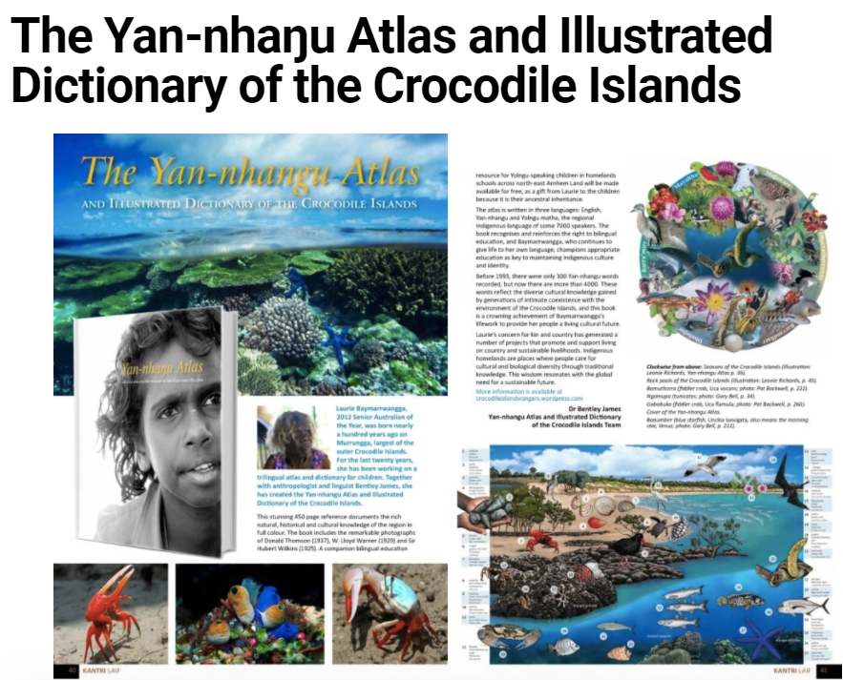
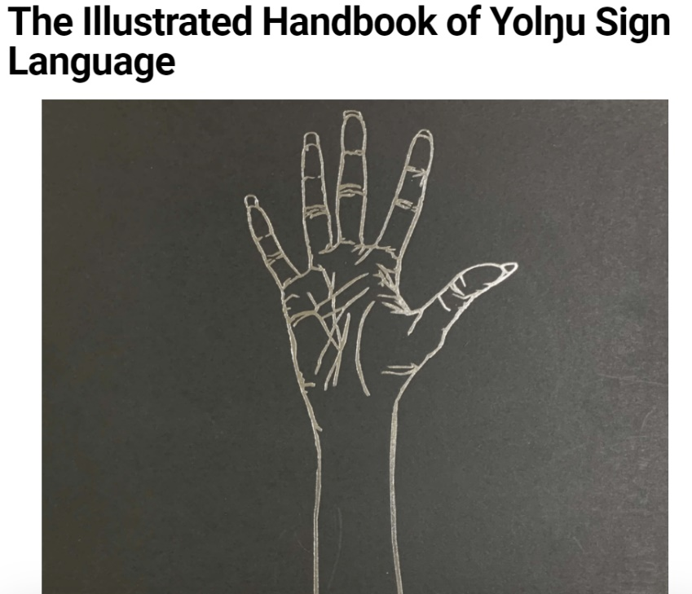

which is the Handbook of Yolŋu Sign Language (YSL) from North East Arnhem Land. And this book comes out of the same project as this book, which is the Yan-nhaŋu Atlas and Illustrated Dictionary of the Crocodile Islands. These books were developed by Laurie Baymarrwaŋa. So today, we will examine the connections between the two projects.
Michael, who has been deaf, since he was born, he is a great communicator
05:21 Bentley James [new slide on screen]
I want you to look when you see him moving, at his body language, as some people say that body language accounts for some 70-80% of our meaning [buzz of static-wrong button] I beg your pardon. This is the hand sign for playing cards. And Michael is doing a beautiful job of interpreting the entire card playing activity, with gestures. So, what is the difference between gesture and sign? A gesture, I beg your pardon. Next slide. Oops.
06:21 Bentley James [one slide shown, then changed to another in quick succession]
Gestures are mediated by the kind of language used in the community and grammar accounts for about four different ways in which gestures are activated and used in a language. Whereas sign is a very distinctive and arbitrarily signified way of communicating that a speech community agrees to. So for example, this thumbs up sign which is ‘OK’ in English speaking communities is apparently rude in Afghanistan and apparently in Greece. However later with the invent of Western technologies in those communities it now has two meanings. In fact, for those who can remember far back enough in Australia, to do that [thumbs up] with the right kind of other body language, was also a rude sign. So a speech community gives meaning to a sign. And in that way it's capable of being able to produce much more significant meaning than just gesture.
07:59 Bentley James [new slide on screen]
Unfortunately, the Yolŋu Sign Language (YSL) like so many other Australian languages is disappearing. I want to bring your attention to the bottom of the screen where it says Yan-nhaŋu. Baymarrwaŋa and I worked together since 1993, to make language projects and resources for students so that they could continue to use their language. However, Yan-nhaŋu language was only spoken by her. So, it was already very, very endangered. At the same time, we also wanted to learn and teach children Yolŋu Sign Language (YSL), especially Yan-nhaŋu Sign Language (YHS) which is particular to the Crocodile Islands. But because of the weight and time necessary we needed to focus on the Yan-nhaŋu language [first]. The reason why these signs are so endangered comes mostly from the wider society and the way that we have dealt with relations between Indigenous people and the State.
09:32 Bentley James [new slide on screen]
Sign languages of the kind that Yolŋu Sign Language (YSL) are, are extremely perishable. Most Indigenous languages in Australia had a parallel or alternate sign language with them, but many of them were lost very early because they're so incredibly perishable. And they are perishable mostly because the environments in which they are used are On Country and in connection to Land. And so, when people's link to Country is broken, these highly perishable signs also disappear. So that is why it became so necessary to do this project.
10:20 Bentley James [new slide on screen]
This is Laurie Baymarrwaŋa, Senior Australian of the Year 2012, who spoke no English and in her 90s was a courageous fighter for her language and culture. Here is a short video that introduces Baymarrwaŋa.
[excerpt from the film, BIG BOSS The Last Leader of the Crocodile Islands Directed by Paul Sinclair https://youtu.be/Sx1koZAh1Lw]
10:38 film/video with voice-over
[music]
On one of the most remote islands of Australia lives in ancient Yan-nhaŋu woman. She has lived on her island for nearly 100 years, surviving off the land and sea. Throughout her life she has fought to maintain her culture and protect her ancient language from extinction. To the Yan-nhaŋu she's Big Boss, the last leader of the Crocodile Islands.
11:19 Bentley James [talks over series of two fast moving slides, including map]
Yan-nhaŋu people live in the Crocodile Islands and they are exclusively sea people. So, they are the last of the exclusively sea people in Australia. The area that is shaded blue is that of people using Yolŋu languages, Yolŋu Matha, ‘Yolŋu’ meaning person, ‘Matha’ meaning tongue, the common tongue, the people's tongue. Yan-nhaŋu is the language of the Crocodile Islands and seas. ‘Yan’ means ‘tongue’/’language’, and ‘nhaŋu’ means ‘this’ or ‘here’, it is the language of ‘here’.
So, from the east in Blue Mud Bay -
12:01 Bentley James [new slide on screen]
- to the west in the Crocodile Islands all people use the Yolŋu Matha language, but they also have a number of languages that belong specifically to their Country. Depending on how you divide them there's up to 60 different languages in North East Arnhem Land. All of these languages have names for places, and these are important connections to Country, and one of the things that is so important about language. And therefore, this project's attempt to save those near invisible links to Country, of language, is the language that these names are in. In the Crocodile Islands, Baymarrwaŋa, and I were lucky enough to spend –
12:51 Bentley James [new slide on screen]
- some 20 years mapping over 600 sites. And in those sites, all of the songs and connections to Country that make those songs, the language they use, and the language around them into examples of ancestral essence, like artworks, like material culture, like songs, like the pattern [sound] of clapsticks. These things are owned by groups, and by people in those groups.
13:27 Bentley James [new slide on screen]
This is Murruŋga Island [Moorongga]. And this is where Baymarrwaŋa, was born, somewhere around 1914 to 1917. She can't remember and there is nobody else alive who can remember either. Baymarrwaŋa was a very strong leader –
13:47 Bentley James [new slide, video still]
- but an incredibly generous, gracious, and kind woman. She understood that she had very little time left to do what she wanted to do, and that is pass on the knowledge of the ancestors to a new generation of young people speaking Yan-nhaŋu and also Yolŋu Matha. Let's have a little listen to Baymarrwaŋa.
14:16 [excerpt from the sample/preview film, BIG BOSS – A Race Against Time https://youtu.be/FQ8Otktmfhc Crocodile Islands;
Voice of Laurie Baymarrwaŋa speaking Yan-nhaŋu, translated subtitles in English on screen:
“This sea is called Maramba. This is my sea, my songs live here [clapsticks can be heard]. My name is Baymarrwaŋa, I am of the Malarra clan. My language is Yan-nhaŋu, this is the language of Murruŋga and Galiwin’ku [Elcho Island]. The language of the seas, this is the truth.”
[Rebecca Kent, AUSLAN Interpreter 2 (on-screen) from 14:55]
14:59 Bentley James [new slide on screen]
So, not absolutely easy to see. But implied in everything that Baymarrwaŋa is saying is this idea of links to Country in language, that it is the language that the ancestors sung as they created the world that is also part of what is important and belongs to the people of the Country. And that's what this book is attempting to hold.
15:32 Bentley James [new slide on screen]
Unfortunately, Baymarrwaŋa died before we could finish this book. It took nearly 30 years to complete. But it is a book that is aimed at exactly the kind of thing Baymarrwaŋa wanted to do - that is save those tiny invisible links of language to Country and people. So, in order to better understand how that works we're going to have a look at the book she did first.
16:07 Bentley James [new slide on screen]
In her work, attempting to get the children of an older generation - a newer generation I beg your pardon - to understand their language she had to do a lot of different economically viable activities. So, she created Ranger programs, and cultural heritage programs, and turtle conservation programs, in order to attract those young people to full time or part time work on their Country that would allow them to access ongoing touching of Country, allowing them to be able to be part of the Country that they listen to in Yan-nhaŋu.
[unmuted audience interruption: …he’s an anthropologist that's been working with a particular Aboriginal group for a long time, it’s pretty interesting]
the Yan-nhaŋu Atlas Project (on the bottom [of the screen]), and the [Y.E.K] Yan-nhaŋu Ecological Knowledge Database Project, and the Bilingual bi-modal Resources Project, are all projects that link into this book -
[unmuted audience interruption: my God,I wasn't on?]
17:18 Bentley James [new slide on screen]
- the book grows out of the need to be able to pass on these near invisible links to a new generation. This book was then given to children in schools, Homelands, and Ranger programs across North East Arnhem Land at Baymarrwaŋa's behest and at her expense.

17:38 Video segment with voice-overs
Voice 1: Bentley James [talking to school children]
These books were made by a very, very old lady on the island of Murruŋga (Moorongga). And the lady who made these books was nearly 100 years old.
Voice 2: Joe Morrison CEO. Northern Land Council
The Old Girl reminded me that we shouldn't just be looking through a ‘balanda’ (European) lens at the world that we deal with but also making sure that we look through the lens of Aboriginal people.
Voice 3: Bentley James
These books are in three languages, English, and in Dhuwal – Dhuwala… [a widely spoken Yolŋu Matha, language] and Yan-nhaŋu
Voice 4: Michele Baratawuy, Baymarrwaŋa’s grand-daughter
They can learn - everything [is] there now in that book.
Voice 5: Bentley James
This is the place of the ancestors, this is a Country like no other in the world. It has stories, and rocks, and paintings, and knowledge, and dances, and words that have been here for 50,000 years, that are just waiting to be rediscovered.
Voice 6: Joe Morrison CEO. Northern Land Council
The fact that they have got something left behind by the Old Girl is profoundly heartening to see.
Voice 7: Bentley James [talking to school children]
This Old Lady wants you to have these books, because she wants you to have the chance to learn about your history from a long, long, long time ago. And that is a gift for you, that is a present from the Old Lady to you.
[end of video segment]
19:12 Bentley James
So Baymarrwaŋa was very, very generous, and kind and gracious, and had a mind like a steel trap. There was absolutely nothing that she could not remember. If, for example, I had lost a notebook or said, “where was that word?”, she would be able to say it was in the blue one, you know, the one that you had yesterday, she had the most magnificent memory. And it's that memory that allowed her to be able to recount such an incredible story, about her Country where she had lived for 100 years.
So, let's have a look at the story of the Yan-nhaŋu Atlas –
19:51 Bentley James [new slide on screen]
- and the things that are inside it. So, we can see from where the links of the Yolŋu Sign Language (YSL) book come from and get an idea of the connections to country that are understood to be part of the way that people live in the world.
20:12 Bentley James [new slide on screen]
The Atlas has three parts, the first part: is about where we are and what it means. All of it translated from Yan-nhaŋu into Yolŋu Matha, the language that everyone in the North East Arnhem Land speaks, and also English for non-Yolŋu speakers. Second part: is a history of photography by famous photographers, and they include [anthropologists] Lloyd W. Warner, Donald Thompson, [adventurer explorer] Sir Hubert Wilkins, [photographer] Edward Reichenbach (‘Ryko’), [and missionaries] Papa Sheppi [Harold Shepherdson], Papa Webb [Thomas Theodor Webb], everybody who took photographs over that 100-year period has photographs in this amazing book, which are then translated by Baymarrwaŋa, showing what they meant, who was there, why they were there, and then translated into English so we can all understand. Baymarrwaŋa gives us an indication in her language -
21:11 Bentley James [new slide on screen]
- of what it is that she wants us to take away from this book and the projects surrounding it. Of course, the Atlas is an enormous work, so it has a ‘how to use’ guide –
21:24 Bentley James [new slide on screen]
- with pronunciation and what language is involved and how to understand its organization.
21:33 Bentley James [new slide on screen]
But it also has a critical triptych, this piece of information I have been looking at for over 30 years now, and it's still not easily clear to me, so I'm not expecting you to pick it up immediately - and there won't be a test at the end of this. But this triptych describes the invisible links between Country and song, and people and generations passing back in time. And it's this understanding that we will examine very quickly in a crash course of ancestral links to Country that explains why it is that across Australia, hand signs of the kind of alternate sign language were ubiquitous. And also, [how] unfortunately, when people were removed from Country, why those signs were so quickly perishable.
22:32 Bentley James [new slide on screen]
So, this first picture shows Murruŋga Island, on which Baymarrwaŋa was born so many years ago. There are three songs in the blue color, they are Dhuwa [moiety] songs, and the three songs in Yirritja [moiety] color [orange]. Dhuwa and Yirritja are two aspects or ways or parts of the world and universe that are comprehensive and that share together in such a way that they create the conditions for fertility - much as ‘yin and yang’, containing some of each other and at the same time being opposite and comprehensive. So Dhuwa songs in blue, link named sites through music and song and clapstick patterns [rhythms], and Yirritja named sites link songs to areas on Country and clapstick patterns and drone pipe [Didgeridoo, in Yolŋu Matha: Yidaki] patterns. And these things are owned by the people who play and use them through an understanding of kinship –
23:41 Bentley James [new slide on screen]
- Dhuwa and Yirritja [moieties], complimentary halves of the universe, that then translate into ancestral essences, which are part of the way that bodies are made, part of the environment, part of the named places, all of these places then coalescing their ancestral essences into what we in English often call ‘estates’, but more accurately, perhaps they might be described as focal areas that radiate out ancestral essences. Those essences, those links to Country, are the same essences as the bones of the father, essences that he passes on to his children, and his children pass on to their male children through the Patri-line. The female part of the generations then pass on the flesh, or the parts of their bodies that create the conditions for continuity.
24:45 Bentley James [new slide on screen]
These kinship relations are expressed in patterns of marriage, or connubia. Those links, those people who live and are part of one particular clan coming through the Patri line pass on their daughters to those of the next group, who then pass on their male children's ancestral essences to those of the next group, through their daughters, in a system of marriages, that includes sometimes 9, 10 or more groups. And those groups continue to pass on this pattern of reproduction through time. And in this area here, since the last sea rise, with the sea becoming approximately where it is now about 10,000 years ago, this has been the pattern. The pattern that precedes this pattern is exactly the same, but without the sea around it. And it is this pattern of continuing marriages through time that are evidenced in recent archaeological finds that have found that DNA taken from hair samples coming from sites are the same as DNA samples in modern living Indigenous people from that area. So, a site-based relationship with Country is evidenced by genetic evidence going back some 50,000 years, the relationship of people to Country is enormously deep; very difficult to imagine.
Much of the knowledge of this Country is remembered in songs and Baymarrwaŋa and I -
26:42 Bentley James [new slide on screen]
- mapped these wonderful songs on Country. We also mapped the regional seasonal resources –
26:49 Bentley James [new slide on screen]
- and the kinds of things that were in the environment, in English, and in Yan-nhaŋu -
26:55 Bentley James [new slide on screen]
- and in Yolŋu Matha and in Latin. Also, we mapped the seasonal pattern of –
27:03 Bentley James [new slide on screen]
- inter-Island travel used by Baymarrwaŋa and her family before the coming of the missionaries in 1922. So, a direct reference to actual patterns of movement throughout the islands to access seasonally available resources as followed by the people of the Country, going back we don't know how long but certainly an enormous time depth and the knowledge associated with it incredibly sophisticated. The fish traps of the Crocodile Islands –
27:38 Bentley James [new slide on screen]
- again, are a very, very interesting and deeply, profoundly, interesting way of living in the world, just the rocks that come from the surrounding areas, those in-situ rocks have about 10 names in Yan-nhaŋu. In other languages, similarly large amounts of names for kinds of rocks. And then other kinds of rocks that also appear in the environment are those that have been transported in, so rocks of the kind that are cutting stones, pounding stones, stones used for grinding, stones used for eating [language name used; sounds like ‘gundirr’], stones used for trade, stones use for color - ratjpa, miku [red toned ochres], buthalak [light, yellow-toned ochre]. These kinds of stones are all to be found in the vicinity of the fish traps, as are freshwater resources, a freshwater well, and also a jungle of the kind that includes all of the species of plants that people used in their everyday. Those kinds of things people that made spears, or fruit or vegetables that were used, were reproduced in that area. So, the farming idea is very clearly mapped - in the what you would call the amenities - that surround fish traps and freshwater sites.
29:13 Bentley James [new slide on screen]
The book also includes these wonderful photographs, and this one taken by [anthropologist] Lloyd Warner on the beach at Milingimbi, is of the Ŋarra ceremony, a Yirritja Ŋarra ceremony. The book includes [photos of] ceremonies in which women were allowed to handle men's spears as part of the Initiation ceremonies –
29:35 Bentley James [new slide on screen]
- wearing as we see the Ŋaṉmarra [conical] mats, a very important part of material culture.
This is Angutjatjiya or the Dhaku or the fish trap [image not shown until 29:55], this is on the mainland, on Cape Stewart, a photograph by [anthropologist] Donald Thompson, but Baymarrwaŋa made quite a few of these fish traps in her career.
29:55 Bentley James [new slide on screen]
The white shell that you see hanging on the stick is there for a very specific purpose. The stick and the shell scare away the mokuy [ghosts]. There is the hand sign [Bentley James demonstrates] for mokuy - the spirits of the dead. Those mokuy interfere with the fish catching, but another important aspect of fish trap usage is that there is to be no mention of fishing and no loud noises or shouting around the fish trap. So hand signs were always used around the fish trap.
Modes of travel, of course, this bark canoe [image not shown until 30:50] is of the kind known as Barrwan, there were much larger ones created by Yan-nhaŋu people as well. But these handy, very quick to make craft, were very fast over water, and Donald Thompson records them having made very quick journeys –
30:50 Bentley James [new slide on screen]
- from Moorongga (Murruŋga) back to Milingimbi. But these craft would undo at sea, and when they did, the people would have to swim. These craft are also associated with stories of truly enormous crocodiles. The new kind of canoe, the Lipalipa, the kind that was brought to North East Arnhem Land by the Macassans over the last 400 years or so, was a floating hollow log canoe, hollowed out of a tree. And that canoe would float, so if it tipped over you might have lost some bits and pieces, but you could always scramble back into it and make your way between the islands. A very, very grateful invention.
Housing styles and the way that people used their environment, which was often very full of mosquitoes and sand flies, and the winds of their environment; to capture the best places to stay and live, perched up on top of big sand dunes –
32:00 Bentley James [new slide on screen]
- or in hills of shellfish middens. These kinds of Gathuwuru [bark shelters], the housing style we're looking at here had a fire that burned beneath them, and that fire would keep the sand flies and mosquitoes away while people sat in the daytime. And, of course, this project -
32:22 Bentley James [new slide on screen]
- of knowledge transfer - is mostly directed towards children and giving back to the children. So that's what this is about. The Atlas in three languages -
32:31 Bentley James [new slide on screen]
- includes practice sentences in English, Yolŋu Matha, and Yan-nhaŋu, parts of speech, and glorious illustrations. It has an English Finder List –
32:45 Bentley James [new slide on screen]
- in English alphabetical order. And a Yolŋu Finder List in Yolŋu bilingual alphabetical order, which keeps all of the sounds of the Yolŋu language together so they're easy for people to recognize, for example, the four different kinds of ‘n’ sounds, ‘ṉ’, ‘ŋ’, ‘nh’ and ‘ny’ - so people who are familiar with Yolŋu languages will know how difficult it is to get your tongue around those wonderful 'n' sounds.
33:17 Bentley James [new slide on screen]
Also, the book provided, is divided into teaching domains, for teachers and students, as is the Yolŋu hand sign guide [Illustrated Handbook of Yolŋu Sign Language of North East Arnhem Land]. So too - the handbook has a grammar for teachers and learners.
33:32 Bentley James [new slide on screen]
So it is easy for people to be able to structure in the way that the language uses its conventions, the signs that they learn. The Illustrated Handbook also has practice sentences and a learner guide.

33:46 Bentley James [new slide on screen]
This book has been distributed to the children in the Homelands, at the schools and the Ranger programs across North East Arnhem Land - again for free - this time not at Baymarrwaŋa's expense, but at the expense of some of the wonderful volunteers that gave, including the lady who is the Yellow Wiggle [Emma Watkins] she gave $20,000 to get this project. And there were a few others who also gave so generously too many to mention now, but to those people, very grateful, because they have helped to save and hand out - back to the kids, these wonderful, wonderful signs.
34:32 Bentley James [new slide on screen]
The thing about sign language, and this one in particular is that it emerges from the community and its relation to each other, and the economic and ecological imperatives of the land in which people live. So, dance, and magic, and mimicry, and all of the things necessary to carry out life on the islands, and on the mainland, are captured within the sign language. So, it's completely capable of being able to express any of the things that we need to express, completely silently. One of the things that Baymarrwaŋa was very, very strong on –
35:14 Bentley James [new slide on screen]
- was that there must be explicit teaching of hand signs around fish traps. This is also something that people across North East Arnhem Land understand, because one of the Laws of the fish trap is that there must be no loud noises, no shouting, and certainly no mention of the idea that people are fishing, because the ancestors who are listening are waiting for any indication that people are fishing, and they will empty the fish trap of the fish. So that is why nobody ever speaks about fishing before, when, during and after they've been fishing.
35:58 Bentley James [new slide on screen]
Sign language is a wonderful way for us to be able to understand secret connections between people. So that if you wanted to talk to somebody while somebody was talking to you, and they were a distance, you could easily signify to them what you wanted to do with sign both visible to the person who's speaking to you, with voice, or invisible to them. So, it's a great way of being able to keep secrets or in the company of kin that you have to avoid to be able to make sure that you don't transgress any of those avoidance rules amongst kin. Sign language allows you really deeply, profoundly, subtle communication, without making a noise.
36:50 Bentley James [new slide on screen]
The book with its learners’ guide, and all its parts, its alphabetical organisation, its indexed organisation, it's grouping into those areas that are impressed. So, for cooking, for kinship, for modern life, for occupations, gives the book usability that is good for anybody who wants to learn Yolŋu Matha, because it is all mapped in Yolŋu Matha, but also the signs. And also, if you happen to be a Yolŋu speaker, it's also in English. So, you can use it as a tool for education in any of the three languages. So, it has a grammar in all three as well.
It also has something that's absolutely remarkable –
37:35 Bentley James [new slide on screen]
- thanks to Baymarrwaŋa there is a class of hand signs that are almost unheard of by a younger generation. And these are the idiomatic hand signs. These are hand signs that belong to an era before the coming of Europeans. So, this lady, dear lady, unfortunately passed away during the making of this book project. But she was a very capable signer, her uncle had been non hearing. And she was also able to help us do these signs. So, they are also captured. Now, idioms, as you know, are things like ‘five sheets to the wind’, these are things that we say that don't actually mean what they say. And similarly, idioms in sign do the same kind of thing – so the sign that you see, Sheridan at the front of the book with her hands like this doing [Bentley demonstrates the sign, hands cupped under cheeks], is a sign that means djulŋi, which is ‘dear’ or ‘precious’, and this sign buku [Bentley touches right hand to forehead], which means forehead or hill. When joined together, ‘hill or forehead - dear’ makes the hand sign for ‘thank you’. And that is the kind of idiomatic hand signs that were almost unheard of, and recorded, which we also have a wonderful collection of in this book. So it has been a remarkable journey.
39:10 Bentley James [new slide on screen]
I was lucky enough to travel around to all of these communities for the third time, in order to be able to hand out these books, and meet again with old friends, old students, and also new students, and talk about the book and hand it out to the schools. The launch was wonderful –
39:30 Bentley James [new slide on screen]
- it was supported by Buku-Larrŋgay [Buku-Larrŋgay Mulka Centre, Yolŋu community-controlled art centre in Yirrkala, see yirrkala.com/], Buku – ‘head; hill’, and Larrŋgay in this construction is ‘sunshine’. So, it means the morning sun of North East Arnhem Land touching your head, and the meaning of that is ‘welcome’. So, these wonderful, wonderful people of Buku-Larrŋgay, gave money and support to us to help us do this book and also to do the book launch. So, we're very, very grateful to Buku-Larrŋgay, they have wonderful insight there and they do wonderful work.
40:14 Bentley James [new slide on screen]
So, at the beginning I said that it would be possible that we could look at the ancestral links that made this book, like the Yan-nhaŋu Atlas, and like all of the other projects by Baymarrwaŋa, about connections to Country, which is the really, really important thing for people on Country. If you wish, you can make a donation to this work and its continuity, because we are going to try and create an online version for schools in North East Arnhem Land, and more broadly. But in order to do so, we need funding. And that, let me assure you over the years has been a very difficult thing to come by. So, if you want to participate and help, you can purchase a copy of the book. The book is absolutely magnificent. And you will not only get a book, but you will also be helping us to create an online version for kids in school and hopefully you'll learn some signs.
41:17 Bentley James [new slide on screen]
If you go to the website, at the bottom of the screen, yolŋusignlanguage.com.au you will be able to find the book for purchase. I can say a little more than [demonstrates Yolŋu sign as explained/demonstrated above, right hand off forehead and cupped hands under cheeks] - ‘thank you’. Thank you all so very much for listening, I hope it wasn't too tiresome. Very kind of you. Please be well.
THANKYOU AND QUESTIONS
41:52 Rebecca Conway
Thankyou Bentley, that was fabulous. My apologies to you and to the audience [again] for the rather rocky start we had. But I think we will all agree that it was worth well worth the wait. I just think your work with Baymarrwaŋa, and other Yolŋu elders and young people coming up, is just amazing. The depth of information that has been funneled through, if you like, into each of these projects is just mind boggling. Truly. It makes - it's both beautiful - I thought, and also quite poignant in a way because I think it indicates - certainly to those of us who live down south - where the contact, colonial contact was incredibly early and violent - t gives you an indication of the kinds of knowledges that were potentially lost down here in there in this part of the world, and so yeah, bittersweet.
I think the books are incredible. And a lot of people have been asking in the chat about getting a hold of it. So I'm glad you've shared that information. But I'll also let people know that we will follow up with some posts on our museum social media. And we will also probably have a bit of an edit and a post, a reposting of this full talk online.
So, some other questions that came through just quickly because I know you may need to get away and you haven't been well. And so, I appreciate that you've spoken to us through a cold. One of the questions um that was asked was about whether the grammar of the signed Yolŋu was similar or different to the spoken language? Can you share a view on that?
44.02 Bentley James
Very good question. Quite right - yes. So, they do have very, very similar kinds of groups of ideas around them because they grow out of the same needs to communicate. So, they are very similar. However, the simplified grammar of the sign language is the easiest thing in the world to learn. And if I had only learned that first, I think I might have been speaking Yolŋu Matha a little bit more quickly. So, it follows a thing called a sort of natural semantic - collection of, coagulation of ideas - so that you know the verb in the communication usually comes first. So, you can say for example, if you're going to the shop, you’ll just do ‘going’ [signs ‘going’] - there we go. So, it's very easy to learn the grammar, but it does - can, it does have - or reflects the spoken grammar. So, there is a relationship between, but the natural grammar is very, very easy to learn and it makes hand signing so useful, because you can speak about complex things over distance, without any difficulty at all [demonstrates a hand sign]. That little hand sign just means please get me some money. You often see that one.
45:26 Rebecca Conway
I need to learn that sign as well. It's some people I wanted to know just at a sort of more general level, how you got started in this work?
45:33 Bentley James
In 1989, I went to Yuendumu [Central Desert Region, Northern Territory] to work for Warlpiri Media Association as a volunteer. And for the two years that I was there, I was lucky enough to run into well, two wonderful people. Three, good lord! There's so many, isn't there? Look, Frank Baarda, amazing, his wife, Wendy Baarda - the linguist, Peter Toyne - the headmaster of the school, my brother - Glen James, who ran the Warlukurlangu Artists Association [warlu.com]. All of these people were immensely interested in language and how it worked to continue links with Country, community and [ceremony] Business. And so, from there, I was filming Old Men and Old Ladies doing [ceremony] Business on Country and I became absolutely besotted. At that time I also came across the work of Adam Kendon, who had only just left, and his amazing work on hand signs. So, it was truly an amazing time to be at Yuendumu. And from there I found an undying appreciation for the value of being able to communicate silently through sign but also of what it is that language gives us in regard to our kinship to Country in Australia - not the English language! Beautiful that it is, the language of Keating and Keats and Milton, and the Bible, you know, a wonderful language - Professor Henry Higgins would have [character in George Bernard Shaw’s, Pygmalion; inspiration for My Fair Lady]. But Yolŋu language or Indigenous language connected to Country has such an incredibly valuable connection to each other, to the people, to the Land, to what's going on, that it is crucial! And so, there is little wonder people are working so hard to get their languages up and running again. And little wonder the government is doing everything it possibly can to undermine such programs, particularly the Northern Territory Education Department, making illegal bilingual education for the first four hours of the school day, a very short-sighted intervention.
47:45 Rebecca Conway
I think we might have time for just one more question. Ah which I just have to find - because I have it written down. Oh - so one of the questions was, and you might have answered this. But some people are wondering whether some of the videos were available as part of the book product? Or alongside the book product? Or through the website? Is that an option? Is that something you’ve looked at, because there is a moving aspect of the sign language?
48:21 Bentley James
Sure. So - no - they are not part of the book production part. But there were about six videos made around Baymarrwaŋa's work during the time that we were trying to get the government to help us start up the Ranger programs. And so, they were tools used at that period. Also, then when Baymarrwaŋa won the Senior Australian of the Year Award [2012], we had to create a couple of different video parts for television. So, they were available online. In fact, the documentary BIG BOSS The Last Leader of the Crocodile Islands, won the UNESCO Indigenous Filmmakers award for Paul Sinclair and the many, many filmmakers from Sydney in 2017 I believe it was. And they are a remarkable unit, many, many, and the people in them are very, very hard working, giving people greater opportunity to see Indigenous film. I would ask them to see if they could put it back online. And I'll see if I can find some way of getting those films online in such a way that they can be viewed, if not through YouTube or something like that, of course I'm totally illiterate in all of this, perhaps through my website blog, and there might be some way of connecting them to that. So, people can watch them there. But they are really wonderful, they are generally all in Yolŋu or Yan-nhaŋu language, and then with subtitles that show precisely what's being said. And they truly do show some remarkable parts of an amazing world. A world that we have absolutely no experience of and we've never seen; a lady who lived in a tin shack on an island 50 kilometres off the coast with no running water and no power, who was able to win the Australian of the Year award, who spoke no English and was deeply grateful for the honor.
[Additional links to available videos are listed at the start of this document under title, SPEAKERS, PRESENTERS]
50:23 Rebecca Conway
No, I agree with you that was a really special moment and a great acknowledgement to her and all her work with you and others, and her for her community, for that next generation that - that sort of vision that she had.
I just like to thank you again Bentley for taking time out and speaking to us and to our audience. And I would also like to thank our Auslan interpreters, Rebecca Kent and Amanda Galea. We will also post on our social media information about Bentley's books and projects with Yolŋu. And hopefully the University's Fisher Library might purchase a copy to reside in that archive alongside a really extensive archive of Yolŋu cultural heritage in the form of photographs like some of those that Bentley showed as part of his presentation, [taken by] Lloyd Warner, and Theodore Webb one of the missionaries up there and also the art that people can experience in the exhibition that's currently on display in the Chau Chak Wing Museum. That was a collaborative project with Yolŋu of the Art Centres of Milingimbi, Ramingining and Yirrkala, Buku-Larrŋgay Mulka, the Centre that Bentley mentioned promoting the book.
A last promo and after thanking Bentley - is that the Darwin [Aboriginal] Art Fair starts tomorrow [6-11 August 2021]. Because of COVID, they will be online, but all of those Yolŋu Art Centres’ will have artwork that taps into this amazing heritage that Bentley has shared aspects [of] with us tonight. And if you would like a little piece of that in your home a bit like the kind of artwork that's behind me [painting by artist Joe Dhamanydji from Milingimbi Art & Culture]. And behind this knowledge system, this amazing, amazing knowledge system yeah - think about going online to the Darwin Art Fair and buying a work, alongside the book. Thank you all for your patience with the presentation. And thank you and good night from Cammeraygal Country [lower north shore Sydney, New South Wales].
Thank you, Bentley.
52:57 Bentley James
Thank you, everyone.

ADDITIONAL LINKS:
Bentley James: drbentleyjames.wordpress.com/

All books: www.yolngusignlanguage.com.au/product-category/books

Crocodile Island Rangers (established by Elder Laurie Baymarrwaŋga, Bentley's Yolngu mentor)
www.crocodileislandsrangers.org/about-us/
'Big Boss' film about Elder Laurie Baymarrwaŋga: available from www.roninfilms.com.au/feature/8078/big-boss.html

