COVID-19 Safe Work on campus: CLOSE CONTACT Risk Assessment
Supervisors are now required to complete this risk assessment and provide approval for any team members who are close contacts to work on campus, if they cannot work remotely. For more information, please refer to the NSW Health Household and Close Contact Guidelines.

Use this tool to assess COVID-19 transmission risks, considering work location and activities, to plan risk controls for individuals identified as a close contact, prior to their return to the workplace. This document contains sensitive personal health information. It must be stored securely and must only be accessible to staff involved in risk assessment and authorised members of the Health & Safety team.

STAFF MEMBERS NAME: | PREPARED BY:
FACULTY/PORTFOLIO: | SCHOOL/UNIT:
WORK GROUP(S): | MANAGER/SUPERVISOR:
STAFF MEMBERS PREFERENCE: | ☐ | Remote working | ☐ | Work on campus
OUTCOME OF ASSESSMENT: | ☐ | Remote working | ☐ | Work on campus
SUPERVISOR APPROVAL: [insert name] | DATE OF APPROVAL:
HOS/HOA APPROVAL: [insert name] | DATE OF APPROVAL:

general risk of transmission

Likelihood of transmission  The University brings together people from different parts of Greater Sydney and beyond, and on campus work including teaching can involve frequent F2F interactions with others (usually indoors).  It is difficult to accurately quantify the likelihood of transmission, but close contact with a variety of different people (staff and students) increases the potential for exposure.  To-date the University’s Standard COVID Precautions have been effective at preventing the spread of COVID-19 on-campus. |  | Severity of consequences  A range of health outcomes are possible dependant on the individual factors that influence vulnerability. For this reason, additional controls and health advice must be considered in the decision-making process. Those who are vulnerable are likely to be most at risk of infection and serious illness.
Low Risk  Likelihood: Possible  Consequences: Insignificant | Medium Risk  Likelihood: Possible  Consequences: Minor / Moderate | High Risk  Likelihood: Possible / Likely  Consequences: Moderate / Major | Very High Risk  Likelihood: Likely  Consequences: Major / Severe

Potential workplace Transmission exposure
Use the below table to assess preliminary risk rating based on required role activities if staff member is proposing to return to work on campus.

Low-risk exposure scenarios  Limited physical interaction  Physical distancing (1.5m) maintained  Brief periods of close contact  Teaching in large venues (> 300m2)  Seminars, tutorials, lectures under 120 students  Working outdoors  Working in large open office space  Duration of indoor activity < 2-hours | Medium-risk exposure scenarios  Moderate physical interaction  Physical distancing (1.5m) most of the time  Short periods of close contact (<15 min/day)  Teaching in a medium size venue (>100m2)  Duration of indoor activity > 2-hours | High-risk exposure scenarios  Frequent close contact is required  Teaching in small internal venues (<100m2)  Duration of activity > 4-hours  Activities generating respiratory aerosols.  Attending large gatherings  Contact with high-risk group individuals.  Clinic activities with public interaction on University campus.  Gym activities with extremely vigorous physical activities. | Very-High exposure scenarios  Visiting aged care, hospitals, disability or correctional facilities  Required visits to patient homes.  Interaction with public required.

Household contacts must not visit high-risk settings (aged care, healthcare, disability care and correctional facilities) for at least 7 days after the last person in their house had a positive COVID-19 test. This includes clinical settings on campus (such as SWHB) and clinics/research where interaction with the public is required. Between day 7 and 14, limit visiting high-risk settings to further reduce the risk of spreading COVID-19.

Information relating to higher risk groups: Support for higher risk groups - Intranet - The University of Sydney

Preliminary risk rating based on exposure scenarios |  | Mandatory controls or recommendations
☐ | Involvement in low exposure activities | Fine to return to campus with this approval. Mandatory requirements include: no symptoms, daily RAT, face mask indoors and physical distancing
☐ | Involvement in medium exposure activities | Fine to return to campus with this approval. Mandatory requirements include: no symptoms, daily RAT, face mask indoors and physical distancing  Additional controls required to lower risk, see table below.
☐ | Involvement of high exposure activities | Work from home for duration or HOS approval required.
☐ | Involvement in very-high exposure activities

standard university risk controls
The University Standard COVID precautions and facilities controls are applied consistently across the University’s campuses to help keep our community safe.

Standard COVID Precautions (behavioural)  - Stay at home if unwell  - Vaccination (or evidence of negative RAT test)  - Avoid physical greetings  - Wash hands regularly  - Practice good cough/sneeze etiquette  - Maintain physical distancing (1.5m)  - Wear masks in certain settings | Standard COVID Facility Controls  - Conditions of entry  - Hand sanitiser at entrances  - Disinfectant wipes for use on shared equipment  - Routine cleaning  - Enhanced cleaning of high touch points  - Optimisation and maintenance of ventilation systems  - Screening at some buildings for entry

additional organisational covid risk controls to be implemented
 |  | Notes
☐ | Timetabling the staff members classes in larger teaching venues
☐ | Review of room setup to support physical distancing
☐ | Review of teaching practice to support physical distancing
☐ | Scheduling of work to reduce the number of people in a workspace at the same time
☐ | Alternate on-site work duties (with less F2F service delivery)
☐ | Limiting or avoiding contact with high-risk group individuals
☐ | Confirmed not attending high risk settings, including health facilities
☐ | Remote teaching / working
☐ | Other [insert]

additional personal COVID Risk controls
 |  | Notes
☒ | Daily Rapid Antigen Test (RAT) before coming into work and use of surgical mask while indoors. Physically distance where possible. | Mandatory.
☐ | Minimise time on campus when not required for F2F teaching/work
☐ | Avoid contact with elderly and immunocompromised persons where possible
☐ | Avoid large gatherings where physical distancing is not possible
☐ | Avoid the use of shared kitchen/break rooms
☐ | Drive or walk to work to avoid exposure while using public transport
☐ | Use of N95 respirator (if practical for relevant work activity) | Requires instruction on fit and proper use. Only available to staff with identified vulnerabilities in situations where use of a N95 respirator will be effective.
☐ | Other [insert]
Agreed risk rating for working on campus

☐ | Low | ☐ | Medium | ☐ | High | ☐ | Very High
APPROVED BY SUPERVISOR |  |  |  | APPROVED BY HOS/HOA

Risk Matrix

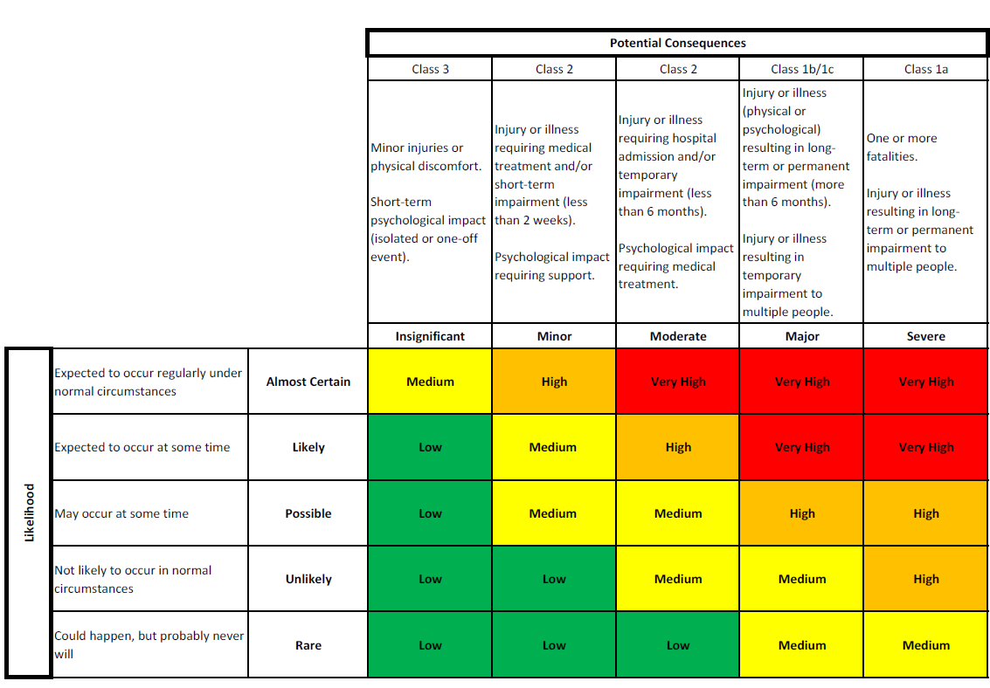

Privacy collection notice: The information collected on this form will only be accessible to authorised staff in your Faculty/School involved in health risk assessments, and staff within the University Health and Safety Unit. The information will only be used to assess the risks that on campus working poses for you or a vulnerable family member. Information will be stored securely and retained in accordance with the University’s obligations under the State Records Act. Your information will not be shared with other staff or business areas or disclosed to third parties, except where required or permitted by law, or with your consent.

You have the right to access or correct any personal information collected about you. For further information, please contact the University Health and Safety team. For information about how the University handles your personal information and how to make an enquiry or complaint, please visit our privacy webpage.

