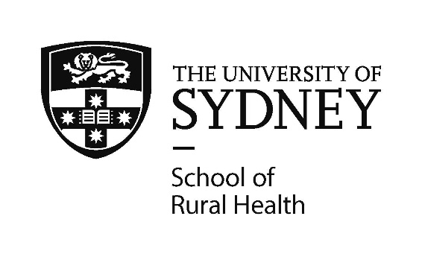

Expressions of Interest (EOI) from Wiradjuri artists and designers for
Aboriginal artwork design for the School of Rural Health (Dubbo/Orange)

APPLICATION FORM
Name

Address

Email

Phone

Signature |  | Date

Do you identify as a Wiradjuri descendent, are accepted by your local Aboriginal community and can present the necessary documentation if required? (please circle) YES / NO
Please tell us about yourself and your connection to Wiradjuri country

Please describe the story of your design and how it relates to the School of Rural Health

Do you agree to the Terms and Conditions of entry? (please circle) YES / NO

Please submit your application by email to srh.school-manager@sydney.edu.au and remember to also attach your sample artwork as a PDF, JPEG, TIFF or EPS file.
If you are delivering your application and sample artwork to the School of Rural Health, please ensure you only provide a copy of the artwork as either a photo, a scanned document on plain paper or on a USB. We will take no responsibility for original artworks.

