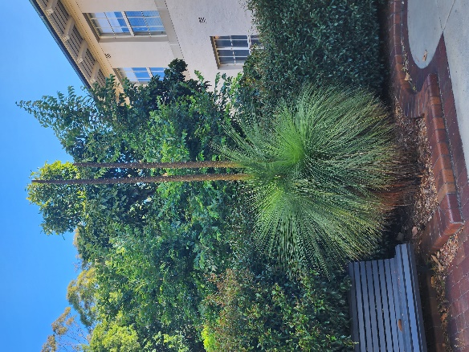
Poche Centre HDR Student Uplift
Application Guidelines

As a Faculty of Medicine and Health research flagship centre, The Poche Centre for Indigenous Health focuses on research excellence that seeks to create a positive impact on the health and wellness of Aboriginal and Torres Strait Islander individuals and communities.

Poche HDR Uplift
We recognise that support for HDR students comes in all shapes and sizes. One initiative we offer Aboriginal and Torres Strait Islander HDR students is a Poche Centre HDR Student Uplift.

The scheme offers Aboriginal and Torres Strait Islander HDR students an opportunity to apply for funding to support the following research related activities:
- Thesis editing
- Research transcription services
- Publication fees (for publications tied to your HDR candidature)
- Other research support activities (by proposal) that would benefit your HDR journey.

Poche HDR Uplift amount
In 2023 HDR students can apply for one round of uplift funding up to the value of $3000. Recipients of the Poche HDR Uplift will be invited to become a Poche HDR scholar and would be willing to acknowledge the support in any research outputs or events.

Eligibility
Applications are open to any Aboriginal and Torres Strait Islander students enrolled in a HDR degree in FMH. Poche Centre will directly pay the provider of the service you need to access ( eg we will pay publication fees directly to the journal, or pay editing fees directly to the editor, on your behalf).

Poche HDR Uplift proposals will be assessed favourably if they:
- Outline how the Poche HDR Uplift that will contribute to the HDR student experience.
- Demonstrate that previous Poche Centre HDR Uplift (if any) has been utilised effectively.
- Increase research capacity of the HDR student or support the completion of their HDR degree.
- Provide a budget outlining how the support funds will be used.

If you have questions, please email poche.admin@sydney.edu.au .

Click this link to apply now.

Please note: The Poche Centre reserves the right to fully or incrementally fund selected applications, to partially fund selected applications, and to increase or decrease budgets, as it deems appropriate.

APPLICATION DEADLINE - apply before 1 October 2023, funds must be spent by 30 November 2023.

