The New Group
PUBLICATIONS

Black HD, Xu W, Horte E, Robertson SI, Britton WJ, Kaur A, New EJ, Witting PK, Chami B, Oehlers SH, The cyclic nitroxide antioxidant 4-methoxy-TEMPO decreases mycobacterial burden in vivo through host and bacterial targets. Free Radicals in Biology and Medicine, 2019, in press.
Kaur A, New EJ*, Bio-inspired small molecule tools for the imaging of redox biology. Accounts of Chemical Research, 2019, 52, 623-632. DOI: 10.1021/acs.accounts.8b00368
Smith DG, Mitchell L, New EJ*, Pattern recognition of toxic metal ions using a single-probe thiocoumarin array. Analyst, 2019, 144, 230-236. DOI: 10.1039/C8AN01747F
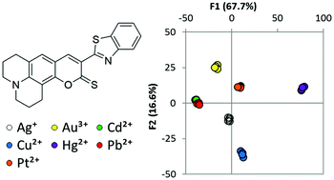
Zwicker VE, Oliveira B, Yeo JH, Fraser ST, Bernardes G, New EJ, Jolliffe KA, A fluorogenic probe for cell surface phosphatidylserine using an intramolecular indicator displacement sensing mechanism. Angewandte Chemie Int. Ed., 2019, 58, 3087-3091. DOI: 10.1002/anie.201812489

Fleming CL, Natoli A, Schreuders J, Devlin M, Yoganantharah P, Gilbert Y, Leslie KG, New EJ, Ashton TD, Pfeffer FM, Highly fluorescent and HDAC6 selective scriptaid analogues. European Journal of Medicinal Chemistry, 2019, 162, 321-333. DOI: 10.1016/j.ejmech.2018.11.020
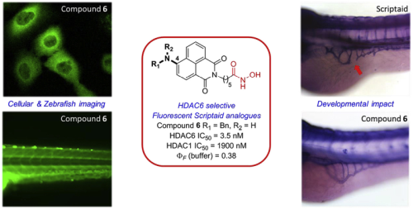
Harris M, Kolanowski JL, O’Neill ES, Henoumont C, Laurent S, Parac-Vogt TN, New EJ,* Drawing on biology to inspire molecular design: a redox-responsive MRI probe based on Gd(III)-nicotinamide. Chemical Communications, 2018, 54, 12986-12989. DOI: 10.1039/C8CC07092J
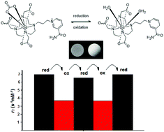
Lim Z, Smith DG, Kolanowski JL, Mattison RL, Knowles JC, Baek S-Y, Chrzanowski W,* New EJ,* A reversible fluorescent probe for monitoring Ag(I) ions. Journal of the Royal Society Interface, 2018, rsif.2018.0346. DOI: 10.1098/rsif.2018.0346
Muellner M,* Kaur A, New EJ, Aspect-ratio-dependent interaction of molecular polymer brushes and multicellular tumour spheroids. Polymer Chemistry, 2018, 9, 3461-3465. DOI: 10.1039/C8PY00703A
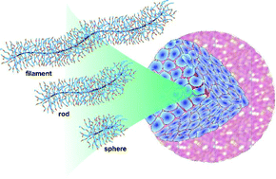
Carney IJ, Kolanowski JL, Lim Z, Chekroun B, Torrisi AG, Hambley TW, New EJ, A ratiometric iron probe enables investigation of iron distribution within tumour spheroids. Metallomics, 2018, 10, 553-556. DOI: 10.1039/C7MT00297A
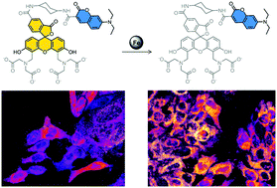
Chong KL, Chalmers BA, Cullen JK, Kaur A, Kolanowski JL, Morrow BJ, Fairfull-Smith KE, Lavin MJ, Barnett NL, New EJ, Murphy MP, Bottle SE, Pro-fluorescent mitochondria-targeted real-time responsive redox probes synthesised from carboxy isoindoline nitroxides: Sensitive probes of mitochondrial redox status in cells. Free Radical Biology and Medicine, 2018, Advance article. DOI: 10.1016/j.freeradbiomed.2018.03.008
Lim Z, Smith DG, Kolanowski JL, Mattison RL, Knowles JC, Baek SY, Chrzanowski W, New EJ, A reversible fluorescent probe for monitoring Ag (I) ions. Journal of the Royal Society Interface, 2018, 15, 20180346. DOI: 10.1098/rsif.2018.0346
Leslie KG, Jacquemin D, New EJ, Jolliffe KA, Expanding the Breadth of 4‐Amino‐1,8‐naphthalimide Photophysical Properties through Substitution of the Naphthalimide Core. Chem. Eur. J., 2018, 24, 5569-5573. DOI: 10.1002/chem.201705546
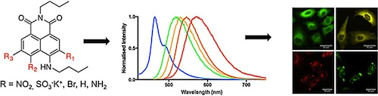
Renfrew AK, O'Neill ES, Habley TW, New EJ, Harnessing the properties of cobalt coordination complexes for biological application. Coordination Chemistry Reviews, 2018, 375, 221-233. DOI: 10.1016/j.ccr.2017.11.027
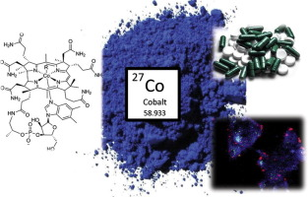
Yang K, Leslie KG, Kim SY, Kalionis B, Chrzanowski W, Jolliffe KA, New EJ, Tailoring the properties of a hypoxia-responsive 1, 8-naphthalimide for imaging applications. Organic and biomolecular chemistry, 2018, 16, 619-624. DOI: 10.1039/C7OB03164E
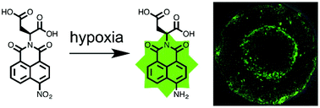
New EJ, Wimmer VC, Hare DJ, Promises and pitfalls of metal imaging in biology. Cell Chemical Biology, 2018, 25, 7-18. DOI: 10.1016/j.chembiol.2017.10.006
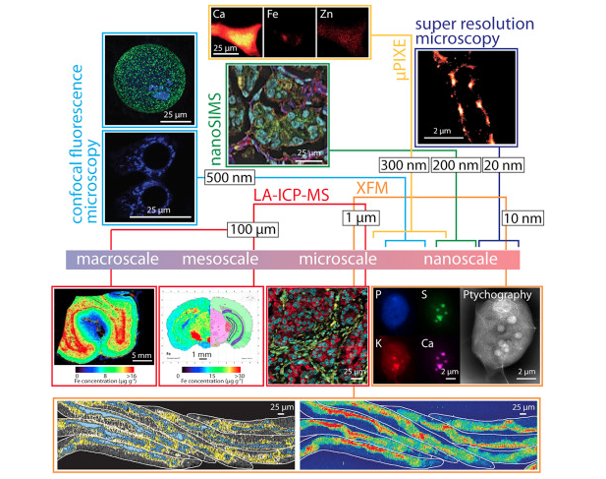
Kolanowski JL, Liu F, New EJ, Fluorescent probes for the simultaneous detection of multiple analytes in biology. Chemical Society Reviews, 2018, 47, 195-208. DOI: 10.1039/C7CS00528H
Kolanowski JL, Dawson LJ, Mitchell L, Lim Z, Graziotto ME, Filipek WK, Hambley TW, New EJ, A fluorescent probe for investigating metabolic stability of active transplatin analogues. Sensors and Actuators B: Chemical, 2017, 255, 2721-2724. DOI: 10.1016/j.snb.2017.09.084
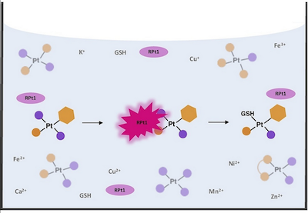
Wright PJ, Kolanowski JL, Filipek WK, Lim Z, Moore EG, Stagni S, New EJ, Massi M, Versatility of Terpyridine‐Functionalised Aryl Tetrazoles: Photophysical Properties, Ratiometric Sensing of Zinc Cations and Sensitisation of Lanthanide Luminescence. European Journal of Inorganic Chemistry, 2017, 44, 5260-5270. DOI: 10.1002/ejic.201700663
Smith DG, Topolnicki IL, Zwicker VE, Jolliffe KA, New EJ, Fluorescent sensing arrays for cations and anions. Analyst, 2017, 142, 3549-3563. DOI: 10.1039/C7AN01200D
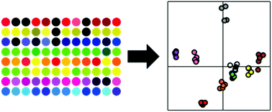
Graziotto ME, Akerfeldt MC, Gunn AP, Yang K, Somerville MV, Coleman NV, Roberts BR, Hambley TW, New EJ, The influence of the ethane-1,2-diamine ligand on the activity of a monofunctional platinum complex. Journal of Inorganic Biochemistry, 2017, 177, 328-334. DOI: 10.1016/j.jinorgbio.2017.07.029
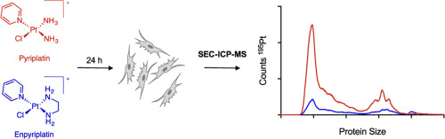
O’Neill ES, Kaur A, Bishop DP, Shishmarev D, Kuchel PW, Grieve SM, Figtree GA, Renfrew AK, Bonnitcha PD, New EJ, Hypoxia-responsive cobalt complexes in tumor spheroids: LA-ICP-MS and MRI studies. Inorganic Chemistry, 2017, 56, 9860-9868. DOI: 10.1021/acs.inorgchem.7b01368
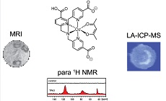
Wu A, Kolanowski JL, Boumelhem BB, Lee R, Kaur A, Fraser ST, New EJ, Rendina LM, A new carborane-containing fluorophore as a stain of cellular lipid droplets. Chemistry – An Asian Journal, 2017, 12, 1704-1708. DOI: 10.1002/asia.201700423
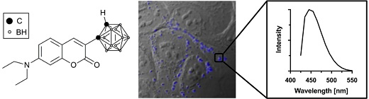
Akerfeldt MC, Tran CM-N, Shen C, Hambley TW, New EJ, Interactions of cisplatin and the copper transporter CTR1 in human colon cancer cells. Journal of Biological Inorganic Chemistry, 2017, 22, 765-774. DOI: 10.1007/s00775-017-1467-y
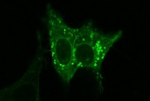
O’Neill ES, Kolanowski JL, Bonnitcha PD, New EJ, A cobalt(II) complex with unique paraSHIFT responses to anions. Chemical Communications, 2017, 53, 3571-3574. DOI: 10.1039/C7CC00619E
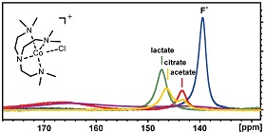
Yang K, Kolanowski JL, New EJ, Mitochondrially targeted fluorescent redox sensors, Interface Focus, 2017, DOI: 10.1098/rsfs.2016.0105
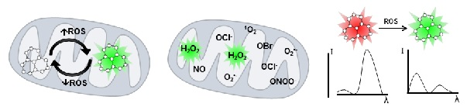
Shen C, Kolanowski JL, Tran C, Kaur A, Akerfeldt MC, Rahme MS, Hambley TW, New EJ, A ratiometric fluorescent sensor for the mitochondrial copper pool, Metallomics, 2016, 8, 915-919. DOI: 10.1039/C6MT00083E
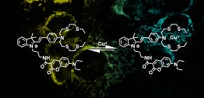
Krishnamoorthy L, Cortruvo JA, Chan J, Kaluarachchi H, Muchenditsi A, Pendyala VS, Jia S, Aron AT, Ackerman CM, Vander Wal MN, Guan T, Smaga LP, Farhi SL, New EJ, Lutsenko S, Chang CJ, Copper regulates cyclic-AMP-dependent lipolysis, Nature Chemical Biology, 2016, 12, 586–592. DOI:10.1038/nchembio.2098
Smith DG, Sajid N, Rehn S, Chandramohan R, Carney IJ, Khan MA, New EJ, A library-screening approach to developing a fluorescent sensing array for the detection of metal ions, Analyst, 2016, 141, 4608-4613. DOI: 10.1039/C6AN00510A
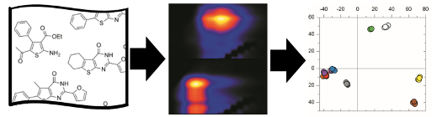
Wilkinson S, Sheedy T, New EJ, Synthesis and characterization of metal complexes with Schiff base ligands. Journal of Chemical Education, 2016, 93, 351-354. DOI: 10.1021/acs.jchemed.5b00555
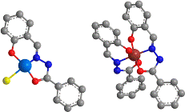
New EJ. Harnessing the Potential of Small Molecule Intracellular Fluorescent Sensors, ACS Sensors, 2016, 1, 328–333. DOI: 10.1021/acssensors.6b00148
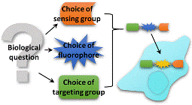
O’Neill ES, Kolanowski JL, Yin GH, Broadhouse KM, Grieve SM, Renfrew AK, Bonnitcha PD, New EJ. Reversible magnetogenic cobalt complexes. RSC Advances, 2016, 6, 30021-30027. DOI: 10.1039/C6RA04643F
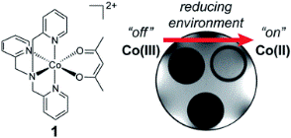
Hare DJ, New EJ. On the outside looking in: redefining the role of analytical chemistry in the biosciences. Chemical Communications, 2016, 52, 8918-8934. DOI: 10.1039/C6CC00128A
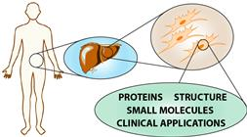
Kaur A, Jankowska K, Pilgrim C, Fraser ST, New EJ. Studies of hematopoietic cell differentiation with a ratiometric and reversible sensor of mitochondrial reactive oxygen species. Antioxidants and Redox Signaling, 2016, 24, 667-79. DOI: 10.1089/ars.2015.6495
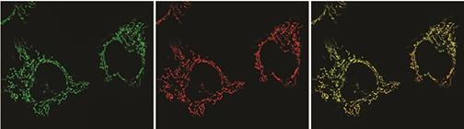
Kolanowski JL, Kaur A, New EJ. Selective and reversible approaches towards imaging redox signaling using small molecule probes. Antioxidants and Redox Signaling, 2016, 24, 713-730. DOI: 10.1089/ars.2015.6588
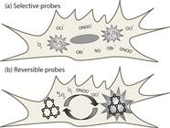
Kaur A, Kolanowski JL, New EJ. Reversible fluorescent probes of biological redox state. Angewandte Chemie, 2016, 55, 1602–1613. DOI: 10.1002/anie.201506353

Hare, DJ, New, EJ, de Jonge, MD and McColl, G. Imaging metals in biology: balancing sensitivity, selectivity and spatial resolution. Chemical Society Reviews, 2015, 44, 5941-5958. DOI: 10.1039/C5C00055F
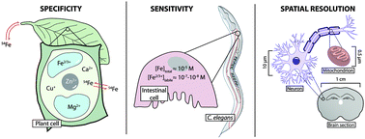
Kaur, A, Haghighatbin, MA, Hogan, CF and New, EJ. A FRET-based ratiometric redox probe for detecting oxidative stress by confocal microscopy, FLIM and flow cytometry. Chemical Communications, 2015, 51, 10510-3. DOI: 10.1039/C5CC03394B
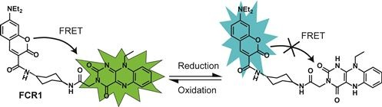
Kaur, A, Brigden, KWL, Cashman, TF, Fraser, ST and New, EJ. Mitochondrially targeted redox probe reveals the variations in oxidative capacity of the haematopoietic cells. Organic and Biomolecular Chemistry, 2015, 13, 6686-9. DOI: 10.1039/C5OB00928F
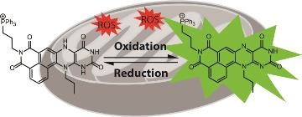
Shen, C, Harris, BDW, Dawson, LJ, Charles, KA, Hambley, TW and New, EJ. Fluorescent sensing of monofunctional platinum species. Chemical Communications, 2015, 51, 6312-4. DOI: 10.1039/C4CC08077G
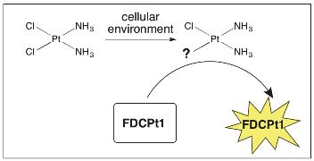
Shen, C and New, EJ. What has fluorescent sensing told us about copper and brain malfunction? Metallomics, 2015, 7, 56-65. DOI: 10.1039/C4MT00288A
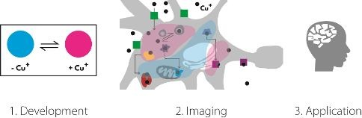
Eljack, ND, Ma, H-YM, Drucker, J, Shen, C, Hambley, TW, New, EJ, Friedrich, T and Clarke, RJ. Mechanisms of cell uptake and toxicity of the anticancer drug cisplatin, Metallomics, 2014, 6, 2126-2133. DOI: 10.1039/C4MT00238E
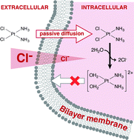
Yeow, J, Kaur, A, Anscomb, MD and New, EJ. A novel flavin derivative reveals the impact of glucose on oxidative stress in adipocytes, Chemical Communications, 2014, 50, 8181-8184. DOI: 10.1039/C4CC03464C
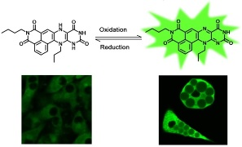
O'Neill, E and New, EJ. Luminescent Lanthanoid Probes. In: Storr T, (Ed.). Ligand Design in Medicinal Inorganic Chemistry. Wiley-Blackwell, Chichester, UK, 2014, 113-143. DOI: 10.1002/9781118697191.ch5
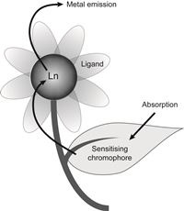
Shen, C and New, EJ. Promising strategies for Gd-based responsive magnetic resonance imaging contrast agents. Current Opinion in Chemical Biology, 17 (2), 158-166, 2013. DOI: 10.1016/j.cbpa.2012.10.031
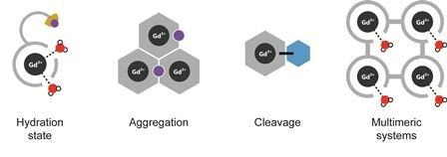
New, EJ. Tools to study distinct metal pools in biology. Dalton Transactions, 42, 3210-3219, 2013. DOI: 10.1039/C2DT31933K
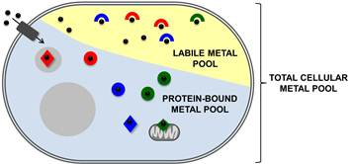
Que, EL; New, EJ and Chang, CJ. A cell-permeable gadolinium contrast agent for magnetic resonance imaging of copper in a Menkes disease model. Chemical Science, 3, 1829-1834, 2012. DOI: 10.1039/C2SC20273E
Au-Yeung, H-Y; New, EJ and Chang, CJ. A selective reaction-based fluorescent probe for detecting cobalt in living cells. Chemical Communications, 48, 5268-5270, 2012. DOI: 10.1039/C2CC31681A
Lippert, AR; New, EJ and Chang, CJ. Reaction-based fluorescent probes for selective imaging of hydrogen sulfide in living cells. Journal of the American Chemical Society, 133 (26), 10078-10080, 2011. DOI: 10.1021/ja203661j
Dias, DM; Teixeira, JMC; Kuprov, I; New, EJ; Parker, D and Geraldes, C. Enantioselective binding of a lanthanide(III) complex to human serum albumin studied by (1)H STD NMR techniques. Organic & Biomolecular Chemistry, 9, 5047-5050, 2011. DOI: 10.1039/C1OB05524K
New, EJ; Parker, D; Smith, DG and Walton, JW. Development of responsive lanthanide probes for cellular applications. Current Opinion in Chemical Biology, 14 (2), 238-246, 2010. DOI: 10.1016/j.cbpa.2009.10.003
New, EJ; Congreve, A and Parker, D. Definition of the uptake mechanism and sub-cellular localisation profile of emissive lanthanide complexes as cellular optical probes. Chemical Science, 1, 111-118, 2010. DOI: 10.1039/C0SC00105H
Miller, EW; Taulet, N; Onak, CS; New, EJ; Lanselle, JK; Smelick, GS and Chang, CJ. Light-activated regulation of cofilin dynamics using a photocaged hydrogen peroxide generator. Journal of the American Chemical Society, 132 (48), 17071-17073, 2010. DOI: 10.1021/ja107783j
New, EJ; Roche, C; Madawala, R; Zhang, JZ and Hambley, TW. Fluorescent analogues of quinoline reveal amine ligand loss from cis and trans platinum(II) complexes in cancer cells. Journal of Inorganic Biochemistry, 103 (8), 1120-1125, 2009. DOI: 10.1016/j.jinorgbio.2009.05.005
New, EJ; Parker, D and Peacock, RD. Comparative study of the constitution and chiroptical properties of emissive terbium and europium complexes with a common tetraazatriphenylene sensitiser; the nature of the sensitiser determines quenching sensitivity and cellular uptake. Dalton Transactions, 672-679, 2009. DOI: 10.1039/B816173A
New, EJ and Parker, D. The mechanism of cell uptake for luminescent lanthanide optical probes: the role of macropinocytosis and the effect of enhanced membrane permeability on compartmentalisation. Organic & Biomolecular Chemistry, 7, 851-855, 2009. DOI: 10.1039/B822145F
New, EJ; Duan, R; Zhang, JZ and Hambley, TW. Investigations using fluorescent ligands to monitor platinum(IV) reduction and platinum(II) reactions in cancer cells. Dalton Transactions, 3092-3101, 2009. DOI: 10.1039/B821603G
Montgomery, CP; New, EJ; Palsson, LO; Parker, D; Batsanov, AS and Lamarque, L. Emissive and cell-permeable 3-pyridyl- and 3-pyrazolyl-4-azaxanthone lanthanide complexes and their behaviour in cellulo. Helvetica Chimica Acta, 92, 2186-2213, 2009. DOI: 10.1002/hlca.200900122
Montgomery, CP; Murray, BS; New, EJ; Pal, R and Parker, D. Cell-penetrating metal complex optical probes: Targeted and responsive systems based on lanthanide luminescence. Accounts of Chemical Research, 42, 925-937, 2009. DOI: 10.1021/ar800174z

