Exercise: Applying the checklist

Case 1: Beenleigh Local Plan (Logan)
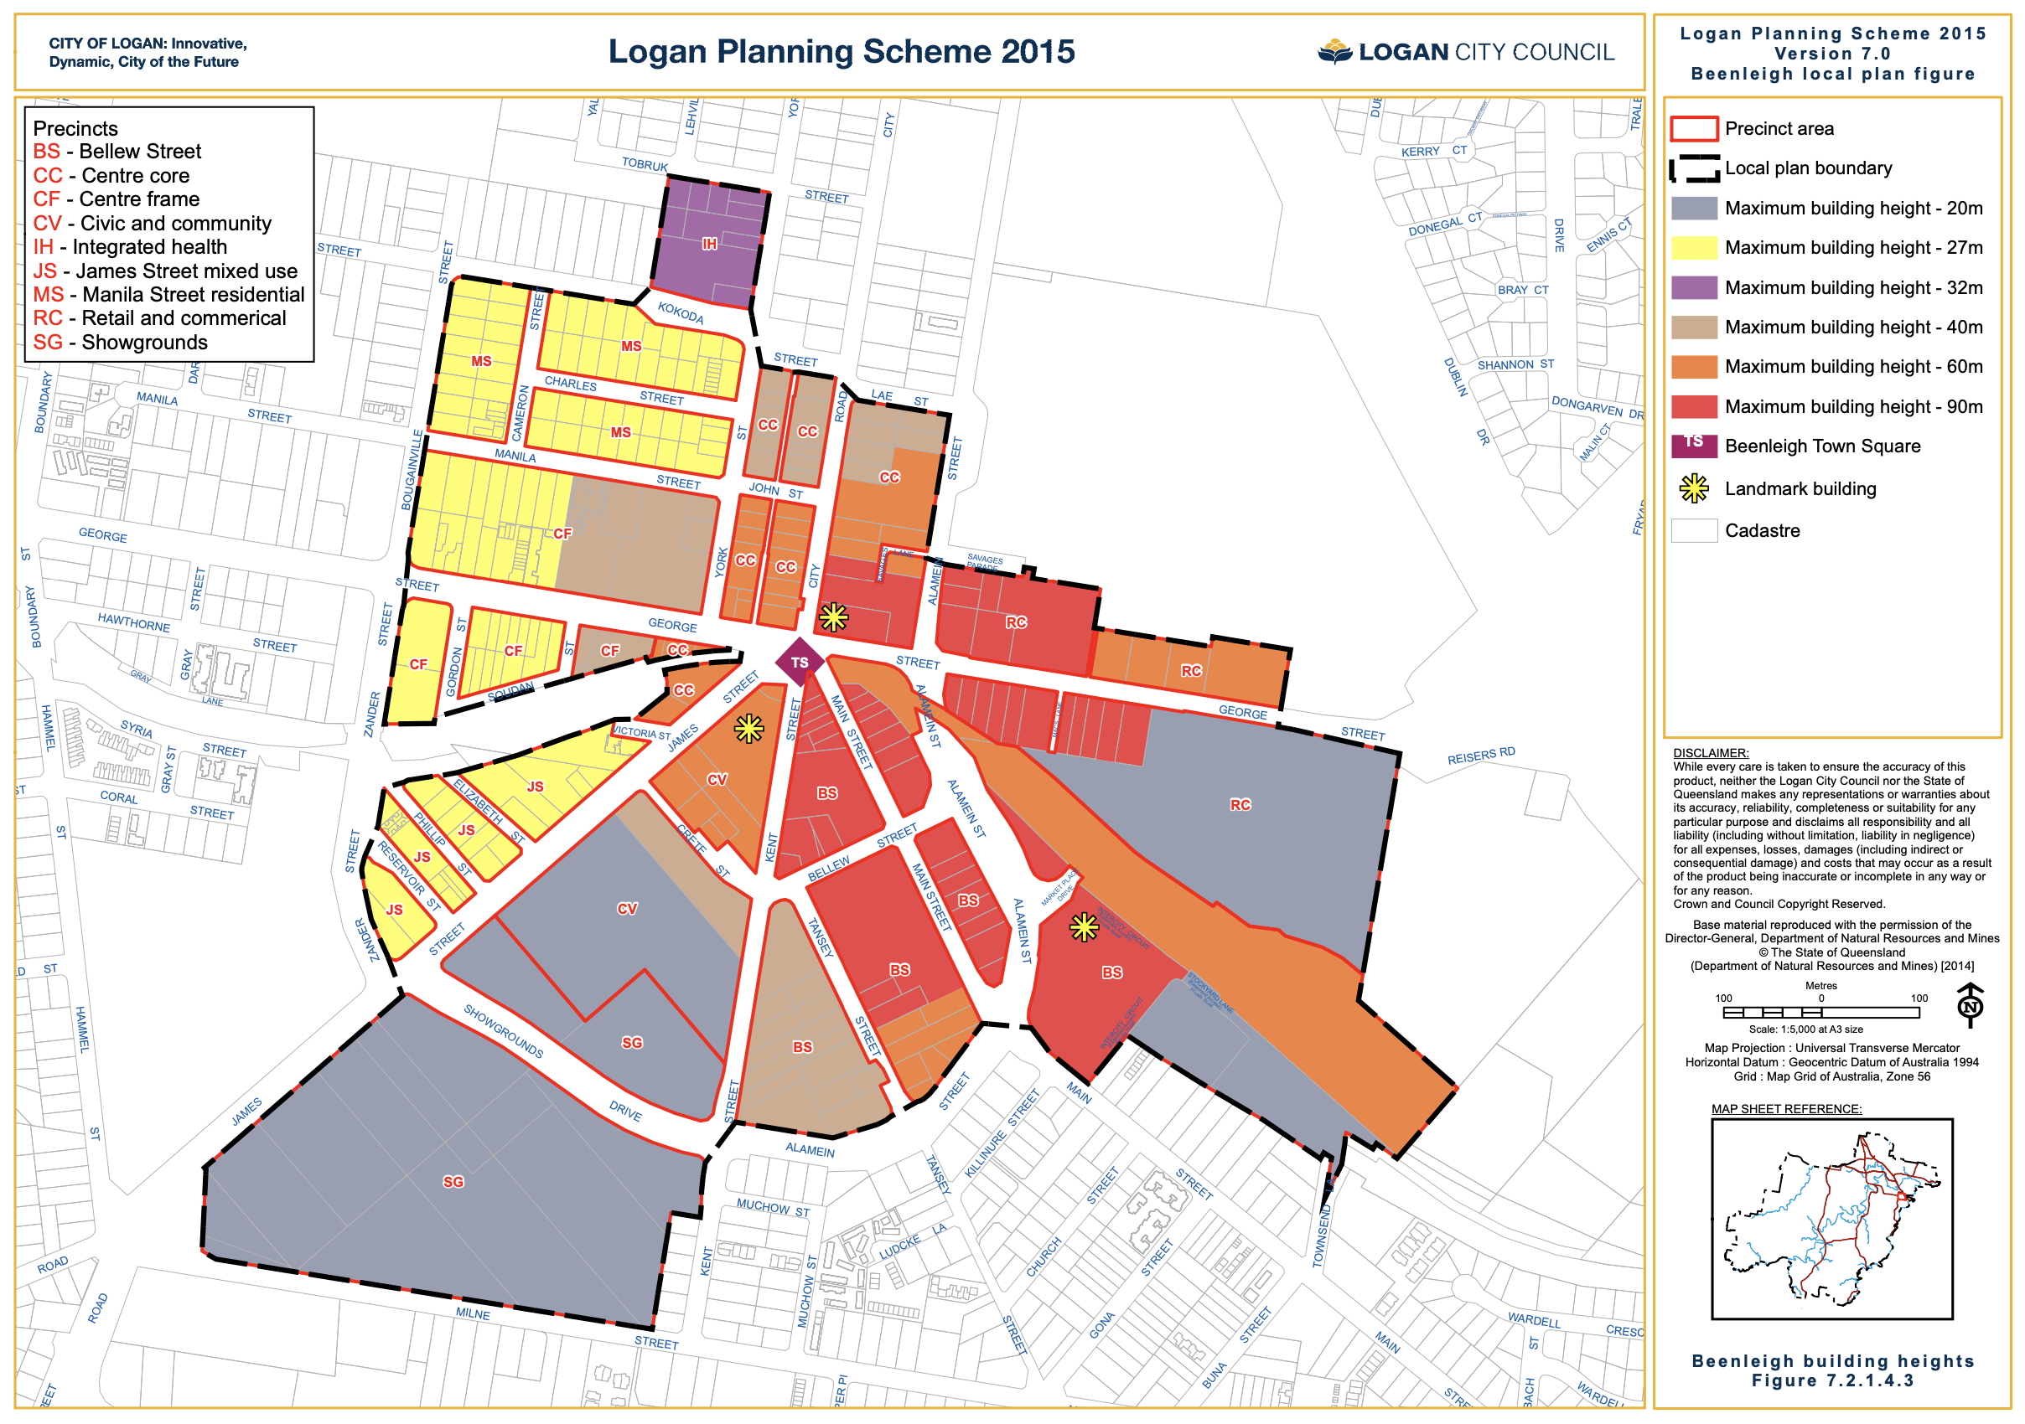
The local planning scheme seeks to densify the central part of Beenleigh. To encourage this, the plan allows for the following use types:
- Residential up to 27m or 32m high in some areas
- Mixed use and commercial up to 90m high in some areas.
There is a clear intention to densify this central Beenleigh area.
How plausible is it that 8 storey apartments or 25 story office towers will be built?

Market evidence:
Two good sources are realestate.com.au (sold tab) and Corelogic suburb profiles and sales reports (for subscribers).
It is tricky to judge the likelihood of a planned use being viable when a suburb doesn’t already have that type of use you are planning. How would a developer judge their expected revenue? You need to make judgement calls based on sales in nearby areas or suburbs in other parts of the city with similar detached housing prices, for example.
Below is a small selection of apartment sales in the areas that are not high-rise, but are would be possible substitutes for buyers.

Table 1: Beenleigh apartment sales evidence
Address | Image | Size  (sqm)  Int/Ext | Beds/  baths | Cars | Sale date | Sale price  ($ ‘000) | Price  ($/sqm)
<10YRS OLD  9/12-14 Hawthorne Street |  | 104 | 2 / 1 | 2 | 17 Jul | 192 | 1,850
10 YRS OLD  10/93-99 Logan St, Beenleigh |  | 90 | 2 / 1 | 1 | 1 Jul | 167 | 1,850
NEW  29/2-4 Elizabeth Street | 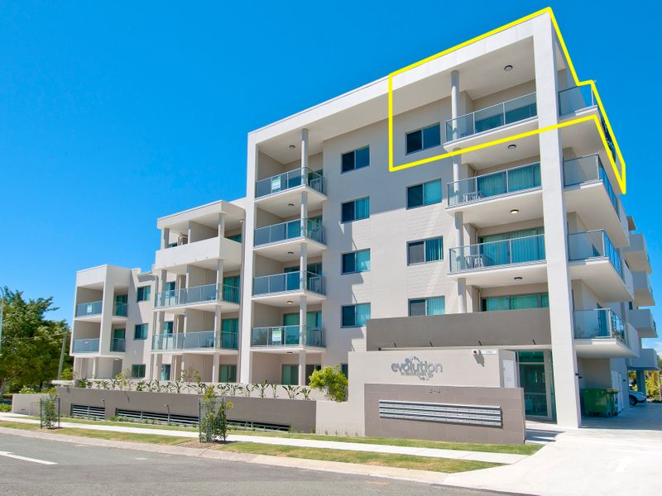 | 70/ 25 | 2 / 2 | 2 | 19 May | 340 | 4,850  (3,570)
3 YRS OLD  10/115 Main Street | 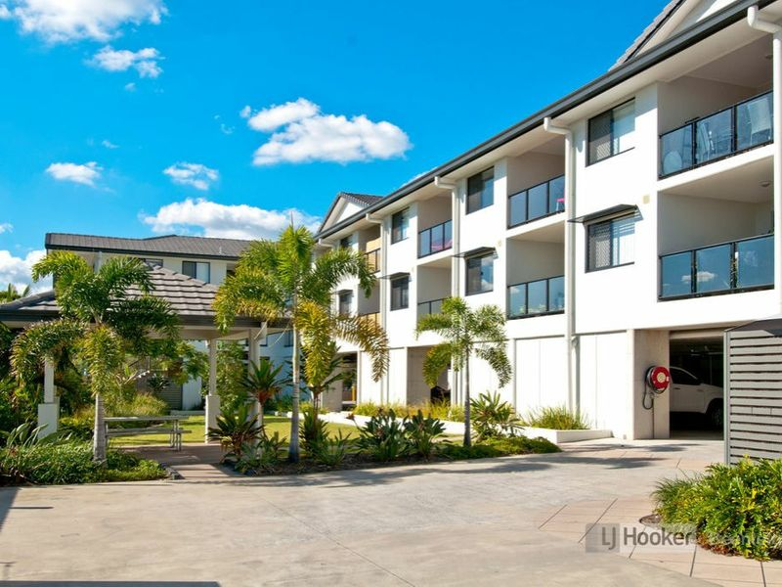 | 70 / 9 | 2 / 2 | 1 | 4 Sept | 220 | 2,750

Notes:
- Very few apartment sales. Though many off-the-plan sales don’t get recorded in publicly available places like realestate.com and require a Corelogic subscription to access the sales records.
- Older stock is very cheap. Many renovated small complexes at low prices.
- Big price gap for new stock.
This makes it a very risky market to build a large apartment building.
* For commercial office buildings we can look at some sales and rental evidence here. The $380/sqm annual rental price per sqm implies $4,500/sqm price at 8.5% yield (aka capitalisation rate—recall the asset pricing model 380/0.085 = 4500).
Construction costs alone are $3,800 - $5,000 per sqm for up to 25 storeys (up to the 90m height limit). These tall towers are infeasible at current market prices, even though they are allowable.

Construction cost evidence:
There are multiple sources of evidence for this. Rawlinsons (subscription and Riders (partly free) are two companies that compile construction cost evidence based on recent construction projects.
Below is an extract from the 2018 Riders cost guide, tabulating construction and services costs per sqm of apartment.
Table 2: Brisbane construction cost evidence
 |  | Construction |  | Services |  | Total
 | Size (sqm) | Low | High | Low | High | Low | High
Walk-up | 85-120 | 1,800 | 3,400 | 253 | 502 | 2,053 | 3,902
Townhouse | 90-120 | 1,500 | 3,500 | 253 | 493 | 1,752 | 3,993
<10 storeys | 60-70 | 2,400 | 3,500 | 464 | 886 | 2,864 | 4,386
 | 90-120 | 2,400 | 3,500 | 442 | 851 | 2,842 | 4,351
10-20 storeys | 60-70 | 2,800 | 3,600 | 562 | 883 | 3,362 | 4,483
 | 90-120 | 2,800 | 3,600 | 533 | 840 | 3,333 | 4,440
20-40 storeys | 60-70 | 3,000 | 3,800 | 639 | 1,010 | 3,639 | 4,810
 | 90-120 | 3,000 | 3,700 | 616 | 969 | 3,616 | 4,669

Notes:
- The only apartment types that are certain to have a construction cost below the market price (less GST) are <10 storeys.
- There is a big jump in construction cost going from walk-up to lift-serviced apartments, and another big jump >10 storeys.

Fees and charges:
Standard maximum charges in Queensland are:
$28,311 per 3-bed or more dwelling
$21,231 per 2-bed or less dwelling
Logan Council has a boutique charging regime that requires you to determine the location and type of works to assess your charge for each type of trunk infrastructure.
We will apply the standard rate for this indicative feasibility.
* It is worth taking a moment to note that the standard fixed charge regime is very popular/uncontroversial. There are benefits to simplicity of a system—it gets more buy in. My view is that zoning codes could be less flexible on key elements (GFA, setbacks, use types, etc) which would increase trust in the system by developers and communities.

Apply the checklist

Check Rule #1
Here’s a template for a quick and dirty feasibility on a per unit basis (rather than a project basis) to check Rule #1.

Market price per unit
LESS GST
Minus development costs | Margin  (20% of costs = 17% of revenue) | 20% on all costs (including site)
 | MAXIMUM TOTAL COST
 | Construction
 | Professional services | ~6% of constr.
 | Fees/charges | QLD charges/unit
 | Marketing and sales | 3% of gross rev.
 | Finance interest/charges | ~6% on 70% of costs
Residual land (site) value per unit

Check Rule #2
Here’s a template to try a 3-storey walk-up style apartment.

Market price per unit
LESS GST
Minus development costs | Margin  (20% of costs = 17% of revenue) | 20% on all costs (including site)
 | MAXIMUM TOTAL COST
 | Construction
 | Professional services | ~6% of constr.
 | Fees/charges | Per QLD charges
 | Marketing and sales | 3% of gross rev.
 | Finance interest/charges | 6% on 70% of costs
Residual land (site) value per unit

Check Rule #3
Recent sales of sites are quite cheap. Here’s 1,012sqm with a run-down house on City Road, just outside the boundary of the central Beenleigh plan. It sold for $331,000 ($300/sqm of site). Here’s a 1,715sqm site just outside the plan area that sold for $385,000 ($220/sqm of site).
Can these higher density uses outbid for sites?

