Exercise: Applying the checklist

Case 2: Fishermans Bend (Melbourne)
The high end of the market is Fishermans Bend in Melbourne. Melbourne has turned inner city industrial land into high density housing before with Docklands, where planning for its modern redevelopment in the 1990s with development picking up pace in the early 2000s.
Before | 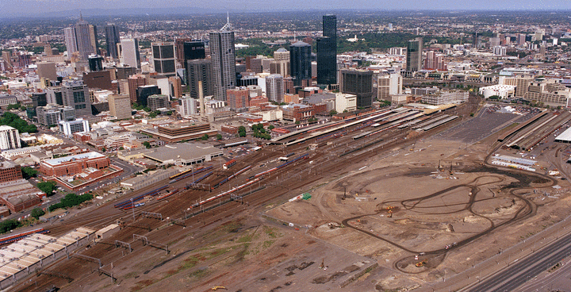
After | 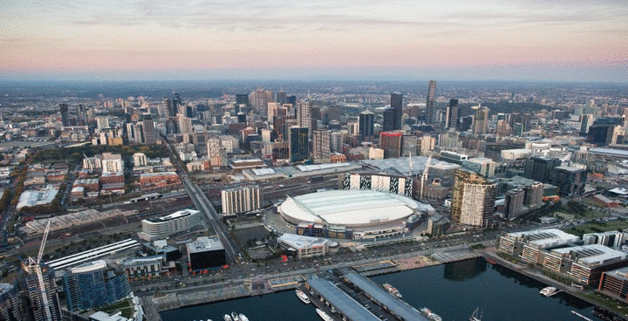
Figure 1: Docklands area before and after the stadium development
We can therefore learn from the path of development what is types of density and use the market will accommodate at Fisherman’s Bend. The main difference here is that there are existing industrial activities and many private site owners in the area. Development will be less driven by public investment and rely on the economic decisions of landowners within planning constraints.
Planners create certainty with these types of maps and simple controls. But in this case when the area was first “rezoned” there was no intention for height limits. It was a poor process; no space for parks, schools, etc. The state government had to then acquire sites for these public purposes at much higher prices since the market price already reflected the high-density rezoning. It’s not enough to say “it’s free for all, go nuts”. The coordinating role of planning helps development.

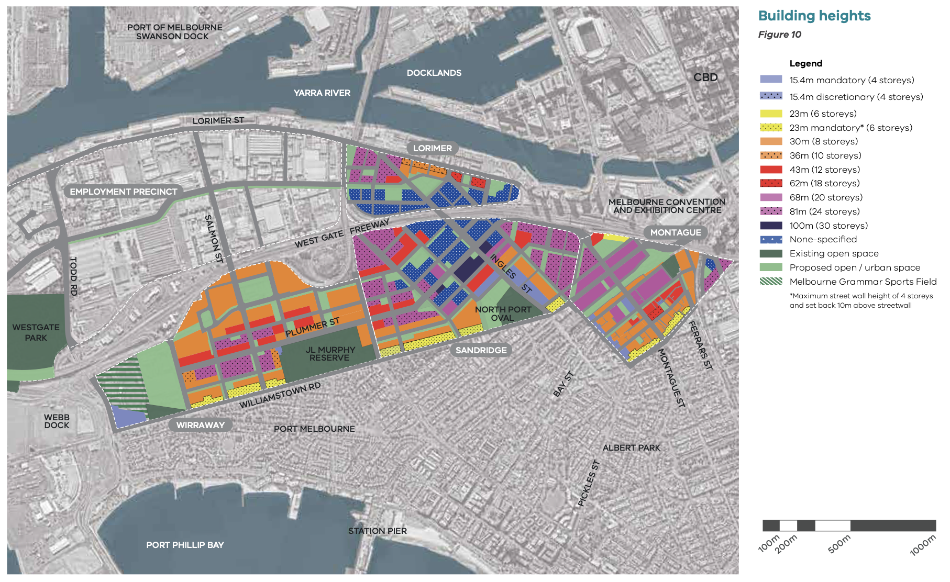

Figure 2: Fishermans Bend building heights
Comparable sales come from nearby suburbs such as Port Melbourne, Albert Park, or Docklands. We are not going to focus on getting the price perfect, just indicative. Not that the variation in new and older apartments is important. Also, the variation between luxury buildings and others, and between penthouses and regular size apartments.

Address | Description | Size  (sqm)  Int/Ext | Beds/  baths | Cars | Sale date | Sale price  ($ ‘000) | Price  ($/sqm)
11.08A/320 Plummer St, Port Melb. | New luxury high rise penthouse (concierge, etc) | 152 | 3 /2 | 3 | 12 Dec | 1,990 | 13,092
20/2 Esplanade West, Port Melb | Near new luxury high rise. | 90 | 2 / 2 | 1 | 3 Feb | 1,330 | 14,700
206/99 Nott Street, Port Melb | Boutique mid-rise. ~10yr old | 70 | 2 / 1 | 1 | 18 Jul | 530 | 7,600
1207/60 Lorimer Street, Docklands | Waterfront new high rise. | 88 / 9 | 2 / 1 | 1 | 30 Jul | 620 | 7,050
310E/126 Rouse Street, Port Melb | Low rise near new, close to bay. | 77 / 10 | 2 / 1 | 1 | 4 Aug | 700 | 9,000

 |  | Construction |  | Services |  | Total
 | Size (sqm) | Low | High | Low | High | Low | High
Walk-up | 85-120 | 1,820 | 3,300 | 209 | 575 | 2,029 | 3,875
Townhouse | 90-120 | 1,820 | 3,050 | 209 | 554 | 2,029 | 3,604
<10 storeys | 60-70 | 2,500 | 3,150 | 518 | 880 | 3,018 | 4,030
 | 90-120 | 2,500 | 3,200 | 512 | 849 | 3,012 | 4,049
10-20 storeys | 60-70 | 2,800 | 3,600 | 554 | 905 | 3,354 | 4,705
 | 90-120 | 2,800 | 3,650 | 554 | 874 | 3,354 | 4,524
20-40 storeys | 60-70 | 3,250 | 3,900 | 648 | 992 | 3,898 | 4,892
 | 90-120 | 3,250 | 4,000 | 627 | 900 | 3,877 | 4,900
40-80 storeys | 60-70 | 3,650 | 4,300 | 821 | 1,220 | 4,471 | 5,520
 | 90-120 | 3,650 | 4,400 | 763 | 1,168 | 4,413 | 5,568

Fees and charges:
Let’s be honest here. I spent an hour looking online for them. It shouldn’t be this hard. Pick a number! In this case a Victorian planner helped me find them - $13,900 per unit.

Apply the checklist

Check Rule #1
Here’s a quick and dirty feasibility on a per unit basis (rather than a project basis) to check Rule #1. Sometimes developers will think in terms of these “per unit” rules of thumb about how much they can pay for a site in different markets. “Oh, I’d pay about $100,000 per apartment for a site in that area.”

Market price per unit |  | $8,500 x 80sqm | $680,000
LESS GST |  |  | $618,000
Minus development costs | Margin  (20% of costs = 17% of revenue) | 20% on all costs (including site) | $103,000
 | MAXIMUM TOTAL COST |  | $515,000
 | Construction | 80sqm x $4,000 | $320,000
 | Professional services | ~5% of constr. | $16,000
 | Fees/charges | charges/unit | $16,000
 | Marketing and sales | ~3% of gross rev. | $17,000
 | Finance interest/charges | 6% on 70% of costs | $20,000
Residual land (site) value per unit |  |  | $126,000

If we have site able to build a 20-storey building with 8 units per floor (ignoring penthouses etc), then we have 20 x 8 = 160 times $126,000 = $20,160,000 for that site.
What about a 40-storey building?

Market price per unit |  | $8,500 x 80sqm | $680,000
LESS GST |  |  | $618,000
Minus development costs | Margin  (20% of costs = 17% of revenue) | 20% on all costs (including site) | $103,000
 | MAXIMUM TOTAL COST |  | $515,000
 | Construction | 80sqm x $4,800 | $384,000
 | Professional services | ~5% of constr. | $16,000
 | Fees/charges | charges/unit | $16,000
 | Marketing and sales | ~3% of gross rev. | $17,000
 | Finance interest/charges | 6% on 70% of costs | $20,000
Residual land (site) value per unit |  |  | $62,000

A 40-storey building with 8 units per floor (ignoring penthouses etc), then we have 20 x 8 = 320 times $62,000 = $19,840,000 for that site.

Check Rule #2
This is a quick and dirty way to think about what the economically optimal height is using Rule #2. Clearly we know that it is less than 40-storeys (assuming we have our price and cost data roughly right—a big assumption).
At 20 storeys, a 20% increase in construction cost makes the marginal construction cost $4,800, or $384,000 per additional dwelling, plus the fixed $69,000 per dwelling, or $453,000 total marginal cost per dwelling. This is still less than the total cost willing to pay of $515,000. Hence, building taller that 20 storeys is viable.
If there was a strict 20 storey height limit, developers would complain. That’s because getting an additional storey provides then $47,000 per extra apartment. Add 5 storeys and that might be worth ~$1.9 million to them.
At 40 storeys a 20% increase in construction cost makes the marginal construction cost $5,800, or $464,000 per additional dwelling plus the fixed $69,000 to give a total marginal cost of $533,000. This is more than the $515,000 total cost they are willing to pay. Hence the optimal height is less than 40 storeys.
Note that where there are height limits they are in the 4-30 storey range, meaning that these height limits will bind and be challenged repeatedly to get the extra value from going higher.

Check Rule #3
We know that in this type of market that a private buyer would pay about $15 million for a site that can fit a 20-storey tower with 8 apartments per storey.
Is this enough to outbid buyers who want to use sites for their current uses?
It would be worth reaching out to some commercial real estate agents in key areas to make sure you have a feel for the market.
Here are a couple of examples sales.
- A 2,764sqm site in a precinct with no height limit and an existing use returning $450,000pa. At a 6% yield (divide by 0.06) the price would $7.5 million I confirmed with the agent that it sold last year for $8 million. This price not yet reflect the value as a development site (there is a 5-year leaseback, for example).
- A 1,888sqm site that sold for $7.3 million in an area that currently has an 8-storey height limit.
Agents tell me there are plenty of large sites around and that developers are (were) active. We can be confident that densification here will work in the 20-40 storey range for residential towers.

Finally
In these situations where development is profitable and density limits bind, flexibility of the planning system is then tied to economic gains for developers. In the above case, every extra apartment they can squeeze on the site above what would usually be expected to fit withing the height limit provides $126,000 to their balance sheet before they build anything in the form of increased land value. One more storey of eight apartments is worth $1million+ to them. That’s why they argue so vigorously for exemptions and flexibility in planning applications. We should tax these gains and see if they still ask to exceed the code. A 75% betterment tax would raise $750,000 in this example of getting one extra storey.

Online feasibility tool
This requires similar inputs and can be done in a more structured way for specific sites and design constraints.
https://msd.unimelb.edu.au/research/projects/current/transforming-housing/affordable-housing-tools/affordable-housing-calculator w

