Exercise: Applying the checklist

Case 2: Fishermans Bend (Melbourne)
The high end of the market is Fishermans Bend in Melbourne. Melbourne has turned inner city industrial land into high density housing before with Docklands, where planning for its modern redevelopment in the 1990s with development picking up pace in the early 2000s.
Before | 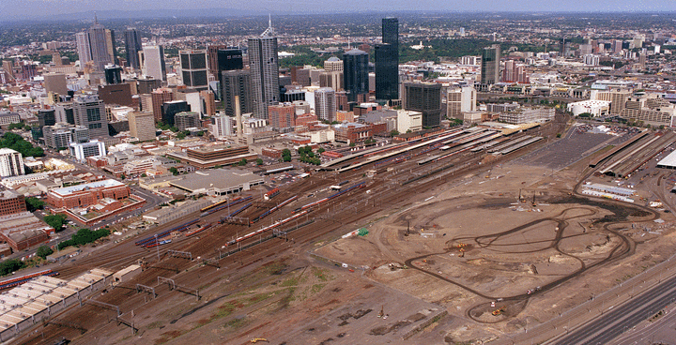
After | 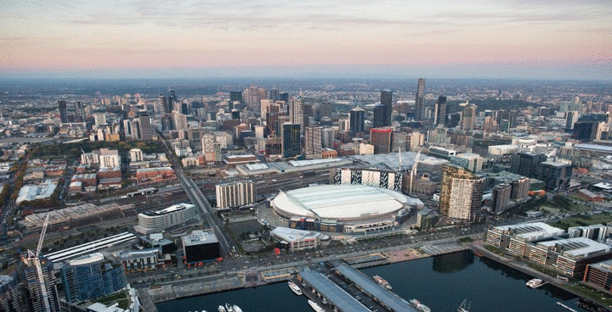
Figure 1: Docklands area before and after the stadium development
We can therefore learn from the path of development what is types of density and use the market will accommodate at Fisherman’s Bend. The main difference here is that there are existing industrial activities and many private site owners in the area. Development will be less driven by public investment and rely on the economic decisions of landowners within planning constraints.
Planners create certainty with these types of maps and simple controls. But in this case when the area was first “rezoned” there was no intention for height limits. It was a poor process; no space for parks, schools, etc. The state government had to then acquire sites for these public purposes at much higher prices since the market price already reflected the high-density rezoning. It’s not enough to say “it’s free for all, go nuts”. The coordinating role of planning helps development.

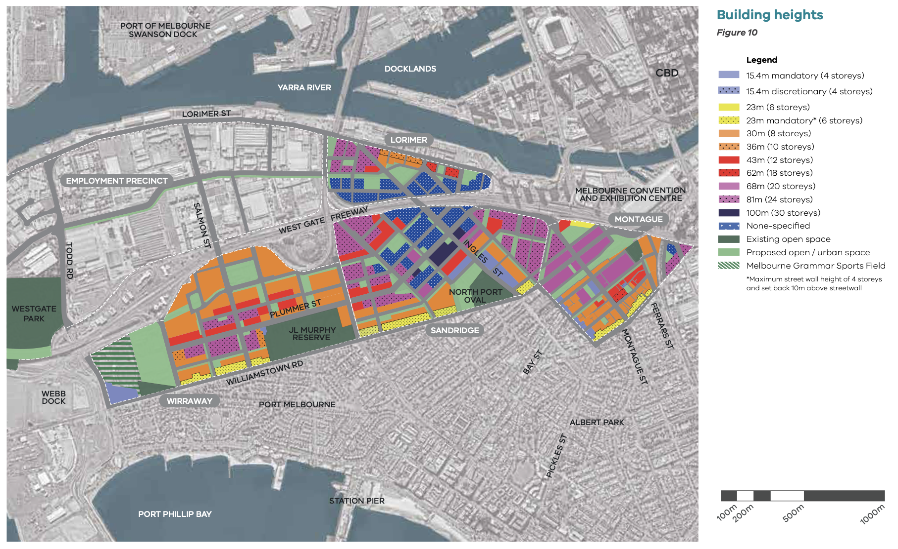
Figure 2: Fishermans Bend building heights

Comparable sales come from nearby suburbs such as Port Melbourne, Albert Park, or Docklands. We are not going to focus on getting the price perfect, just indicative. Note also that the variation in new and older apartments is important, as well as the variation between luxury buildings and others, and between penthouses and regular size apartments.
Check on realestate.com.au for sold apartments in comparable areas in new buildings.

Address | Description | Size  (sqm)  Int/Ext | Beds/  baths | Cars | Sale date | Sale price  ($ ‘000) | Price  ($/sqm)

 |  | Construction |  | Services |  | Total
 | Size (sqm) | Low | High | Low | High | Low | High
Walk-up | 85-120 | 1,820 | 3,300 | 209 | 575 | 2,029 | 3,875
Townhouse | 90-120 | 1,820 | 3,050 | 209 | 554 | 2,029 | 3,604
<10 storeys | 60-70 | 2,500 | 3,150 | 518 | 880 | 3,018 | 4,030
 | 90-120 | 2,500 | 3,200 | 512 | 849 | 3,012 | 4,049
10-20 storeys
20-40 storeys
40-80 storeys
Refer to Rider’s cost guide to complete the table.
https://www.rlb.com/wp-content/uploads/2018/11/2019-RLB-Rider-Digest_Melbourne_2.pdf

Fees and charges
Let’s be honest here. I spent an hour looking online for them. It shouldn’t be this hard. Pick a number! In this case a Victorian planner helped me find them - $13,900 per unit.
Can someone help me?

Apply the checklist

Check Rule #1
Here’s a template for a quick and dirty feasibility on a per unit basis (rather than a project basis) to check Rule #1. Sometimes developers will think in terms of these “per unit” rules of thumb about how much they can pay for a site in different markets. “Oh, I’d pay about $100,000 per apartment for a site in that area.”
Use this template to calculate the site value per unit for a 20-storey building.

Market price per unit
LESS GST
Minus development costs | Margin  (20% of costs = 17% of revenue) | 20% on all costs (including site)
 | MAXIMUM TOTAL COST
 | Construction
 | Professional services | ~5% of constr.
 | Fees/charges | charges/unit
 | Marketing and sales | ~3% of gross rev.
 | Finance interest/charges | 6% on 70% of costs
Residual land (site) value per unit

Now do the same exercise for a 40-storey building.

Market price per unit
LESS GST
Minus development costs | Margin  (20% of costs = 17% of revenue) | 20% on all costs (including site)
 | MAXIMUM TOTAL COST
 | Construction
 | Professional services | ~5% of constr.
 | Fees/charges | charges/unit
 | Marketing and sales | ~3% of gross rev.
 | Finance interest/charges | 6% on 70% of costs
Residual land (site) value per unit

If you can get twice as many units on the site at 40 storeys, is the site worth more to develop at this height or at 20-storeys?

Check Rule #2
Rule #2 is “rule of thumb” for thinking about the economically optimal height.
At 20 storeys, a 20% increase in construction cost makes the marginal construction cost
________________ or _______________ per additional dwelling
Add in the fixed cost of __________ per dwelling to get a total marginal cost per dwelling
of _______________.
Is this below the market price (net of GST)?

Check Rule #3
We know that in this type of market that a private buyer would pay about _______________ for a site that can fit a 20-storey tower with 8 apartments per storey.
Is this enough to outbid buyers who want to use sites for their current uses?
It would be worth reaching out to some commercial real estate agents in key areas to make sure you have a feel for the market.
Here are a couple of examples
- A 2,764sqm site in a precinct with no height limit and an existing use returning $450,000pa. At a 6% yield (divide by 0.06) the price would $7.5 million I confirmed with the agent that it sold last year for $8 million. This price not yet reflect the value as a development site (there is a 5-year leaseback, for example).
- A 1,888sqm site that sold for $7.3 million in an area that currently has an 8-storey height limit.
Agents tell me there are plenty of large sites around and that developers are (were) active.

Finally
In these situations where development is profitable and density limits bind, flexibility of the planning system is then tied to economic gains for developers.
In the above case, every extra apartment they can squeeze on the site above 20-storeys provides _____________ to their balance sheet before they build anything in the form of increased land value.
One more storey of eight apartments is worth ______________to them. That’s why they argue so vigorously for exemptions and flexibility in planning applications. We should tax these gains and see if they still ask to exceed the code.
A 75% betterment tax would raise _____________ in this example for getting one extra storey of allowable height.

