

The Matilda Centre
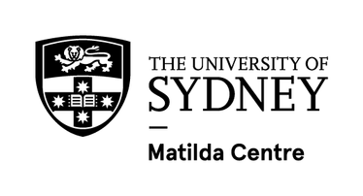
2025 Annual Report

Table of Contents

03 2025 at a Glance

Your guide to our Annual Report
04 Director’s Report
06 About the Matilda Centre

- Awards
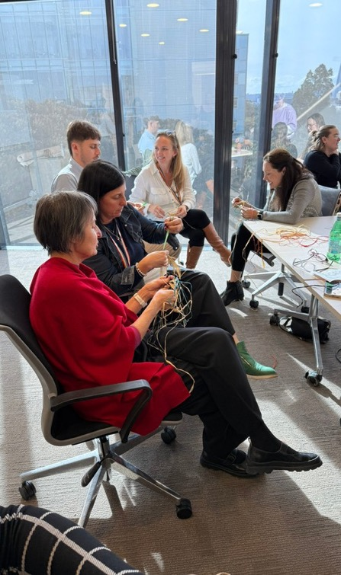
- Update: Epidemiology and Biostatistics
10 Update: Prevention
12 Update: Treatment and Translation
14 Update: Research and Strategy
16 Strategic Plan 2025-2029
17 Strong & Deadly Futures
18 PREMISE Next Generation CRE
20 Online Community of Practice
21 Mentally Healthy Futures Project
22 Policy Highlights
24 NSQDMHS Accreditation
26 Lived Experience
28 Executive and Deputy Directors
29 Senior Matilda Centre Academics
30 Operations
31 Higher Degree by Research Students
32 Key Partnerships
34 Culture and Wellbeing
36 What’s Next?
37 2025 Staff List

2025

At a Glance
The Matilda Centre had an exceptional 2025, with significant achievements
in our efforts to further mental health and substance use research.
These achievements include:


138 $12.1

Publications
published in research journals

40 students, including 18 Higher Degree by Research and 22 placement students

Three PhD candidates completed their degrees
million
Awarded across 23 new grants



58 2.4x

Funding
applications submitted, with a 33% success rate


12 media events, with 143 mentions
Times the average
academic citations in our field, with a 2.4 Field Weighted Citation
Impact score 6000 social media followers

65%

Five policy submissions

Of published papers involved external collaborations
30 lived experience
partners

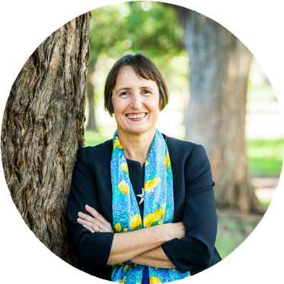
Director’s

Report
From Distinguished Professor Maree Teesson and the Matilda Centre Executive
It is an immense privilege to serve as the Director of The Matilda Centre.

The depth and breadth of our work is inspiring. The Matilda Centre continually strives to improve and impact lives around the world. Our vision, to ensure a healthier tomorrow for everyone, has shone bright over the last 12 months. Our partnerships are at the heart of all we do; research thrives in collaboration, and this year has seen those partnerships strengthen, diversify and grow.

As we look back on the past year, the impact of research conducted in collaboration with partner organisations has gone from strength to strength. Our commitment to responding with speed and rigour to emerging global challenges has seen us undertake research in areas such as vaping, medicinal cannabis, youth mental health, trauma, alcohol and other drug use, digital mental health and early intervention.
These programs demonstrate that we can respond effectively, and that we can develop and deliver effective prevention approaches and treatments that meet the needs of communities.

We were delighted to continue our work in partnership with the OurFutures Institute. With the support of a $9 million Australian Government investment, together we are working towards delivering evidence‑based prevention programs to more than one million young Australians. This landmark collaboration reflects our shared commitment to improving the wellbeing of young people across the country.

We have continued to address the drivers of poor mental health, including the influence of the tobacco and vaping industry, climate change, housing instability, social and economic inequity, and exposure to trauma. Our teams are generating and delivering evidence to inform policy, regulation and interventions that prevent and reduce harm, such as through policy evaluations, national guidelines, trialing novel service models, and co‑design work with communities.

Our Youth Advisory Board (YAB) continued to strengthen the relevance and impact of our youth focused research. Made up of diverse young Australians, the YAB provides lived experience insight that shapes our priorities and ensures our work reflects what young people need. This year, members contributed to co-designing resources, advising on youth wellbeing, suicide prevention and harm reduction, and sharing perspectives on youth involvement in media and research. They also met with teams across the Centre and with the NSW Minister for Mental Health and Youth’s office to discuss youth co-design and emerging priorities.

We also strive to make a meaningful impact on clinical practice and health systems, improving the identification and responses to substance use and mental health concerns. Our epidemiology teams continue to build understanding of risk and protective factors, population trends, and the long‑term impacts of mental health and substance use across the lifespan, strengthening the evidence base that informs clinical care and service planning.

Climate change, housing and financial stability have emerged as growing areas of research focus. As we deepen our understanding of how environmental and social stressors shape mental health outcomes, we were delighted to welcome new PhD students and early‑career researchers who are driving innovation in these developing fields.

Across the Centre, we have remained dedicated to making trusted, high‑quality evidence accessible. Our national digital knowledge platforms, Cracks in the Ice, Positive Choices, Learning with FASD and Comorbidity Project continue to reach hundreds of thousands of practitioners, clinicians, families, carers, teachers and educators each year, developed in partnership with communities and supported through enduring collaborations with the Australian Government Department of Health, Disability and Ageing.

In 2025 we launched our new five‑year Strategic Plan, built around five pillars: Research Excellence and Innovation; Capacity Building; Reach and Impact; Equity and Lived Experience. This plan reflects our vision for the next stage of growth and our commitment to research that is high‑impact, community‑informed and future‑focused.

These were only some of the many areas of impact and focus at The Matilda Centre this year. We continue to generate evidence for better prevention, better treatment, and a better understanding of mental health and substance use, working closely with those with lived experience, their families and loved ones, community, health practitioners, educators and policymakers.

The passion and success of all this work comes from the amazing staff of The Matilda Centre, the dedicated researchers, professional staff and highly skilled operational teams whose expertise, integrity and commitment underpin every achievement. We acknowledge the leadership of the Executive and warmly welcome our newly appointed Deputy Program Directors, who will support the delivery of our strategy in the years ahead.

Matilda Centre benefits enormously from the guidance and wisdom of its inter/national Expert Advisory Board. We thank Professor Nancy Baxter, Professor Camille Raynes-Greenow, Professor Kathy Belov, Professor Mary Collins, Professor Ian Hickie, Professor Paul Haber, Professor Kevin Gurnay, Professor Frances Kay, Professor Pat Dudgeon, Ms Paula Hanlon, and Ms Heidi Berry for their generosity in 2025.

The University of Sydney has been a highly supportive home for The Matilda Centre over the past seven years, and we are grateful for their continued partnership. We are also deeply appreciative of our enduring and new international collaborations and our many government, non‑government and community partners across Australia.

This has been an incredible year for The Matilda Centre, and this Annual Report highlights just a selection of the many achievements and impacts delivered by our talented team.

We look forward to continuing this important work, together, towards a healthier tomorrow for everyone.

About Us
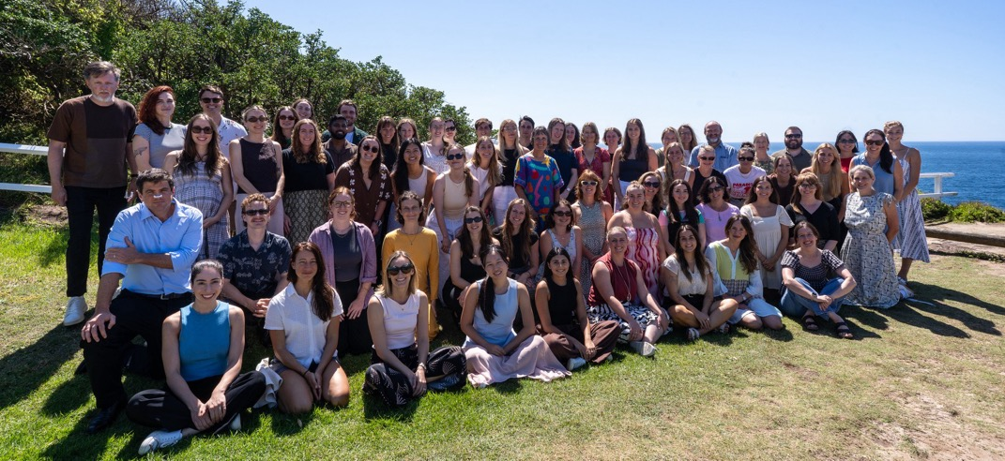
Founded in 2018, the Matilda Centre for Research in Mental Health and Substance Use is a multidisciplinary research centre committed to improving the health and wellbeing of people affected by substance use and mental health disorders.

Led by Distinguished Professor Maree Teesson AC, the Matilda Centre is built upon 30+ years of world-leading research into mental health and substance use prevention, treatment, epidemiology and research capacity building. The Matilda Centre aims to build upon that work to develop the next generation of researchers working for a healthier tomorrow for everyone.

We generate innovative and workable solutions to address substance use, mental health disorders, and their co-occurrence, which are currently leading global causes of burden and disease.

We work closely with research collaborators, clinicians, educators, policy experts and people with lived experience to streamline data, skills and new technologies to prevent and treat substance use and mental health disorders.

We are committed to leading research to build the evidence base for a thriving and empowered population across the lifespan. We do this by acting as a focal point and link between researchers, policy leaders, clinicians, youth and people with lived experience to create a healthier tomorrow for everyone.

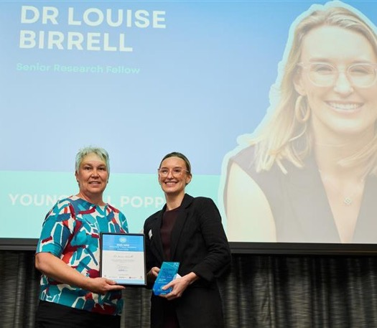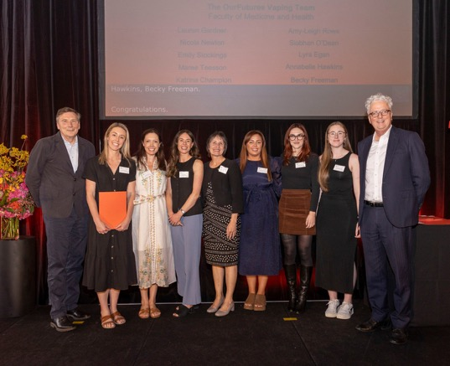

Above: Dr Louise Birrell receives the NSW Tall Poppy Award
Dr Steph Kershaw and Tariq Isaacs receive TheMHS Learning Network Lived Experience Storytelling Award for Cracks in the Ice
Left: The OurFutures Vaping team receive the 2025 Vice-Chancellor’s Award for Research Excellence
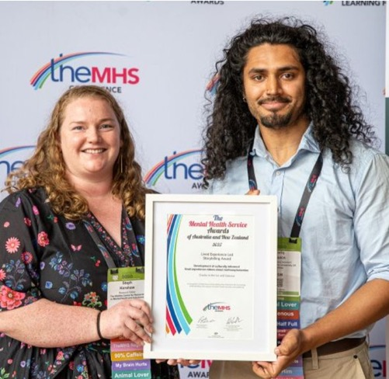
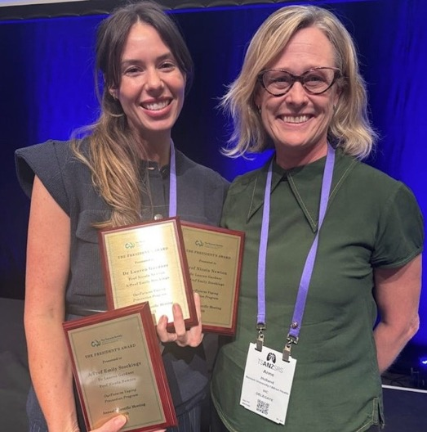

Above: A/Prof Emily Stockings receives the Thoracic Society for Australia and New Zealand’s 2025 Presidents Award

Above: Dr Lauren Gardner (Helen Christensen Medal for Breakthrough Research) and Dr Louise Birrell (SMHR Rising Star Award) receive awards at SMHR Conference 2025
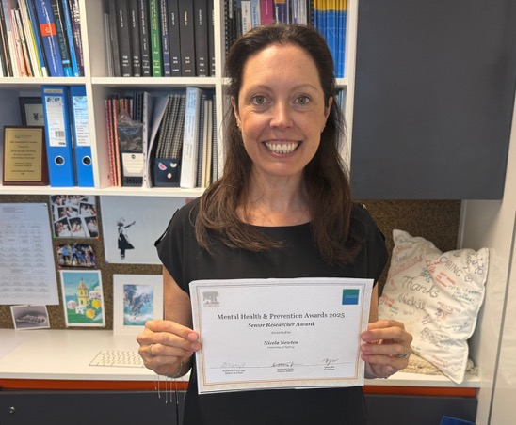
Above: Professor Nicola Newton with her Mental Health & Prevention Journal Senior Research Award 2025 certificate

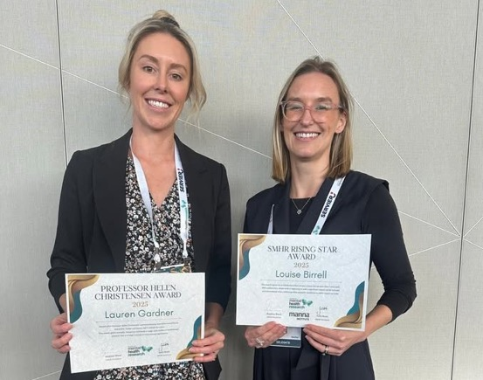
Awards

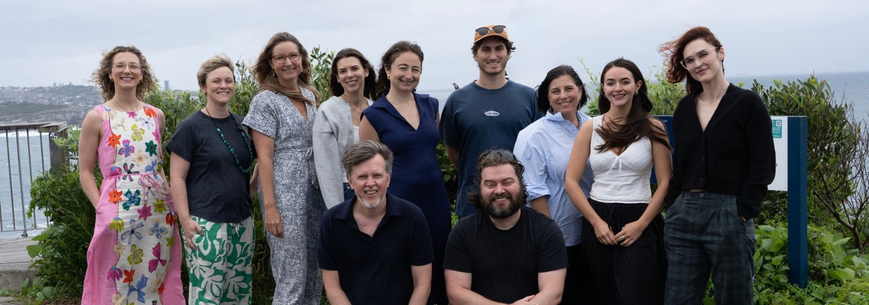
Epidemiology & Biostatistics
Understanding causes and risks
The Epidemiology and Biostatistics team had a dynamic and highly impactful year in 2025. One of our headline achievements was the analysis and wide-ranging dissemination of findings from the landmark Australian National Study of Mental Health and Wellbeing—the largest lifecourse epidemiological survey of mental and substance use disorders ever conducted in Australia. The team delivered an extraordinary research output, publishing 11 papers in 2025 and submitting another six for review.

Our work shed new light on the rising prevalence of anxiety and depression since 2007, particularly among women and young adults aged 16–25, coupled with illustrated shifts in severity, comorbidity, and service use. These insights were showcased in invited conference presentations and directly informed policy discussions at state and national levels, including contributions to the National Mental Health Commission.

Strengthened by the establishment of the PREMISE Next Generation NHMRC Centre of Research Excellence, the team also expanded its cutting-edge investigations into contemporary risk and protective factors shaping mental health and substance use in adolescence and young adulthood. We explored the critical role of social media on youth wellbeing, the long-term mental health effects of early adult MDMA use, gender-specific links between parent and child alcohol use, and the mental health consequences of financial hardship.

Together, these studies are building a rich evidence base on how risk unfolds over time - providing the crucial groundwork needed to design innovative prevention and early intervention strategies. The team is also pushing the frontier of statistical prediction and causal inference, applying advanced analytical methods to large cohort datasets through growing national and international collaborations.

In 2025, the team also completed a major milestone: harmonising data from more than 50 research studies, representing over one million datapoints, to map psychological distress across the Australian population. This achievement builds on the team’s novel data search tool, also published in 2025, which identifies datasets containing psychological distress measures.
This body of work lays a powerful foundation for future research examining age and cohort-related patterns in distress, allowing us to pinpoint where change is occurring and which groups may need targeted support. The team’s success was further reflected in major funding wins, including a $1.2M NHMRC Ideas Grant to develop smarter measurement tools for mental and substance use disorders, and a $4.5M NHMRC Cohorts and Clinical Trials Grant to explore intergenerational contributors to shifting mental health trends.

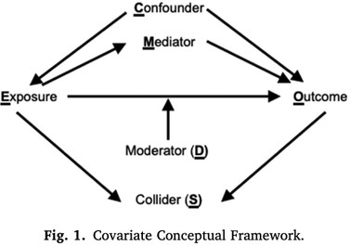
Figure: the major epidemiological components that need consideration when thinking about whether a risk factor is causally related to an outcome

This body of work lays a powerful foundation for future research examining age and cohort-related patterns in distress, allowing us to pinpoint where change is occurring and which groups may need targeted support.
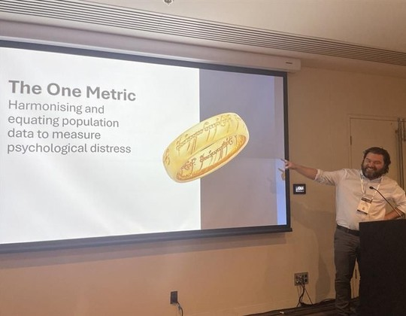
Beyond research excellence, the Epidemiology and Biostatistics team continued to build capability across the Matilda Centre through their innovative statistical education and support programs; most notably the much-valued biweekly Stats Drop-In Sessions. The team also celebrated remarkable student achievements, including the PhD submissions of Zachary Bryant and Joel Tibbetts, and we welcomed new PhD candidates including Coleen Leung and Lily Teesson into the team.

Associate Professor Matthew Sunderland presents on the ‘Standing on the Shoulders of Giants’ data harmonisation project at the Society for Mental Health Research Conference 2025 in Adelaide, South Australia
Professor Tim Slade & Associate Professor Matthew Sunderland

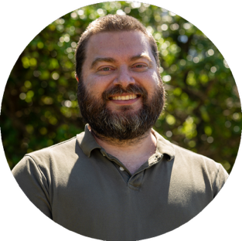

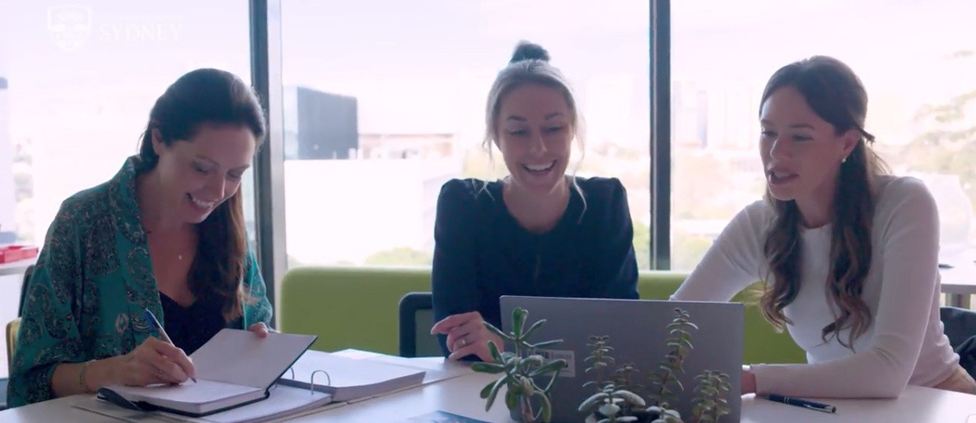
Prevention
Stopping onset and escalation
2025 was a year of significant growth and achievement for the Prevention team at the Matilda Centre.
We continued to develop novel interventions to prevent substance use and mental disorders and successfully executed multiple world-first clinical trials to establish the effectiveness of these interventions.

The Strong & Deadly Futures trial of a culturally-inclusive substance use prevention program continued in 22 schools in diverse communities across Australia, and the OurFutures Vaping study completed its 24-month follow-up surveys in 40 schools across the country. Our team continued to prioritise the co-development of prevention resources with youth and communities, such as with families experiencing disadvantage (Health4Life Parents & Teens study), with primary school students and their educators (the OurFutures Vaping Prevention Primary Schools Trial), and with First Nations youth communities (Strong & Deadly Futures Vaping module).

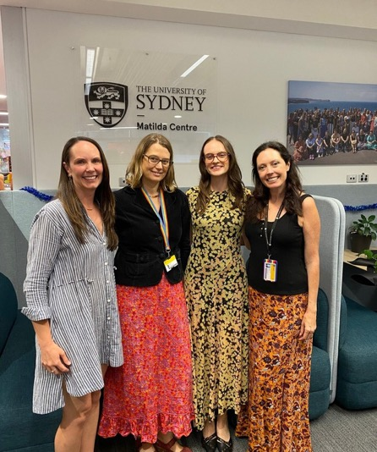
Research excellence
In 2025, we continued to publish our research in world-leading journals including in the Lancet Public Health, Nature Mental Health, and Behaviour Research and Therapy.

Our research excellence was acknowledged through numerous awards including the OurFutures Vaping team being awarded the University of Sydney's Vice Chancellor's Award for Research Excellence and the 2025 President's Award from the Thoracic Society of Australia and New Zealand.

Our staff were invited to present their research to numerous national and international conferences including the Society for Mental Health Research, the Australasian Professional Society for Alcohol and other Drugs, the Positive Schools conferences, and the Global Consortium for Prevention on Depression in the Netherlands.

Dr Katrina Prior, Professor Lexine Stapinski, Tara Gückel and Professor Nicola Newton at the submission of Tara’s PhD in December 2025

Translation into policy and practice
We made significant advances in translating our research into policy and practice. We contributed to policy on effective prevention strategies via submissions to the government including to the 20-Year Tasmanian Preventive Health Strategy 2026-2046 Consultation, and through advisory roles including on the NSW Health Centre for Population Health, ‘E-cigarettes and young people’ working group, and the National Prevention and Wellbeing Coalition.

We launched the new OurFutures Vaping program with Australia's Minister for Health, Disability and Ageing, Mark Butler MP. The program has now reached students from over 1000 schools – one third of all Australian high schools.


In addition, Positive Choices - Australia’s national portal for providing evidence-based alcohol and drug education - reached 4.5 million views and celebrated its 10th birthday. In November, Positive Choices achieved Australian National Safety and Quality Digital Mental Health Standards (NSQDMHS) accreditation, making it (along with partner portal Cracks in the Ice) the first AOD-focused digital tool and the first University of Sydney developed tool to achieve this significant milestone.
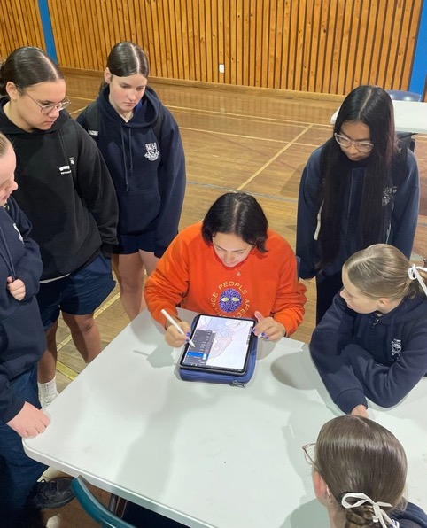
Conducting focus groups with schools in NSW as part of the Strong & Deadly Futures program across 2025

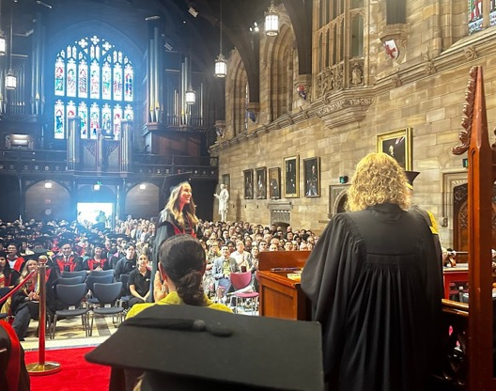
Dr Lyra Egan at her PhD graduation in 2025

PhD completions and staff promotions
In 2025, the prevention team celebrated the successes of many HDR students including Dr Lyra Egan and Dr Sasha Bailey being awarded their PhDs, and Tara Gückel submitting her PhD.

Excitingly, we also had numerous students commence their PhD candidatures within our team including Annabelle Hawkins, Roisin McNamara, Laura Wade, and Toni Coote.

Finally, we closed the year out by celebrating academic promotions for Lexine Stapinski to Professor (Level E) and Katrina Champion to Associate Professor (Level D), both effective from 1st January 2026.

We look forward to another year of growth and achievements in 2026.


Professor Nicola Newton and Professor Lexine Stapinski

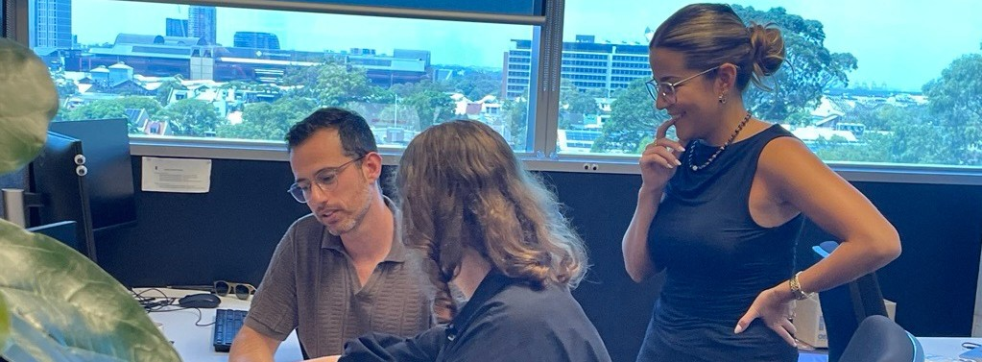
Treatment & Translation
Improving treatment responses and translating evidence
into practice
The Matilda Centre's program of Treatment and Translation research aims to develop and evaluate new interventions for the treatment of substance use and mental health conditions, and to support the uptake of evidence-based practice in clinical settings.

2025 was a busy and exciting year, during which we welcomed opportunities to grow existing collaborations and develop new partnerships with our national and international research collaborators and stakeholders. It is a great privilege for us to be guided by, and work closely with, practitioners from a variety of disciplines; people with lived and living experience; their families, carers and loved ones; and other key-stakeholders from across Australia and the world. This work ranges from randomised controlled trials, naturalistic longitudinal studies, and implementation trials of new interventions delivered via a range of modalities, including in-person, telehealth, and online.

Our work this year has also focused heavily on developing resources and workforce development activities to facilitate the translation of evidence-based approaches into clinical practice. It is impossible to capture the full range of activities and achievements, but some examples are highlighted below.

2025 highlights
Completion of a 5-year study funded by icare NSW to develop and undertake a pilot implementation trial of a stepped-care approach to addressing substance use among NSW public safety personnel delivered via an online portal called Stable Ground. Based on the principles of harm-minimisation, person-centred, and trauma-informed care, the model aimed to support personnel in making informed, empowered, and proactive decisions regarding their alcohol and other drug (AOD) use and help-seeking, and facilitate access to appropriate levels of intervention based on an individual’s level of risk. The portal reached >6,500 public safety personnel over the 12-month trial period and is the only one of its kind internationally.

The Inroads team finalised recruitment and program delivery for their trial of a supported, online early intervention for youth with co-occurring anxiety and alcohol concerns. In total, 587 young adults participated in the trial and will now be followed-up for 18 months to determine the benefits of this world-first intervention.

Extending on our previous work examining the efficacy of an integrated psychological treatment for traumatic-stress and substance use among young people aged 12-25 years (called COPE-A), we commenced an MRFF-funded randomised controlled trial to compare the efficacy of this treatment when delivered via telehealth versus in-person. These studies both extend on our previous successes in trialling the adult COPE treatment, which in 2025 was recognised as a first line treatment for co-occurring post-traumatic stress and substance use disorders by American Psychological Association.

Iterative co-development focus groups were conducted with new mums, to inform development of Healthy Mum, Healthy Bub, a novel online program for mums who are experiencing anxiety and engaging in risky drinking in the postpartum period. Combined with expert clinical and technical input, these lived experience perspectives directly shaped development of the online program, in preparation for a pilot trial commencing in 2026.

The reach and impact of the Australian Government Department of Health, Disability and Ageing “Guidelines on the management of alcohol and other drug and mental health conditions in alcohol and other drug treatment settings” and its accompanying foundational online, skills-based and train-the-trainer programs have continued to grow. With funding from NSW Health, we have been able to expand our training offerings to reach more AOD practitioners across the state, which will improve the capacity of the AOD workforce to respond to co-occurring mental health conditions.

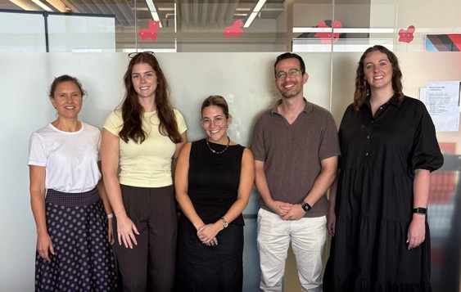
The COPE-A team, in order: Virginia Winter, Annabel Hughes, Dr Natalie Mastrogiovanni, Yoni Manor, and Chantell Sheehan

Associate Professor Christina Marel, Alexandra Azzi, Isabel Rewais, Aleksa Kamenjas, and Madhu Senthil Kumar at APSAD Conference 2025

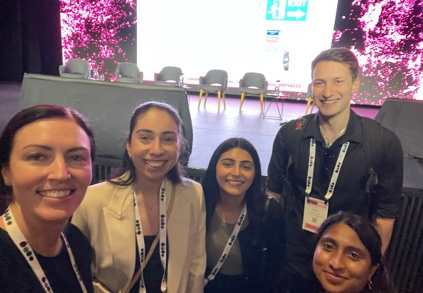
Nationwide consultations were completed to inform the development of several new translational resources to support the uptake of evidence-based approaches to managing mental health conditions in AOD treatment settings. These new resources include national practice standards, an organisational implementation toolkit and an online community of practice. Work also commenced on the development of national guidelines for the management of AOD use disorders in mental health settings.

New discoveries continued to be made and disseminated through publications and presentations, as well as other ongoing and previously completed studies (such as the Australian Treatment Outcome Study), and the vital work conducted by our PhD students, including Dr Jayden Sercombe who completed his PhD. Collectively, these findings are critical to informing the development of innovative new interventions, clinical practice, and supporting health care practitioners to implement evidence-based practice nationally and internationally. In addition to scientific outputs, we have led and contributed to several national submissions to government enquires throughout the year to inform national policy.



Professor Katherine Mills and Associate Professor Christina Marel

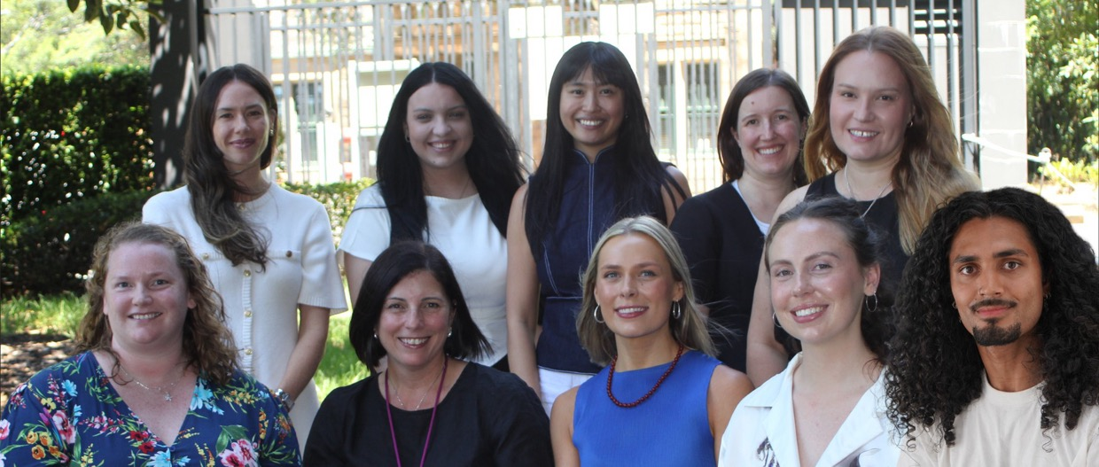
Research & Strategy
Genuine partnerships, collaboration & engagement
Our work in Research and Strategy is guided by the principles of Culture, Connection, Wellbeing, and Leadership that underpin the Matilda Centre strategic plan. We work in collaboration with Directors and staff across all Matilda Centre streams to develop key partnerships, build capacity amongst research and professional staff, youth and lived experience experts. These collaborations foster a strong, supportive culture to contribute to a diverse and world-leading mental health and substance use research program. Through these efforts, we aim to create an environment where innovation, equity, and wellbeing are embedded in every aspect of research and leadership.

Our focus areas span strategic planning, leadership development, youth and stakeholder partnerships and culture and wellbeing. We conduct research in co-design, youth and digital engagement, community impact and stigma. We lead youth and lived experience engagement initiatives through coordination of the Youth Advisory Board (YAB), the Youth Engagement Network (YEN), the Group for Lived Experience Engagement (GLEE) and the Lived Experience in Research Network (LEARN), amplifying the voices of young people and those with Lived and Living Experience in research.

We cultivate partnerships with key policy and funding bodies, including Commonwealth and State governments and philanthropy, to support major national initiatives such as Cracks in the Ice, Positive Choices, Strong & Deadly Futures Vaping, and Learning with FASD. The team drives and co-ordinates capacity-building programs under the NHMRC-funded PREMISE Next Generation Centre of Research Excellence (2025-2029), promoting collaboration, career development and support for early and mid-career researchers.

2025 highlights
Following consultations in 2024 and 2025 with YAB, LEARN and GLEE, academics, and professional staff, we developed the Lived Experience and Equity pillars for the 2025–2029 Strategic Plan. A comprehensive culture survey informed planning and strengthened organisational values and team members joined leadership groups across all five pillars of the plan to support the implementation of the Strategy, led by Matilda Centre Operations Manager Christine Anderson.

Culture and wellbeing
We provided mentorship and strategic guidance for >45 Fellowship, Grant, Promotion, and Award applications for multiple programs of work at the Matilda Centre and the Faculty of Medicine and Health. We planned and delivered workshops for senior academics focused on supporting personal and team wellbeing. The team also co-ordinated workshops for early career staff on the University of Sydney Wellbeing Strategy to help them navigate wellbeing support for themselves, their staff and students. Our team supported early career academics and professional staff leaders to co-design a restructure of core meetings and networking mechanisms. Peer-led initiatives included alternating agendas for monthly meetings (collaboration/ professional development vs. core business) and organising Matilda Academic and Leadership Group (MAGS) networking events. As part of the activities of the newly established PREMISE Next Generation CRE we co-ordinated the award of $90K in research seed funding, lived experience partnership and travel/career development awards.

Youth and stakeholder partnerships



In 2025 we expanded the scope and impact of YAB activities, appointing new members to the Board and began consultation and development for a new researcher mentoring program for youth with lived experience, strengthening capacity-building efforts under the PREMISE Next Generation CRE. The team contributed to multiple government and peak body consultations and submissions via strategic advice and review, content development and writing to translate Matilda Centre research into policy.

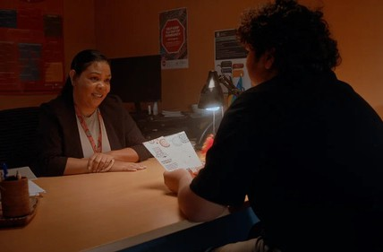
A still from the Cracks in the Ice Lived Experience videos developed in partnership with First Nations production company Garuwa

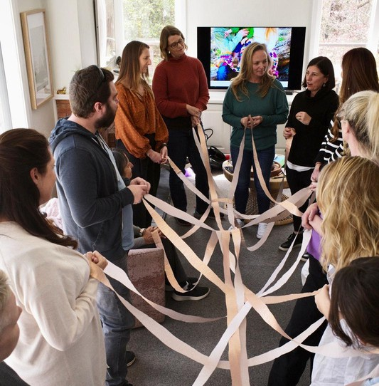
Senior Matilda Centre researchers at a strategy workshop, engaging with the different ways we need to work together to achieve a goal

We continued to lead strategic partnerships with the Commonwealth Department of Health, Disability and Ageing, to support national prevention and translation initiatives over the next four years and beyond, and contributed to the evaluation of the National Drug and Alcohol Program where three Matilda programs were cited as examples of best practice. We also celebrated academic promotions for Steph Kershaw to Senior Research Fellow (Level C) and Louise Thornton to Associate Professor (Level D) effective from 1st January 2026.

Professor Cath Chapman, Associate Professor Emma Barrett (January-August 2025), and Associate Professor Emily Stockings (September 2025-present)

Strategic Plan 2025-2029
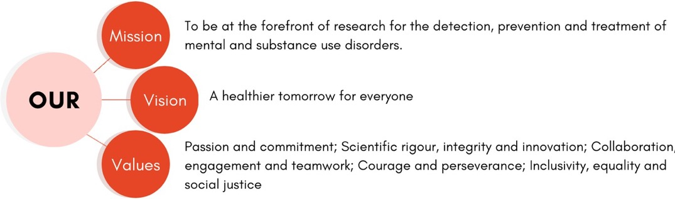
Our strategy sets a bold and compassionate vision: to lead in the identification, prevention and treatment of mental health and substance use disorders through scientific excellence, innovation and meaningful partnership with communities.
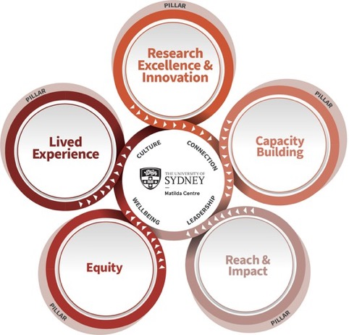
Centred around five pillars: Research Excellence and Innovation, Capacity Building, Equity, Lived Experience, and Reach and Impact, our strategy reflects our commitment to advancing knowledge, strengthening prevention and treatment, cultivating emerging leaders, embedding equity, and ensuring our work is accessible, influential and impactful across policy, practice and community settings.

These pillars are grounded in our values, including collaboration, courage, inclusivity, integrity and social justice, and together they guide us toward a healthier tomorrow for everyone.
As we move from establishment to implementation, each strategic pillar is clarifying what success looks like and laying the foundations needed to deliver on our shared goals. Pillar groups are coming together to define their roles and shape their priorities for 2026 and beyond. They are articulating the conditions required for success; whether that means establishing clear frameworks, strengthening cross-pillar collaboration, embedding lived experience, or ensuring equity considerations are integrated into everyday decision-making.

Foundational work is underway to build shared baselines, establish planning processes, set expectations for impact, and create structures that support cohesive, Centre-wide activity.

These early efforts reflect a Centre term strategic objectives. They also demonstrate a collective commitment driven and forward looking way as we bring the strategy to life.

Strong & Deadly Futures
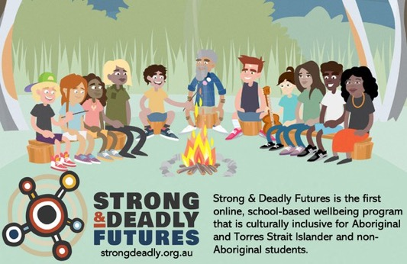
Strong & Deadly Futures is an empowering, curriculum aligned, alcohol and drug prevention program that is culturally inclusive for Aboriginal and Torres Strait Islander students. The program responds to evidence that effective and culturally relevant prevention approaches must incorporate cultural strengths and be developed in collaboration with communities.

Strong & Deadly Futures was co-designed with Aboriginal and Torres Strait Islander students and staff at four schools in QLD and NSW, and developed in partnership with Aboriginal-owned creative agencies Gilimbaa, Garuwa and Cause/Affect. The program aims to prevent uptake and harm from alcohol, tobacco and cannabis use, and embeds preventive messages within an engaging, animated story that draws on students’ lived experiences and cultural strengths to promote protective factors and resilience. Following a successful pilot trial, broader consultations were conducted in 22 communities across NSW, WA and QLD, which resulted in four regional adaptations of the program to reflect differences in landscapes and character representation.

Long-term benefits of the program compared to health education as usual are currently being assessed in a randomised controlled trial in 22 schools.
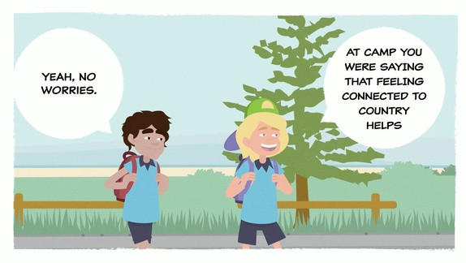



Figure 1: the Strong & Deadly Futures program information with students around a campfire

Figure 2: characters from the Strong & Deadly Futures program

Figure 3: a slide from a module showing students discussing a recent camping trip

Figure 4: a slide from a module sharing two students talking to each other about being on country

Building on this work, in 2024 the Australian Government Department of Health, Disability and Ageing provided further funding to develop and pilot a new Strong & Deadly Futures module focused on vaping prevention. The materials for the vaping module are culturally inclusive, empowering and co-designed with Aboriginal and Torres Strait Islander youth and school staff, with oversight from an Aboriginal Reference Group.

During 2025, consultation sessions and creative workshops have been conducted with >100 students aged 12 to 16, Aboriginal Education Officers, teachers and vaping prevention experts. The vaping module will be finalised in mid 2026 and then piloted in four schools to gain feedback and assess its acceptability and feasibility.


PREMISE

Next Generation

New targets, new interventions
The NHMRC PREMISE Next Generation Centre of Research Excellence (CRE) is led by Professors Tim Slade, Nicola Newton and Cath Chapman, with policy leadership from Professor Maree Teesson. Building on the strong foundations of our previous CREs, it brings together seven world leading translational research centres in youth mental health and substance use, alongside Australia’s largest group of mental health focused health economists, to drive innovative and impactful research.

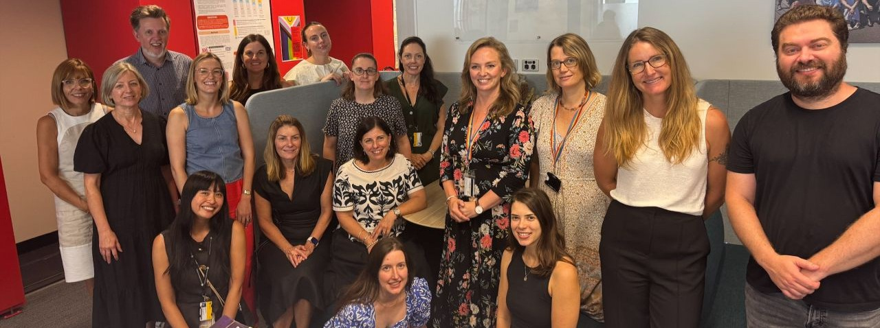
New collaborative grants for PREMISE Next Generation investigators
Funding Source | Name
NHMRC Ideas Grant | Standing on the Shoulders of Giants: Harmonising population-based data to detect changing trends in psychological distress across age and birth cohort
NHMRC Cohorts and Clinical Trials Grant | The 18 and Up Study: Determining the causes, patterns and implications of intergenerational changes in mental health
Australian Rotary Health Grant | Co-design and cluster randomised controlled trial of a mental health literacy program for upper primary-school aged students
MRFF Maternal Health and Healthy Lifestyles Grant | Quick Fix Good Night Out: evaluate a new social network targeted approach to reduce AOD use and harm in young university students
PREMISE Next Generation investigators secured major cross institutional grants with partnering institutions, including:

Knowledge translation and policy influence
PREMISE Next Generation researchers led a national consortium of >20 experts to analyse the National Surveys of Mental Health and Wellbeing, publishing 11 papers in 2025—including a special series in the Australian and New Zealand Journal of Psychiatry. Our joint submission to the Productivity Commission’s Mental Health and Suicide Prevention Agreement Review made a significant impact, being cited 17 times in the final report.

Capacity building highlights
In a significant investment in future research leaders, PREMISE Next Generation CRE and the Matilda Centre awarded $80K in grants to students and early to mid-career researchers to spark innovation and foster national and international collaborations. Activities included research exchanges at the University of Bern and Columbia University; international and national conference presentations; and pilot studies to improve evidence-based mental health content dissemination on social media and to investigate the antecedents of climate distress. We were also proud to establish a new PhD scholarship co-funded by PREMISE Next Generation and the CORE DEP Depression Treatment Precision CREs (led by Black Dog Institute) to understand mechanisms of change to optimise prevention targets in youth mental health.

Youth and lived experience leadership
The PREMISE Next Generation team continued to oversee the Matilda Centre Youth Advisory Board (YAB) and Youth Engagement Network (YEN) facilitating more than 25 opportunities for young people to contribute to research across collaborating institutions. We worked in partnership with the YAB and collaborators from the Medical University of South Carolina to begin co-development of a Youth Researcher Mentoring Program to strengthen research and career pathways for young people with lived and living experience of mental health and substance use. We awarded two Lived Experience Research Partnership Grants to the Matilda Centre Group of Lived Experience Engagement (GLEE) and the Climate Change, Place, and Mental Health Incubator, to build co-design capacity and deepen partnerships with people with lived and living experience.






Youth Advisory Board co-chairs Heidi Berry and Thomas Wedding at the behind the scenes shoot for the OurFutures
Vaping #ResearchForGood campaign
The Matilda Centre for Research in Mental Health and Substance Use
19




Launching a National Online Community of

Practice for Alcohol and Other Drug & Mental Health Workers
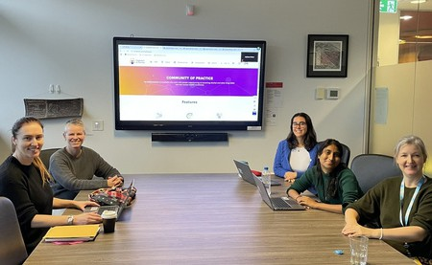
There is a well-recognised need to better support frontline workers delivering care for people experiencing co-occurring mental health and substance use conditions. Despite growing awareness, many workers remain isolated, with limited access to ongoing training, peer support, and practical tools to implement evidence-based care.

In response to this gap and funded by the Australian Government Department of Health, Disability and Ageing, the Matilda Centre developed a national online Community of Practice to support the implementation of the Comorbidity Guidelines and broader capacity-building across the alcohol and other drug (AOD) workforce.

The Community of Practice team at the launch of the website in April 2025

Education / Research / Systems 11%
Peer / Lived experience 8%

Medical 2%

Allied Health 27.8%

Highlights:
- Since going live in April 2025, almost 2000 people have joined the Community of Practice.
- Every Australian state and territory and a diverse cross-section of the AOD and mental health workforce are represented by our members.
- We have hosted 14 events: seven webinars and seven case study or panel discussions, focused on building capacity within the workforce and encouraging networking, collaboration and shared learning.

Counselling / AOD 32.8%
Infographic: The breakdown of health and

Nursing 18.4%
Feedback from members indicate that the Community of Practice is valued as a trusted space for connection, peer learning and professional support, reducing isolation and supporting reflective, evidence informed practice – particularly for those working in complex, rural, remote or integrated service settings. Members actively use the

community workers currently engaged with the Community of Practice across 2025
platform to navigate challenges in their practice, and there is strong engagement from a wide, multidisciplinary audience across Australia.


In this way, the Community of Practice is more than a website - it’s a living network, which shows great promise as a model to:
- Better support frontline workers.
- Help this workforce feel better connected and supported, with a way to connect to ongoing training, peer support, and practical, evidence-based resources and tools to implement evidence-based care.
- Ultimately, positively impact the health outcomes of people who experience co-occurring conditions.
Find out more, including information about membership, at community.comorbidity.org.au/about-us

Mentally Healthy Futures Project

The Mentally Healthy Futures Project (led by Dr Marlee Bower, Dr Scarlett Smout and Professor Maree Teesson) focuses on advancing evidence-based policy to improve population mental health, with a particular emphasis on the social determinants of mental health. The project generates evidence through reviews and epidemiological studies examining structural and environmental drivers of mental health. We then translate this evidence into policy through advocacy and engagement with decision-makers, including research support for Australia’s Mental Health Think Tank and contributions to government inquiries and policy consultations.

Amarina Donohoe-Bales, Lily Teesson, Camilla Sedgwick, Sophia Spallek, Lauren Scott and Jacky Dawkins provide research support.

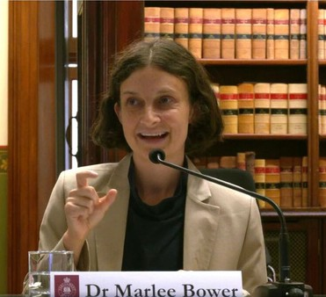
Dr Marlee Bower presenting evidence at Parliament for the Inquiry into Prevalence, Causes and Impacts of Loneliness in NSW

Highlights:
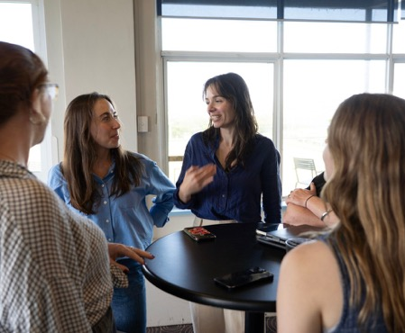
In 2025, the project produced research examining key drivers of population mental health, including a study analysing the policy implications of Australia’s 2020–22 National Study of Mental Health and Wellbeing, which highlighted rising prevalence of mental health problems and the need for stronger population-level policy responses.

The Mentally Healthy Futures Project team discuss new research
Alongside this research, the project team led an expert submission to the NSW Inquiry into the Prevalence, Causes and Impacts of Loneliness, outlining evidence on the growing mental health impacts of loneliness and proposing six policy recommendations to strengthen social connection, cross-government coordination, community infrastructure and the evidence base; several of these were reflected in the NSW Government’s response released in November 2025.

The team also contributed to a 2025 Federal Election submission from Australia’s Mental Health Think Tank outlining eight evidence-based policy recommendations to address key drivers of youth mental health challenges, three of which were reflected in the Federal Government’s pre-election mental health funding commitments.

Policy Highlights
Throughout 2025, teams across the Matilda Centre continued to make strong contributions to policy and guidelines through the translation and implementation of our research. Through submissions to public inquiries, we have highlighted the latest evidence and the voices of people with lived and living experience, shaping national mental health and substance use policy.


Policy impact highlights for 2025
2025 Policy submissions
The Productivity Commission’s Review of the Mental Health and Suicide Prevention Agreement mentioned the Centre’s and PREMISE Next Generation’s submission 17 times, drawing on our evidence on understanding the intersection of alcohol and other drugs, mental health, and suicidal distress. Our submission helped shape recommendations for a new national schedule in the next agreement addressing the co-occurrence of problematic use of alcohol and other drugs, mental health conditions and suicide, and the stronger integration of lived experience in system design and governance.

The Final Evaluation Report of the Drug and Alcohol Program (DAP) recognised the Matilda Centre’s leadership in prevention and evidence translation, highlighting Cracks in the Ice as a non-stigmatising
digital toolkit shown to improve community knowledge and reduce stigma around crystal methamphetamine
use. It also profiled Positive Choices as a national exemplar of accessible, evidence-based school and community drug education. Together, these programs were cited in the evaluation as best practice models of scalable prevention infrastructure meeting the DAP’s objectives of school and community drug education.

The Standing Committee on Health, Aged Care and Sport’s Issue Paper on the health impacts of alcohol and other drugs in Australia mentioned the Matilda Centre’s 2024 Submission 12 times, citing our evidence on AOD harms, unmet treatment need, comorbidity workforce development needs, and the importance of lived experience-led and culturally responsive approaches. The Committee will use the report in providing final advice to Government on the next iteration of the National Drug Strategy.

The Matilda Centre contributed to the NSW Inquiry into the Prevalence, Causes and Impacts of Loneliness through an expert submission led by the Mentally Healthy Futures Project. The submission provided evidence on the rising mental health impacts of loneliness in NSW and outlined six policy recommendations. These included prioritising social connection as a policy focus, coordinating efforts across government departments, investing in public awareness and community infrastructure, and strengthening the evidence base.

A 2025 Federal Election Submission, written by Australia’s Mental Health Think Tank, outlined eight evidence-based policy recommendations to address key drivers of mental health issues among Australian youth. It emphasised the need for systemic changes to improve mental health outcomes and support recovery. Three recommendation areas were picked up in the Federal Government’s pre-election mental health funding promise.

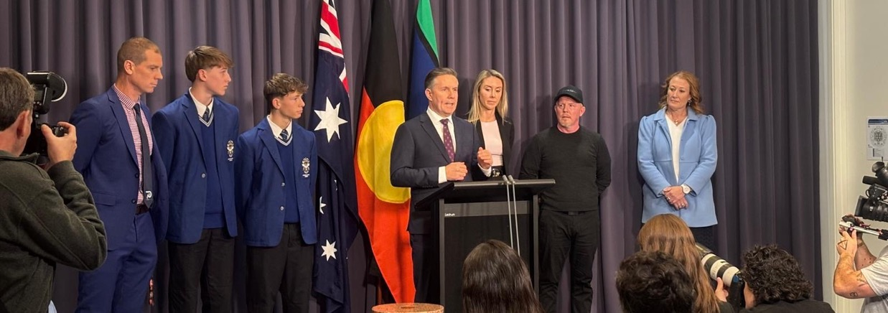
Above: Dr Lauren Gardner at Parliament House in July 2025 as Minister for Health, Disability and Ageing, Mark Butler MP, announces the results of the 12 month follow up from the OurFutures Vaping trial.

Spotlight: National Vaping Policy
In April 2025, Professor Maree Teesson and Associate Professor Emily Stockings, on behalf of the wider OurFutures Vaping team, were invited to attend a national roundtable on managing illicit tobacco and novel nicotine products in Australia. Professor Teesson and Associate Professor Stockings highlighted the particular vulnerability of young people in the face of wide access to cheap, illicitly sourced tobacco and vapes. A key strategic priority identified was the inclusion of school-based prevention efforts in the illicit tobacco agenda. Professor Teesson attended a second roundtable in December 2025, where public health responses to illicit tobacco were highlighted as an urgent need, alongside increased enforcement efforts.

In July 2025, the results of the OurFutures Vaping trial were announced by the Hon Mark Butler MP and the Matilda Centre’s Dr Lauren Gardner at a high profile parliamentary press conference in Canberra. Including more than 5,000 students from 40 secondary schools across Australia, it is the world’s largest, and Australia’s first, randomised controlled trial of a school-based vaping prevention program. Published in the prestigious Lancet Public Health, the study demonstrated that students who received the OurFutures Vaping Prevention Program were 65% less likely to vape one year later, compared to those receiving standard health education.
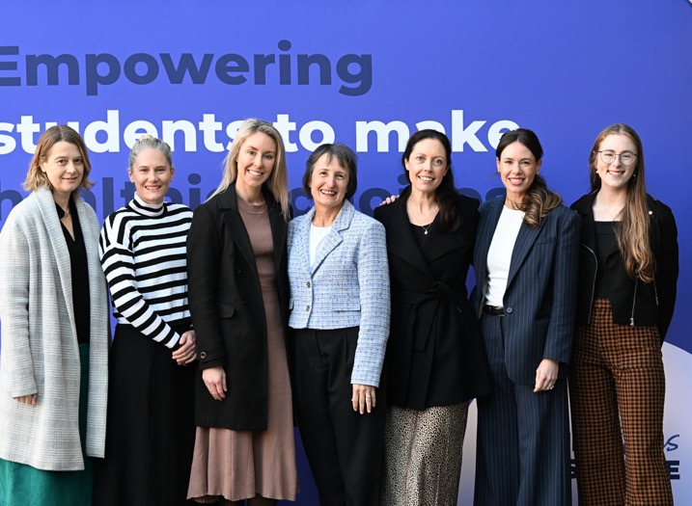
The program also significantly improved students’ knowledge about vaping, smoking, and the associated harms.

Building on this landmark evidence, the national launch of the OurFutures Vaping Prevention Program took place in August 2025 at the University of Sydney’s Chau Chak Wing Museum. The event brought together educators, policymakers, researchers, students, and community leaders, signalling a collective commitment to tackling youth vaping. Speakers including the Hon Mark Butler MP, The University of Sydney Vice-Chancellor, Mark Scott, Professor Maree Teesson, and OurFutures Institute CEO, Ken Wallace. The event highlighted the program’s significant impact and momentum, with the program having reached more than 130,000 students in over 600 schools across Australia.

Members of the OurFutures Vaping team: Professor Lexine Stapinski, Associate Professor Katrina Champion, Dr Lauren Gardner, Professor Maree Teesson, Professor Nicola Newton, Associate Professor Emily Stockings, Annabelle Hawkins


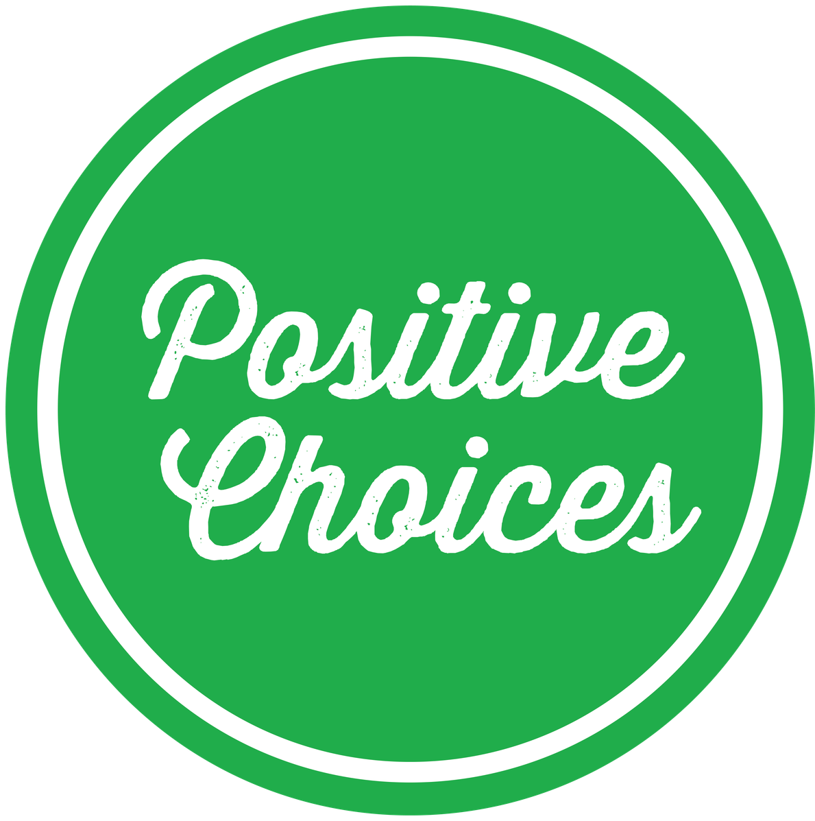
NSQDMH Standards

Accreditation
Ensuring our research meets the highest quality standards

As part of the Matilda Centre’s commitment to delivering research of the highest quality, two of our programs undertook accreditation in 2025 under the Australian National Safety and Quality Digital Mental Health Standards (NSQDMHS).

The NSQDMH Standards have been developed by the Australian Commission on Safety and Quality in Health Care, and are independently assessed to ensure digital mental health service provision meets nationally endorsed safety and quality requirements.

The standards include the implementation of frameworks to ensure safe and high-quality care for service users, partnerships with consumers through all stages of the service lifecycle and creating systems that minimise the risk of harm.

In November 2025, the Positive Choices and Cracks in the Ice programs were awarded accreditation to the NSQDMH Standards. Meeting these standards indicates that the Positive Choices and Cracks in the Ice programs are of the highest quality for digital mental health service delivery. These two programs are the first digital tools for alcohol and other drugs to achieve accreditation, as well as the first tools developed at the University of Sydney to be recognised.

High quality standards in digital mental health programs are vital for safety and reducing potential harm. These principles sit at the heart of the Matilda Centre’s work in mental health and substance use, and by undertaking accreditation against the NSQDMH Standards, we strengthen our expertise and lift the quality of all our program standards.

Learn more about the Positive Choices and Cracks in the Ice programs.

The Matilda Centre for Research in Mental Health and Substance Use 24

Cracks in the Ice
Cracks in the Ice is an online toolkit providing evidence-based information and resources
about crystal methamphetamine for the Australian community. It was developed in response to the Final Report of the National Ice Taskforce which
was established in 2015 by the Australian Government to provide advice on the impacts of crystal methamphetamine in Australia.
Across 2025, Cracks in the Ice reached over 156,000 website users, had over 289,000 page views, and

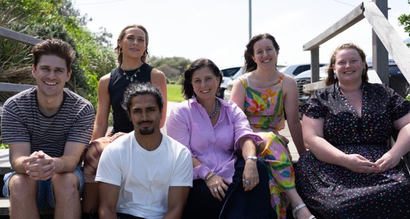
The Cracks in the Ice team

distributed a total of 30,580 hardcopy resources to 126 organisations. Cracks in the Ice also continued its successful webinar series facilitating 5 free webinars (996 live attendees) on topics including barriers to help-seeking
and treatment for women who use methamphetamine, methamphetamine overdose, and culturally safe crisis support with 13YARN.
Additionally, Cracks in the Ice, in partnership with First Nations led creative agency GARUWA, co-produced 3 videos highlighting the lived experience of Aboriginal and Torres Strait Islander peoples impacted by crystal methamphetamine. These videos have had over 1.1 million views and reached over 900,000 people with overwhelming support and positive feedback. This work was awarded the Lived Experience Led Storytelling award
by The Mental Health Services Learning Network of Australia and New Zealand. The award recognises storytelling productions and resources that contribute to improving media reporting, addressing stigma and elevating the voice of lived experience. These Cracks in the Ice resources were also 'Highly Commended' in the Engagement Australia Excellence Awards 2025 for ‘Excellence in Indigenous Engagement’.

Positive Choices
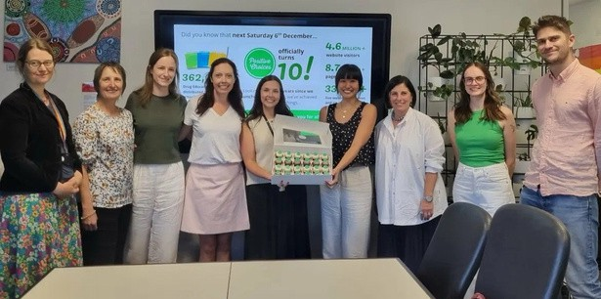
Funded by the Australian Government, Positive Choices is an online portal that helps Australian schools and communities access
trusted, evidence-based alcohol and other drug (AOD) education resources.

2025 was a milestone year for the portal, with the team celebrating 10 years since launch. With youth mental health rates worsening, the concerning rise of new substances such as vapes, and health misinformation rampant, Positive Choice’s role is more important than ever.

The Positive Choices team at the 10th Anniversary in December 2025

Over the past 10 years, Positive Choices has had more than 4.7 million website users and over 8.6 million page views. Evaluation of the portal demonstrated that 100% of parents and 84% of school staff intend to adopt evidence-based AOD prevention strategies after visiting the website.

Throughout the past year, Positive Choices also continued its successful webinar series, delivering free webinars on topics such as supporting secondary school students with Fetal Alcohol Spectrum Disorder and real world implementation of evidence-based substance use prevention and mental health programs. Additionally, new
resources were developed for the portal, including content on vaping in the news and whether there is a healthy amount of alcohol, among others. Six new externally developed resources were also added to the portal following rigorous evidence review.

Lived Experience 

Youth Advisory Board
Youth engagement and involvement in research continued to make its impact in 2025. The year started with a recruitment round which welcomed six new members to the Matilda Centre Youth Advisory Board (YAB): Mason Hill, Lateekah Stanely, Savannah Bolt, Timothy Duy To and Mia Giovannoni, hailing from WA, the NT, Sydney and Central NSW. Our new members brought their unique insights and experiences from different corners of the country to the YAB’s already diverse membership. These new members join Dominique Rose, Heidi Berry, Mariam Hussein, Taryn Lee, Beau Sheehan, Conor Hinds, Kyra Dunning, Smrithi Ravindra, and Thomas Wedding.
The YAB met on four occasions across 2025, twice online and twice in-person in Sydney wherein they contributed to 15 youth-focused research projects. In addition, YAB members participated in a total of 13 opportunities outside of regular meetings. These included media interviews, grant submissions, conference presentations and policy submissions like the ‘Tasmanian 20-year Strategic Health Consultation’, where Tasmanian and YAB co-chair Heidi Berry channelled her lived experience
into shaping the state's health policies over the next two decades.
Notably ‘The Coproduced Youth Priorities Project: Australian Youth Priorities for Mental Health and Substance Use Prevention Research’ was published in Health Expectations, with YAB members Cheryl Ou, Tanya Dearle and Smrithi Ravindra as co-authors as well as the Matilda Centre Youth Advisory Board as a co-producer. The study is one of the largest to date to ask young people what really matters to them in the mental health space. Over 650 young people shared their perspectives through a national online survey and focus groups. YAB members collaborated on content development for the Matilda Centre’s social media channels through reels and infographics distributed across Instagram and Linkedin.
YAB co-chairs Heidi Berry and Thomas Wedding spent more time in front of the camera for the University of Sydney’s ‘Research for Good’ series which spotlighted the influential school-based online OurFutures anti-vaping program to the University’s 220k+ Instagram follower base.
To date, the YAB have contributed to 73 youth-focused projects and have acted as Associate Investigators on seven research grants, providing invaluable perspectives for youth mental health and substance use research.
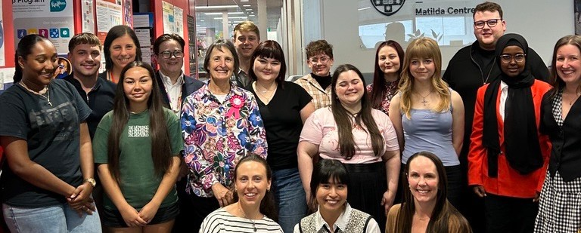
The 2025 Youth Advisory Board with Matilda Centre coordinators

Youth Engagement Network
The Matilda Centre’s Youth Engagement Network has continued connecting young people with mental health and substance use research throughout 2025, sending over ten newsletters and sharing more than 25 pathways for young people to get involved in research, advocacy and policy. The network’s audience grew by 26% over the last year. We look forward to expanding the reach and the opportunities shared through the YEN even further in 2026. You can sign up to the Youth Engagement Network newsletter by visiting the Lived Experience page of our website.

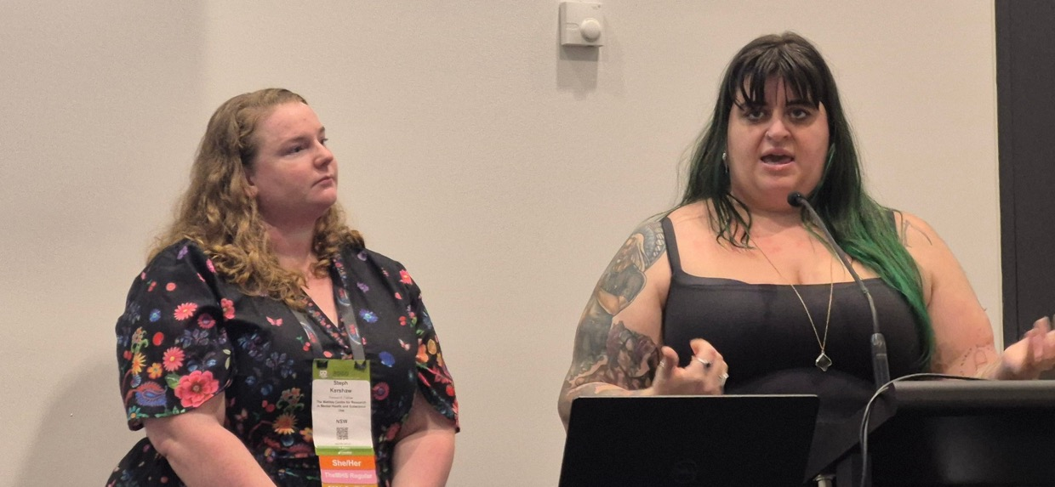
Group for Lived Experience Engagement (GLEE) Co-ordinators Dr Steph Kershaw and Emma Paino at TheMHS Conference 2025

Group for Lived Experience Engagement/ Lived Experience in ResARch Network (LEARN)
The Group for Lived Experience Engagement (GLEE) are the coordinating team for the Matilda Centre’s Lived Experience ReseARch Network (LEARN), a community of 60+ people aged 18+ with lived and living experience of mental health and/or substance use conditions. LEARN members are passionate about using their knowledge and expertise to inform and shape research and related activities.

Throughout 2025, GLEE focused on building sustainable capacity for lived experience engagement across the Centre, supporting both Matilda Centre staff and LEARN members to build meaningful research partnerships, via training and engagement opportunities.

The GLEE team celebrated significant achievements, including being awarded a PREMISE Lived Experience Partnership Grant and welcoming Lived Experience Researcher Kiara Roche to our team. Member Paula Hanlon was also appointed as a Life Member of Flourish Australia in recognition of her achievements in lived experience peer work and leadership. Outcomes from GLEE’s 2024 Lived Experience Engagement survey were shared nationally, with GLEE members Steph Kershaw and Emma Paino co-presenting at The Mental Health Services (TheMHS) Conference, and Georgette Borel presenting at the Society for Mental Health Research (SMHR) Conference.

Over the year, 12 engagement opportunities were circulated to the LEARN, with members contributing to a range of research outputs, including leading lived experience commentaries alongside journal publications and reviewing dissemination resources. LEARN members also helped shape future research by providing feedback on grant proposals, participating in judging panels, as Associate Investigators on submitted grants and undertaking roles on Expert Advisory Groups.

GLEE also launched a quarterly newsletter for LEARN members to share updates, opportunities, and help connect our growing community.

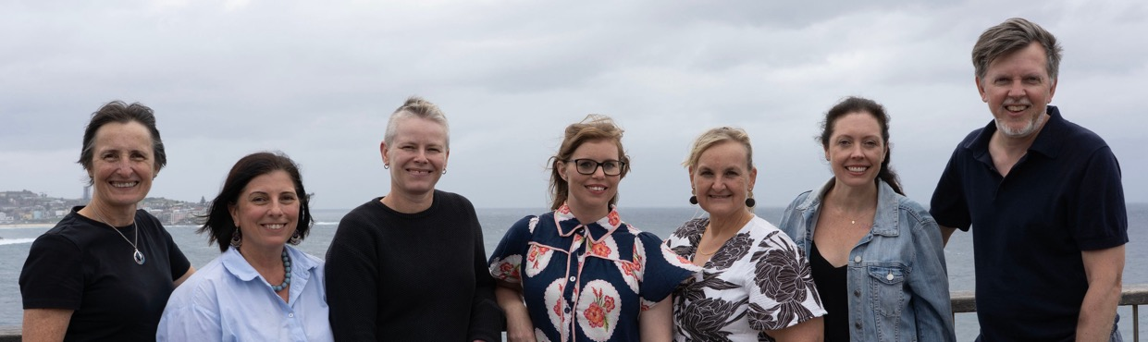
Executive & Deputy Directors
The Matilda Centre Executive and Deputy Directors work together to drive leadership, mentorship and guidance for the Matilda Centre team. These leaders move the needle to support the Centre’s academic excellence and strategic direction, strengthening partnerships and shaping high‑impact research.


Professor Maree Teesson
Matilda Centre Director


Professor Cath Chapman
Director of Research and Strategy
Christine Anderson

Operations Manager


Professor Katherine Mills
Director of Treatment and Translation


Professor Nicola Newton
Director of Prevention
Professor Tim Slade
Director of Epidemiology and Biostatistics


Deputy Directors
Associate Professor Emma Barrett Deputy Director of Research and Strategy (January-August 2025), Program Lead in Trauma and Crime Research


Professor Lexine Stapinski
Deputy Director of Prevention, Program Lead in Intervention and Implementation

Associate Professor Christina Marel Deputy Director in Treatment and Translation, Program Lead in Treatment and Translation in

Complex Populations


Associate Professor Emily Stockings Deputy Director of Research and Strategy (September 2025-present), Program Lead in Smoking, Vaping and Mental Health


Associate Professor Matthew Sunderland
Deputy Director of Epidemiology and Biostatistics, Program Lead in Measurement and Methodology
The Matilda Centre for Research in Mental Health and Substance Use
28

Matilda Centre Senior Academics
The Senior Matilda Academic Group (SMAGs) drives the Centre’s academic excellence and strategic direction, strengthening partnerships and shaping high‑impact research. Their guidance helps turn our work into real‑world policy and practice outcomes, while supporting strong performance, innovation, and talent development across the Centre.


Dr Louise Birrell
Program Lead in Young People’s Mental Health and Wellbeing


Associate Professor Katrina Champion
Program Lead in Adolescent Risk Behaviours and Mental Health


Dr Steph Kershaw
Program Lead in Stigma and Substance Use


Dr Katrina Prior
Program Lead in Maternal and Young Adult Mental Health
Dr Marlee Bower

Program Lead in Social Determinants of Mental Health


Dr Lauren Gardner
Program Lead in School-Based Health Interventions


Associate Professor Louise Mewton Program Lead in Lifespan and Brain Health


Associate Professor Louise Thornton Program Lead in Digital Interventions and Engagement

Operations 
The Matilda Operations team works in close partnership with professional and academic staff to support and enhance research activities across the Centre. Acting as a bridge between academic and administrative functions, the team facilitates communication, streamlines processes, and removes administrative and logistical barriers, contributing to a collaborative environment where research can thrive.

Portfolio support

Playing a vital role in supporting a number of Centre portfolios, the Operations team ensures these initiatives run smoothly and continue to enrich the Centre’s research environment. Their collaborative and responsive approach helps foster a positive, inclusive, and connected research community, while also supporting professional development, wellbeing, and research excellence across the Centre.

Strategy implementation
The Matilda Centre 2025–2029 Strategy provides the foundation for the Centre’s growth, sustainability, and success over the next five years. The Operations team is central to turning strategy into action, supporting delivery across the five strategic pillars by driving operational excellence and encouraging synergistic collaboration.

Accreditation
The Operations team led two of our projects (Positive Choices and Cracks in the Ice) to successfully attain National Safety and Quality Digital Mental Health Standards Accreditation in 2026. Not

The Matilda Centre Operations team: Anamaria Bunčuga, Brooklyn Hutchinson, Jasmin Bartlett and Georgie Adamson. Missing: Christine Anderson, Kay Powell

Environment
only were they the first projects to gain this accreditation at the Matilda Centre, but they were the first across the University of Sydney. The Operations Team designed and implemented system‑level communications, policies and operating processes, and supported development and collection of application evidence to achieve successful outcomes.

The Operations team onboards all new staff, students, and guests to the Centre and support new starters as they connect with the wider Centre. As the leaders in WHS and wellbeing, the Operations team regularly creates and shares wellbeing comms and works closely with the DEI Portfolio to share resources and events with staff. The Operations team has established great relationships with supervisors of staff and the faculty. These connections all work together to ensure staff have the equipment and space to complete their work and collaborate with one another, in line with Centre values and culture of being social and welcoming people into our space.

Communications
The Operations team spent much of 2025 supporting the external communications activities of the Matilda Centre. Whether it’s in the media, on social media channels, or through our website or newsletters, our communications activities ensure our research does not stay locked just behind paywalls and are given to as many people as possible. 2025 gave major achievements, such as national and international recognition for Dr Bridie Osman’s paper on chronic illnesses and neurodevelopmental disorders and food intake, and considerable growth in our LinkedIn and Instagram channels. The Operations team are supported by fantastic Instagram and Newsletter teams, who provide support for the delivery of our social media and newsletter content.


Christine Anderson, Jasmin Bartlett, Georgie Adamson, Felicity Duong, Tasma Hunt and Brooklyn Hutchinson with an Operations-led donation to the It’s in the Bag campaign

Higher Degree by Research

Students
The Matilda Centre has a strong focus on building research capacity in the fields of mental
health and substance use research across all our research streams. Our higher degree research students are core to achieving our vision of building the next generation of research leaders.



PhDs Conferred in 2025

Dr Jayden Sercombe
PhD title: Holding the Line: Stressors, Wellbeing, and Coping in Crisis Supporters Accepted: November 2025

Dr Sasha Bailey
PhD title: Understanding and preventing mental ill-health, substance use, and their co-occurrence, among gender and sexuality diverse young people in Australia
Accepted: April 2025

Dr Bridie Osman

PhD title: Food for Thought: Investigating Adolescent Nutrition, Health Behaviours, and Mental Health and Their Association with the Onset of Chronic Inflammation
Conferred: March 2025

2025 Students
Dr Nicholas Hoy
PhD title: Using hierarchical dimensional models to investigate the genomic and neural correlates of transdiagnostic psychiatric phenotypes across the lifespan
Accepted: September 2025

Dr Lyra Egan
PhD title: Understanding and preventing poor diet, alcohol use, tobacco smoking and vaping among adolescents from low socioeconomic and geographically remote areas through eHealth interventions.
Accepted: March 2025

Zachary Bryant
Highs and Lows: A Multi-Method Investigation of MDMA and Mental Health
Amarina Donohoe-Bales
Measuring and future-proofing against the impacts of natural
disasters on youth mental health
Tara Gückel
Prevention and early intervention for co-occurring anxiety and alcohol use disorders
Annabelle Hawkins
Exploring information exposure, knowledge and behaviours related to e-cigarettes among young Australians
Coleen Leung
Investigating the causal relationship between trauma and substance use
Julia Macauley
Pathways to prevention and early intervention for youth mental health and substance use in rural regional and remote areas
Eliza Oliver
Exploring the integration drama and theatre practices with psychotherapies as novel treatment for trauma

Kirsty Rowlinson
Understanding the neurobiological and psychosocial mechanisms of trauma and PTSD in women

Laura Wade
Intervening on social determinants for youth experiencing disadvantage with internalising disorders

Toni Coote
Contextualising youth mental health to optimise school-based prevention interventions

Eliza-Rose Gordon
Responding to the Mental Health Effects of Climate Change Among Youth

Logan Harvey
The role of trauma in the nature and treatment of substance use

Arvind Kendurkar
The relationship between PTSD and Opioid Use among adults
with Chronic Non-Cancer Pain

Erin Madden
Improving evidence-based practice for alcohol and other drug and mental health conditions: The role of implementation toolkits

Roisin McNamara
The relationship between vaping, weight control, body image dissatisfaction & disordered eating among young people.

Monique Piggott
Unravelling the complex interconnections between anxiety, aggression and substance use

Joel Tibbetts
The Longitudinal Relationship Between Financial Hardship and Mental Health

Key Partnerships
The Matilda Centre is proud to maintain long-standing professional partnerships with significant organisations across the mental health and substance use sectors. These collaborations help share our research widely and create new opportunities for impact. We are pleased to share some of our standout partnership activities from 2025.

The Mental Health Services (TheMHS) Learning Network
The Matilda Centre was proud to be an official program partner for The Mental Health Services (TheMHS) Conference in 2025.
Professor Cath Chapman served as Chair and Board Director throughout 2025, and Professor Maree Teesson, Dr Louise Birrell, and Dr Steph Kershaw all contributed as Association Members. Dr Kershaw was re-appointed as Program Co-Convenor, undertaking the review of more than 300 abstracts and co-ordinating the development of the three-day conference in Brisbane. We were also pleased to have strong attendance at TheMHS Forum 2025, with YAB members Heidi Berry, Thomas Wedding and Mariam Hussein attending as program advisors.

Society for Mental Health Research (SMHR)
The Matilda Centre continued a close connection with the Society for Mental Health Research (SMHR) throughout 2025. Associate Professor Louise Thornton served as the NSW representative on the SMHR Executive Committee and Dr Deanna Varley contributed as Deputy Chair of the SMHR Early and Mid-Career Researcher Committee.
They supported the organisation of the 2025 SMHR Conference, coordinating networking events and leading a pre‑conference workshop for emerging researchers. The workshop provided opportunities to connect with peers and offered practical insights into overcoming challenges and progressing research careers. The conference was strongly attended by Matilda Centre researchers.
Australasian Professional Society for Alcohol and Other Drugs (APSAD)
The Matilda Centre continues its valued partnership with the Australasian Professional Society on Alcohol and Other Drugs (APSAD), working together to advance research and best practice approaches in the substance use field.
In 2025, Associate Professor Christina Marel co-convened the APSAD 2025 Conference in Gadigal (Sydney), with Dr Robert Stirling, Kurt Simpson, and Dr Suzie Hudson. The conference focused on strengthening collaborations between Aboriginal community-controlled organisations, government and non-government organisations, and peak bodies. We were also proud to sponsor the Early‑Career Researcher Breakfast, giving emerging researchers a relaxed space to connect and build networks.

Department of Health, Disability and Ageing
Through our long‑standing partnership with the Australian Government Department of Health, Disability and Ageing, the Centre delivered the highly successful Positive Choices, Cracks in the Ice, Comorbidity Guidelines Project and Learning with FASD initiatives. In 2025, an independent evaluation of the Australian Government’s Drug and Alcohol Program (DAP) highlighted Positive Choices and Cracks in the Ice as Best Practice examples of digital prevention initiatives, recognising their national reach, partnerships, and strong evidence base.

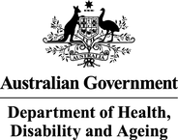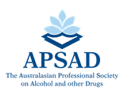

Alcohol and Drug
Foundation
Through our Cracks in the Ice and Positive Choices initiatives, we continued our knowledge‑sharing partnership with the Alcohol and Drug Foundation in 2025. This included bi‑monthly meetings on shared priorities and cross‑promotion, such as sharing social media content, as well as providing expert review of several ADF resources.

WellMob
The Strong & Deadly Futures, Positive Choices and Cracks in the Ice projects are honoured to work in partnership with WellMob, a national portal for social, emotional and cultural wellbeing resources for Aboriginal and Torres Strait Islander peoples. The WellMob website team are part of the national
e-Mental Health in Practice program that do workforce development around digital mental health. Over the past year, WellMob have collaborated with Matilda staff on several joint wellbeing initiatives, including travelling to schools to run workshops with youth to co-develop the Strong & Deadly Futures vaping prevention program.

OurFutures Institute
Our long‑standing partnership with the OurFutures Institute continued throughout 2025. Matilda Centre researchers delivered the 12‑month follow‑up results for the OurFutures Vaping program, showing it reduced a young person’s likelihood of vaping by more than 65% compared with standard education.
Following these promising outcomes, the program has secured funding to be implemented in schools across Australia. The OurFutures Institute team is now working closely with schools, parents, educators, and communities to deliver the program to one million young people by 2028.

Cause /Affect
Since 2021 the Strong & Deadly Futures team has been working in partnership with Cause/Affect, an Aboriginal-owned creative design agency. Over the past year we have continued our strong collaboration, travelling to communities and schools to conduct consultations and youth workshops to co-develop the Strong & Deadly Futures program. To date we have trialled the Strong & Deadly Futures program in 26 schools across WA, NSW, and QLD, and this year alone the team have travelled 38,000+ kilometres together.



Culture & Wellbeing

Diversity, Equity and Inclusion portfolio
In 2025, the Diversity, Equity and Inclusion (DEI) portfolio continued our focus on embedding DEI into business-as-usual across the Matilda Centre. This included initiatives such
as establishing a sensory room (a multi-purpose room to support people with sensory-related needs) and all-gender bathrooms, regular seminars and staff learning, and partnering with other portfolios, such as the social committee for the inaugural Wear It Purple walk and Ikigai Aboriginal bracelet weaving.

Dr Elly Fitzgeraldson, Sally Boardman, Dr Steph Kershaw, Georgette Borel, Jessica Deng, Jordon Mathers-Jones, Professor Lexine Stapinski and Dr Kriscia Tapia at the 2025 Tribal Warrior Cruise

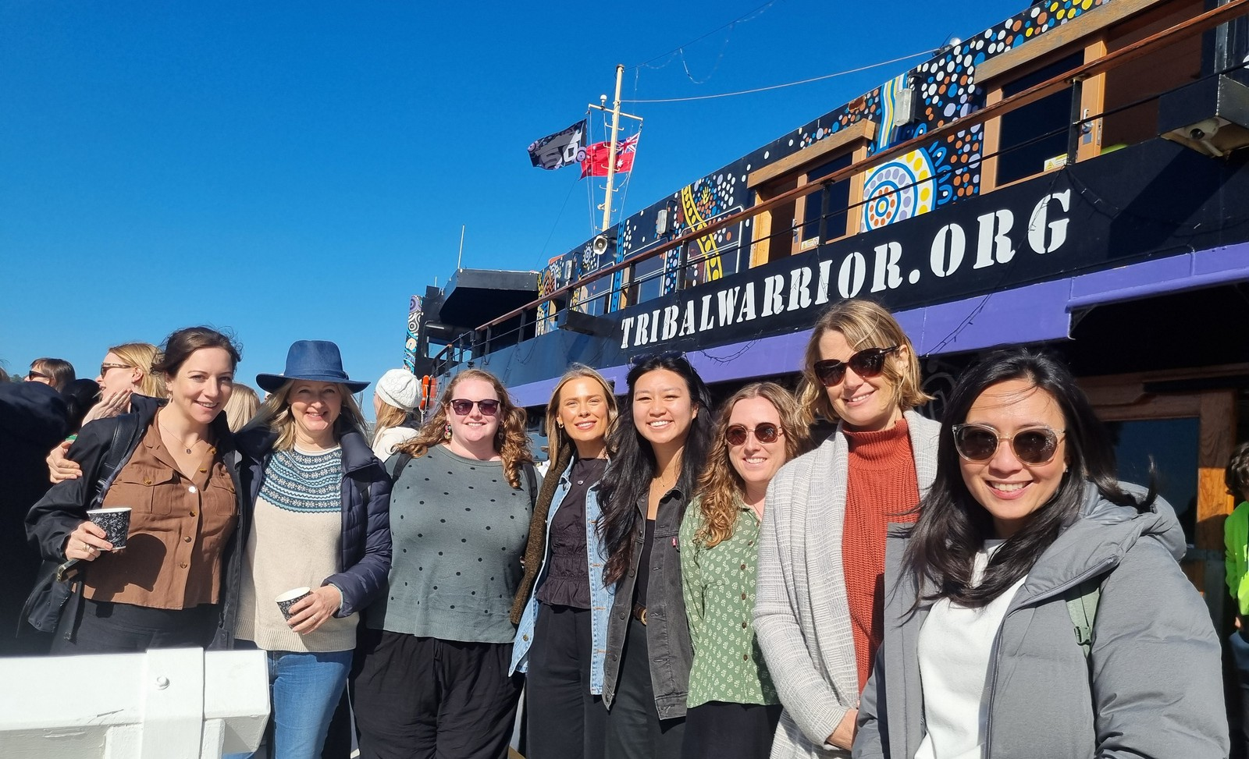
The seminars included David Edwards from WellMob, who shared insights on culturally grounded approaches to social and emotional wellbeing; Professor Angela Nickerson, on refugee mental health; and Layne Scapano, who discussed her work supporting students from low-income backgrounds. The short learning sessions were delivered at all staff meetings, focusing on practical topics such as inclusive language and using plain English to support people with lower literacy.

In December, the portfolio hosted a charity drive in support of Share the Dignity’s It’s in the Bag campaign, which collects essential items for women fleeing domestic violence. The portfolio also played a central role in representing the Matilda Centre at broader university and FHM events, including the Mardi Gras celebrations, the NAIDOC Week Tribal Warrior Cruise, and Mabo Day.

Green Team/Climate Change and Health special interest group
The Matilda Centre’s Climate Change and Health Special Interest Group was established to explore the intersection between climate change and mental health, highlighting research priorities and opportunities. The Group’s expertise spans climate-related emotions, mental health responses to environmental disasters, and the impact of the built environment on mental health, amongst other topics. The Group’s members collaborated with external researchers through funded research projects such as the ‘Climate Change, Place and Mental Health’ Research Incubator, and the Orygen-led research developing the ‘Platform for Research and Interventions in youth Mental health and the Environment’ (PRIME).

A new initiative the Group pioneered at the Matilda Centre was involvement in the University’s ‘Green Impact’ program. This program paved the way for the Group to identify opportunities for our Centre and staff to be more sustainable in their work and personal lives. The Group hosted a seminar with a speaker from the University’s Sustainability Team and collaborated with other Centre portfolios (e.g., DEI and social portfolios) to participate in sustainability-related events. A key outcome was that social events prioritised sustainability, particularly in relation to decorations and waste management strategies. The Group received a ‘Gold award’ in the 2025 Green Impact program, reflecting our accrual of 300+ points across the sustainability activities specified in the program.
The Matilda Centre for Research in Mental Health and Substance Use 34

Grant Development Workshop
In 2025, we held the 15th Matilda Centre Grant Development Workshop at the Clovelly Bowling Club. The Grant development Workshop is an annual two-day event where all staff at the Matilda Centre gather for an offsite workshop. This event is dedicated
to discussing our new research ideas and how we secure the all-important funding that allows us to put these ideas into action. This year we had 65 attendees and we discussed new projects focused on climate change and mental health, new models of prevention for mental and substance use disorders, social media literacy for youth, and large-scale data harmonisation focused on psychological distress, among many others.

Matilda Centre staff listen to a presenter at the 2025 Grant Development Workshop

In addition, we had Matilda Centre expert reviewers and previous grant review panel members discussing their top tips and tricks for a successful grant review. We also had presentations from external experts, including a member of the Matilda Centre Youth Advisory Board, where we discussed the importance of lived experience in developing our grants, and the support available to the Matilda Centre through our various lived experience networks. Finally, we wrapped things up with a presentation from expert consultant, Rebecca Murray, which focused on grant writing strategy. Overall, over 90% of attendees indicated that the workshop improved their knowledge and understanding of the grant writing process and that they are likely to use the knowledge they’d gained in their own grant writing or other work.

Social Committee

2025 ‘Sugar and Spice’ Bake Off theme

Matilda Centre team on the Wear it Purple Walk at the University of Sydney in August

The Matilda Centre social committee is dedicated to fostering staff wellbeing, connection, and community impact through thoughtful and inclusive social activities. In 2025, we enjoyed a fantastic mix of morale boosting events from music trivia and office bingo to the Easter egg hunt, presentation karaoke, Wear It Purple Walk, PJ Day, blind taste tests, ping pong, and our spectacular Roaring Twenties End of Year Party.

A favourite wellbeing tradition continues to be our themed Bake Offs. Every 2–3 months, staff are invited to bake or cook something and submit it anonymously for a shared morning tea. It’s a simple but meaningful way for people to pause, come together, enjoy great food, and vote online for their favourite creation. Each round ends with the crowning of our much loved “Master Baker”, competition is fierce.
Non-bakers can contribute to our collective charity efforts, with staff nominating and voting on charities at the end of each year. In 2025, the Bake-Off community raised $542, which was shared between the Asylum Seeker Centre and the Sydney Dogs & Cats Home, with the Sydney Dogs & Cats Home receiving matched funding.


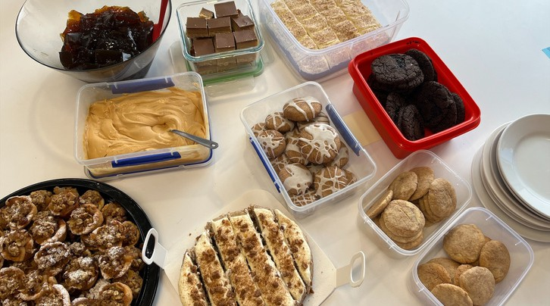
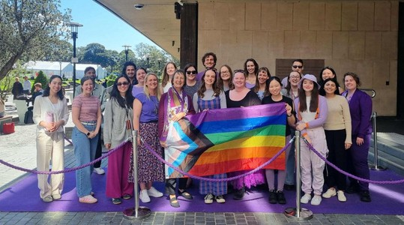

The Matilda Centre for Research in Mental Health and Substance Use 35

What’s Next?
As we move into 2026, the Matilda Centre is energised by the opportunities ahead. We’re building on the strength of our existing programs while boldly exploring new areas of research to help create a healthier tomorrow for everyone.

New Grants



Dr Katrina Prior
NHMRC Investigator Grant: The dangerous path of self-medicating postpartum stress and anxiety with alcohol: Intervening early to improve the health and wellbeing of both mother and child



Dr Rachel Grove
NHMRC Investigator Grant: The freedom to live a flourishing life: Co-creating autistic wellbeing
Dr Lucy Grummitt
NHMRC Investigator Grant: Addressing childhood trauma to prevent substance use and mental disorders: Improving precision psychiatry and developing innovative interventions

Associate Professor Matthew Sunderland
NHMRC Ideas Grant: New Models and new measures for mental health: developing more meaningful assessment and diagnostic tools

New Projects



The Matilda Centre for Research in Mental Health and Substance Use
36


PhD: Medicinal Cannabis Use in Young People: Health Outcomes, National Trends, and Lived Experiences Olivia Dobson


OurFutures Vaping replication trial - low socio-economic schools Dr Lauren Gardner
respectED: a school-based consent and respectful relationships program
Dr Siobhan O’Dean & Dr Amy-Leigh Rowe

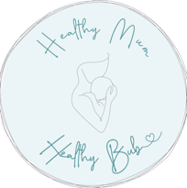
Healthy Mum, Healthy Bub
Dr Katrina Prior

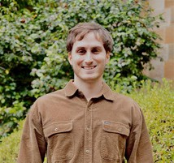
PhD: Evaluating the causal relationships between extreme violent and misogynistic content, hostile sexism and domestic violence perpetration Samuel Jones

OurFutures Vaping Prevention Primary Schools Trial Associate Professor Emily Stockings

Staff list 2025
Meet those leading a healthier tomorrow for everyone

Executive
Professor Maree Teesson Christine Anderson Professor Cath Chapman Professor Katherine Mills Professor Nicola Newton Professor Tim Slade

Senior Matilda Academic Group
Associate Professor Emma Barrett Dr Louise Birrell
Dr Marlee Bower
Associate Professor Katrina Champion Dr Lauren Gardner
Dr Rachel Grove Dr Steph Kershaw
Associate Professor Christina Marel Associate Professor Louise Mewton Dr Katrina Prior
Professor Lexine Stapinski Associate Professor Emily Stockings
Associate Professor Matthew Sunderland Associate Professor Louise Thornton

Matilda Academics and Professional Leadership Group
Jasmin Bartlett Dr Hollie Byrne Dr Sarah Cavallin Dr Lily Davidson Dr Emma Devine Felicity Duong Dr Lyra Egan
Dr Elly Fitzgeraldson
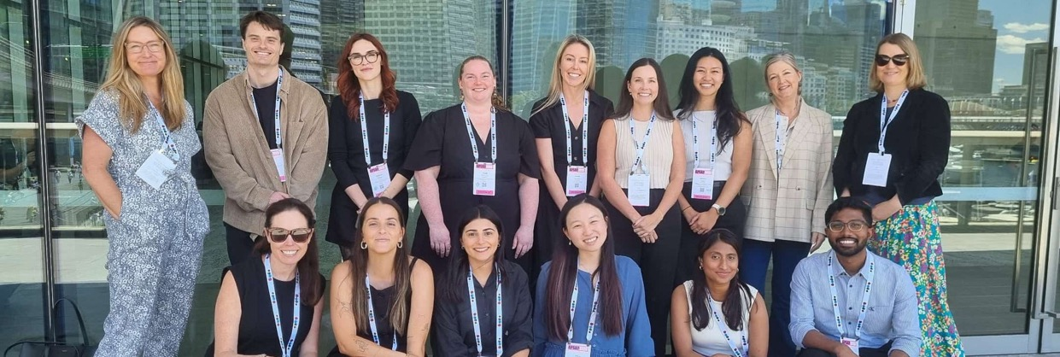
Acknowledgement of Contribution
We warmly thank our casual staff, members and affiliates for their dedication and generosity throughout 2025. Their expertise, collaboration and commitment have been central to the Matilda Centre’s work and impact, and we are deeply grateful for their ongoing contribution to our shared purpose.

Dr Lucy Grummitt Tara Gückel
Dr Amelia Henry Dr Ivana Kihas
Dr Cynthia Kroeger Dr Shweta Kulkarni Dr Jessy Lim
Dr Bridie Osman Dr Siobhan O’Dean Kay Powell
Kate Ross
Dr Amy-Leigh Rowe Dr Jayden Sercombe Dr Scarlett Smout
Dr Kriscia Tapia Dr Deanna Varley
Dr Fotini Vasilopoulos Dr Rachel Visontay
Dr Lucy Watchirs-Smith Dr Jack Wilson

Professional Staff
Georgie Adamson Alexandra Azzi Sally Boardman Georgette Borel Zachary Bryant Anamaria Bunčuga Toni Coote
Jacky Dawkins Jessica Deng Olivia Dobson
Amarina Donohoe-Bales
Roberto Garruccio

Eliza-Rose Gordon
Natalie Gorgioski
Isabelle Greenway Alexander Haidinger Annabelle Hawkins Eliza Hewson Annabel Hughes Tasma Hunt
Emily Hunter Brooklyn Hutchinson Tariq Isaacs
Isobel Ivison Samuel Jones Aleksa Kamenjas Stephen Knight Coleen Leung Yoni Manor
Jack Marsden
Dr Natalie Mastrogiovanni Jordon Mathers-Jones Roisin McNamara Natasha Radmall
Ivone Rebelo Isabel Rewais Julia Riches
Amelia Russell Lauren Scott Camilla Sedgwick
Madhu Senthil Kumar Chantell Sheehan Lily Teesson
Laura Wade Virginia Winter

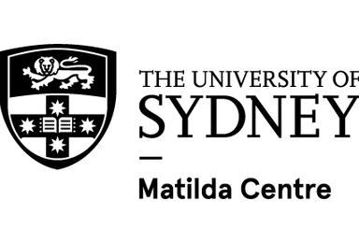
Learn more
sydney.edu.au/ matilda-centre

