Guidelines for mental health researchers using Twitter
Erin Madden1, Katrina Prior1, Tara Guckel1, Sophia Garlick-Bock2, Zachary Bryant1, Siobhan O’Dean1, Smriti Nepal1,3, Caitlin Ward4, Louise Thornton1,5,6

Author Affiliations:
1 The Matilda Centre for Research in Mental Health and Substance Use, Faculty of Medicine and Health, The University of Sydney, Sydney NSW Australia
2 ReachOut Australia, Pyrmont NSW Australia
3 Sax Institute, Haymarket NSW Australia
4 Faculty of Medicine and Health, The University of Sydney, Sydney NSW Australia
5 The University of New South Wales, Sydney NSW Australia

6 The University of Newcastle, Newcastle NSW Australia

We acknowledge the tradition of custodianship and law of the Country on which the University of Sydney campuses stand. We pay our respects to those who have cared and continue to care for Country.

Who are these guidelines for and when should they be used?
- These guidelines are intended for mental health researchers using Twitter to disseminate research findings
- The guidelines have two key aims:
- To increase engagement with mental health research Tweets (i.e., increase number of favourites, comments, video views or Retweets)
- To increase user awareness and confidence in determining which mental health research Tweets are evidence-based (e.g., what is the information, and where has it come from?)
  - We note that these guidelines are preliminary, and welcome feedback from researchers using the guidelines to disseminate findings. If you have any suggestions or enquiries, please email matilda.centre@sydney.edu.au or mention us via @TheMatilda_USyd

How were these guidelines developed?
  - These guidelines were developed to accompany the research publication Madden, E., Prior, K., Guckel, T., Garlick-Bock, S., Bryant, Z., O’Dean, S., Nepal, S., Ward, C., Thornton, L. (2023). “What do I say? How do I say it?” Twitter as a knowledge dissemination tool for mental health research. Journal of Health Communication, DOI: 10.1080/10810730.2023.2278617
  - This publication aimed to answer the questions of ‘what do I say’ and ‘how do I say it’ for effective dissemination of mental health research via Twitter by analysing a large sample of mental health research Tweets (n=300)
  - Results showed that researchers may be able to maximise engagement on Twitter by highlighting the population groups that the research applies to and enriching Tweets with multimedia content, however the evidence basis of research Tweets could not be reliably determined
  - The authors subsequently developed these freely available guidelines and accompanying examples of their use in practice for mental health researchers using Twitter

The Guidelines

Based on findings from a thorough analysis of 300 mental health research Tweets from two large, nationally representative Australian mental health research organisations, preliminary guidelines were developed for mental health researchers using Twitter to disseminate findings.

Last updated 13 November 2023 Page 5

Guidelines for mental health researchers using Twitter

What do I say? | How do I say it?
- Tell the audience what the information is, and where it came from (i.e., your key finding and the evidence-basis is clear)  - Tell your audience who you’re speaking to (i.e., if your finding relates to a specific population group, make it clear) | - Use media that adds to the Tweet, expanding on what the information is and where it came from (e.g., images, videos)  - Use hyperlinks to verify research information in Tweet  - Minimise over-use of hashtags (i.e., seek out hashtags that relate to specific events, communities or conversations)
Madden, E., Prior, K., Guckel, T., Garlick-Bock, S., Bryant, Z., O’Dean, S., Nepal, S., Ward, C., Thornton, L. (2023). “What do I say? How do I say it?” Twitter as a knowledge dissemination tool for mental health research. Journal of Health Communication, DOI: 10.1080/10810730.2023.2278617

The Matilda Centre, University of Sydney Last updated 13 November 2023 Page 6

Examples of the Guidelines in use
We reviewed Tweets from our dataset that contained evidence-based information (n=147) to find common examples of how real Tweets did or did not utilise recommendations made in the guidelines. We then ‘mock Tweets’ as examples of how Tweets might look after all the recommendations in the guidelines had been implemented.

Last updated 13 November 2023 Page 7

Example of Tweet containing expert opinion via a conference presentation
Not using guidelines

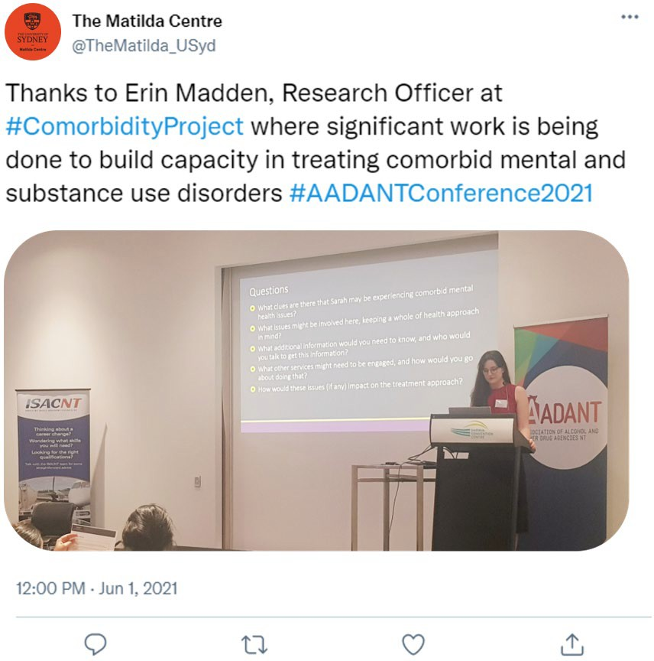
Evidence basis of information on slide is unclear (what is the information, and where did it come from?)
Specific population group that research findings relate to is unclear (who is this research for?)
No hyperlink to verify research information in Tweet

Image used adds to Tweet (information is coming from researcher at a conference)

Hashtags are not over-used (relate to a specific event/project)

Example of Tweet containing expert opinion via a conference presentation
 Using guidelines

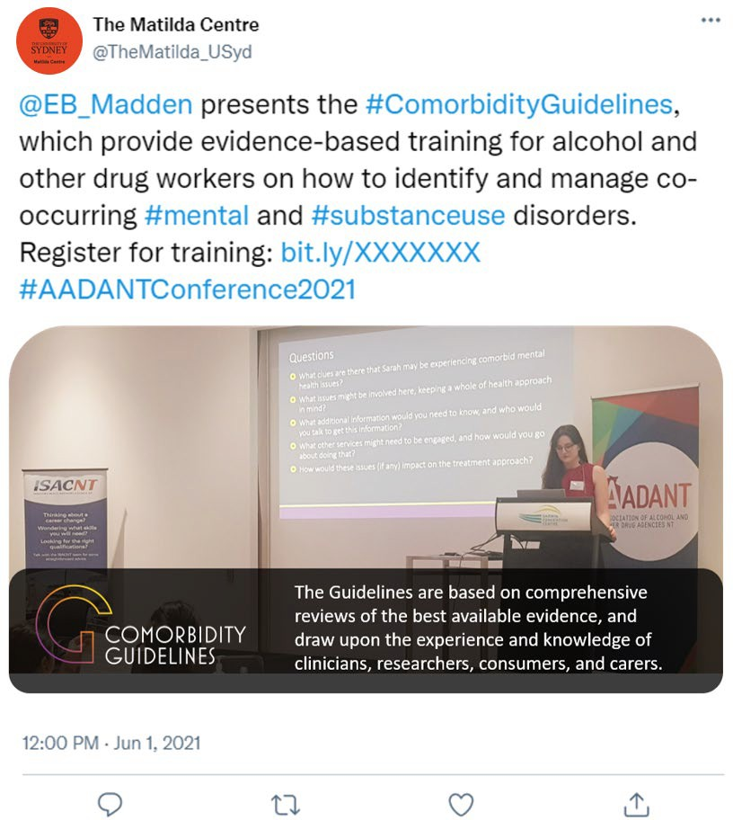
Through a combination of the image and Tweet, evidence basis of information on slide is clear (guidelines and training resources for co-occurring mental and substance use disorders, based on literature reviews and consultations)
Specific population group that findings relate to is clear (alcohol and other drug workers)
Hyperlink to verify research information in Tweet
Hashtags are not over-used (relate to a specific event/project)

Example of Tweet containing expert opinion via news article or blog post
Not using guidelines

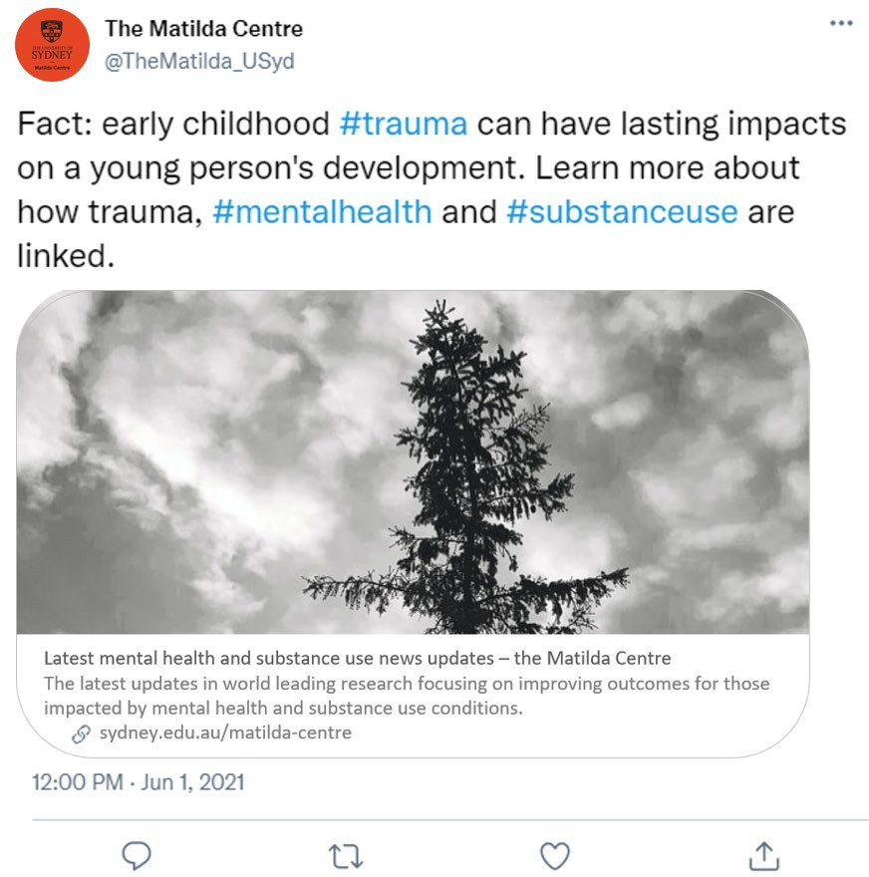
Evidence basis of information is unclear (what is the information, and where did it come from?)

Image used adds nothing to Tweet

Hyperlink to verify research information in Tweet

Specific population group that findings relate to is clear (young people)

Hashtags are not over-used (relate to specific conversations)

Example of Tweet containing expert opinion via news article or blog post
 Using guidelines

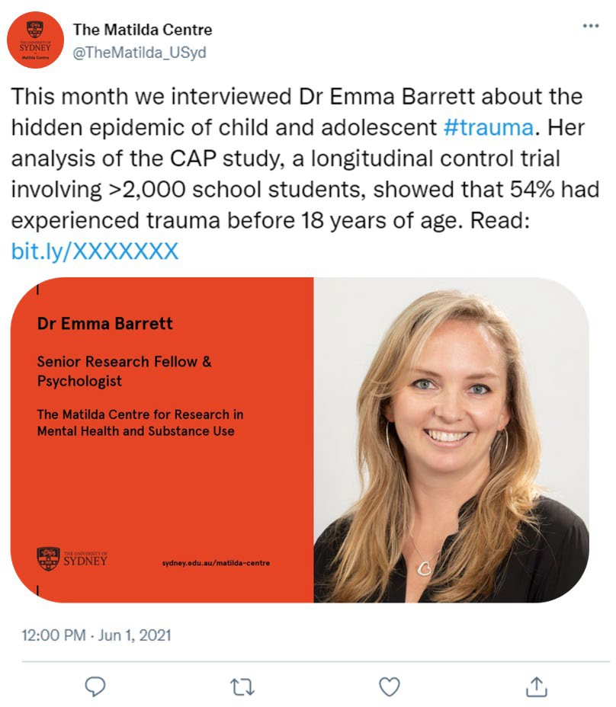
Evidence basis of information is clear (prevalence of trauma in young people, comes from analysis of a clinical trial)
Image used adds to Tweet, shows information is also based on expert opinion

Hyperlink to verify research information in Tweet

Specific population group that findings relate to is clear (young people)

Hashtags are not over-used (relate to a specific conversation)

Example of Tweet containing expert opinion (other event)
Not using guidelines

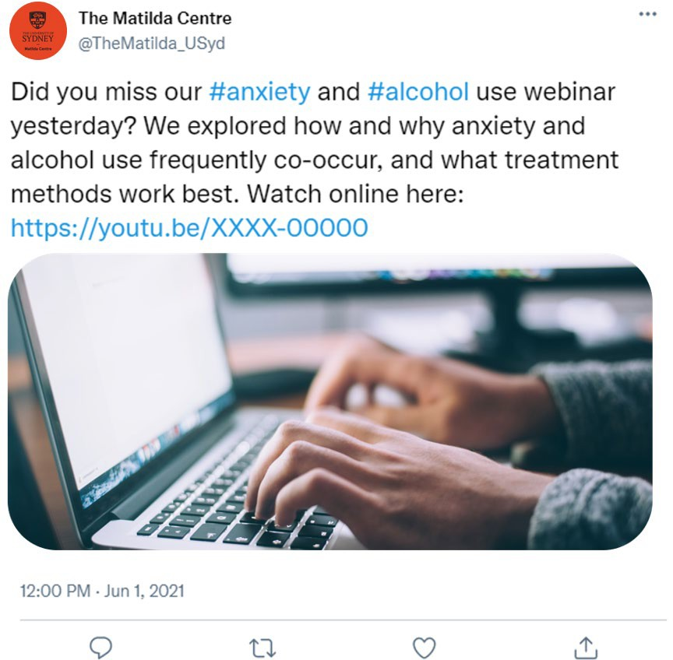
Evidence basis of webinar is unclear (information presented is clear, but where did it come from?)

Image used adds nothing to Tweet

Specific population group that findings relate to is unclear (clinicians, clients or both?)

Hyperlink to verify research information in Tweet

Hashtags are not over-used (relate to a specific conversations)

Example of Tweet containing expert opinion (other event)
 Using guidelines

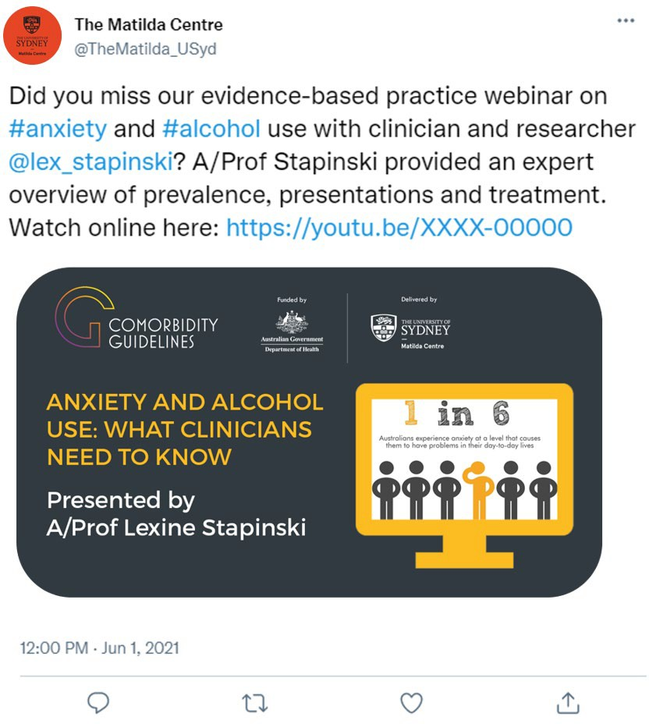
Evidence basis of webinar is clear (overview of prevalence, presentations and treatment for anxiety and alcohol use by clinician and researcher, expert opinion)
Image used adds to Tweet

Specific population group that findings relate to is clear (clinicians)

Hyperlink to verify research information in Tweet

Hashtags are not over-used (relate to specific conversations)

Example of Tweet containing an evidence-based report
Not using guidelines

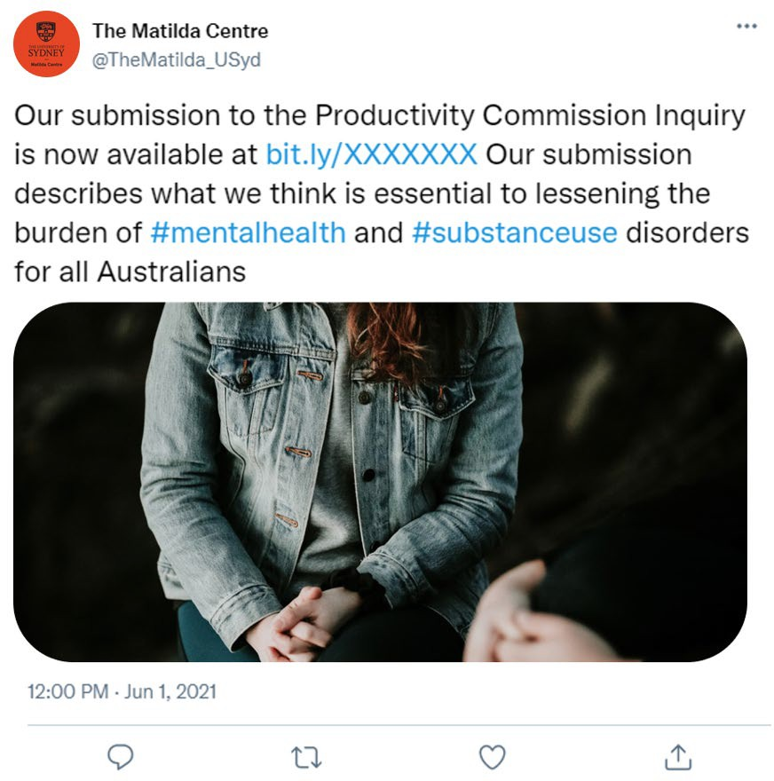
Evidence basis of information is unclear (what is the information, and where did it come from?)

Image used adds nothing to Tweet

Specific population group that findings relate to is clear (all Australians, federal policy)

Hyperlink to verify research information in Tweet

Hashtags are not over-used (relate to specific conversations)

Example of Tweet containing an evidence-based report
Using guidelines

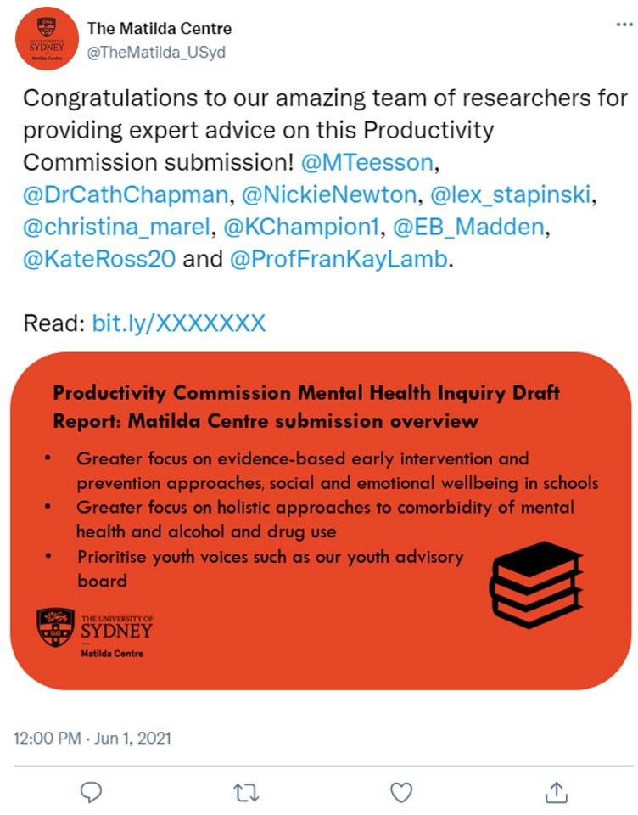
Through a combination of the image and Tweet, evidence basis of information is clear (key recommendations in submission are clear, expert advice as source is clear). Notably, mentions of accounts replace hashtags to illustrate number of experts providing input.

Specific population group that findings relate to is clear (all Australians, federal policy)
Hyperlink to verify research information in Tweet

Example of Tweet containing an evidence-based resource (treatment program)
Not using guidelines

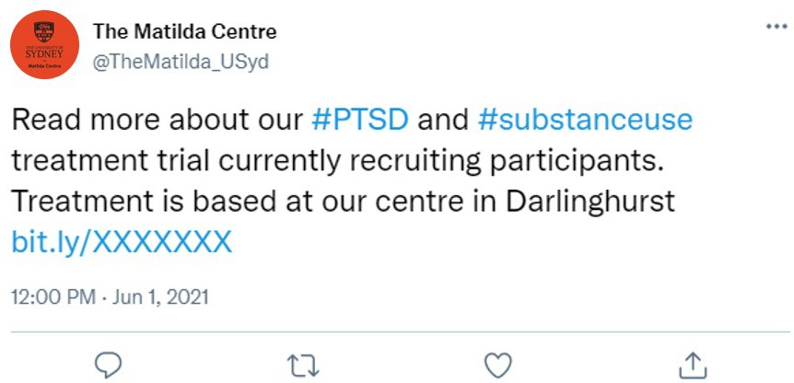
Evidence basis of information is unclear (what is the treatment program, and where did it come from?)

No media used to support Tweet

Specific population group that findings relate to is clear (people experiencing PTSD and substance use)

Hyperlink to verify research information in Tweet
Hashtags are not over-used (relate to a specific conversation)

Example of Tweet containing an evidence-based resource (treatment program)
 Using guidelines

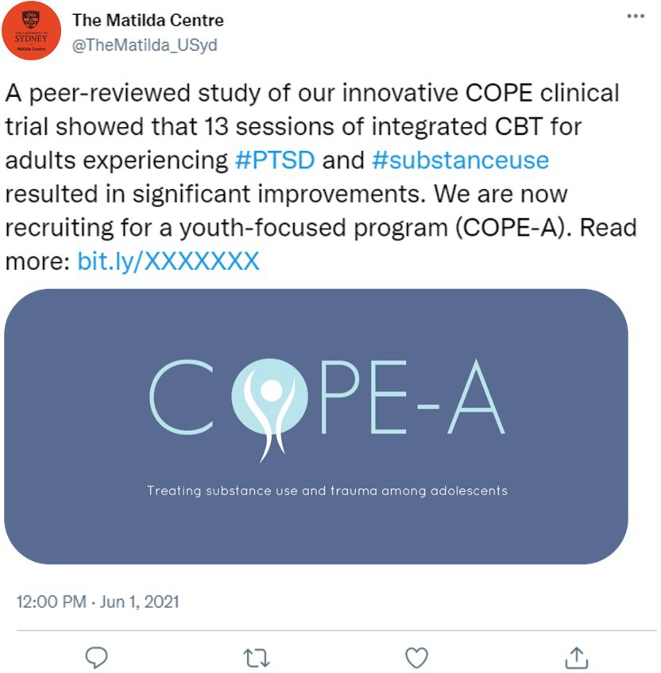
Evidence basis of information is clear (treatment program is a clinical trial, previous trial has peer-reviewed publication showing efficacy)
Image is used and adds to Tweet

Specific population group findings relate to is clear (young people experiencing PTSD and substance use)
Hyperlink to verify research information in Tweet
Hashtags are not over-used (relate to a specific conversation)

Example of Tweet containing an evidence-based resource (factsheet)
Not using guidelines

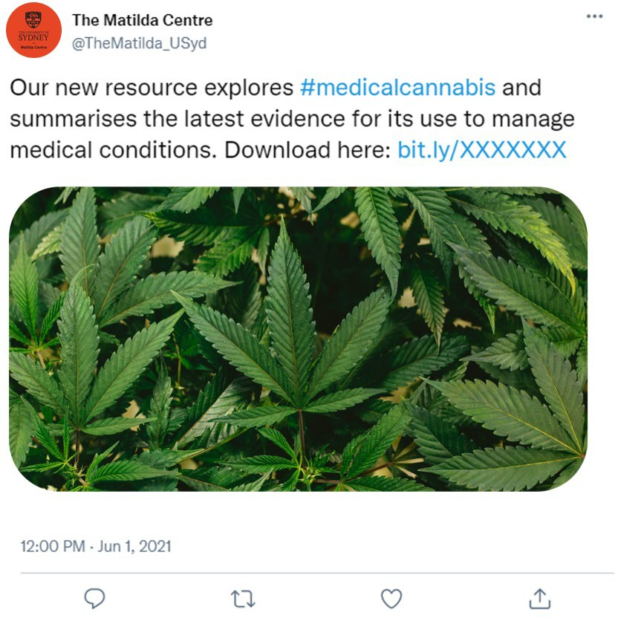
Evidence basis of information is unclear (what is the resource, and where did it come from?)

Specific population group that findings relate to is unclear (who is this resource for?)

Image used adds nothing to Tweet

Hyperlink to verify research information in Tweet

Hashtags are not over-used (relate to a specific conversation)

Example of Tweet containing an evidence-based resource (factsheet)
Using guidelines

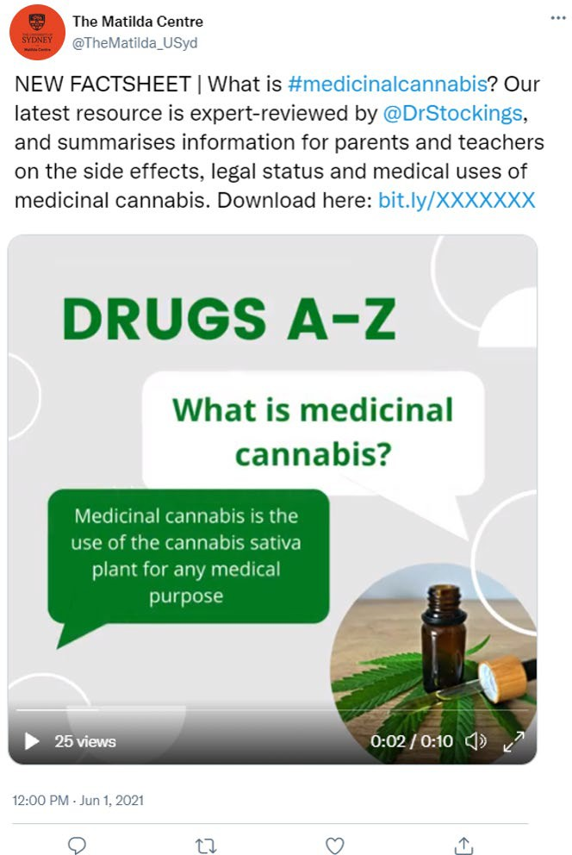
Evidence basis of information is clear (an expert reviewed factsheet on medical cannabis)

Specific population group that findings relate to is clear (parents and teachers)

Video used adds to Tweet (provides some examples of facts from resource)

Hyperlink to verify research information in Tweet

Hashtags are not over-used (relate to a specific conversation)

Example of Tweet containing a peer-reviewed publication
Not using guidelines

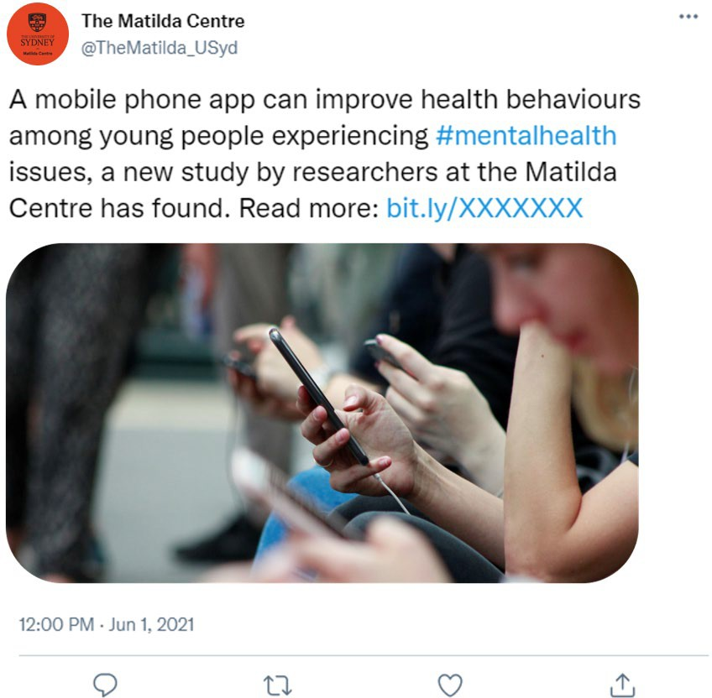
Evidence basis of information is unclear (finding is clear, but where did it come from?)

Image used adds nothing to Tweet

Specific population group that findings relate to is clear (young people)

Hyperlink to verify research information in Tweet

Hashtags are not over-used (relate to a specific conversation)

Example of Tweet containing a peer-reviewed publication
Using guidelines

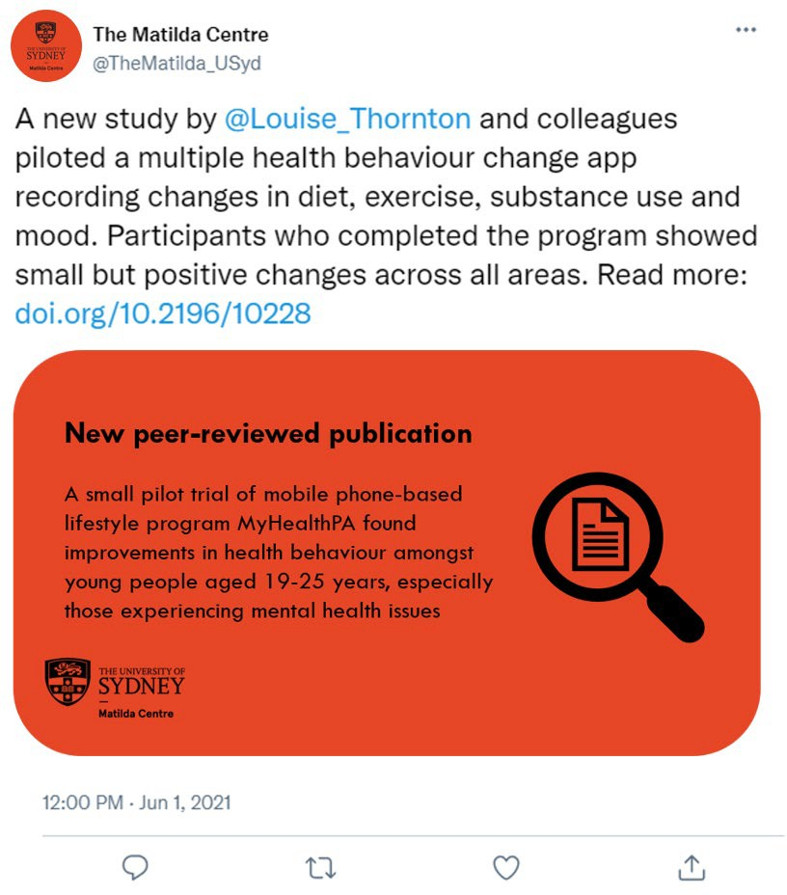
Through a combination of the image and Tweet, evidence basis of information is clear (finding is clear, and that it comes from peer-reviewed publication is clear)

Specific population group that findings relate to is clear (young people)

Hyperlink to verify research information in Tweet

Hashtags are not over-used (relate to a specific conversation)

Connect with us
matilda.centre@sydney.edu.au sydney.edu.au/matilda-centre
 TheMatildaUSyd  @TheMatilda_USyd
 TheMatildaCentreUSyd

The Matilda Centre, University of Sydney

