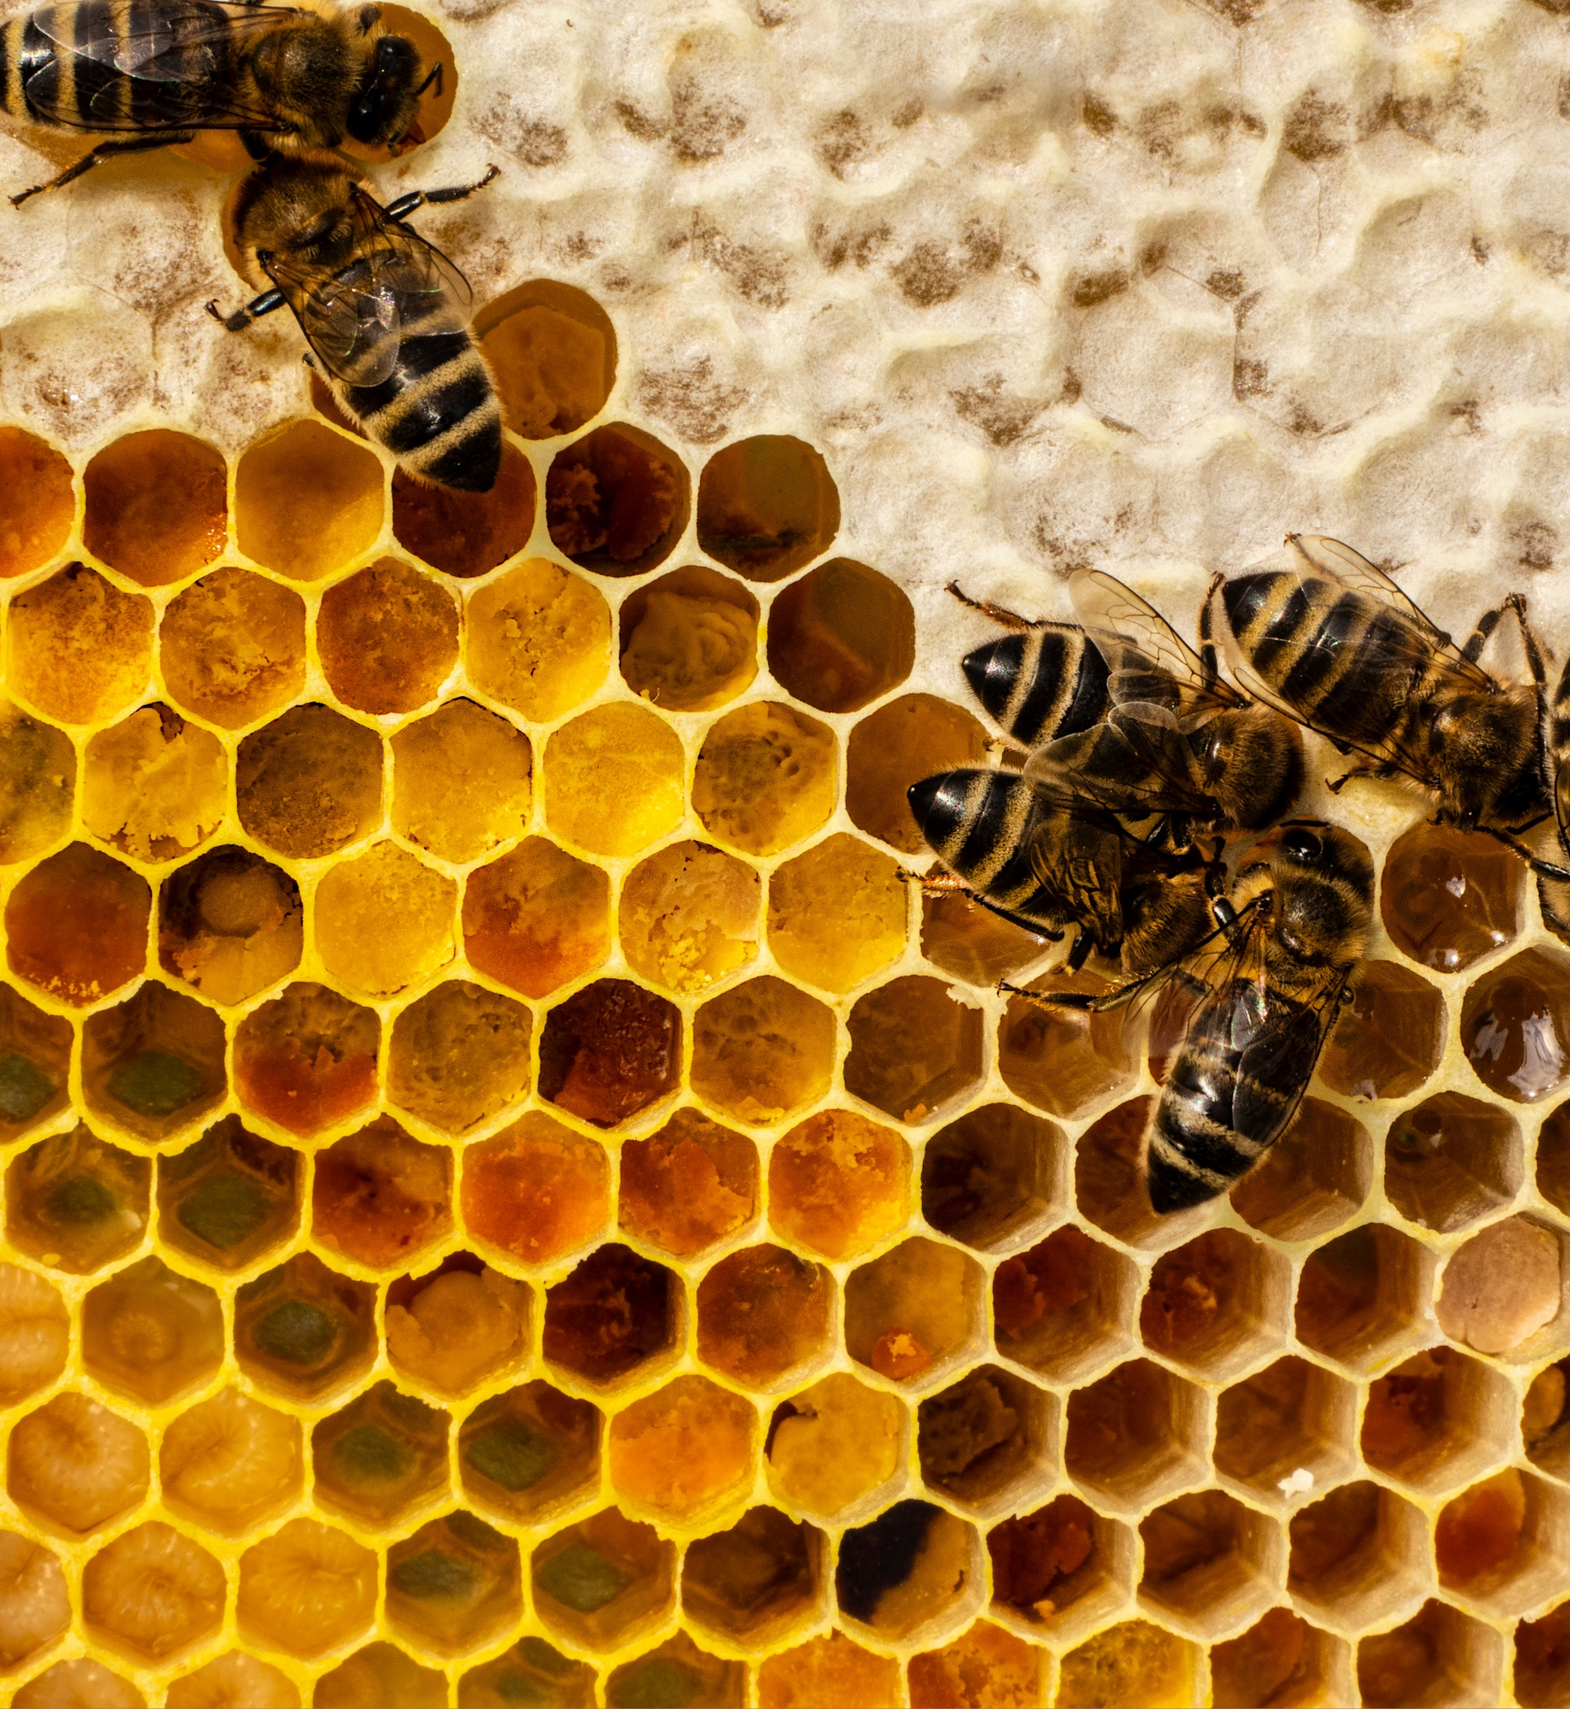

DRAFT Environmental Sustainability Policy 2026
Sample image only
 About this document
Printed or electronic copies may be out of date. Always check the Policy Register for the current version.
Title page image credit: AdobeStock_807304140

Table of contents
Part 1 Purpose and application 3
1.1 Purpose 3
1.2 Start date 3
1.3 Application 3
Part 2 Principles 4
2.1 Principles 4
2.2 Climate and Nature Transition Plan (CNTP) 5
2.3 Environmental Management System (EMS) 5
Part 3 Reporting and monitoring 7
3.1 Reporting 7
3.2 Monitoring 7
Part 4 Roles and responsibilities 8
4.1 Senate 8
4.2 University Executive 8
4.3 Sustainability Team 8
4.4 Environmental Risk Team 8
Part 5 Definitions 9
Part 6 Notes 11
Part 7 Amendment history 13

Purpose and application

Purpose
- This Policy:
  - explains how we embed environmental sustainability in:
    - strategy;
    - governance;
    - operations; and
    - activities on University lands;
  - helps us meet our legislative and regulatory obligations; and
  - reflects and advances the University values.

Start date
- This Policy commences on [commencement date].

Application
- This Policy applies to:
  - staff, affiliates, students, and visitors;
  - occupants of University lands;
  - University operations; and
  - activities on University lands.
Note: See definitions in Part 5
- This Policy does not apply to:
  - research; or
Note: See Research Code of Conduct
  - coursework teaching and course content.
Note: See Teaching and Learning Policy

Principles

Principles
- We:
  - incorporate environmental sustainability principles into our:
    - strategies;
    - planning, and
    - decision-making;
Note: See clause 540 of the Enterprise Agreement
  - protect the environment;
  - prevent pollution;
  - minimise our environmental impacts;
  - implement our Climate and Nature Transition Plan (CNTP), and publicly report on progress;
  - have an Environmental Management System (EMS);
  - identify, assess and manage risks and opportunities related to:
    - the environment;
    - climate; and
    - nature;
  - together with our staff and students, develop and deliver environmental sustainability initiatives;
Note: See clause 540 of the Enterprise Agreement for information on how we engage with staff.
  - set clear accountabilities for:
    - achieving sustainability outcomes; and
    - driving continual improvement;
  - recognise Indigenous:
    - knowledges; and
    - practices of sustainability and land management;
  - comply with all applicable environmental legislative and regulatory requirements;
Note: See the Legislative Compliance Policy.
  - help staff, students and affiliates understand their environmental responsibilities; and
  - allocate resources to meet environmental compliance requirements.

Climate and Nature Transition Plan (CNTP)
- The Climate and Nature Transition Plan sets out:
  - our commitment to environmental sustainability and protection;
  - targets for:
    - progress towards our net-zero emissions targets;
    - energy efficiency;
    - water efficiency;
    - resource efficiency;
    - waste reduction;
    - enhanced biodiversity; and
    - protection of natural ecosystems on University lands;
  - pollution prevention initiatives; and
  - actions to mitigate and adapt to climate change, including managing:
    - physical risks; and
    - transition risks.
Note: See definitions in Part 5.
- The CNTP must be:
  - endorsed by University Executive;
  - approved by Senate; and
  - maintained and updated by the Sustainability Team, in collaboration with relevant organisational units.

Environmental Management System (EMS)
- The Environmental Management System (EMS) is:
  - a set of tools and processes;
  - overseen by the Environmental Risk Team within the Health, Safety and Wellbeing Team, in collaboration with relevant organisational units
Note: See the staff intranet [link will be included when available].
- The EMS helps us to:
  - proactively manage our environmental impacts and risks;
  - monitor our:
    - environmental impacts and risks; and
    - progress towards the targets in the CNTP;
  - evaluate and report on our environmental performance;
  - meet our legislative and regulatory obligations; and
  - drive continual improvement in environmental performance and management practices.
- All staff and operational units must:
  - comply with the EMS; and
  - contribute to continual improvement as needed.

Reporting and monitoring

Reporting
- The Sustainability Team will:
  - report twice a year to UE on the operational delivery of the CNTP;
  - report annually to Senate on the University’s overall sustainability performance; and
  - prepare the annual Climate Related Financial Disclosures Report for consideration, and if appropriate approval, by Senate.

Monitoring
- The Sustainability and Environmental Risk teams must monitor compliance with:
  - this Policy and any related procedures; and
  - legislative and regulatory environmental obligations.

Roles and responsibilities

Senate
- approves the CNTP;
- receives annual reports on progress against the CNTP;
- sets the University’s strategic direction for environmental sustainability;
- receives reports on environmental compliance; and
- approves the annual Compliance Related Financial Disclosures Report.

University Executive
- reviews and, if appropriate, endorses the CNTP;
- reviews and, if appropriate endorses environmental sustainability reports, including annual Climate Related Financial Disclosures Report.
- receives reports from the Sustainability Team twice a year; and
- allocates resources to meet environmental compliance requirements and deliver the CNTP.

Sustainability Team
- leads the coordination and oversight of the CNTP;
- works with key stakeholders to deliver initiatives in the CNTP;
- monitors performance and reports on progress, risks and impacts as required by this Policy.

Environmental Risk Team
- oversees and manages the EMS;
- monitors compliance with:
  - this Policy; and
  - legislative and regulatory environmental obligations;
- reviews and improves the EMS;
- advises and assists staff to adopt and implement the EMS;
- reports on progress and compliance as required by this Policy. .

Definitions
- In this Policy a reference to ‘we’, ‘our’ or ‘us’ means the University.
Climate and Nature Transition Plan (CNTP) | the University’s environmental sustainability and protection strategy and plan. It was formerly known as the Sustainability Strategy.
Climate Related Financial Disclosures Report | the annual standardised reporting of how climate change impacts operations, risks, and opportunities, required from NSW public sector entities.
emission targets | time-bound goals that set the level of greenhouse gas emissions we aim to reduce or limit, including interim and long-term targets.
environmental impact | any change to the environment, whether harmful or helpful, caused in whole or in part by our activities, operations, or decisions.
Environmental Management System (EMS) | a documented management system consistent with ISO 14001:2026.
environmental risk | the potential for an activity, decision, or event to cause harm to the environment or to result in non-compliance with environmental obligations, policies, or standards.
environmental sustainability | the long-term care of natural resources and ecosystems, focused on minimising harm, maintaining ecological integrity, and supporting resilience for current and future generations.
ISO 14001:2026 | the internationally recognised standard for environmental management systems (EMS) published by the International Organisation for Standardisation.
net zero | a state where our greenhouse gas emissions are reduced as far as practicable, with any remaining emissions balanced by verified removals.
physical risk | the risk of financial, operational or environmental impact arising from the physical effects of climate change and nature degradation. This includes acute events (e.g., extreme weather or natural disasters) and chronic changes (e.g., temperature rise, biodiversity loss, ecosystem decline).
pollution | introducing substances, contaminants, or energy into the environment that causes or is likely to cause harm to human health or the environment.
resource efficiency | optimising the use of materials, energy, and other resources to reduce waste, and minimise environmental impact.
transition risk | the risk of financial, operational or reputational impact from the transition to a low-carbon, climate-resilient and nature-positive economy. This includes changes in policy, regulation, technology, market conditions or stakeholder expectations.
University lands (also referred to as “our lands”) | includes any land or road occupied or used by, or in connection with,  the University. This includes:  - all or part of any building or structure; and  - any land used or occupied in connection with a building or structure.
University values | the University values that serve as guiding principles for behaviour and decision making: They are:  - Excellence – pursuing outstanding performance in service to our communities.  - Trust – actively creating an inclusive and collaborative working environment.  - Accountability – owning our successes and failures, both collectively and individually.  Note: See the staff intranet for more information on the University values.
waste reduction | steps to prevent, minimise, or remove waste through better design, procurement, practices, and resource recovery.

Notes
Recissions and replacements
This document replaces the following, which are rescinded from the date this document commences:
- Environmental Sustainability Policy 2015, which commenced on 9 June 2015

Environmental Sustainability Policy 2026
Date approved | [date]
Date commenced | [date]
Date for review | [date]
Approver | Vice-Chancellor and President
Owner(s) | Senior Deputy Vice-Chancellor and Provost  Vice-President (Operations)
Date last amended
Related documents | Biodiversity Conservation Act 2016 (NSW)  Biodiversity Conservation Regulation 2017 (NSW)  Biological Control Act 1985 (NSW)  Contaminated Land Management Act 1997 (NSW)  Environmental Planning and Assessment Act 1979 (NSW)  Environmental Planning and Assessment Regulation 2021 (NSW)  Environmental Protection and Biodiversity Conservation Act 1999 (Cth)  Environment Protection and Biodiversity Conservation Regulations 2000 (Cth)  National Greenhouse and Energy Reporting Act 2007 (Cth)  National Greenhouse and Energy Reporting Regulations 2008 (Cth)  Ozone Protection Act 1989 (NSW)  Protection of the Environment Operations (General) Regulation 2022 (NSW)  Protection of the Environment Operations Act 1997 (NSW)  Protection of the Environment Operations (Waste) Regulation 2014 (NSW)  Soil Conservation Act 1938 (NSW)  Legislative Compliance Policy

Amendment history
Clause | Amendment | Date amended | Approved by

