India Innovation Challenge
Application form

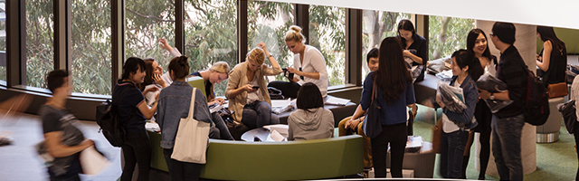

Please fill details below.

Please note: All fields are mandatory and must be completed.
If you have any difficulty completing this form, contact india.info@sydney.edu.au

Student details
First Name
Last Name
Age (in years)
Email id
Phone number
Mentor teacher (optional)
Full name

School name
School address
(Include street, suburb, state and postcode)
School phone number
School email ID
School website address

- NAME OF THE PROJECT
>> Limit of words: 10

- YOUR PROJECT DESCRIPTION
>> Limit of words: 350

- WHICH SUSTAINABLE DEVELOPMENT GOAL (SDG) YOUR INITIATIVE HAS THE MOST IMPACT ON?
(Tick the right answer )
GOAL 1: No Poverty

GOAL 2: Zero Hunger

GOAL 3: Good Health and Well-being

GOAL 4: Quality Education

GOAL 5: Gender Equality
GOAL 6: Clean Water and Sanitation

GOAL 7: Affordable and Clean Energy

GOAL 8: Decent Work and Economic Growth

GOAL 9: Industry, Innovation and Infrastructure

GOAL 10: Reduced Inequality

GOAL 11: Sustainable Cities and Communities

GOAL 12: Responsible Consumption and Production

GOAL 13: Climate Action

GOAL 14: Life Below Water

GOAL 15: Life on Land

GOAL 16: Peace and Justice Strong Institutions

GOAL 17: Partnerships to achieve the Goal

- WHICH PROBLEM DO YOU SOLVE WITH YOUR PROJECT?
Describe the problem that your project/ solution is solving.
Give the jury a summary of what issue your project solves, which issue it addresses and why it makes an impact.
>> Limit of words: 350

- HOW DO YOU SOLVE THE DESCRIBED PROBLEM? *
- Describe what your project achieves/aims and provide details on how it works.
- Who is targeted/impacted by the project?
- Please provide in this field comprehensive, detailed information about your project.
- Please summarise the important aspects of your project. It should give the jurors an overview about your project
- Please be precise and on point and give a solid impression on your project.
>> Limit of words: 350

- WHY SHOULD YOUR PROJECT BE SELECTED AS A WINNER?
Explain why is your project outstanding.
>> Limit of words: 350

- PLEASE PROVIDE YOUR PROJECT YOUTUBE VIDEO LINK.
Upload your video to YouTube and provide the video link in the box below.

VIDEO UPLOADING GUIDELINES
- To upload videos to YouTube from a computer or mobile device, you should follow the instructions in this link: https://support.google.com/youtube/answer/57407?hl=en&ref_topic=9257439
- General video making guidelines
  - Clarity of messaging: Your video should clearly state and explain the project’s relevance to the chosen UN SDGs.
  - Articulate a plan of action or solution for achieving the SDG.
  - Make a strong, engaging visual impact that leaves the viewer with a good understanding of the project, make it memorable, motivational and inspirational.
  - Lastly, present the message with creativity and originality.

