Waverley Council Shark Survey
A project of the Sydney Environment Institute

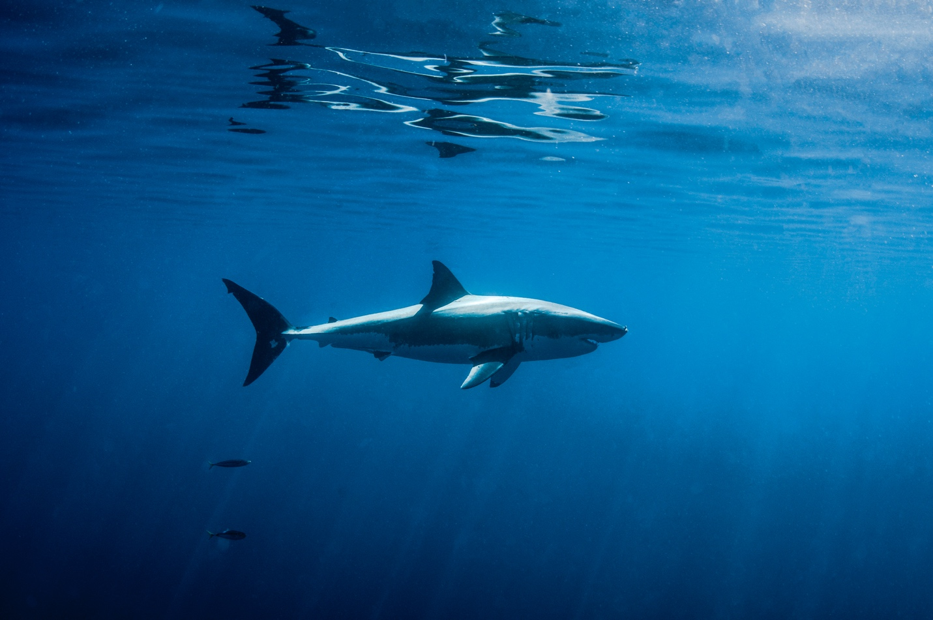

Author
Dr. Chris Pepin-Neff
University of Sydney
Waverley Council Shark Survey 29 March 2023
Executive Summary
Introduction
Today, a survey of 500 residents from Waverley Council in Sydney, Australia was released regarding public attitudes towards sharks, shark nets, and shark bite mitigation. This survey is one of the largest beach community surveys of the Bondi beach and surrounding area to ever be conducted on the issue of sharks. We find that 70% of Waverley respondents would not blame the government in NSW if shark nets were to be removed and there was a shark attack. This is the first time this question has ever been asked.
The Waverley Council Shark Survey is similar to surveys that the University of Sydney has conducted to improve beach safety and public education following shark bites in Perth/Mindarie/Mandurah (n=600) in 2016, Ballina (n=500) in 2015 and Cape Town (n=100) in 2012, as well as at Sydney Aquarium (n=500) in 2017. The full results and comparison data are included in this summary. This survey was developed through principal funding from the Sydney Environment Institute (SEI) at the University of Sydney.
This project aims to devise long-term public education tools and policy options to investigate how Australians’ attitudes and views regarding sharks can address public safety measures and public policy. Specifically, we are looking to analyse how public education can facilitate the coexistence, public safety, and conservation of sharks in Australian waters.
Results
The Waverley Council Shark Survey results show a beach community that has turned the page on shark nets. The survey shows the most active water-usage of any community survey in this study, with 56% of the people who responded to the survey (i.e., respondents) go into the ocean at least once a week. In addition, 59% of Waverley respondents think the phrase “shark attack” is too sensationalized by the media and 44% believe the primary purpose of lethal responses to shark attacks are to “calm the public” – a result in line with Ballina (47%) and Perth (53%).
Highlights from the Waverley Shark Survey include the following:
- 70% (1-5) would not blame the state Government if shark nets were taken out and there was a fatal shark attack at that beach;
- 75% (6-10) would return to the beach if shark nets were taken out;
- 71% believe shark attacks are accidental;
- 71% believe “no one” is to blame for shark attacks; and
- 7% support putting in shark nets following a shark attack.

Figure 1. Question #8: How likely are you to blame the NSW Government if they take out shark nets and there is a fatal shark attack at that beach?

Figure 2. Question #7: How likely are you to return to the beach if shark nets are taken out of the water?

Figure 3: Question #5: When shark attacks occur, [what] do you think that it is?

Figure #4: Question #10: Who do you think is to blame when sharks attack people?

Methods
An approval letter from Human Ethics at the University of Sydney was received on Friday March 17, 2023. TKW Research was then commissioned to administer a phone survey of individuals (n=500) 18-65+years of age between March 20-27, 2023. Calls were restricted to the post codes of Waverly Council. The phrase “shark attack” was intentionally used to prime more negative responses. Questions were modelled off the Perth, WA surveys in 2016 and Ballina, NSW in 2015. Importantly, those surveys were conducted following shark bite incidents, which was not the case in Waverley. However, the data appears consistent and comparable across the regions.
Background: Shark Nets
According to the New South Wales Department of Primary Industries, “the NSW Government’s Shark Meshing (Bather Protection) Program includes 51 beaches between Newcastle and Wollongong.” The nets were installed at beaches starting in 1937. Shark nets have been a controversial policy response to shark bites since the idea was initiated in 1935 (Neff, 2012). More recently, a 2021 DPI survey of preferred shark mitigation measures of NSW coastal councils and their communities found that among shark bite mitigation measures in NSW, “the most preferred measure was Drones, followed by Research and Personal shark deterrents. The least preferred was shark mesh nets.”
In addition, the effectiveness of shark nets has been called into question by the NSW Fisheries Scientific Committee, which stated, “approximately 40% of shark entanglements occur on the beach side of the nets, because sharks are able to swim over and around the nets.”
Acknowledgements
The author would like to thank Dr. Thomas Wynter who assisted with data collection and analysis in Ballina in 2015 and Perth in 2016.
Questions
Any questions regarding the survey can be directed to Chief Investigator Dr. Chris Pepin-Neff at chris.pepin-neff@sydney.edu.au
Comparative Results
Question | Waverley 2023 | Ballina 2015 | Perth 2016
Age
18-24 | 3% | 4% | 6%
25-34 | 7% | 5% | 14%
35-44 | 16% | 16% | 19%
45-54 | 27% | 22% | 22%
55-64 | 24% | 22% | 16%
65+ | 23% | 31% | 24%
Gender | Waverley 2023 | Ballina 2015 | Perth 2016
Male | 48% | 49% | 47%
Female | 51% | 51% | 53%
Gender X | 1%
How often do you go in the ocean? | Waverley 2023 | Ballina 2015 | Perth 2016
Never | 9% | 19% | 28%
Less than once a month | 15% | 21% | 35%
Once a month | 11% | 12% | 14%
Twice a month | 9% | 9% | 10%
Once a week | 15% | 15% | 6%
Twice a week | 23% | 16% | 6%
Daily | 18% | 8% | 2%
When sharks attack is it? | Waverley 2023 | Ballina 2015 | Perth 2016
Intentional | 19% | 21% | 22%
Accidental | 71% | 55% | 52%
Not Sure | 9% | 24% | 26%
How frightened are you of sharks? | Waverley 2023 | Ballina 2015 | Perth 2016
Not frightened at all - 1 | 18% | 14% | 13%
2 | 12% | 6% | 7%
3 | 13% | 6% | 7%
4 | 5% | 5% | 4%
5 | 14% | 16% | 14%
6 | 5% | 4% | 4%
7 | 8% | 8% | 8%
8 | 7% | 10% | 8%
9 | 3% | 5% | 5%
Extremely Frightened - 10 | 15% | 23% | 29%
Return to the beach without shark nets | Waverley 2023
1 – Not Likely | 12%
2 | 2%
3 | 3%
4 | 3%
5 | 7%
6 | 4%
7 | 5%
8 | 8%
9 | 3%
10 – Extremely Likely | 55%
Blame NSW Govt if there is a shark attack at a beach after nets removed | Waverley 2023
1 – Not likely | 48%
2 | 5%
3 | 6%
4 | 3%
5 | 8%
6 | 3%
7 | 5%
8 | 5%
9 | 2%
10 – Extremely likely | 15%
Who is to blame for shark attacks | Waverley 2023 | Ballina 2015 | Perth 2016
Sharks | 6% | 8% | 7%
Swimmer | 14% | 23% | 28%
Government | 3% | 4% | 4%
No one | 71% | 63% | 59%
Not sure | 6% | 2% | 1%
How much pride in local sharks | Waverley 2023 | Ballina 2015 | Perth 2016
1 - No pride | 14% | 11% | 15%
2 | 4% | 3% | 3%
3 | 5% | 3% | 4%
4 | 2% | 3% | 3%
5 | 20% | 22% | 21%
6 | 5% | 4% | 6%
7 | 9% | 7% | 9%
8 | 10% | 13% | 14%
9 | 4% | 6% | 3%
10 - A lot of pride | 27% | 23% | 16%
Don't know | 0% | 4% | 6%
How should GOVT respond? | Waverley 2023 | Ballina 2015 | Perth 2016
Put in shark nets | 7% | 10% | 11%
Educate the public | 25% | 22% | 14%
Hunt the shark | 3% | 3% | 5%
Leave the shark alone | 6% | 6% | 8%
Invest in new non-lethal tech | 36% | 23% | 28%
Put in baited drum lines | 2% | 2% | 6%
Conduct more research | 17% | 33% | 25%
Shark attack too sensational | Waverley 2023 | Ballina 2015 | Perth 2016
Agree | 59% | 66% | 67%
Disagree | 35% | 32% | 32%
Not sure | 6% | 2% | 1%
Main purpose of lethal response | Waverley 2023 | Ballina 2015 | Perth 2016
To protect the public | 27% | 23% | 25%
to calm the public | 47% | 45% | 53%
to help tourism | 12% | 27% | 19%
not sure | 13% | 5% | 3%

