Conference: Children, Migration and the Right to Health
Thursday 24th—Friday 25th of July

- Welcome to Country Allan Murray, Board Member, Metropolitan Local Aboriginal Land Council.
  - Talked about diversity of indigenous people, welcoming migrants and called on participants to read the ‘Uluru Statement from the Heart’.

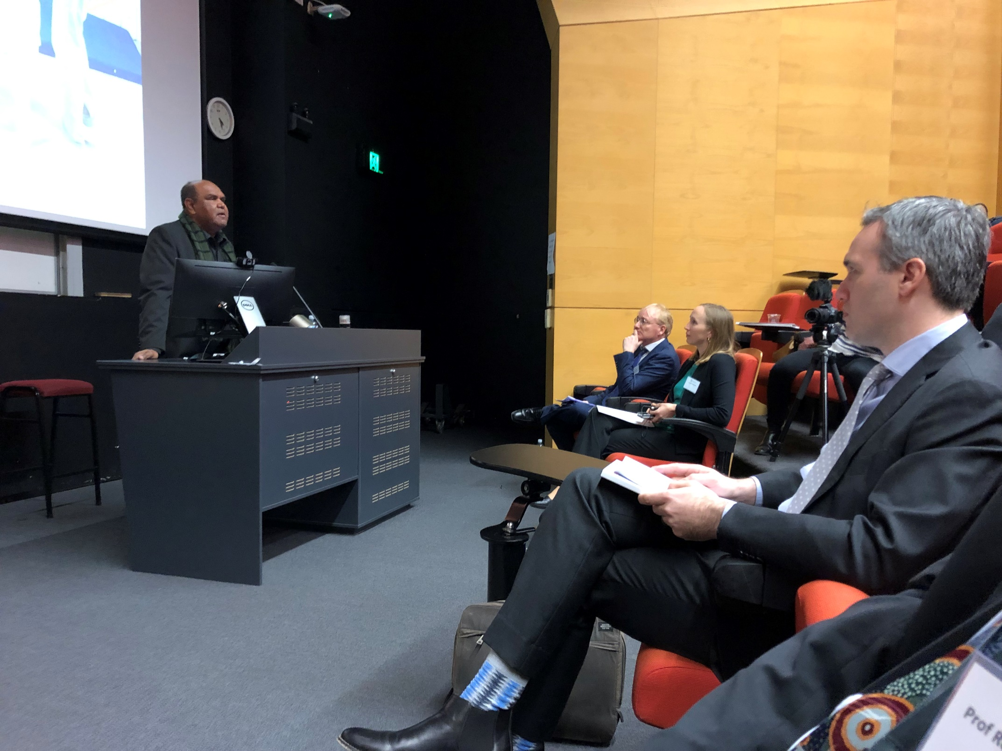
- Opening, Professor Simon Bronitt, Head of School and Dean of the University of Sydney Law School.

Plenary Session 1— Frameworks and Challenges

- Introductory remarks by Zaki Haidari: Reflections on childhood as an asylum seeker and refugee.
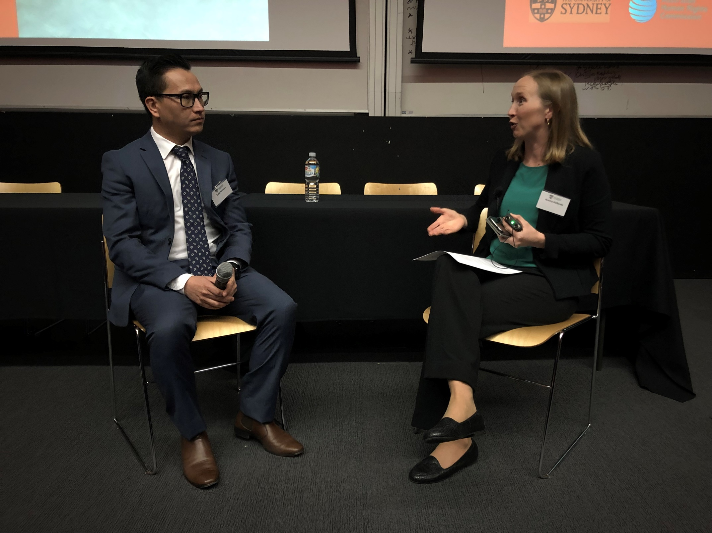

- Chair: Jemma Hollonds, Senior Solicitor, Refugee Advice and Casework
  - Human impacts of law and policy
  - Commented on generational breaks in education in Afghanistan due to persecution and the challenges in accessing education when seeking asylum commented on the November, 2012 policy changes that those who came after August, 2012 who came by boat wouldn’t be able to achieve PR status which meant no access to education.
  - His ID card showing he was 17 was not believed and was subsequently ‘forced’ to be found as an over 18-year-old. He had no option but to accept, thinking of potential consequences, (in that he could have been transferred to Nauru/Manus Island). He was released to the mainland on a bridging visa but this meant he lived in a detention centre with a man who was 10-15 years older than him.
  - He was not able to speak publicly about his position (like so many who don’t speak out) for fear of jeopardizing the visa.
  - Came into the community with no English and describes the situation as one where his rights were ‘taken away from me’.
  - Zaki correlated the fear and uncertainty here in Australia with the dangers he experienced and witnessed in Afghanistan.
  - The limbo created by Zaki’s bridging visa expiring every 6 months, leads to the real-time fear that he would be taken by the Department who he told the room, do take people on this transition night of a visa being granted.
  - Zaki relayed the worst elements of family separation whilst his family are in a warzone, as he is on a temporary visa and can’t bring the family here; nor can he visit them.
  - He described this situation as if his family were behind a mirror where he could see them in flames and fire but couldn’t go to help them; couldn’t reach them.
  - Taking this risk was not his decision, his mum who lost husband and brother, feared he was next and had to send him away. But to bring his family, Zaki said he needed to be a citizen which the current policy prevents. He sees no foreseeable future of being with his family.

- Keynote Address: Edward Santow, Australian Human Rights Commissioner,

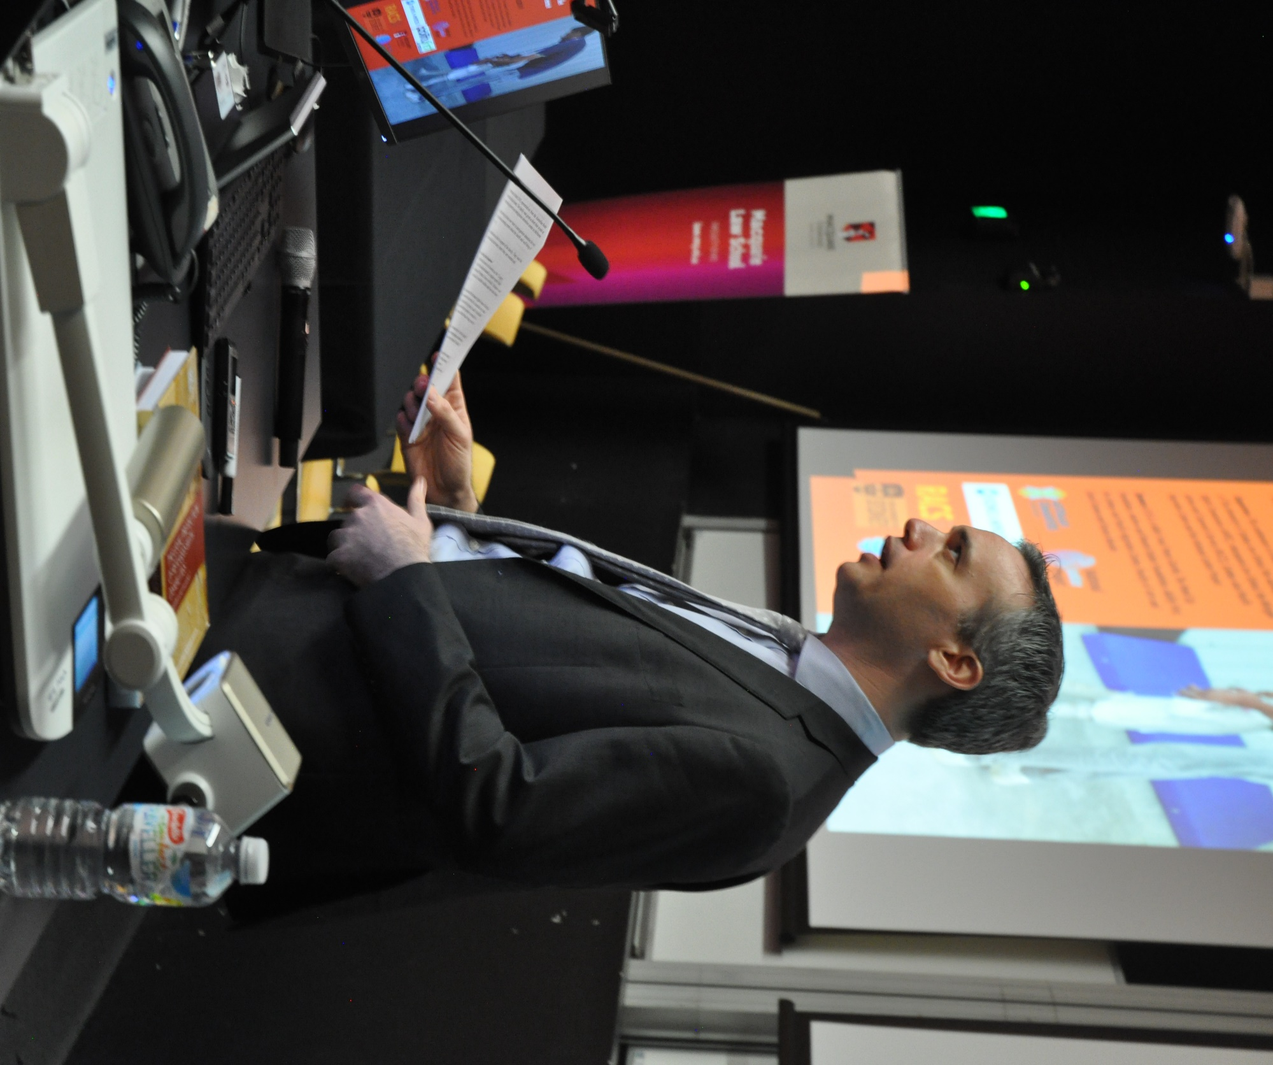

‘Asylum seeker children and their families: Lives on Hold’.
  - Commented on the theme of migration and our presence on Aboriginal land, and how Aboriginal culture is embracing of multiculturalism such as by having over 500 language groups.
  - Introduced the Legacy Caseload report, by telling a true story from the legacy caseload of a couple who had each arrived by boat and had two children born in Australia. Although they had been in living in Australia for 6 years, the whole family had a temporary legal status. They were given a short period of time to leave and were then placed in immigration detention for one year. The town protested to bring them back and eventually they were allowed back into the community.
  - Referring to arrivals prior to 1st of January 2014, many remain on mainland Australia rather than on Manus Island or Nauru.
  - There is a fundamental problem in their waiting 5 years or more for long term protection.
  - From the Legacy Caseload, there are two main groups:
    - Half had their protection claims accepted and are living in Australia only on 3-year Temporary Protection Visas (‘TPVs’), or 5-year safe haven protection visas (‘SHEV’) (neither visa provides long-term protection). These people must reapply every time their visa is expiring.
    - The second group are still awaiting final determination regarding their legal claim to protection.
    - 7,000 have had no processing of their claims and others are waiting judicial and merits review processes.
    - According to International Law, the Australian government must protect their basic human rights whilst in processing, to assist those at risk of destitution or homelessness.
  - SRSS-Status Resolution Support Services –provides assistance to asylum seekers whilst claims are assessed, to find work and financial assistance.
    - However, income support is withdrawn as employment is gained (including across the board single parents etc.)
  - Some people are not permitted to work or have access to healthcare.
  - To have an adequate amount for a family to live, $997 is the ‘recommended lowest amount for a family’.
    - For a comparison of those on assistance to the Newstart financial assistance, approximately $800 per week.
    - SRSS is approximately $700 per week.
  - Prevalent to those people in the legacy caseload is that they are caught in a holding pattern marked by prolonged delays and uncertainty leading to a precarious state that induces silence and a high risk of suicide.
  - The report charts the group experiences in this caseload and provides:
    - 31 practical recommendations to government to change law and policy to improve human rights.
    - Those in the community need basic needs and to live in dignity, ensuring they have access to healthcare and secure housing.
    - This requires not just expediting processing but maintaining thorough procedures for people in this group to avoid prolonged separation for these people.
  - The Australian Human Rights Commission has been long-opposed to TPVs, a significant part of the government’s agenda, to alleviate suffering and prevent the deterioration of health. Another repercussion of these visas is that the victims of family violence and conflict, aren’t able to go to authorities where they are dependents on visas, due to fear of jeopardising their visa status.
  - The Immigration Assessment Authority (‘IAA’), limits asylum seeker’s ability to make claims, particularly vulnerable children and women who experience violence. Under the fast track process they mightn’t have other opportunities to make a claim.
  - Administrative Appeals Tribunal (‘AAT’) agreed with the original decision maker in 20% of cases for those who arrived.
  - The IAA now agrees with 86% of cases.
  - Included a personal story of a migrant background and how migrants contribute to Australian society.
  - Finishing remarks were about how Australia used to be world leading in policy for refugees and asylum seekers.
  - The question left remaining is: ‘Will they feel like they belong’.
  - Australia benefits from these migrants as they “will be good for Australia”.

- Professor Mary Crock, Sydney Law School,

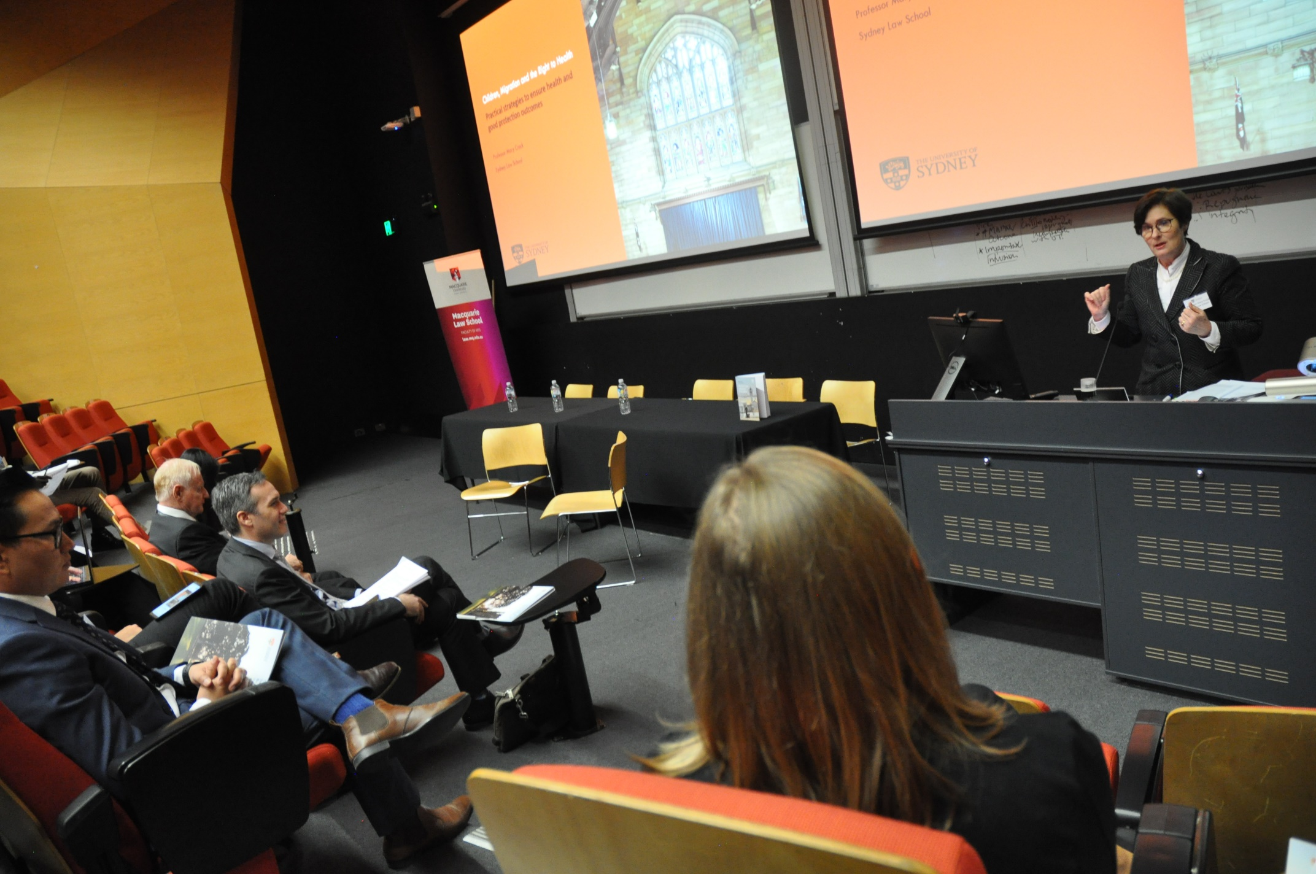

‘The ‘best interests’ of migrant children: Devising practical strategies to ensure health and good protection outcomes’.
  - Discussing practical Strategies to ensure health and good protection outcomes.
  - Health is the first thing to suffer where they ‘don’t know you’re a child or don’t care if you’re a child’.
  - Promoting a capabilities approach to human rights, functionality and functioning (emotional happiness, self-respect, social and political participation).
  - Capabilities (need to look at lived experience – not going to achieve rights, unless look at capabilities).
  - Convention on the Rights of the Child (‘CRC’)- most subscribed to Convention, and since 2014, individuals have been able to make complaints to the CRC Committee.
  - CRC shifted the rights framework to a capabilities approach: children were acknowledged as autonomous rights bearers.
  - Art 12 – ICESCR outlines their right to participate in decision making and regarding their health.
  - Discussed Professor John Tobin’s research and writing on the rights of the child, that indicates children in position of war or humanitarian disasters have positive rights.
  - Disability
  - Commented on children with disabilities and a child’s right to be informed and have a say in decisions affecting their lives.
  - Definition in the Convention on the Rights of Persons with Disabilities (‘CRPD’) –of disability as a failure to accommodate for an impairment and this for the first time included, not just regarding armed conflict, but also humanitarian disasters.
  - Capabilities approach (don’t expect people to tell you directly about issues/disabilities).
    - 1. Seeing the migrant child
    - 2004 cohort unaccompanied minors.
    - There is no obligation to make separate asylum claims (babies often get ignored/forgotten).
      - Applicant A v MIMA (1997): The High Court held parents giving birth in contravention of China’s One Child policy were not refugees. Nobody thought to ask about the baby until heavily pregnant woman was sent back to China where baby was forcibly aborted.
      - Chen Shi Hai v MIMA (2000): The High Court held that the ‘black children’ belong to an appropriate social group that should be protected as refugees.
    - 2. Hearing the migrant child
    - When should children be considered as separate applicants (as opposed to ‘secondary’ applicants attached to the claims of parents or carers)?
    - 3. Substantive care
    - Risk factors
      - Detention
      - Lethal hopelessness
    - Services
    - Expertise
  - Concluded by saying that we weed service providers and lawyers to perform impact litigation.

Plenary Session 2—Children on the move as forced migrants

- Chair: Professor Jennifer Burn, University of Technology Sydney and Interim NSW Anti-Slavery Commissioner.
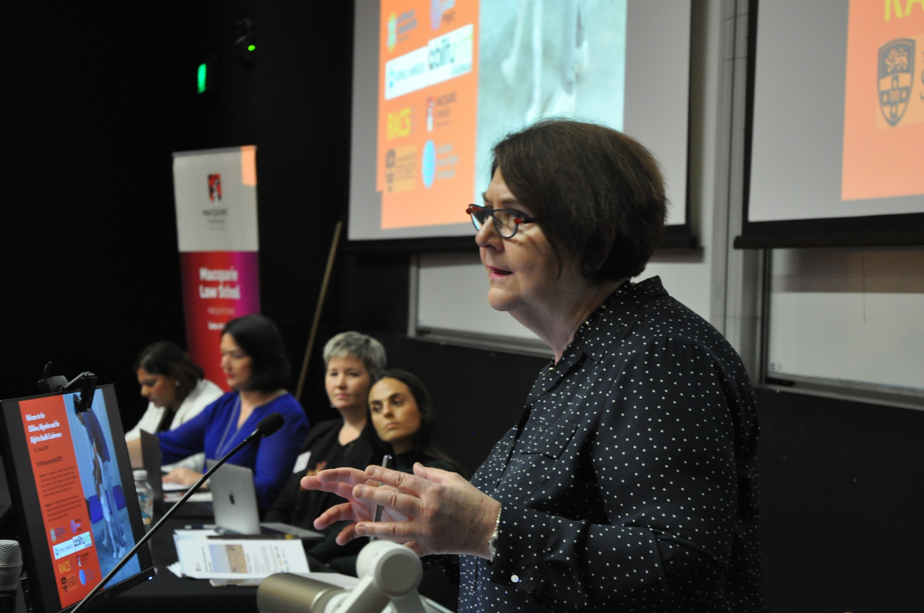
  - Delved into Modern Slavery legislation (NSW) to address the global epidemic of modern slavery, the Act is in many ways a “Human Rights instrument” incorporating: human trafficking, debt bondage, forced marriage, commercial or personal gain, bonded labour, sexual exploitation and forced labour.
  - Those who have experienced slavery often suffer from mental health disorders and have a disrupted education.
  - This Act demonstrates the NSW government recognises the need to reduce the risks of our country being complicit in crimes of modern slavery and is much broader in identification and protection.
  - The scope of reporting in the NSW Act covers government procurement in that every single government agency needs to identify risks of modern slavery in supply chains; a significant measure. This will make a difference to cross-government agencies and provide oversight of supply chain reporting and government procurement.
  - Commented on deaths from ‘exploitation caused by trafficking’, slavery being the utmost rejection of human rights.
  - ‘Everyone of us has a role to play in ending modern slavery’.

- Arezo Malakooti, Senior Expert in Migration, Global Initiative against Transnational Organised Crime, ‘Global movements of children travelling as forced migrants’.
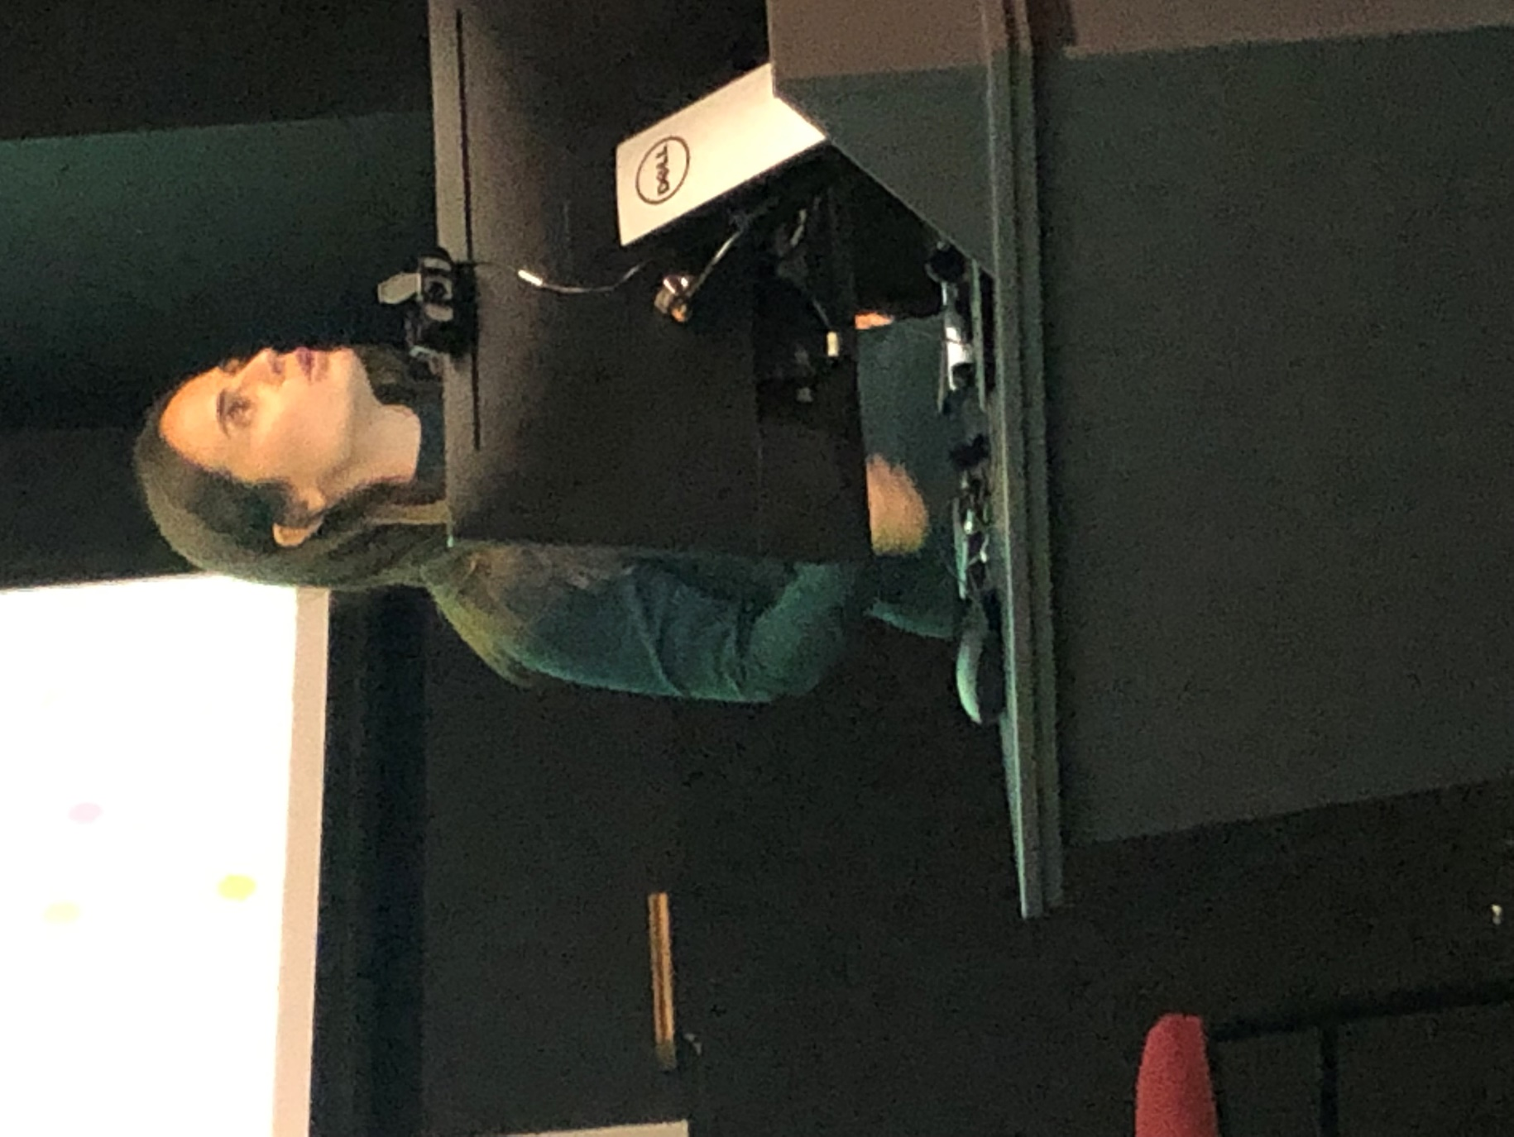
  - Why are children on the move?
  - Over half world’s refugees are children.
  - Fleeing alone or with family or as the goal setter, where family then come over after child establishes a base and initiates family reunification.
  - Some children are sent to work, or separated along the way.
  - It is common they are seeking a brighter future or fleeing persecution and conflict.
  - There are ‘push & pull’ factors where the home is unbearable, and a pull to seek potentially a brighter future.
  - Syrian refugees: Jordan is often the first nearby country to begin the move where secondary movements are to Europe seeking long-term naturalisation.
  - In 2015, 31,000,000 were migrating with a growth rate of 2% from 2010- 2015. There was a slightly higher growth rate for children.
  - Children account for 31% of the global population, thus they are overrepresented in refugee statistics.
  - Ms Malakooti then discussed different definitions between unaccompanied and separated children, noting that most children attempt an internal migration first as Internally Displaced Persons (‘IDPs’).
  - In 2015, 41 million were Internationally Displaced, UNICEF counted that 17 million, 41% were children.
  - Children will do the journey in steps, they will work during some stages, for example, to pay a smuggler, which incurs greater risks because of the different promises made by smugglers in different parts.

- Dr Kate Van Dore, Griffith Law School, ‘Migrant or trafficked? Children on the move to access opportunity’, Securing the rights of children in supply chains.
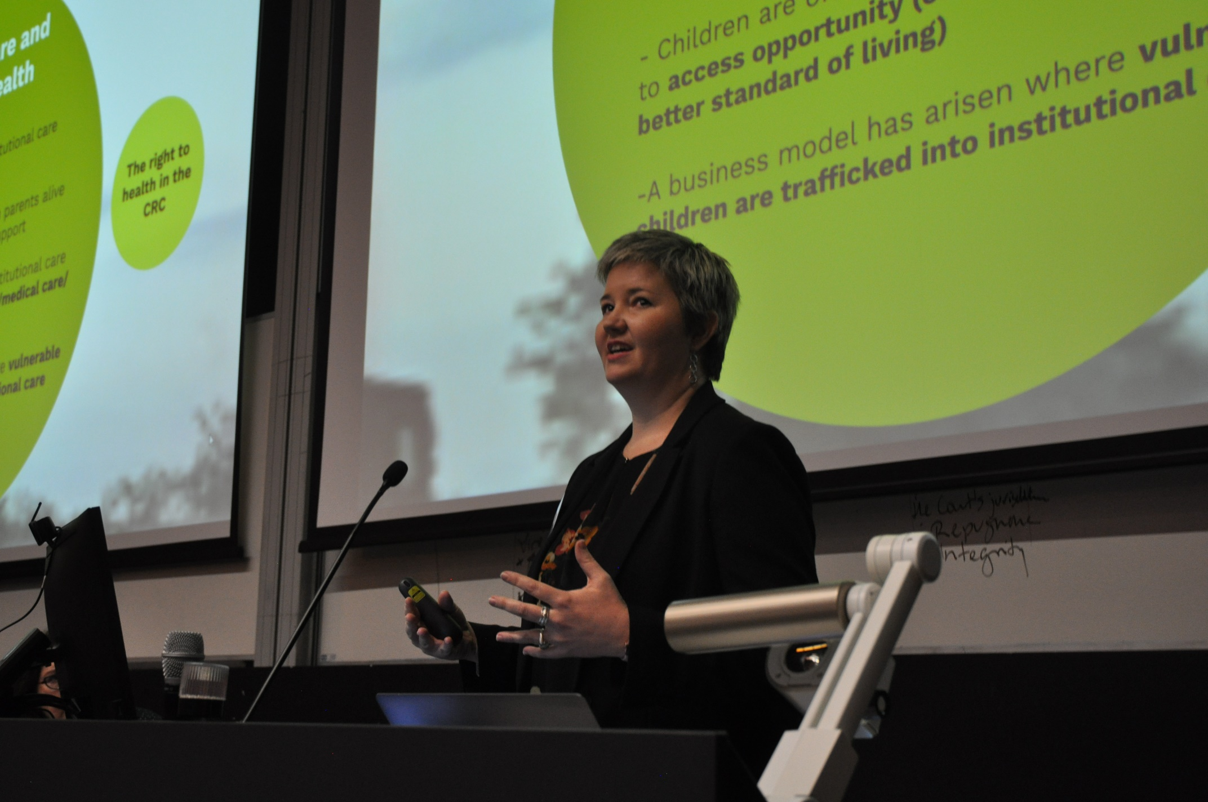
  - Orphanage trafficking provisions require Australia’s legislative response.
  - Overall presentation focused on how children can be sold into an orphanage where the organisation gains access to foreign funding.
  - To fundraise money there is a perpetuating issue where children are kept in a poor and unhealthy state, to attract the funding. The poorer the orphans may look, the more funding attributed to their organisation.
  - She referenced the reliance on foreign funding as problematic and the cycle of institutional care and the cycle of institutionalisation.
  - Described the epidemic of: ‘paper orphans’ – where children’s parents’ deaths were faked on paper, and children are given a fake birth certificate to fit an orphan status.
  - Commented that the propagation of ‘orphanages in tourist hot-spots’ ‘doesn’t correlate with the demand of’ hardship in those areas.
  - Referenced, Right to health – Art 24(1).
  - When people place children into orphanages they are more likely to face violence, be sexually abused, result in higher rates of incarceration, and suicide.
  - Australia was the first country to recognise children held in these orphanages is modern slavery.
  - The Modern Slavery Act, leads to new policy in Federal Education and DFAT launched its smart volunteer campaign.
  - Kate referred to her personal realisation of having co-founded and orphanage where the children that were taken in were not actually orphans. Endeavoured to find and re-locate families to return the children.
  - A subsequent issue is that new orphanages who realise they are in the trafficking system, still don’t reach out to connect back to family.
  - The right to family life is critical and institutional care doesn’t provide this.
  - UN Convention on the Rights of the Child Resolution, 2019.
    - In September: looked at issue of children without parental care and what should happen to children on the move.
  - Drew to a close by referencing the golden thread in that when a child is returned to a family, it is as if gold is laid at their family’s feet.

- Sarah Morse, Unchained Business Services, ‘An introduction to Australia’s modern
slavery laws’.
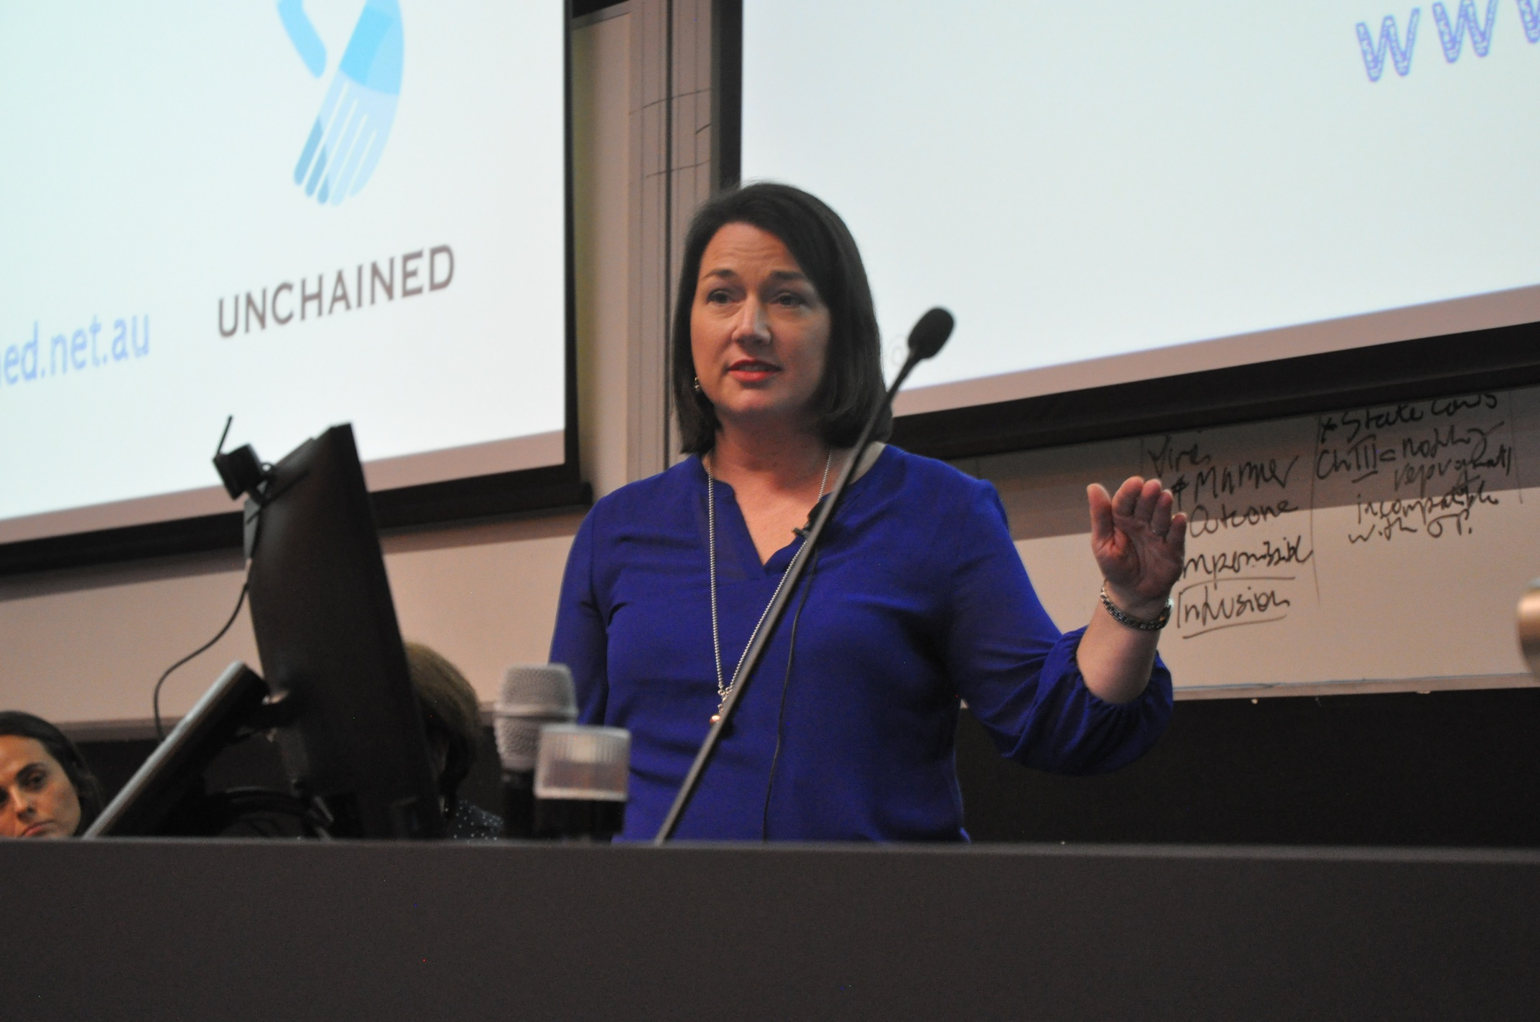

  - 40 million currently living in Modern Slavery worldwide.
  - 72% women/children are trafficked.
  - 15,000 people are currently living in modern slavery in Australia’s agricultural, construction, hospitality and sex industries; a $150 billion dollar industry.
  - Despite slavery having been ‘abolished’ 150+ years ago; there is more slavery today than ever before.
  - Two-thirds of these slaves live in the Asia-Pacific region where people inadvertently benefit from modern slavery produced goods: Technology, Clothes, in part directed by where companies invest.
  - The Modern Slavery Act is a culture changer.
  - Remarked about an orphanage in Romania where children had been trafficked and that trafficking also occurs in Australia where victims are ‘hidden in plain sight’. It often occurs where there are promises of work, and their passports are taken.
  - These traffickers are: organised, ruthless, collaborative, creative, entrepreneurial, well-funded – we need to be the same, we need to be like the traffickers.
  - Ethical purchasing – is a major part of the solution. The End slavery model is useful:
    - E – Explore the issues in supply chains.
    - N – Navigate the risk.
    - D – Determine action.
  - A productive example experienced by Qantas was provided: where potential issues were identified for Malaysian baggage handlers, in navigating this risk in Malaysia Qantas allocated more protections on the ground to navigate risks and source options resulting in determinative action.
  - Also recommended: Good on You app, Good Fashion Guide.

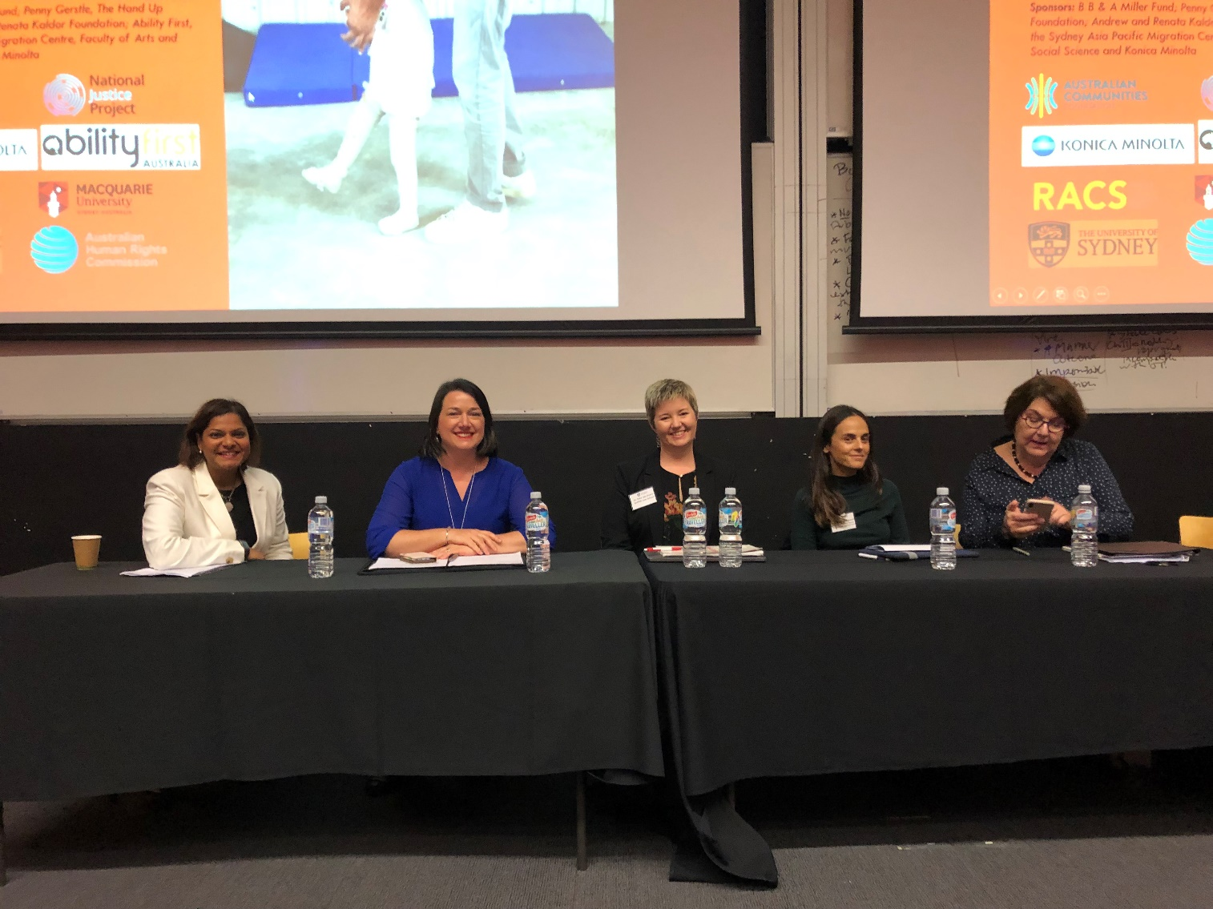
- Nicole D’Souza, Ethical Sourcing Manager, Konica Minolta Australia.

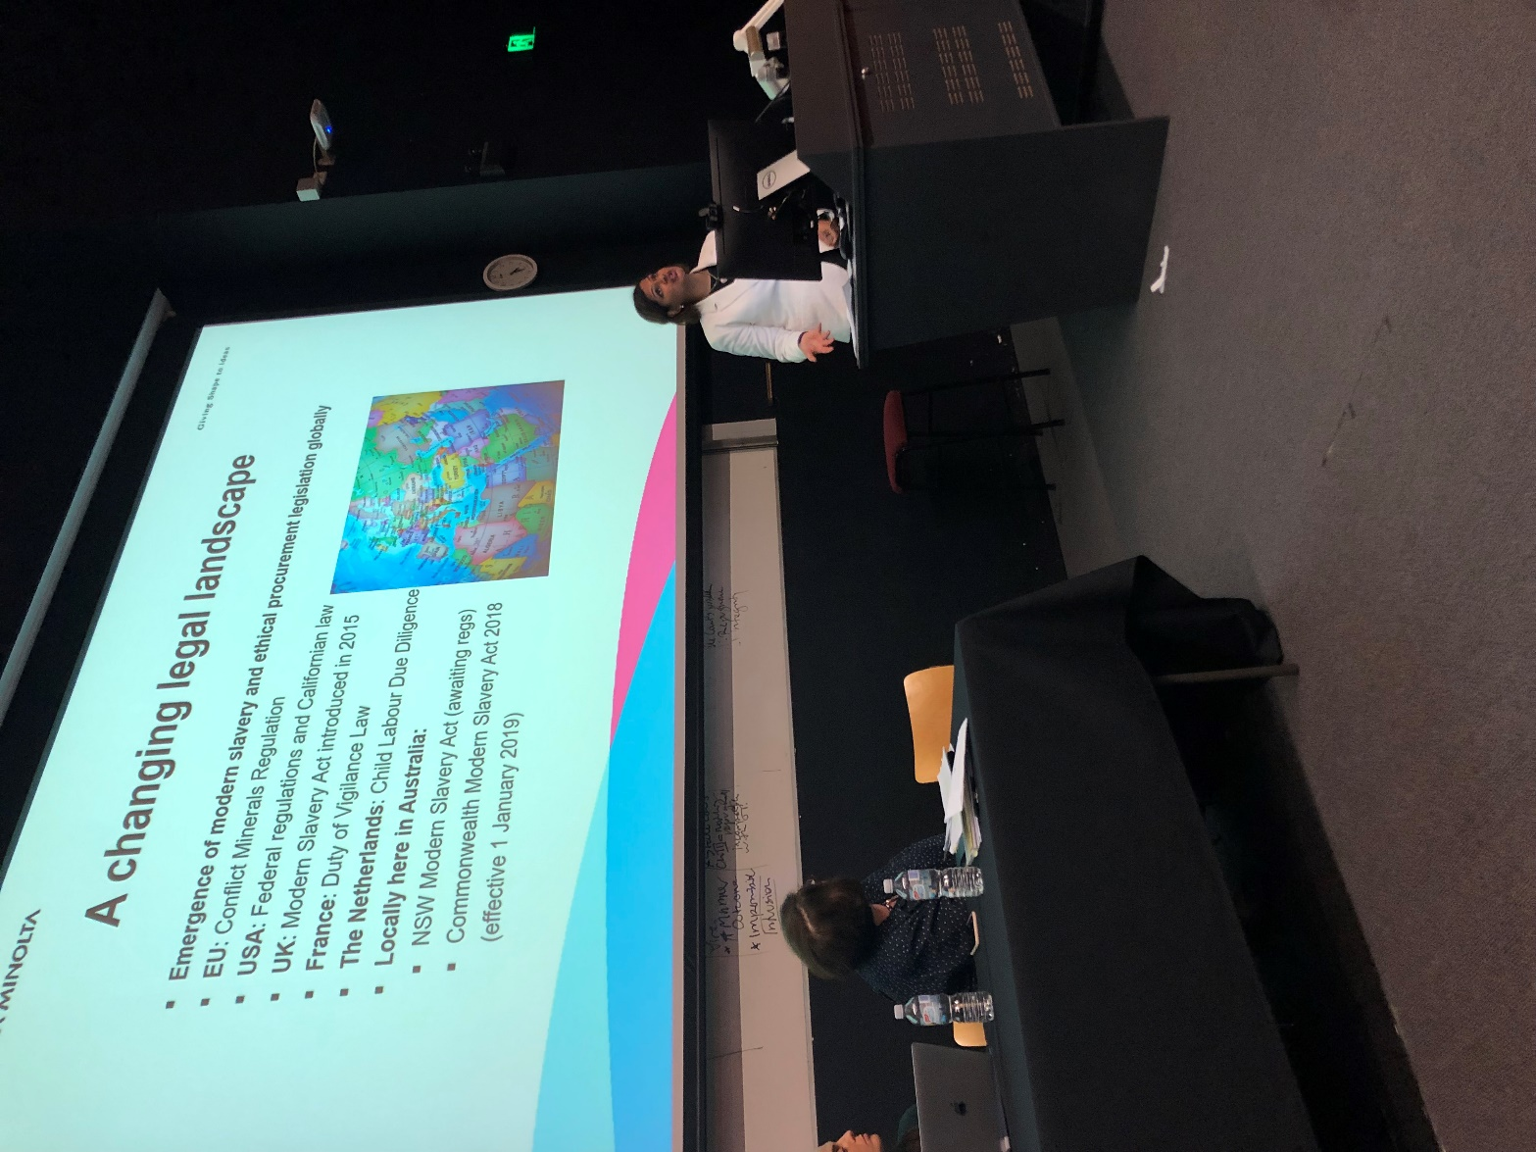
  - Shared reflections on human rights practice and how to build collaboration and partnerships.
  - Hazardous work performed by children in child labour violates their right to mental and physical health.
  - Konica Minolta is a global business with a global business plan that is aligned to the Sustainable Development Goals (‘SDGs’).
  - Dr David Cook, Director in Australia initiated and brought this focus to the fore for the Australian branch.
  - Konica Minolta produced a human rights position statement on labour rights and an ethical sourcing roadmap in an attempt to adopt ILO standards and the United Nations Guiding Principles on Business and Human Rights, the “Respect, Protect & Remedy” Framework.
  - The reality of businesses is difficult and a complex process of supply chains with a collaborative effort needed.
  - Gave international examples of progressive steps:
    - Dutch government’s child labour due diligence legislation.
    - The definition in the Commonwealth’s Modern Slavery legislation of “the worst forms of child labour”.
  - Human rights due diligence requires identifying and addressing human rights impacts including assessments of internal procedures and systems.
  - As an example, to promote and encourage the ethical sourcing in industries, Sedex, empowers responsible supply chains to address risks of exploitation.
  - Another example of organisation assisting supply chain transparency: FRDM, where 5-10% of a company’s subscription directly supports children victims of child labour.
  - The Global Compact Network of Australia (‘GCNA’) also encourages a business community of good practice.
- Breakout Session 1— (1.) Guidelines intensive
- Jemma Hollonds, RACS
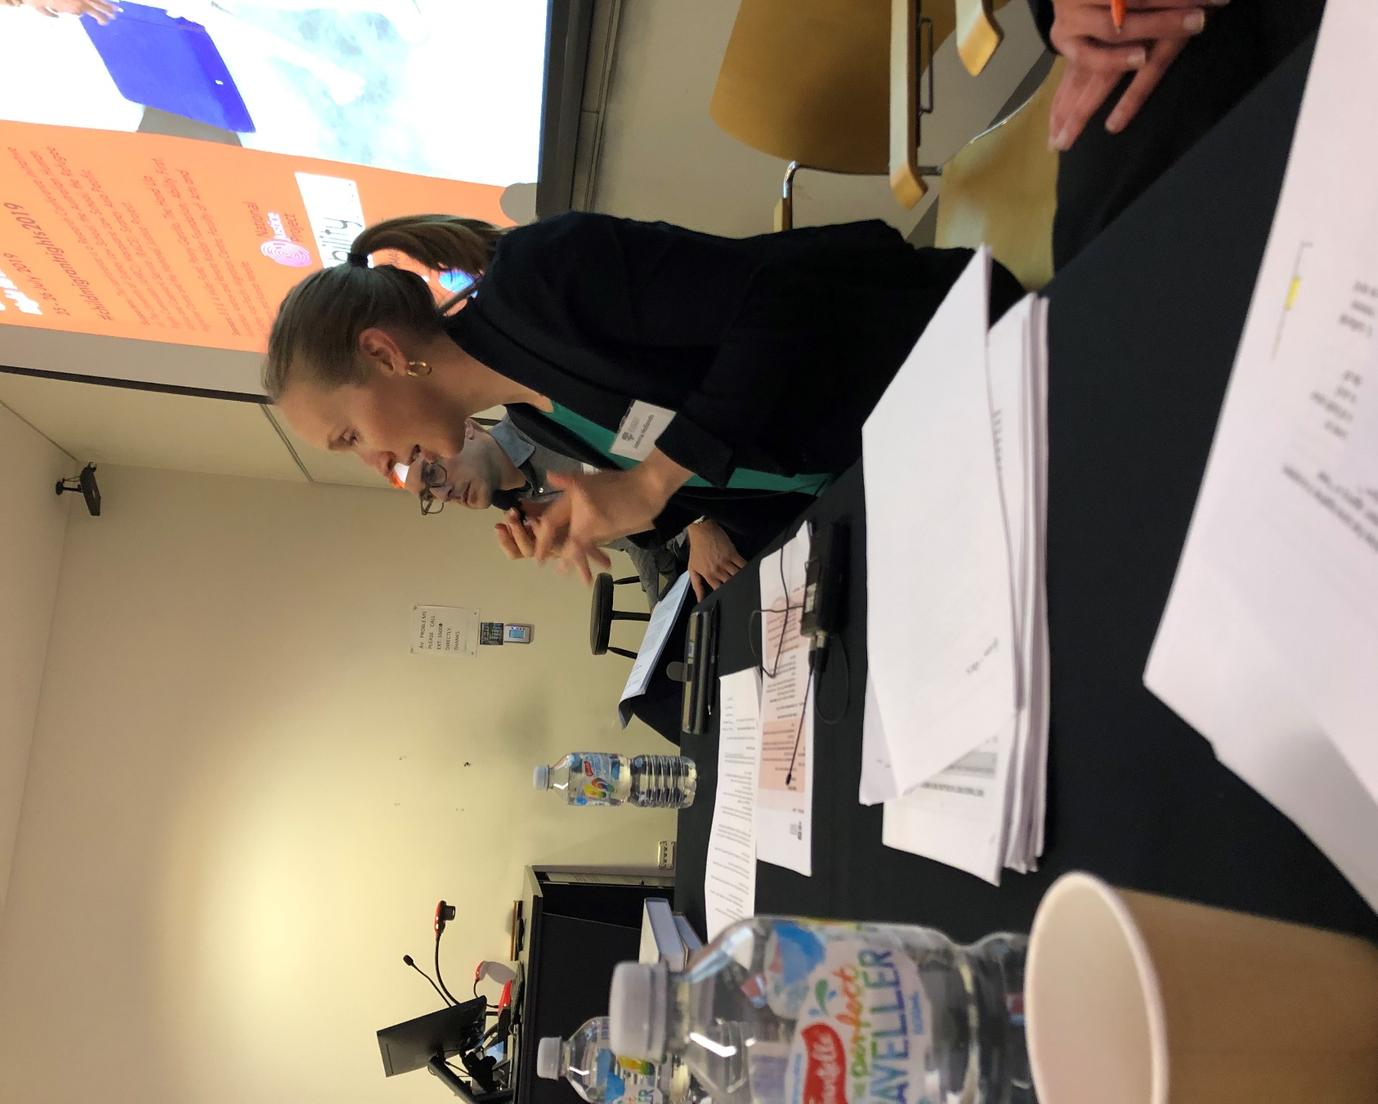

Sabrineh Ardalan Harvard Immigration Clinic
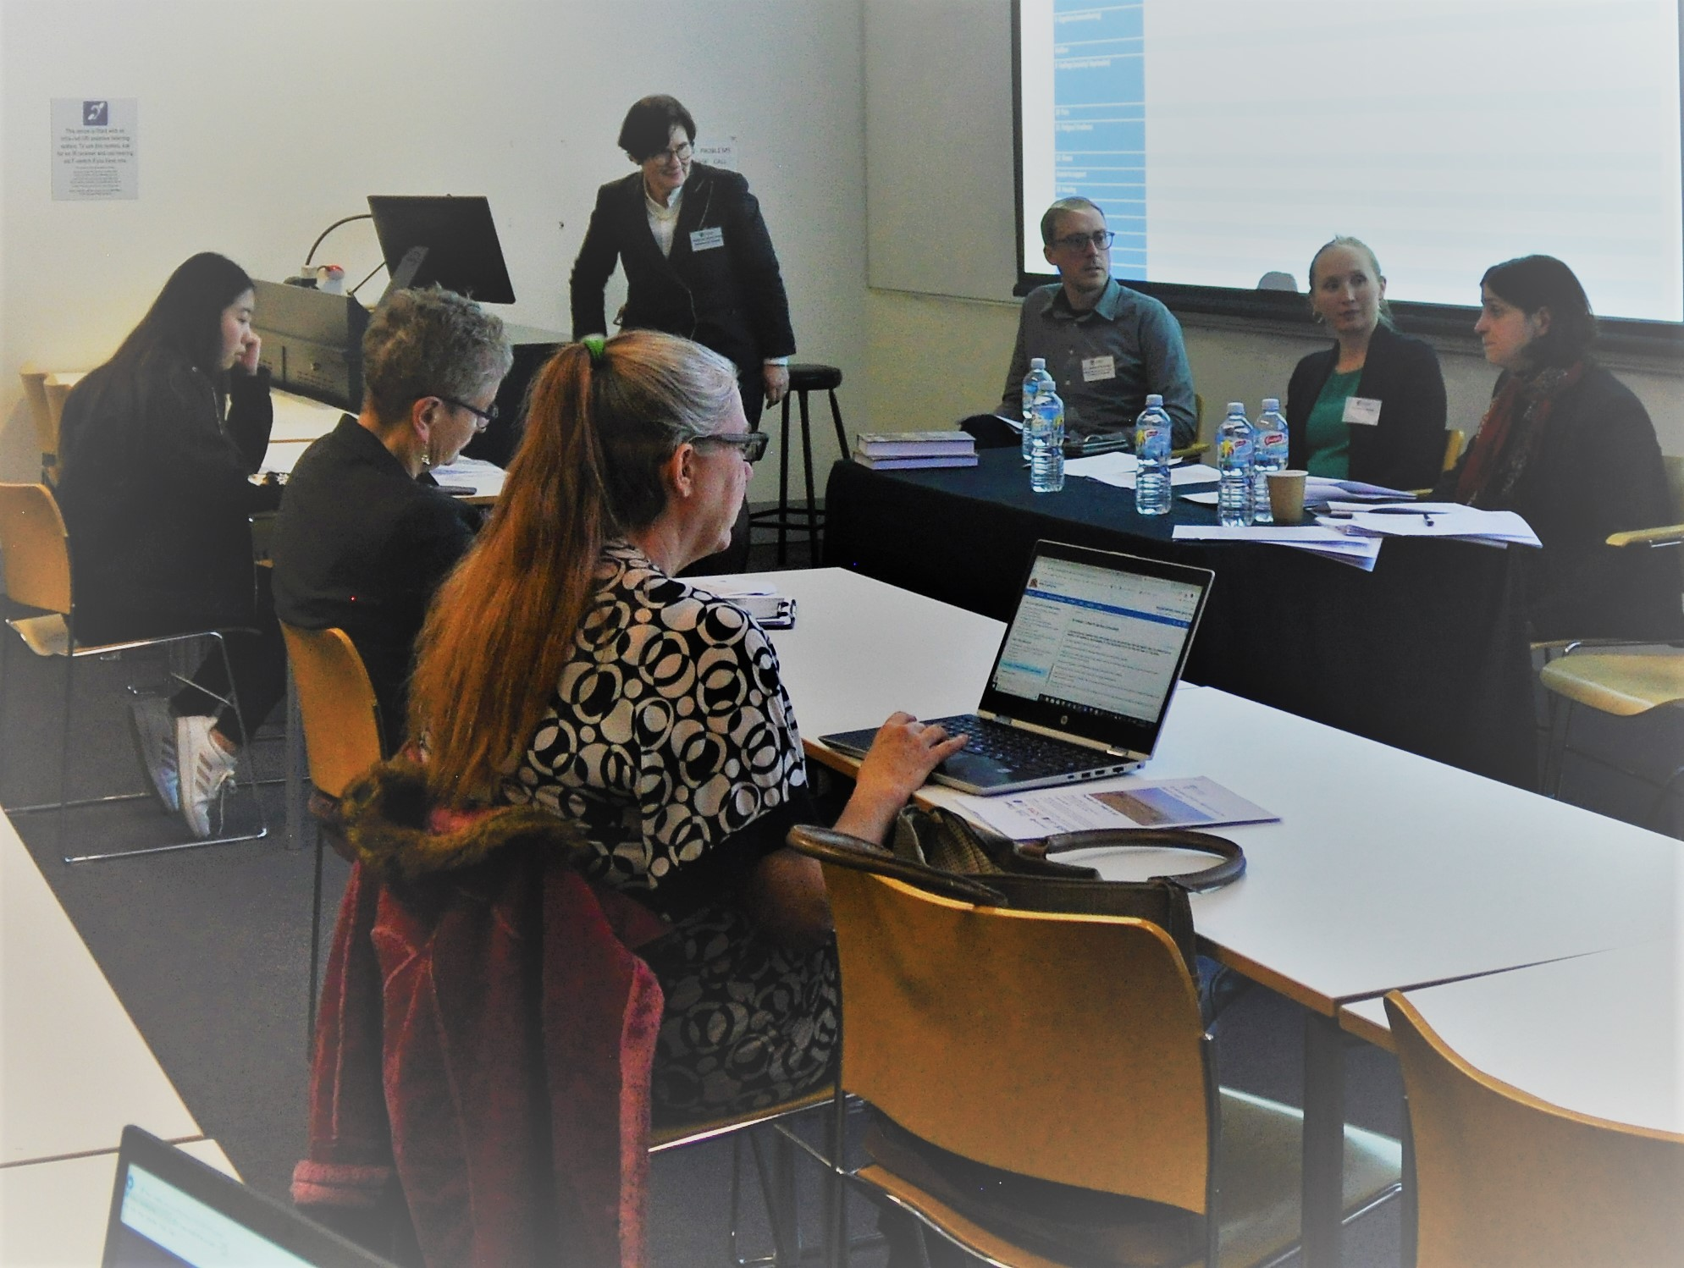
- Jemma Hollonds, RACS
  - Key issues
    - Human rights framework – rights to practitioner, legal processes
  - Challenges
Identifying and articulating the claims of children. The only considering the adult – even detail claim for children
      - How to phrase the claim – avoid dismiss the claim
      - Trust – Children are affected by community – uncomfortable with processes
      - Right to participation – meaningful way – promote right to participation – giving choices Being flexible eg. Email
    - Giving choices opportunity to family and children, - broader scope
    - How to build knowledge of children – self-advocate
    - Create child safety in culture
  - How to influence the sector
- Assistant Professor Sabrineh Ardalan
  - See the child
    - focus on the child claim
    - child might have strong claim than adult
  - How to phrase the claim
    - To get more protection
  - Identify disability or special needs
    - Claim for protection
  - Work with social worker
  - Listen to the client while the practioner’s word is understood
    - Communication in both ways
  - Trauma
    - Not enough time spent on that
  - How to practice under time constraint
  - How to draw boundaries with children
  - Family conflict
    - Daughter less willing to share information when mother in the office
  - Memory, concentration issue – ask at the beginning – eg. write down the key points
  - Asking questions ensure the client share info with us
  - Client are resilient
  - Giving choices to the client about the topics and have a control over it.
  - Child may unable to draw connection between the protection ground and the issue
- Mary Crock
  - Introduce the guidelines
  - Issue of temporary visa prevalence
  - Equal treatment bench book as inspiration (UK publication)
  - Move to include Transgender youth, young people with different sex orientation
  - Culture competence
    - Awareness, respect, safety
    - Expectation from young client can be damage
    - Understand people with different culture
    - Modify behaviour
    - Working with children check
    - Cautious about safety – damaged clients can be dangerous

- Breakout Session 1— (2.) Children, detention and community activism
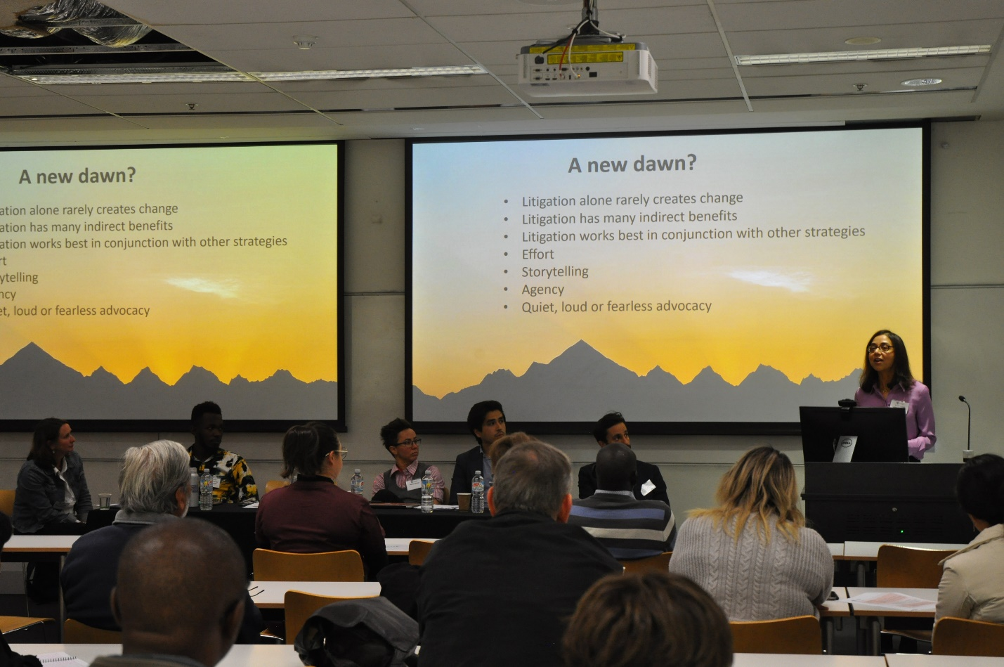

Breakout Session 1— (3.) Children, national security and citizenship.
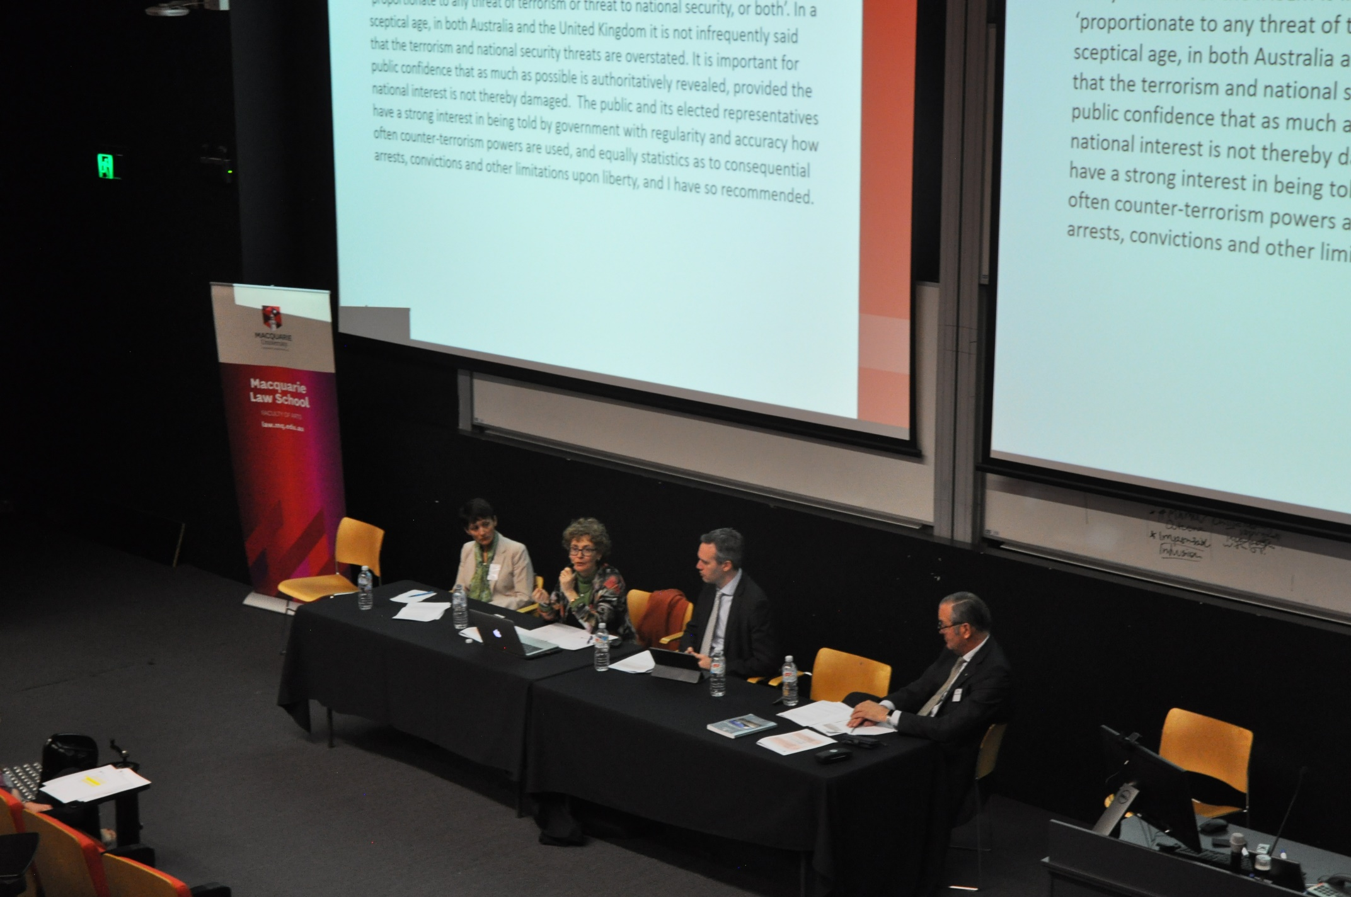

- Chair: Edward Santow, Australian Human Rights Commissioner

- Dr James Renwick SC, Reflections as Independent National Security Legislation Monitor (Jurisdiction- federal offences).
  - 2001- beginning of legislative change INSLM – to constitute serious federal offences children would be likely to commit.
  - Children of foreign fighters, below the age of 10, had no possibility being charged of criminal offence.
  - Age 10-14, there was a presumption against criminal intent.
  - In some jurisdictions in Australia, up until age 21.
  - Australian Citizenship Act: s 35A, included where the Minister intended to renounce citizenship (this provision hasn’t yet been used).
  - Other controversial provisions: such as when there is an act of terrorism or fighting, a person can lose their citizenship yet the person might not be told they have lost their citizenship for 5 years.
  - How Australian laws matched up against obligations and key recommendations:
    - Under s 19AG, Crimes Act, there is a clear breach of the Convention on the Rights of the Child (‘CRC’) under international obligations, as per the children’s report, regarding the ‘75% rule’. This is where convicted criminals, whether adult or child, if serving in jail or juvenile detention, they must serve 75% of their initial sentence. This is counter- productive as children are capable of being de-radicalised and disengaged.
  - For more ‘serious-end’ terrorist offences, a 15-year old communist leader child if convicted, would have received a substantial sentence.
    - Federal offence should be trial by jury; perhaps when trialling children, there could be less typical court ‘wear’ and other measures to make procedures less intimidating.
    - Judicial exchanges, CJ Ferguson, from the Supreme Court of Victoria, is keen on judicial exchanges as per recommendations from the children’s court.
  - Key issue is a question of trust, there should be regular publications of prosecutions of terrorism.

- Professor Kim Rubenstein, Law School, Australian National University ‘Children, citizenship and foreign fighters’.
  - In the 1901 constitution, there was no reference to Australian citizenship (from 1901-1949), the fullest form of ‘status’ was British subject status.
  - This reveals the disjuncture between status and rights.
    - For example, British subjects from elsewhere had greater ‘rights’ than indigenous Australians.
  - The Australian Citizenship Act 1949, began by sitting beside British subject status in how to gain and lose citizenship.
  - Dual citizenship was permitted, where someone took up another citizenship, meant Australian law did not require you to formally renounce it.
  - In 2002, this section repealed was repealed resulting in automatic loss of citizenship.
  - When there was a provision to repeal, arguments arose that an automatic loss of citizenship would be un-constitutional.
  - Under citizenship law, in the case of Kioa v West, 1985, consisting of a deportation order where an order was sought that where a child had been born in Australia, the child’s interests needed to be taken into account.
    - The High Court didn’t take this into account but did hold though that if there was something related to the applicant's position that the applicant did to change their position and migration status, the applicant needed to be told of it (ratio).
  - After this case, the legislation was altered where a birth in Australia alone was not enough to warrant citizenship, the new baby needed to be born in Australia and have one parent be a citizen or permanent resident.
  - Security law policy:
    - There was a dramatic change in December, 2015, that INSLM has been reviewing; that if you fight for a country that is at war with Australia, determined by the Australian government, that citizenship can be suspended?
    - As Australia hasn’t issued any formal declarations of war, s 19 has never been triggered, no someone could challenge this in court.
    - The overall framework in placing it within citizenship law is inappropriate.
    - Criminal law is the more appropriate framework for dealing with these issues.
    - Between 1901-1949 we were subjects (concept derived from the Feudal notion, ‘crown and subject’, subject is subject to the crown, crown has responsibilities to all subjects).
    - Citizenship comes from the fundamental rule of law notion where constitution is there to enable the relationship between state and any individual citizen. It added to the rule of law notion and is not subject to the excessive power of the state.
    - By way of change to the Citizenship Act, the Executive has capacity to strip citizenship. This is not curtailed by fundamental democratic notions.
  - Does this enhance our security protection or make us more vulnerable?
    - In the context of children and this context for discussion of children of foreign fighters, where they are innocent of their parents fighting; they are innocent yet can lose their citizenship as a consequence.
  - For groups who are more likely to be targeted or identified in this scenario, this has the potential to radicalize within. There is a sociological potential to radicalize where children are growing up in an environment where their citizenship can be stripped.
  - Discussion of: Temporary exclusion order bills.
  - Referring to a rights association with citizenship:
    - Voting rights, the Electoral Act, and
    - Moving in and out of the country, the Migration Act (related to non-citizens). Home Affairs officers organise this affectively under Migration Act powers, making positive or negative determinations under the appropriate visa.
    - The passport proves a right of entry (not covered by the Migration Act).
  - Australian citizenship is not subject to the State being able to preclude an individual coming in (with a passport) and whether the Temporary Exclusion Act is constitutionally valid is unsure as they don’t have written in our constitution that a citizen has a right to live in Australia.
    - Yet, it is unequivocal that in our country, as per international law derived from the International Covenant on Civil and Political Rights (‘ICCPR’), that we do have this right to live in own country.

- Meda Couzens, University of Sydney Law School, ‘The best interests of the child in the context of national security’.
- 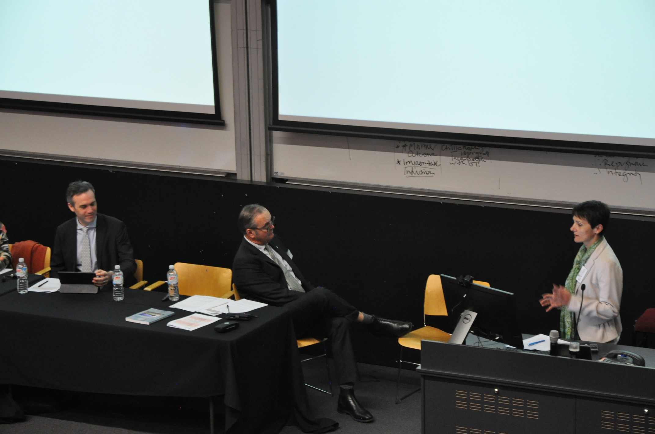
  - Referring to children associated as foreign fighters, (currently overseas with the potential of return).
  - Where there is a separation of children, from age 12 being held separately, there is a severe lack of access to basic necessities, malnutrition and negative impact on children.
  - There is a potential threat to communities of origin.
  - Where children are militarily trained, they are looking at the role of women being active in recruitment.
  - They can be held separately to non-governmental groups.
  - Law needs to be able to accommodate for the individual child’s situation; as they are ‘not a homogenous group’.
    - For example, when people join ISIS, their passports are taken, this means they cannot access assistance and there is no Australian diplomatic representation in Syria.
  - The State can invoke the responsibility of another state. For example, where State A, says that State B has mistreated its aliens. But where detention is imposed by non-state actors, this complicates the issue.
  - Nationality is not just an issue of status; it is a gateway to access certain benefits.
  - Failure to act and recognise children can lead to potential breaches.
  - This can be interpreted by an obligation to bring foreign fighters back.
  - Domestic law issues to secure the return of Australians is weak or uncertain.
  - Diplomatic protection is not a right in Australia, (post-Hicks).
  - There have been European developments in law for diplomatic protection.
  - The government ignored Art 3(1), in considering the individual circumstances of each child by not currently considering these circumstances. Though there was no current attempt to distinguish whether they were a child or an adult. There is no effort in the bill –for example, the fact of being a child is not mitigated.
  - In the ASIO annual report, people who return from this area are held in higher esteem and have increased knowledge of security issues.
  - General Comment 14- outlines that the decision maker be mindful and consider the best interests of the child. The Bill automatically gives more consideration to the community interests.

  - Could apply to court, though notably, a right is useless unless you know you have it or know you’ve lost your status. It is very difficult to challenge a decision where in this case the person is not told their citizenship status has been revoked. (In Britain you are always told).

Plenary Session 3—Jurisprudence on children and asylum

- Chair: Professor Lenni Benson, leading immigration scholar, New York Law School.

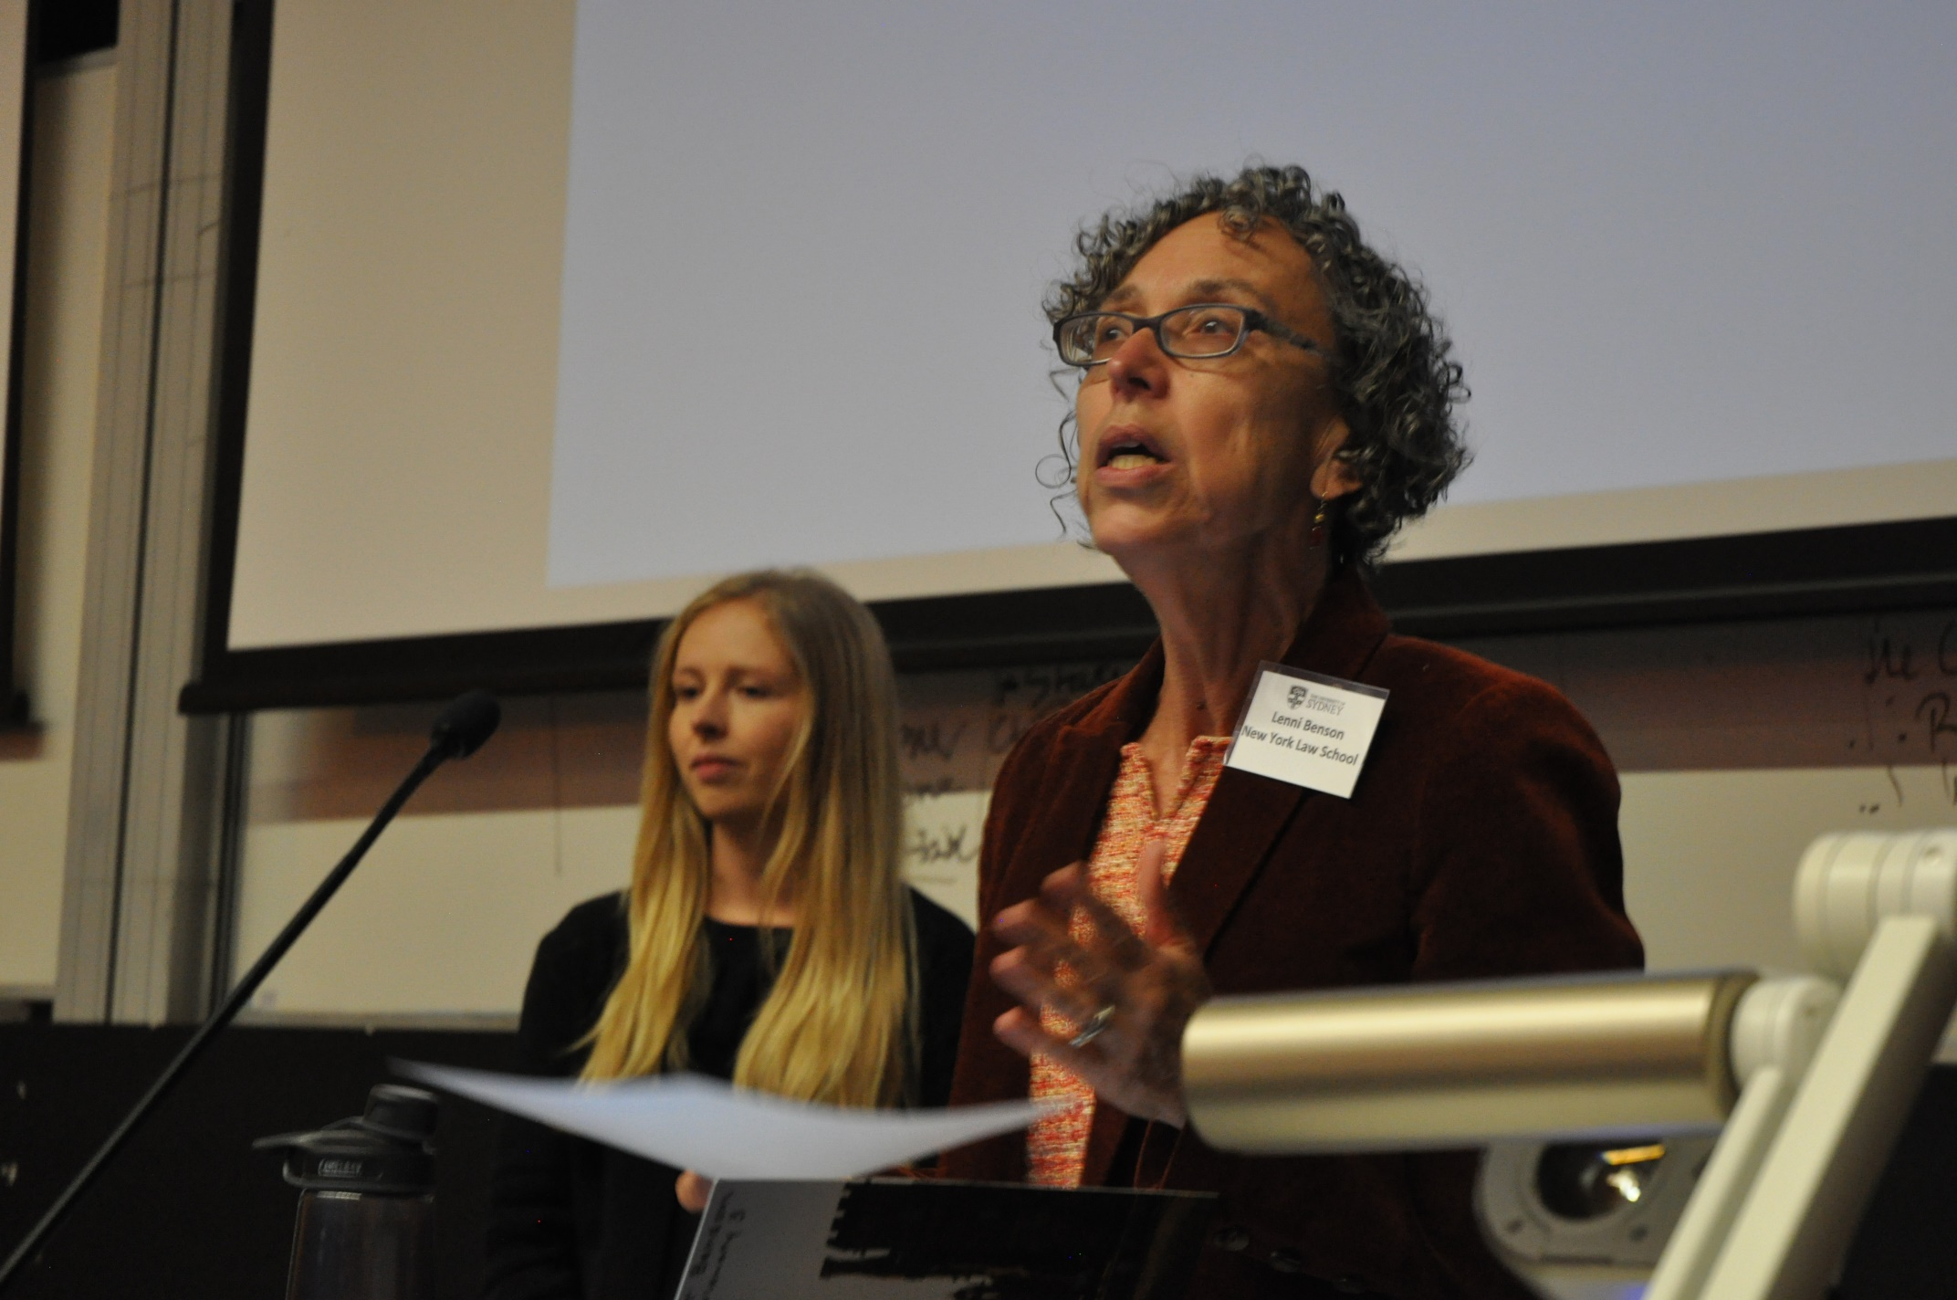
- Kate Bones, Legal Aid NSW, ‘Children as Convention Refugees’.
  - How definition of a refugee applies to migrant children in Australian law.
  - In the 1951 Refugee Convention, the definition under Art 1A(2), there is no reference to children and largely in the Convention, when it does refer to children is unclear.
  - Children have no distinct circumstances in the definition incorporated into domestic legislation in Australia and the US.
  - Regarding persecution, level of harm and vulnerability:
    - Australian law is lagging behind and there is still no High Court case to determine whether vulnerability is relevant to a child.
    - MIBP v WZAPN – went towards developing better approaches to children’s claims by addressing the meaning of serious harm (under s 5). Any period of harm counts for an asylum seeker.
    - They reached a unanimous decision that any period of detention counts, no matter how brief they would be detained, instead of length.
    - The Fed court was arguing this immigration assessment was a jurisdictional error as it required an assessment of gravity.
    - The IAA was saying this was not serious harm and this is sufficient.
- United States:
  - US Government guidelines look at the harm a child fears or has suffered where events have to be looked at from the perspective of the child.
  - If a child has fled to Mexico and an immigration judge has reached a conclusion they had not suffered where they experienced injuries, they do not look at events from their perspective.
- Discussed membership of a particular social group:
  - Applicant A: was found to be the sharing of an attribute of a distinct group (other than joined by fear of persecution); street children, homeless youth, children born in contradiction to the ‘one child policy’, ‘girls’.
- In Australia where they discussed membership of a particular social group:
  - Applicant A: was found to be the sharing of an attribute of a distinct group (other than joined by fear of persecution); street children, homeless youth, children born in contradiction to the ‘one child policy’, ‘girls’.
  - Applicant S v MIMA, 2004, the High Court rejected an Afghani man where the decision maker said he couldn’t qualify. The High Court disagreed on whether he was part of a social group. This was determined objectively by a third party yet often can be invisible to society.
- United States:
  - A group can be defined by particularity; the origins of requirements, this drew on Australian law by looking at the social distinction test which was picked up by the Board of Immigration Appeals, Department of Justice.
  - In 2014, the amendments to the Migration Act codified the test for social group in an attempt to restrict the definition, making it broader than in comparable countries. There were amended in the Senate to broaden alternatives.

- Syd Bolton, ‘Strategic litigation of migrant children’s rights’.

- 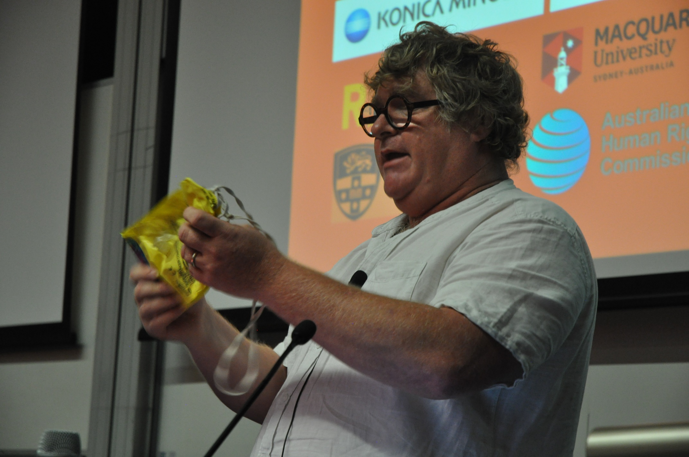
  - Bringing strategic litigation relies on strength and diversity of impact litigation.
  - Mentioned Jason Pobjoy, Blackstone Chambers for his work on refugee children.
  - Quoted: Professor Goodwin-Gill, speaking of children ‘all seem to be at worst invisible, at best an afterthought’.
  - Regarding refugee children’s’ rights, the systematic approach involves using the CRC in caselaw (Bolton performs training with lawyers in how to address and incorporate the CRC into their practice).
  - The UK had signed a reservation to this convention which meant the rights of children were removed from its consideration.
  - Mr Bolton depicted the NGO level children’s rights movement which caught the attention of the committee, in the periodic reports and resulting in the UK withdrawing its reservation at the end of 2009.
  - In 2000, there was a tragic death which led to a public inquiry to safeguard migrant children where they had been failed by police and service providers. The children’s office of the Commission was also created.
  - The UK Government legislated to require the incorporation of safeguarding procedures. The statutory safeguarding provision led to operational policy instructions for border agencies.
  - Mr Bolton’s approach was to start litigation by looking for cases to adopt core principles into case law precedent. In one landmark case in 2010, he decided against third party intervention as thought the case should be argued academically in the Supreme Court to deal with the best interests in consideration of refugee children.
  - In a series of extradition cases, (KAC, HH & others?), where people were due to be extradited, permanently or for long periods and separated from their children, a helpful judgment was reached. Although the parents lost these cases; they produced detailed judgements for identifying the best interests of the child and what countervailing interests might be.
  - Commented on Professor Jane McAdam’s work looking at complementary protection.
  - Cases can be funded by a strategic legal fund to fund a strategic push for test cases.
  - Lawyers need to take a strategic approach. For example in France, in the EU, there have been actions taken against detention camps, a lack of family reunion measures.

- Adjunct Professor George Newhouse, National Justice Project/Macquarie Law
- School, ‘Using tort law to effect change in immigration detention’.

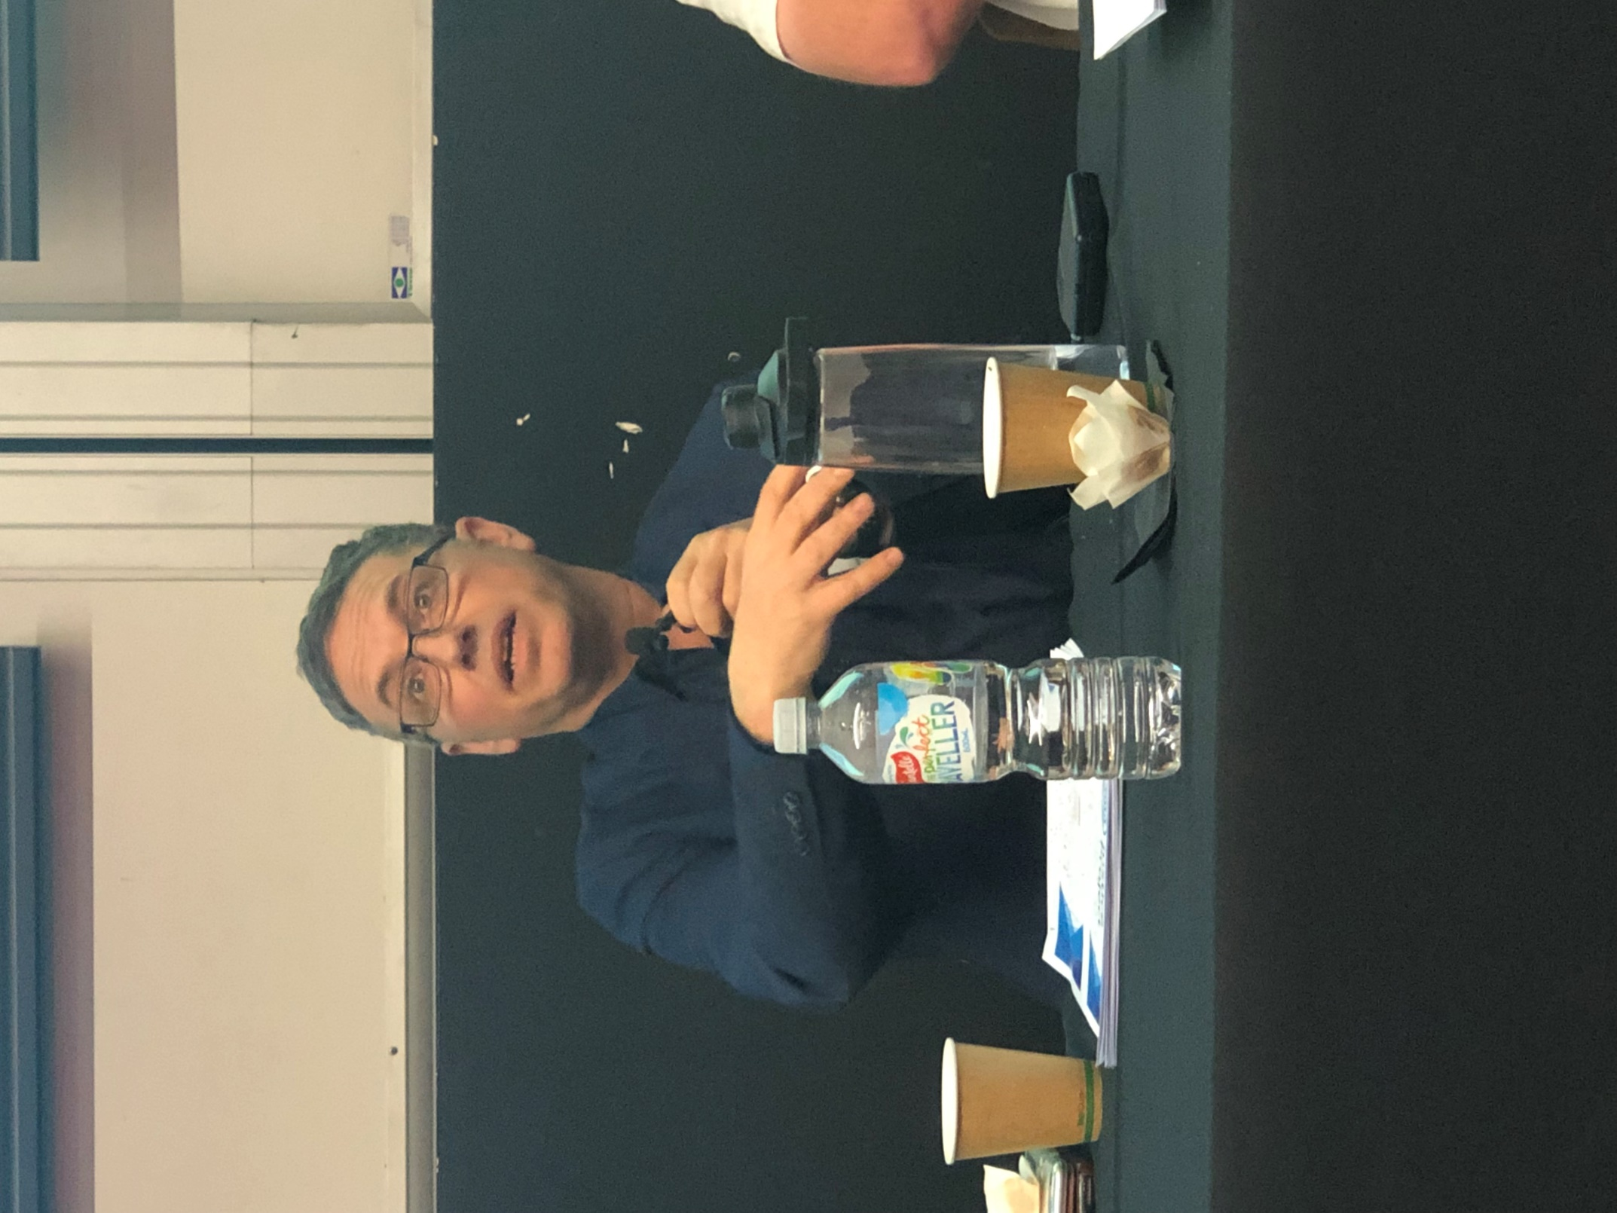
  - The National Justice Project – (‘NJP’ on all social media).
  - In Tort law, you don’t have international protections, conventions are virtually meaningless. You can’t look beyond domestic law and get judges to create precedence.
  - Australia is the only modern constitution that doesn’t have human rights embedded –and actually has racist provisions.
  - The two states where the domestic constitution was discussed argued that it shouldn’t be included.
  - The race power s 51 (xxvi), deals with any alien race and provides for racial discrimination.
  - Professor Newhouse talked about immigration cases and onshore treatment, that people can be held in harsh conditions, but still keep their tort rights.
  - Domestic legal principles apply to treatment of detainees onshore which he describes is part of the foundation of the offshore strategy.
  - As an example, Professor Newhouse gave Shayan Badraie’s case, where conditions spiralled downwards and this 6 year old developed a mental illness and post-traumatic stress disorder. He stated that most children on Nauru were experiencing resignation syndrome.
    - After the Tribunal held the application was for the Minister to decide, the Minister for Immigration at the time (Minister Ruddock) wrote “bucklies” on the application for release.
  - Vivian Alvarez Solon was a case where the Australian government deported the wrong woman and they had known for 2 years that they had deported the wrong woman.
  - Cornelia Rau was awarded the highest exemplary damages award of an undisclosed amount.
  - Case M68, was where the High Court held detainees in PNG and Nauru prima facie were being detained. The question was whether this stopped domestic legal protections.
    - The High Court acknowledged that a duty of care extends offshore from the Commonwealth because the government had transferred the individuals and their families to the offshore location and was still sustaining them.
  - After Vivian Alvarez Solon and the Cornelia Rau cases, a report instigated by Nick Palmer and the inquiry undertaken by Mr Neil Comrie AO APM, recommended medical oversight be provided for people in detention. This was then removed under the Abbott government.
  - Studying a series of rape cases:
    - Abyan case: Where this woman was raped, became pregnant and required an abortion, she asked for a psychological report.
    - Professor Newhouse noted termination was illegal on Nauru, and also argued it was illegal on PNG.
    - S99, was another case where a woman was raped, a woman who was an interpreter on Nauru who was requiring termination went to the High Court. Justice Keane found a novel duty of care.
    - The Australian government had argued ‘logic’ yet, in this case, the government had flown her to Port Moresby meaning the government had already been involved.
    - Taking the checklist from the Caltex case, a multi factorial test, they found there was a duty of care offshore but that duty hadn’t been brought home to Manus Island.
    - In FRX 17, a detainee attempted suicide and when taken to Nauru’s hospital, she was provided no psychological care by IHMS medical staff.
    - She won an injunction to be brought to Australia even though the government argued there was no duty of care.
    - They had won injunctions, where a child could die, but the actual legal problem hadn’t been aired.
    - The government persisted using the ‘Balance of Convenience’ test and won through the argument of where expense outweighed benefit.
    - Lastly referred to DCQ18, where a Somali woman who had type III Female Genital Mutilation required termination and medical attention. The government argued that it could be handled in Taiwan and the NJP won argument against that proposition.

DAY II

Sessions:

- Video of Nujeen Mustafa interviewed by Professor Mary Crock.
  - Girl who travelled from Syria to Germany in a steel-wheelchair.
  - Best thing a government could do would be to send a girl to school.
  - Demonstrates a ‘Spirit of positivity’ – what welcoming refugees could look like.

Plenary Session 4— Solutions – Towards Best Practice

- Chair: Edward Santow, Australian Human Rights Commissioner.

- Louise Aubin, UNHCR Representative for Australia, New Zealand, Papua New Guinea and the Pacific, ‘Ageing out: Refugee protection on both sides of 18’.

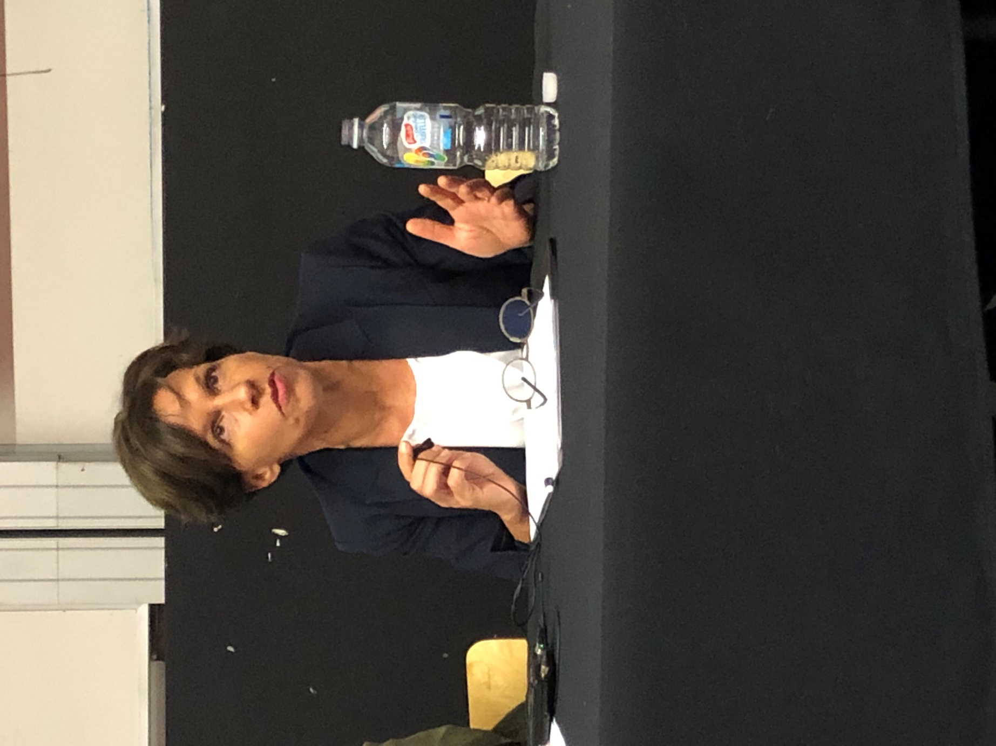
  - The refugee convention makes no distinction between adult and child.
  - Youth and child shares age specific needs and capabilities.
  - The Global Compact for refugees contains the cardinal principle of ‘forceful return’ with specific language around children and youth.
  - A framework for equitable treatment and responsibility sharing (not shifting) cannot be achieved without a whole of country approach.
  - In December, the Global Refugee Forum, of Ministerial level discussed a whole of society approach.
  - Noted Art 22 of the CRC, referencing the access to enjoy Human Rights.
  - Child specific forums of persecution, such as immigration detention are commented on by the Committee as against the rights of the child who should never be detained, even because of their migration status.
  - Just because a child turns 18, doesn’t change that person’s needs.
  - Youth v Child:
  - Youth are 18-24 (based on the UN definition) which is designed to characterise this transition stage.
  - In community detention, where education can be mandatory before 18, leaves the next stage elusive.
  - Referenced the Legacy caseload and prospects for reuniting with family.
  - In the EU, children are trying to pass off as adults to avoid extensive ‘administrative procedures’ holding up their transition through countries.
  - Children are exposed to a high-risk period of forced recruitment using coercive methods. Where they refuse they are suspected of belonging to a rival gang if they don’t cooperate and are treated as such. They are also suspected as gang members by security personnel. There is a high level of sexual violence.
  - Planning around refugee youth needs to look at adult hood.
  - Louise gave a very positive example where Lebanon youths who are refugees have embraced mentoring of LGBTI youths.
  - In the Central African Republic, young people team together for a peace carnival with both Christian and Muslim peace representatives.
  - She spoke of a Kenyan, ‘United for Peace’ theatre and film making groups in Kakuma.
  - Where youth are also voicing gender equality and refugees are talking about LGBTI. Refugee youth also had a say in drafting the Global Compact for refugees (and now have a voice to the UNHCR for policy direction?)

- Catriona Jarvis, Co-founder and co-convener of the Last Rights project and former judge of UK Immigration Appeals Court, ‘Beyond Protection? Addressing challenges to safety and to enjoyment of rights for refugee and migrant children on the move in the Mediterranean and European context’
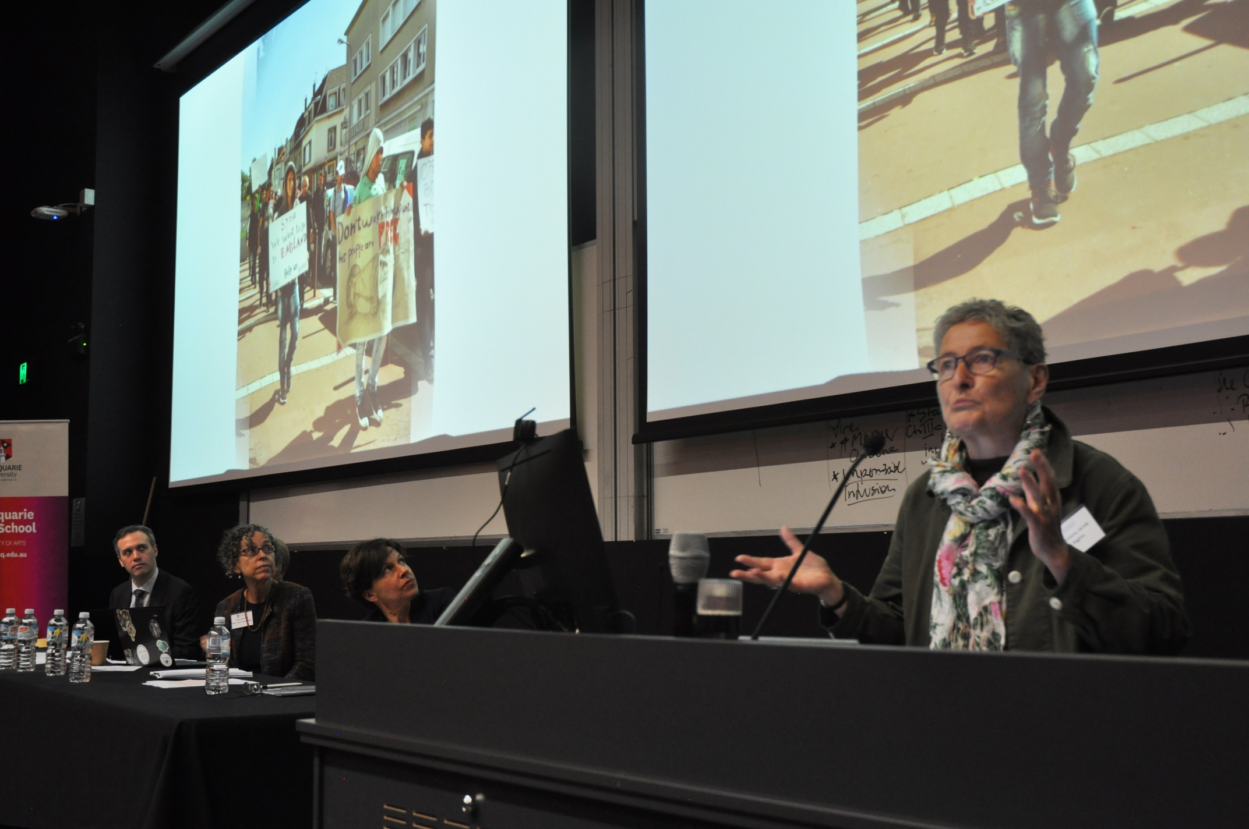
  - (This presentation was accompanied by a gripping photographic display of images portraying border areas and scenes).
  - How to look beyond immediate immersion protection?
  - Full examination of the rights of a child together culminate their best interests.
  - A holistic approach is a welfare consideration with respect for their rights and a child friendly justice system that benefits from appropriate long term planning.
  - As explained by the former human rights commissioner, Chris Sidotti, in his keynote at the conference, attempts have failed to consider their best interests.
  - Children are on the move and shall be considered children first and foremost to be ensured the same rights as all other children.
  - An individual and family assessment should be made where children at the border shall not be refused shelter.
  - There are serious problems including: family reunification and lengthy separations from parents showing consistent failure to prioritise the best interests of the child.
  - 10% may abscond of lose faith in the process.
  - In the EU, a case, (A & S v Netherlands?) it was held there is a right to family reunion, even after the age of 18 and an introduction of his/her asylum application even if the child attains the age of majority.
  - Ms Jarvis commented on living conditions for children in transit, living in conditions of squalor, violence and that sexual assault for example is frequent on the camps on the Greek Islands.
  - Rights, Remedies and a Justification report:
    - 197 countries have specific forms of reasoning.
    - In 2014, a complaints mechanism was used (Australia is a part of the complaints procedure).
    - Children and those acting of their behalf cease to prohibit the ability to issue retribution for these children which is not good.
    - We should avoid children needing to go through multiple processes.
    - On the 22nd of July, there was a Bill passed through parliament regarding legal aid for unaccompanied and separated children.
    - The CRC and the Committee for Rights of Migrants made some joint recommendations to States, to “help children on the move”.
    - A submission from a group lodged a complaint suggesting that the EU and member states treatment of those fleeing Libya constitutes, crimes against humanity.
    - Chris Sidotti, former Human Rights Commissioner, called acts of the Australian government: inhumane and crimes against humanity.
    - Options: suggested social bonds issued by governments for children asylum seekers.

- Professor Lenni Benson, leading immigration scholar, New York Law School, ‘The Safe Passage Project: Building a pro bono network to assist unaccompanied migrant children in the US’.
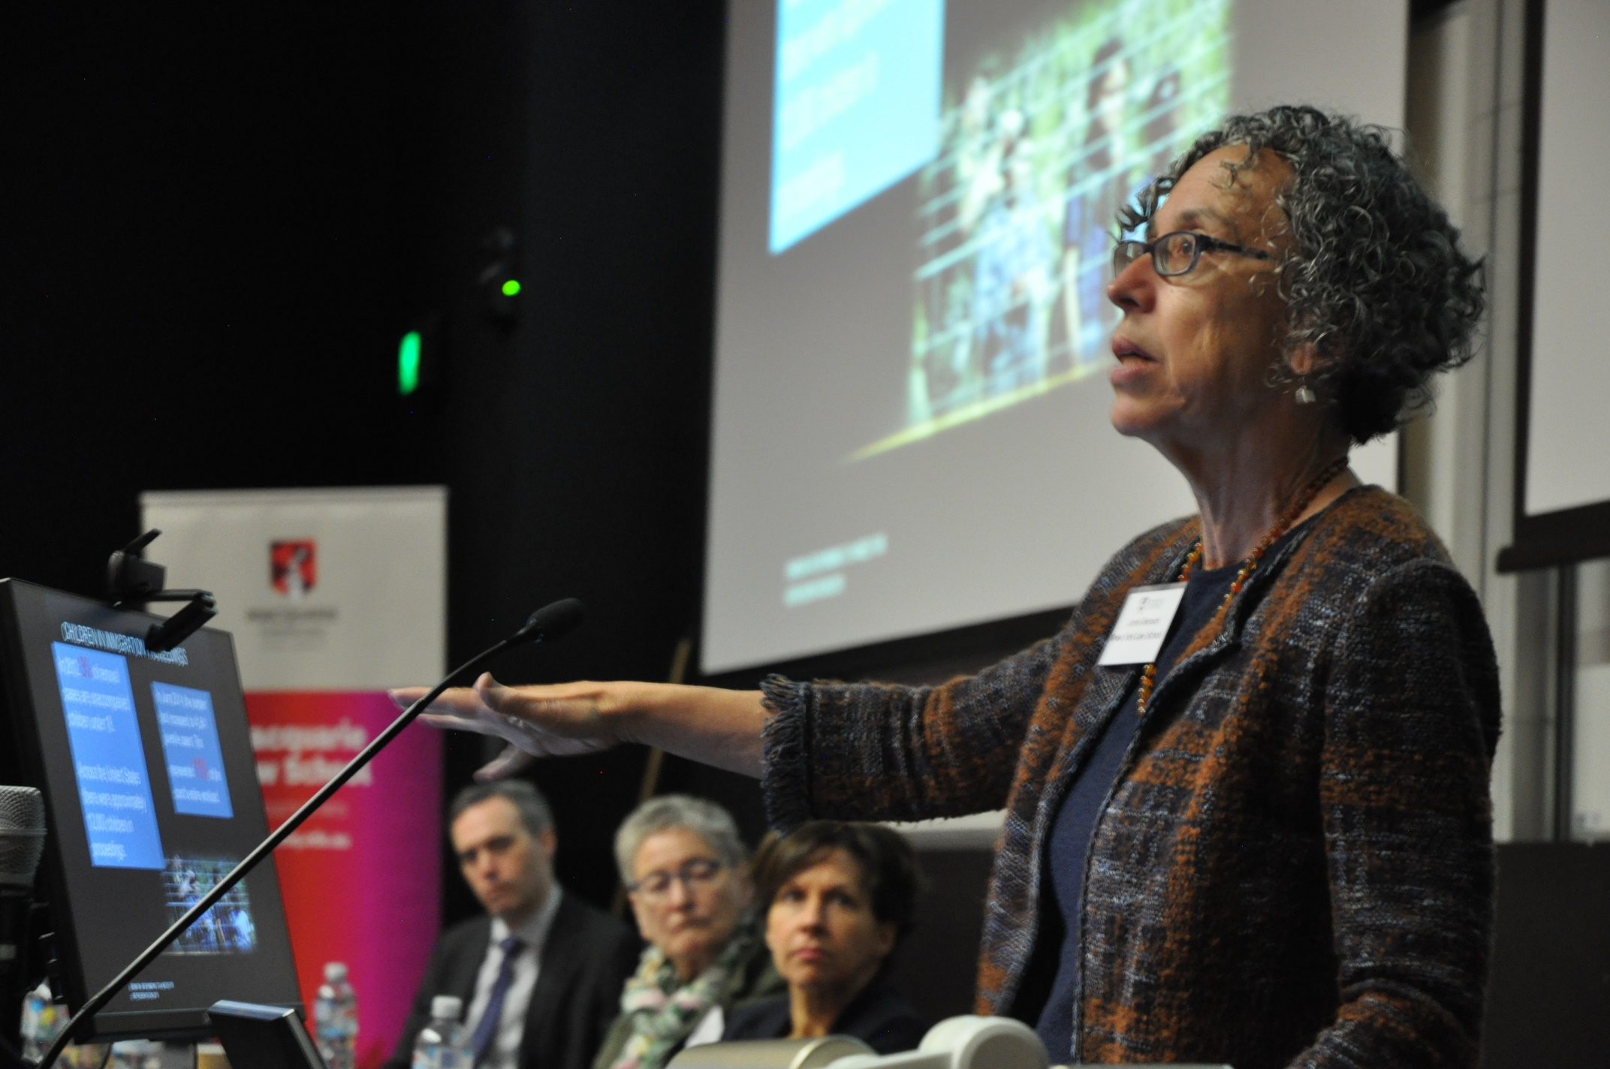

  - The Safe Passage Project involves: Recruiting and mentoring pro bono council to provide legal services to migrant children as a response to the child migration crisis.
  - The US chose the adversarial process as the forum for determining unaccompanied children’s status which has resulted in those in processing becoming increasingly separated.
  - In 2012, 3% of all cases led to the removal of unaccompanied children under 18.
  - 12,000 children were processed in the US.
  - In June, 2014, 11% grew to 41,641.
  - There are 52 different Migration courts in the US.
  - Post-Trump, many more put in removal situations.
  - There were nearly 1 million pending cases, totalling about 90,000 pending cases regarding children portraying exponential growth.
  - There should be a specialized docket, for those unaccompanied however the government has eroded this set up.
  - In civil administrative proceedings, although they are entitled to counsel, they are not entitled to free counsel so are required to have to find it themselves and it is very difficult for them to access substantive relief, even if there are relief processes.
  - In 32% of cases, children are found absent from trial. This in absentia order stays on their record, even without their knowing it once it’s ordered. Moreover, the government has been using this rate to increase detention.
  - Where a child is represented, 86.3% achieve a positive result.
  - Under federal data, where 68% were represented, examples were given of cities funding legal aid if the federal government wouldn’t and saw in absentia matters decrease.
  - Professor Benson’s clear message was that ‘the forum matters!’; not just the representation.
  - There has been a shift in the definition of unaccompanied, now even if waiting for years for asylum, when a child turns 18, they then need to go to a different forum, a waste of time and effort.
  - Ended with the starfish analogy story ‘it matters to this one’.

- Jennifer Robinson, Human Rights Barrister, Doughty Street Chambers, ‘the 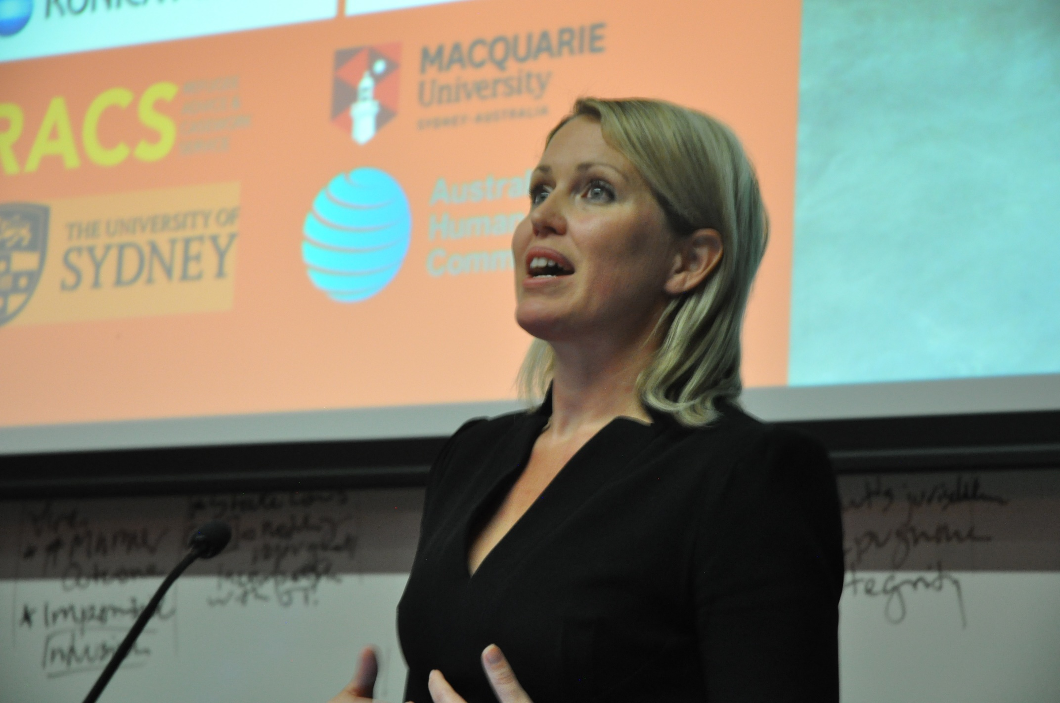protection of child refugees in a global and comparative context’.

  - Example of a refugee case in London, regarding s 67 Migration Act.
  - There was a legislative scheme from the UK government regarding the refugee crisis in the EU where unaccompanied children living in transit could access advocate protection of refugees. The intention was to push the UK government to do better with a positive policy.
  - There were 2,000 children in Greek camps.
  - There were 10,000 children found as victims to children trafficking in the context of migration and asylum. The UK implemented the Dubs amendment s 67, Immigration Act, UK, a 2016 amendment – (Lord Alf Dubs).
  - This required the secretary of state as soon as possible after the act was passed, to pass regulation. (May 2016)
  - The intention was to determine what capacity they had in each region to place the children within local care. It was determined that at least 3,000 more places were available but due to a flawed consultation process, there were only 320 that had been relocated to the UK.
  - They forced home affairs office to admit that at least 130 placements that could have been placed in the UK, 40% more than what the government had indicated. Flaws in the process of consultation meant the government hadn’t properly consulted or determined their resources.
  - The second ground of appeal was overlooked in the process as children had been assessed in camps or had been verbally assessing claims, yet there had been no review process.
  - Help Refugees Ltd, who run ongoing campaigns, brought a case.
  - Art 4 CRC states they need to secure best interests and in the joint general comments, it was recommended that eligibility needs to be assessed as quickly as possible.
  - Through consultation, the federal government had failed to gather data by not consulting properly, they missed out asking most councils and removed the children applicants’ ability to understand why they were not allowed in as they did not tell them reasons for their refusal.
  - Evidence given in the Court of Appeal revealed there was internal correspondence that the reason the applicants weren’t told the reasons was because they feared the children would challenge the decision. It was mishandled.
  - The court found that consultation was lawful by recognizing a ‘speed’ argument by the government. (Ultimately probably because they didn’t want to overburden the government).
  - In the Court of Appeal, the case was won due to procedural fairness because they failed to give reasons to the children. This process would have meant about 40% more children would now be able to be processed. They also decided that there would be no way for a child to launch an appeal from Calais jungle.
  - The confusion originated and was discovered through litigation; they had effectively been brought under the Dubs amendment.
  - Comparing Australia and the UK:
  - Unlike this Australian government, at least the UK has a legislative scheme to protect these children.
  - When the Trump administration started separating children, this was condemned by UN experts, yet Australia has a widespread and systematic policy that provides for the separation of children without drawing the same international critique. Some believe Trump got the idea from Australia.
  - Trump had said to Malcolm Turnbull with admiration; ‘you are worse than I am’, no person should ever be allowed in.
  - Yet compared to the Trump scheme, Australia hasn’t seen the same amount of condemnation.
  - The period of separation ranges from 1 month to – 5 years. This threatens their mental health. In the context of Australia’s separation policy, this compounds the suffering.
  - Many refugees suffer physical and mental health trauma in facing indefinite separation.
  - There is ongoing physical and sexual violence happening in the camps which will result in psychiatric trauma for these children. We need to start using the word torture in regards to treatment.
  - Under Australia’s international obligations Ms Robinson commented that part of the resettlement deal can be to relinquish the rights to the child.
  - Committee General Comment 3, 2017, refers to Australia’s obligations to the UN CRC, as interpreted by the committee.
    - Each child, including those placed in a state outside of its borders cannot be arbitrarily separated
  - We need to litigate at home here and in international forums to target this type of treatment and separation.

Panel discussion—The Right to Health

- Chair: Mary Flanagan, Public Interest Advocacy Centre.

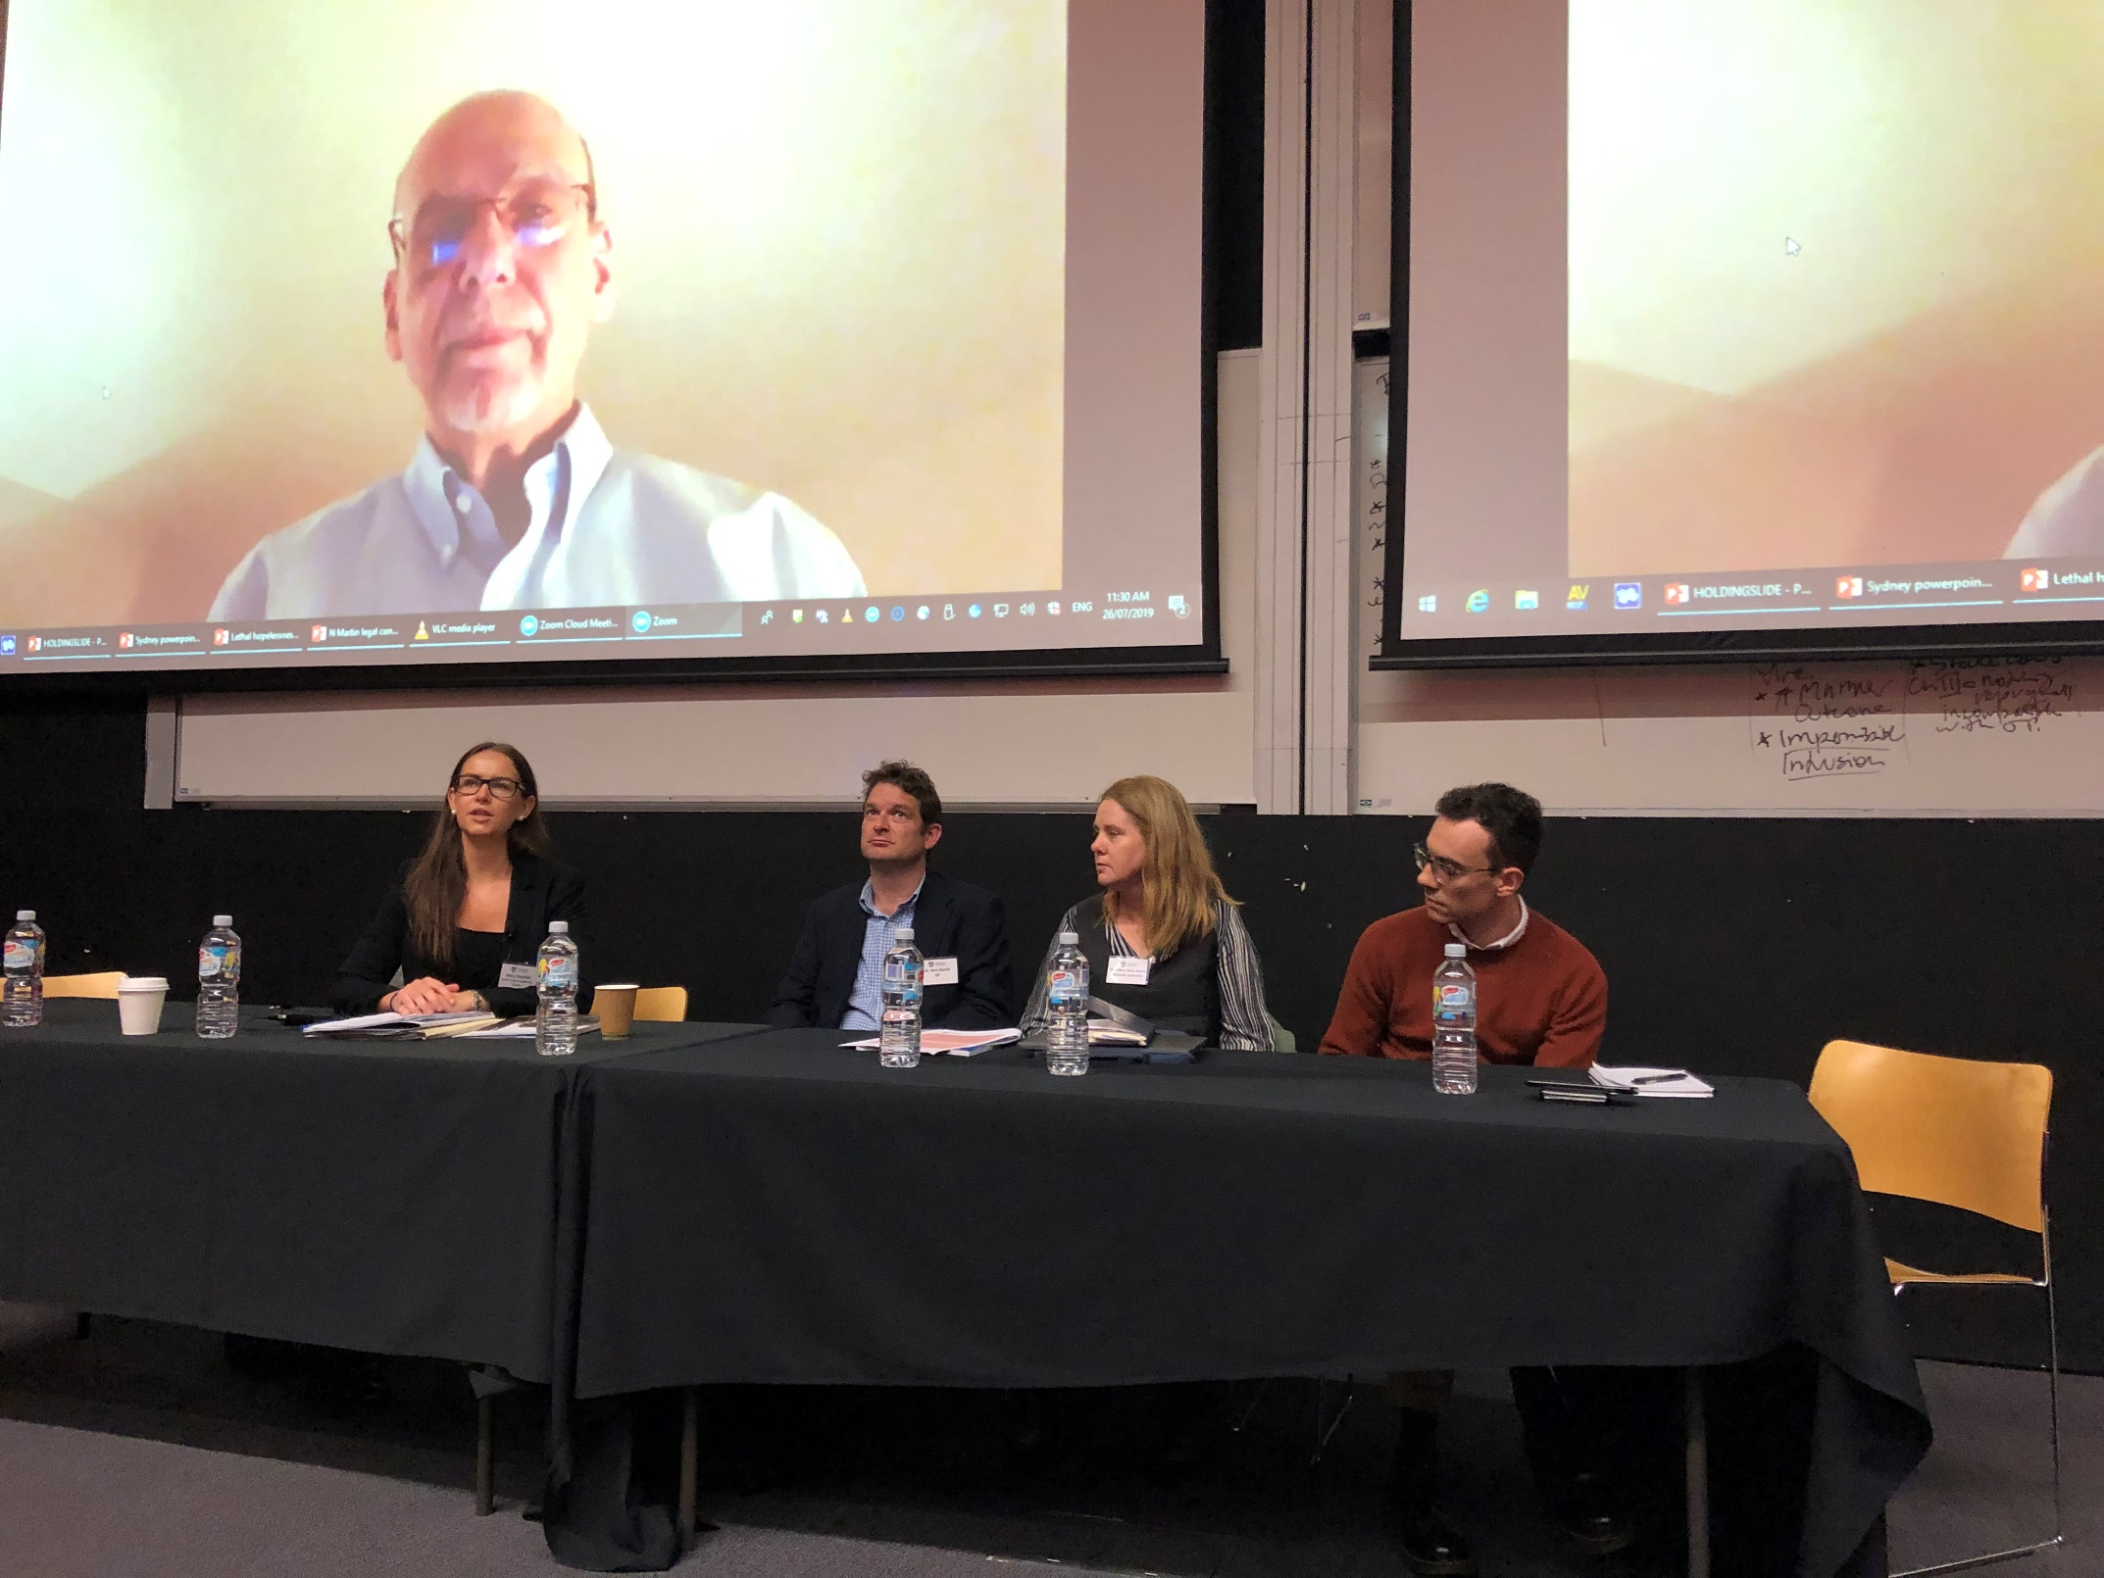

- Professor Gerald Neuman, Harvard Law School (via skype), ‘Immigration detention and the protection of children’s human rights’
  - Global Immigration Detention.
  - Referred to the prominent work of Professor Lenni Benson and Professor Mary Crock in reference to refugee children.
  - The excessive detention of children is a violation of human rights, endangering their physical and mental health. Based directly from the International Covenant on Civil and Political Rights 1976 (‘ICCPR’), that 173 state parties are signatory to as an international Bill of Rights.
  - There need to be procedural guarantees, a right to judicial review with reasons provided.
  - Referencing Art 10 for those deprived of liberty, and Art 24 in that all children require rights to protect migrants in detention.
  - CRC Art 37: Allows for the arrest, detention and imprisonment of a child only for the shortest appropriate period. Every UN member state has ratified this convention.
  - Committee’s General Comment 35 – from the rapporteur stated that detention should not just be included in the course of proceedings for control of immigration per se – but that detention needs to be relative and used to document them, record their claims and to determine identity if in doubt.
  - Children should not be deprived of liberty as a primary consideration noting conditions of detention and need for care of unaccompanied children.
  - Spoke against the use of detention powers as a general deterrent against unlawful entry; especially for children. Unaccompanied minors should not be detained except as a measure of last resort and taking into consideration their best interests and care.
  - In 2012, the Committee voiced a position also consistent with this approach and policy of detaining children as irregular migrants, subject to time restraints.
  - More recently though, from the Committee’s General Comment, they recommended that States should expeditiously cease or eradicate detention of immigrant children.
  - Professor Neuman’s view was not completely on par with this position, that any kind of detention should be prohibited by law and fully implemented in practice (only to be used as a measure of last resort such as juvenile justice) as it conflicts with the rights of the child.
  - He was of the opinion that it is misguided for the Committee to align itself with an overstated reform campaign.
  - It is not an aspiration for the Human Rights Committee to include any form of deprivation of person by broad definition.
  - The definition of detention does include some forms of deprivation of liberty. It can serve in the child’s best interests and can still be recognised as detention (therefore Art 9 protections apply) as may be necessary for children.
  - Restricting the movement of very young children travelling with an adult, need to be determined and considered under close scrutiny regarding trafficking etc.
  - States should not be prevented from responding appropriately to the child. If some form of detention is determined; it should be only as the last resort.
  - That is, Professor Neuman suggests it cannot be categorically prohibited.

- Dr Joseph Lelliott, University of Queensland Law School, “Unaccompanied minors in 'legal limbo' ” The human rights and health consequences of precarious status.
- 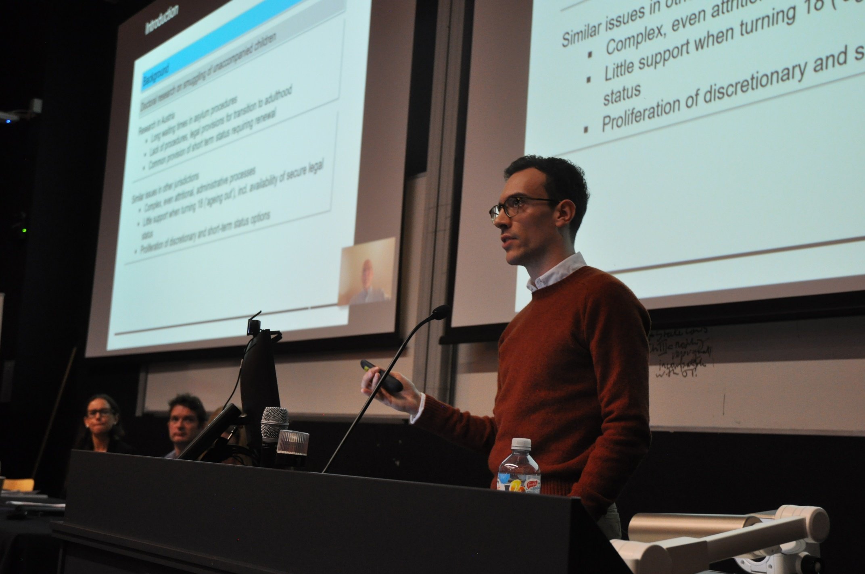

  - Regarding the legacy caseload, their legal status is pending asylum claims.
  - His current research is in limbo situations, specifically effecting unaccompanied children.
  - The set up also results in children stuck in periods of limbo even afterwards as well.
  - What is legal limbo?
    - Smuggling of unaccompanied children.
    - Risk factors.
  - Case study: Austria
    - There are long waiting times in asylum procedures.
    - Whilst not in immediate harm, during the time of ambiguity, there is a heightened danger for removal and a lack of social assistance.
  - Case study: South Africa
    - Children’s Act provides for care and protection of children.
    - Where apprehended, they are put in children’s court to proscribe minimum standards for the unaccompanied children however this doesn’t provide legal status.
    - Accessing the asylum system, there was a lack of clarity in understanding, making it largely inaccessible.
    - Children were put in with adults to access the system but for protection, were unable to access the system until they were 18.
    - This resulted in an increased risk of removal and detention for unaccompanied children, most ended up on the street.
    - They are also vulnerable to arrest and detention on turning 18.
    - Unaccompanied Asylum-seeking Children leave (‘UASC’ leave) terminates in the UK. (Where children who mature to turn 18 must apply for extended leave to remain in the Uk).
  - Health consequences:
    - There was an increased risk of ‘going missing’.
    - There are clear adverse effects on health, particularly mental and emotional well-being and proper development.
    - Daily stressors included mental health depression and anxiety.
    - There is an importance of identity formation.
      - UNHRC –provides a holistic perspective; an inclusive right.
      - There are underlying determinants of health and a clear link made to a need for certainty and a secure legal status for health.
    - Required is a reduction of discretionary and temporary status, especially where protections terminate on turning 18.
    - The key importance is to provide accessible avenues to secure legal status.

- Associate Professor Mary Anne Kenny, Murdoch University, ‘Lethal hopelessness: Understanding and responding to asylum seeker mental deterioration’.
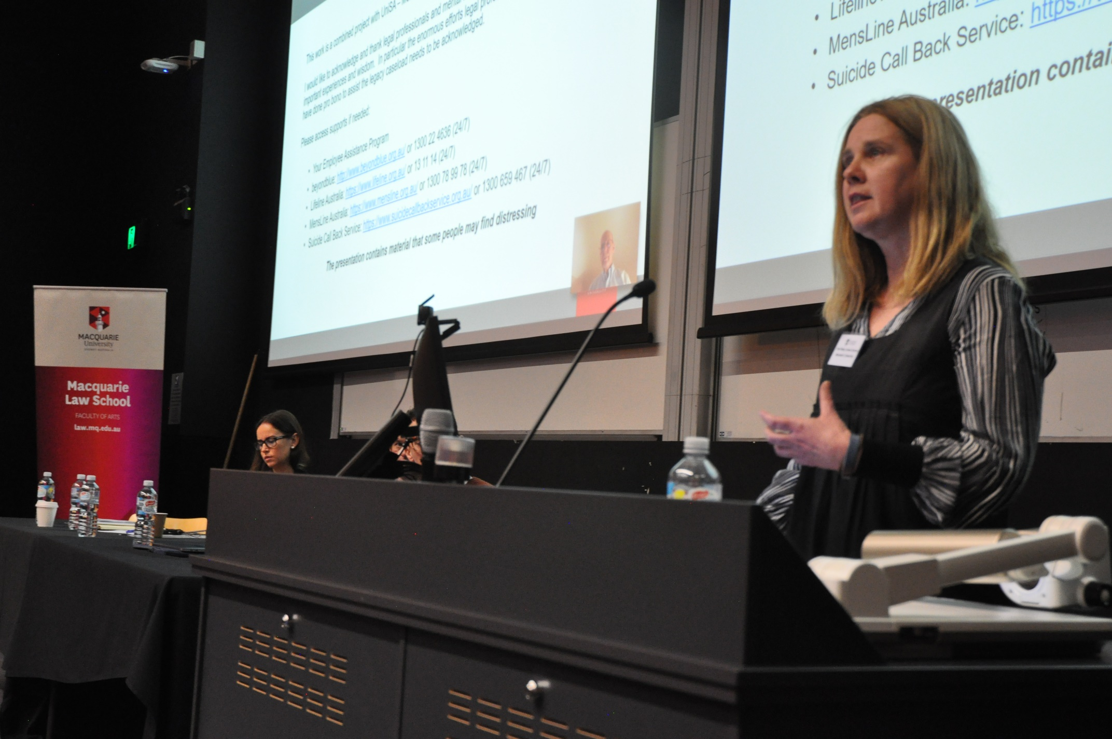

  - Law Reform Commission in WA
  - Referencing the Legacy Caseload, of 30,000 arrivals between August 2012 and December 2013.
  - Throughout the continual period of people arriving in this period (also incorporates children born to people who arrive during this time).
  - Due to the fast track assessment, discussed how this is impacting on the mental health of asylum seekers and refugees.
  - 87% of decisions are affirmed under the fast track review process compared to around 20% previously.
  - A report that came out 23rd July, looking at the AAT; the high court saying that it can be a good process.
    - Report showed that the merits review was limited on the process.
    - Only eligible for Temporary Protection Visas (‘TPV’) or Safe Haven Enterprise Visas (‘SHEV’).
    - Includes those born after the parent/s arrived. As an example, where the father arrived before 2012 and the mother arrived after 2012, because both arrived by boat, all three are now on different legal tracks due to policy changes and how these are applied, they are processed by different and separate legal processes. This is completely contradictory to family unity and creates a “serious adverse impact”.
    - Another problem is the transition stage for those aged between 18 and 25 as supports end at age of 18.
    - This has a severe mental health impact as parents can be separated from children.
    - There is also the myth of the ‘single males’ as most actually have family overseas.
  - Lethal hopelessness:
    - There have been 22 deaths; some in detention, some in the community.
    - There is a significant impact on refugees, asylum seekers and support workers.
    - How do we try to respond?
    - There was a man who took his life as part of the Legacy Caseload, and another man who attempted self-immolation.
    - Legal representatives were often first responders for witnessing distress.
    - Professor Kenny interviewed 50 lawyers to gain information about the distress these lawyers had witnessed and experienced.
    - Particular distress of Unaccompanied Minors included lawyers talking about resiliency of clients, people unravelling, disassociation, psychotic states and being hospitalised.
    - South Australian University: used crowd funding for suicide prevention organisations and to provide assistance for refugees.
    - Legal professionals were working closely with mental health professionals.

- Dr Nick Martin, ‘Nauru, health care and refugee children: the reality of practicing as a doctor on Nauru’.
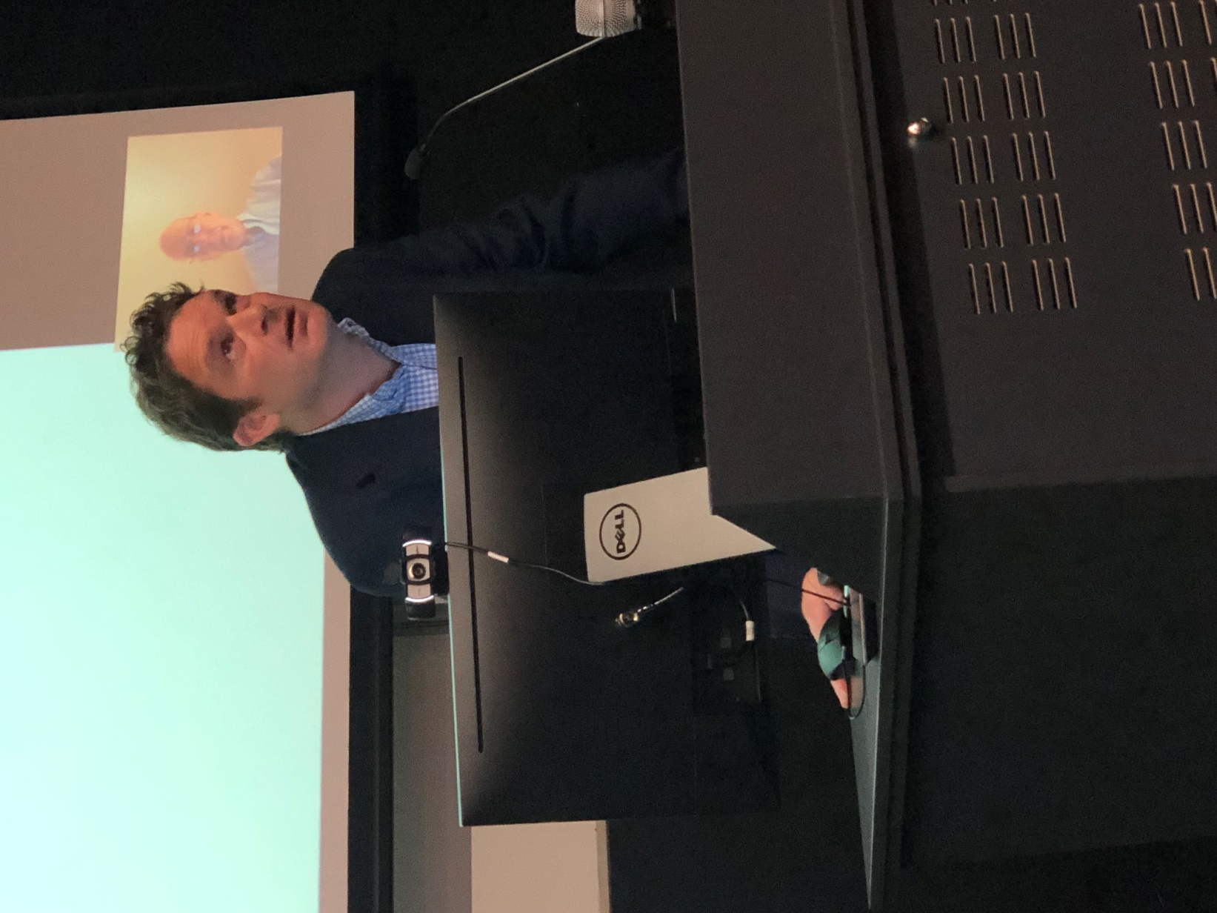
  - Previously worked in Royal Navy in places such as Kosovo.
  - Worked as a Senior Medical Officer in Nauru.
  - Notes the government of Nauru has the responsibility for refugees. These refugees are in Nauru on 10 year residential visas.
  - Nauru is smaller than Sydney’s Tullamarine airport.
  - Money into Nauru is a big factor, they only transfer people to Australia if they are in life threatening situations.
  - The Republic of Nauru (‘RON’) hospital is the national hospital that employs people who were not doctors as doctors. The government is chaotic and they are also responsible for these people.
  - IHMS: is the company employed by the Department of Home Affairs to give medical advice.
  - There are occasions where the Government of Nauru say the refugees can’t come off and use that power.
  - Duty of Care in regards to those people and asylum seeker healthcare:
  - Some refugees are in their 7th year of indefinite detention.
  - Where the ‘kids off Nauru’ protest and outcry was prominent in the Australian community, kids who arrived on Nauru at age 13 are now aged 20; there are no longer kids on Nauru because they have grown up to be adults in indefinite detention.
  - The burden of mental health leads to PTSD, and psychiatric diagnoses as a consequence of Australian offshore detention living conditions. There are poor conditions for pregnant women and stress caused due to family separation and Australian Border Force (‘ABF’) strategies.
  - As a doctor, he was confronted by people being often mugged, robbed, attacked by packs of dogs.
  - When kids were held there, they were not attending schools.
  - Pregnant women needing terminations should be done earlier at 8 weeks. Yet wouldn’t be allowed into Australia (delayed process), where termination was taking place at 20-22 weeks. This was the deliberate policy in place causing these women to leave later.
  - There is coercion being used to keep children where they were and in horrific situations under Peter Dutton and Scott Morrison.
  - This has created a generation and cohort of people in community detention in uncertain situations with a legacy of mental health issues who are living with the ongoing consequences of keeping them on Nauru.
  - They are experiencing complex and chronic trauma missing childhood development.
  - The policy which separates families create hopelessness and leads to levels of abuse by guards, Nauruan people and vicarious trauma from the stories added to their horrific journey and why they left their homes.
  - Nauru don’t have to release any information.
  - Call to action: there is a job needed to triage all the lawyers to get together and assist people needing medical attention.
  - Organisations on Naura work for the sole purpose of keeping people on Nauru.
  - This comes at a large cost to the Australian taxpayer.

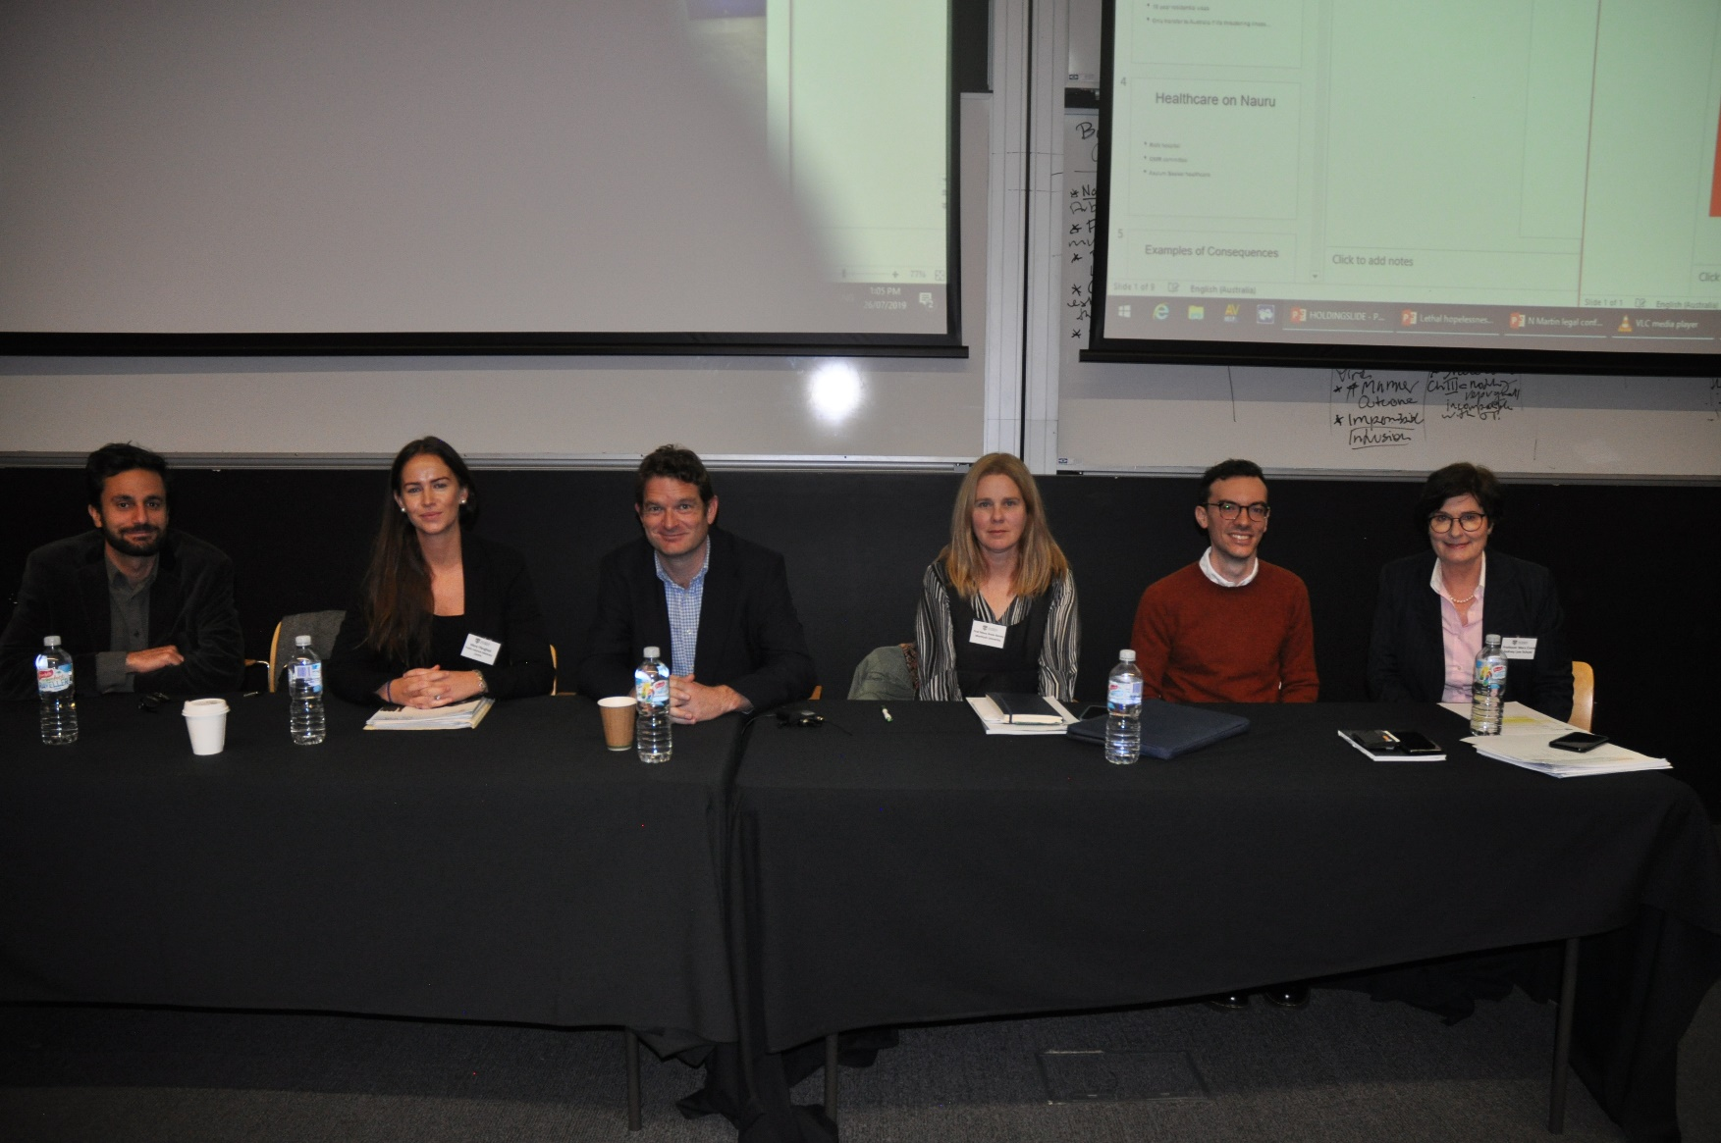

Breakout Session 2— (1.) Asylum seeking children.

- Chair: Dr Noam Peleg, UNSW Law School.

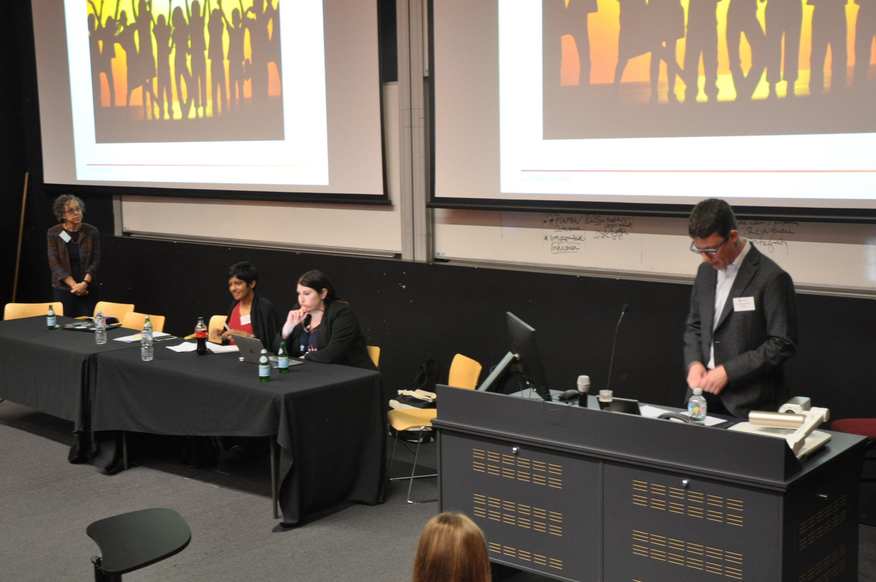

- Associate Professor Savitri Taylor, La Trobe University (Melb), ‘Asylum seeking children and the Australian protection visa process’.
@SavitriTaylor / s.taylor@latrobe.edu.au
  - Noted Article 3 and Article 12- where children are acknowledged as capable forming their own view, the right of child to participate).
  - The application for a protection visa and those who are rejected, may apply for merits review under Part 7 Migration Act (to the AAT –refugee section).
  - The Department of Home Affairs, (‘DHA’) is arguably inconsistent with Art 12 (the right of child to participate)
  - This should be enabled in an appropriate, child friendly setting.
  - There is an Annex dealing with minors where accompanied or unaccompanied. As a UAM, in their own right they can make an individual protection claim through procedures.
  - The AAT have Guidelines on vulnerable persons. Children fall into this category, where the tribunal is to be constituted by a member with relevant experience.
  - They are allowed additional representation or support and members are provided with guidance through departmental decision makers.
  - The DHA and AAT are compliant in practice.
  - AZAEF v MIBP [2016], shows Australian officials don’t always get it right through interviews with child members.
    - In this case, they asked a 6-year-old some questions where an assessor rejected them on credibility grounds.
    - But the appellant was held to have been denied procedural fairness as there was no opportunity to comment after the 19-and-a-half-year-old, half-brother was disbelieved (the other sibling was not told of this).
    - Held it was only perfunctory assessment of the half-brother.
  - UN CRC General Comment Number 12: outlines there should be sufficient knowledge and understanding of a support person or family member, as they may not be the appropriate representative of the young child.
  - It is problematic where there is no consideration of whether the parents are the appropriate representative.
  - WZAOT v MIC [2013]
    - Jurisdictional error, where the decision maker has failed to consider the best interests of the child.
    - Ceased to be conducted in a just and fair way
    - Justice Barker held the mother was uniquely positioned due to the confluence of interests between mother and child.
  - MZAHU v MIBP [2016] FCA
    - The second appellants in the AAT upon application for judicial review were denied procedural fairness.
    - Justice Buchanan held WZAOT was distinguishable as it was a claim for a protection visa application based on their own right (where the legal representative had been unsuccessful in the previous case).
    - There was no conflict of interest regarding the ‘the notion that the mother should not speak for the child’.
    - It would be better to separate representation where the mother supports FGM and also where the mother’s claim fails and the child faces refoulement.
    - This was complicated by comprehension and communication abilities.
    - DHA getting help from the immigration advice and application assessment scheme IAAAS.
  - AXL17 v MIBP [2019] FCA
    - Federal Circuit Court relied on the Federal Court where it was argued that the AAT had failed to take the best interests of the children as a primary consideration.
    - The judge said no, this had not happened (this was compliant with Australian Domestic law at the time that shows non-compliance with international law.)
    - Though it was commented that the best interests of the child are important when a child comes up against border forces as this is overbearing.
  - Noted the concluding comments in 2012 of Australia’s comments to the Committee of the CRC and the Attorney-General’s written response to CRC report.

- Professor Lenni Benson, leading immigration scholar, New York Law School, ‘Children caught in the web of bureaucratic borders’.
  - Smugglers, people movers, or people smugglers, also known as ‘coyotes’ tell the children to surrender which they usually do. If they are UAMs, they are then detained and are likely to be released to a ‘sponsor’ (which is not a legal term). Most of the time, this is a close or immediate relative where it is true that they’re looking for refuge.
  - In the US, there are 11 million undocumented migrants, with a high percentage from Central America.
  - At the border control stage they are given packaged food, children are kept by the ‘office of refugee re-settlement’.
  - Every day, 14,0000 children are in in detention (these look like juvenile delinquency set ups).
  - NYC receives a high percentage of people coming over.
  - However, if a child is Canadian or Mexican, unless they make a relevant trafficking claim, they are going to be taken back.
  - There are two NYC immigration courts in lower Manhattan, including the largest court in the immigration system.
  - LA has 100,000 cases where 15,000 cases are children.
  - It was argued that a child doesn’t need an attorney if they have a parent.
  - In processing, they are then ordered to go to an asylum office where they might have to travel for days.
  - In describing the bureaucracy of borders Professor Benson talked about how they re-characterised what a child is and changed jurisdictions saying the asylum office no longer have jurisdiction and now involve five separate federal agencies.
  - Several clients were accused of being gang members due to artworks.
  - Outlining a problem, Professor Benson described how there was no database to read the lower court cases, to see why cases had won as judgments were not written.
    - A judgment was only written when the court decided against the child and an accessible record of decisions was only becoming available for appellate purposes. So they had started collecting a database of these cases.
    - UAMs were on track to hit 66-70,000.
  - Children cannot be detained for more than 20 days with adults.
  - Children represent 10% of court cases.
  - Trump has not been putting out regulations.
  - Tijuana is a very dangerous border city for girls and transgender people where they are preyed upon by gangs.
  - They will adjudicate their claim but the applicant must wait in Mexico.
  - Lawyers who are trying to help people are at risk as the government is saying they’re violating migration law by going down to Mexico to help and can be arrested as people smugglers.
  - Another issue is where decision makers will be fired if determinations are 20% out of consistency with appeal opinions.
  - The Attorney-General has also been writing their own opinions.
  - It was said the Federal Court would be the only one with authority for release and be non-appealable.
  - The immigration judge is not empowered to enact international law, nor empowered to judge on constitutional law either as it has to be embedded in domestic law.

- Sarah Dale, RACS, ‘Protecting asylum seeking children: The role of the independent guardian’.
  - As the principle solicitor at RACS, Ms Dale heads up the legal practice ensuring refugees are given a fair hearing working with kids seeking asylum under 18. She also represents refugees before the UN Human Rights Committee.
  - Worked with kids who were under 18 at the time of arrival, shedding light on the government’s policy that ‘ages out children’. She interviewed with boys who were 17 and are now 23/24 and she argued they should be processed as if they were assessed 6 years ago.
  - As a sector, Ms Dale argues we should move away from this idea that once the age changes to 18, the transition of policy to adult kicks in; that this is misinformed.
  - A UAM, without a parent/guardian, an unaccompanied humanitarian minor, whether they arrive through air or boat, she describes them as – ‘you are pretty lucky because the Minister for Border Protection or Immigration is your dad’, ‘he is your guardian’.
  - This continues until you turn 18 or you leave Australia permanently.
  - In NSW, Life Without Barriers, are service providers who provided welfare and support whilst refugees and asylum seekers are waiting for their case to be processed.
  - A large number of people are detained as children.
  - Under the Migration Act, s 4AA, outlines detention should be at the last resort, but in practice, this is not what is seen as children are detained for ‘long-periods of time’.
  - The Minister being a guardian for children is an absolute conflict because the Minister is there and we see time and time again that the exercise of those pieces of legislation is in direct conflict to the interests of the child.
  - Under the Guardianship Act, under s 8, the best interests of child do not impose obligations upon the Minister over that of the Migration Act.
  - Legislation that we rely upon to protect UAMs, goes so far as to say the best interests of the child do not trump the provisions of the Migration Act.
  - So why is this still an issue where kids are off Nauru?
    - Whilst numbers are low, children are still held in detention and lack the protection of a family unit, where they are still at risk and their visas can still be cancelled.
    - As an example, where two UAMs were given the status of their parents; they were not heard and basically given no legal rights.
    - Where they are unaccompanied, the legal guardian is the Minister.
    - Domestic law, even outside of the Guardianship Act, the best interests of the child aren’t ever required to be considered by the law.
  - The problems:
    - An example, Asylum Seeker Tye arrived at age 15, on the 20th of July 2013 and had the Minister appointed as his guardian.
    - The Minister had a choice to detain him on Christmas Island under Government policy and held he must be transferred from Nauru to Manus Island. This was not in the best interests of the child as he was detained for 18 months.
    - Now in FOI applications, where the ‘best interest determination’ in the records appears– a line is struck through that page and left blank where a box is ticked indicating he was a ‘boat arrival’.
    - As another example, John, a young boy from Hazari town, Pakistan, an area constantly bombed in his school was attacked. His parents made the decision he needed to go to Australia and John was held in community detention after arrival.
    - John hated going to school for this reason and yet a condition of community detention was that he attended school. No other alternative arrangements were put to him nor was his severe reluctance understood.
    - Instead, he was put in a car by officials and taken to Villawood to be shown where he would end up if he didn’t continue to go to school so could remain in the community.
  - Issues with Children Safe Haven Enterprise Visas (‘SHEV’):
    - These are temporary visas so a person on this type of visa can’t bring their family. Nor are they eligible for tertiary education. Under the SHEV visa, they are qualified as an international student but because of tuition fees, these places are not obtainable due to cost.
    - Positively, universities are now providing scholarships (University of Sydney, Western Sydney, University of New South Wales).
    - The Minister can give them this visa yet they have no rights to stay, no rights to an education, or bring their family. The Minister therefore is granting these children visas that are not in their best interests.
    - An anomaly case could easily be identified where due to young age, a child may not be able to articulate their fears and concern for their family where the Minister, the child’s legal guardian then orders the child will be returned.
    - In comparison, a lawyer needs to articulate what the child tells the lawyer they want. Yet in immigration, why is there not a voice for the best interests of the child as the Minister doesn’t act in their best interests
  - Recommendations:
    - We need to repeal, strip and reform the Guardian Act.
    - There is not even consideration of whether parents represent the best interest of their child/children where for example, parents views might be in conflict with their child’s best interests.
    - In the US, there is another person, who acts as a guardian analyst to help make a best interest determination as part of the immigration system (Not part of US asylum).

Breakout session 2 – (2.) Migrant Children and Best interests Determinations

Elizabeth Frankel, Young Center for Children’s Rights, ‘Strategies for determining the best interests of migrant children’

Dr Belinda Liddell, Refugee Trauma Recovery Program UNSW, ‘Mechanisms underlying the impact of family separation in mental health’

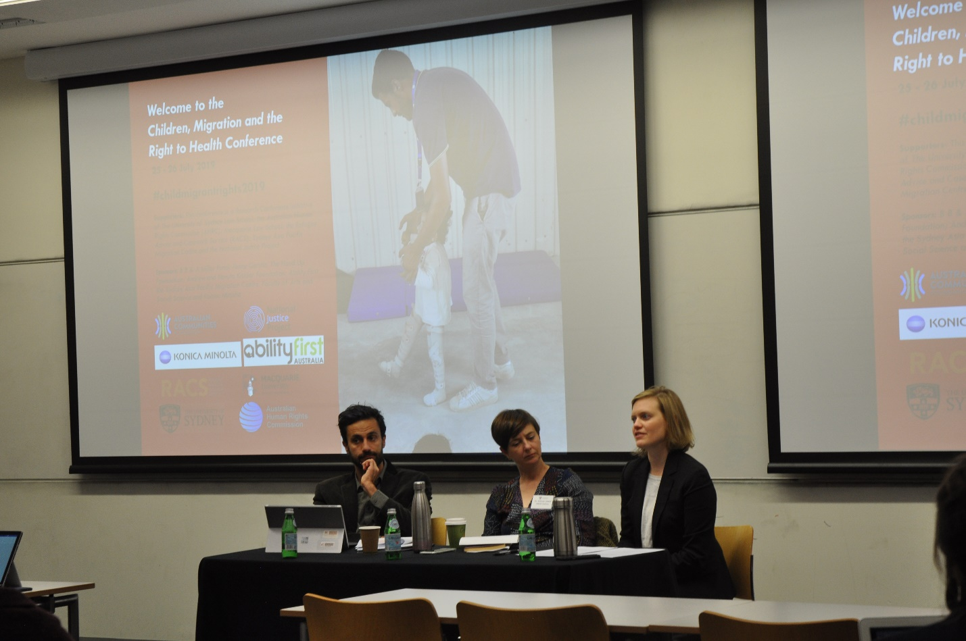

Migrant children and best interests determinations
- Elizabeth Frankel
  - US govt separate child and parents
  - 700 families
  - Average age 7
  - 50% - 5
  - A month to reunify
  - 3 times normal child in the detention
  - Child don’t recognise with parents
  - Institutional setting detending children
  - Mexico boarder age 0-17
  - Facilities for teenager not for kids – just expand the license
  - Child advocate – for the best interest of child
  - System is for adult – lack of facilities for children – appeal to the court alone
  - Immigrant system – don’t require the federal court to consider the BOC
  - Didn’t ratified CRC
  - Change single cases -> change judges expectation -> expand
  - Practice – appreciate for the BOC recommendation
  - 3 steps
    - Gathering – learn child cases
    - Develop recommendation – avoid
    - Advocate BOC
  - Learning child – child first
  - New model
    - Bilingual volunteer under supervision – cultural confidence – build trust – open up
    - Volunteer – time – 1 v 1 – visit once a week – 6 months – spend time with the kid
    - Help to open up – activities eg. drone, mobility mapping (draw community, what they like/dislike)
    - Health issue – psychologist
    - Presume child telling truth
    - Parents, family members
      - What parents want for children – speak for BOC
      - International house study
      - Assessment of safety
    - Talk with stakeholders – eg. Govt
  - Develop recommendation
    - Best interest in US – primary goal – find out pro/con state welfare system
    - Ensure the child’s voice
  - Child advocate paradigm for assessing best interests – state/international law
    - Childs wishes – child advocate should always advocate for the child wishes unless there is a clear risk to safety
    - Childs safety – the child advocate should always advocate for the child’s safety
    - Family unity – child’s right to be with parents, siblings, children
    - Liberty – child’s right to be free from detention
    - Development – child’s right to food, shelter, education and medical care
  - Cases
    - Sarah, 3 yrs old, parents back home, can’t speak for herself - see 5months with no movement -> speak to parents -> advocate for return
    - 2 sisters 3, 5 – mother deported – willing to reunify with mother – mother hit one girl before – not confident -> international home study - > no risk to home -> spend time with girls -> find out they want to be with the mother
    - Conflict between kid and the parents – child 13 – grow with mother to age 3 – than with grandma and 2 aunts – can’t pay the threat
    - Govt separate the grandfather with the child – child want to go to aunt (who raise him from 3 to 13 )instead of father. Father disagrees - Govt caution when child not unify with parents – child’s decision
    - Complex cases – panel – help to resolve the best interest of the child
  - Collaboration – get input from other people – see outside bias, own perspective – case consultations
- Belinda Liddell – mechanisms underlying the impact of family separation on the mental health of refugees
  - Family separation impacts on mental health – depression, PTSD, disability, reduced quality of life, sadness, worry, guilt, helplessness, low energy, insecurity
  - Family separation impacts on settlement
    - Reluctance to settle
    - Difficulty establishing self without familial references
    - Sense of foreshortened future
    - Increased burden/changed roles/family expectations
    - Cultural disruption
    - Cognitive effect, difficult to learn skills
  - Why separation so harmful
1. worry
fear for safety of separated family members
Guilt, powerlessness, distress and uncertainty
2. social
low support, additional burden and new roles
Unmet emotional needs, no buffering effect to assist with stress coping
3. $$
economic burdens
Remittances and pressre to support separated family
4. cultural
collectivistic self-representation places high value on family cohesion – central to self-identity
Reduced continuity of cultural practice
  - Refugee adjustment study
    - Longitudinal investigation of changes in refugee and asylum-seeker mental health over time
    - Participants
      - Arrived after jan. 2011
      - Refugee, asylum-seeker background
      - Not living in detention centre
  - Participant-focused approach
    - Participants 1085
    - 5 surveys, every 6 months
    - 23% no family in Australia

Breakout Session 2— (3.) Refugees with Disability

Asher Hirsch, RCOA and Monash Law School, ‘Barriers and exclusions: The support needs of newly arrived refugees with a disability’

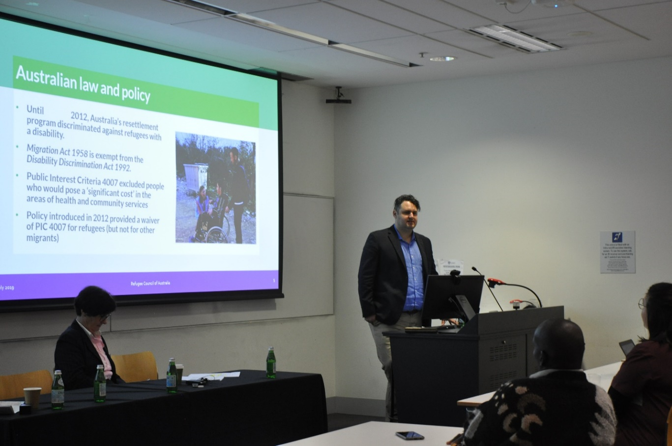

Introduction
- A lot of disabilities are not visible to the naked eye
Asher Hirsch (AH)
- Report published in February 2019 (collaboration between FECCA, NEDA, RCA) – Barriers and Exclusions: The support needs of newly arrived refugees with a disability
- Former refugee from Iran (a stateless Kurdish person) has become a close friend. Became blind due to an improperly performed surgery.
- Spent almost 2 years in immigration detention.
- Learnt to write and read in Braille and speak English.
- Former Disability Discrimination Commissioner advocated for his release.
- Currently on a SHEV visa, now a Paralympian.
- Highlights policy problems – but also amazing resilience through the whole process.
- The global picture
- Refugees are statistically more likely to have a disability – war, violence, inadequate healthcare
- Only in recent years has this group been a focus for research and advocacy
- International law
- Protections/rights under CRPD, Refugee Convention, other HR treaties
- Resettlement – not an obligation under the Convention, but a voluntary commitment from signatory States.
- AH: Australia and other States should not be discriminating against refugees with disabilities in resettlement – violation of CRPD. But regularly happens.
- The focus of resettlement is vulnerability – we should see more people with a disability come through this program, rather than less.
- Recent steady increase in those arriving and being granted a humanitarian visa (persons who need assistance).
- Australian law and policy
- Until 2012 – Australis had a policy in its resettlement program which discriminated against refugees with a disability (Public Interest Criteria 4007 – excluded people who would pose a ‘significant cost’ in health/community services)
- Migration Act is exempt from Disability Discrimination Act
- Removal of policy by waiver in 2012 (PIC 4007)
- Barriers: on arrival support
- Lack of information from Department of Home Affairs to settlement organisations (assisting refugees on arrival in Australia) about needs of persons prior to arrival
- Policy and practice issues affecting people when they arrive in Australia
- Delays in medical assessments – many months wait to be assessed by specialists.
- Delays in specialist support and equipment – wheelchairs etc
- Lack of accessible housing
- These issues could be easily resolved by more effective communication.
- Barriers: accessing the NDIS
- Lack of support to navigate and apply for NDIS
- Difficult even for native English speakers/educated persons to navigate the NDIS system – exacerbated for refugees
- Very little interpreter support
- Lack of support to obtain specialist assessments
- Lack of knowledge about NDIS and available services, rights and entitlements – they undersell what they need
- Concept of ‘choice’ in a neoliberal service setting – services may exploit or under-service people
- People seeking asylum and refugees on TPV/SHEV
- No access to the NDIS, and no access to state-based disability services
- No access to the Disability Support Pension
- People are living on about $400 a fortnight with a disability and supporting families
- Reliant on donations
- Lack of available statistics
- We do not know how many people are arriving in Australia with a disability
- Recommendations in the report
- Provide access to the NDIS for those on temporary visas
- Many other recommendations

Associate Professor Edwin Abuya, ‘Child Refugees with Disability in Kenya’

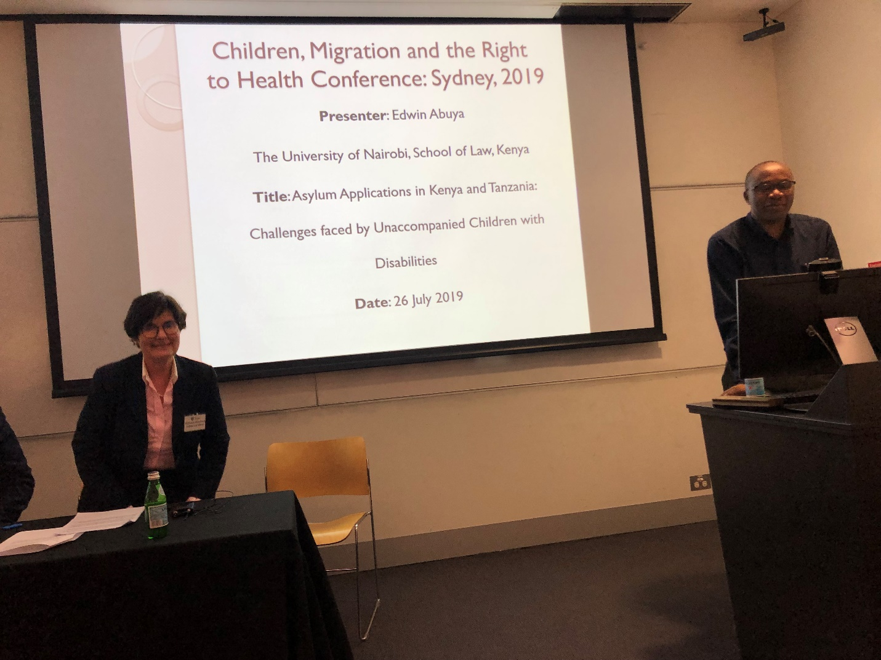

Dr Edwin Abuya
Focus: displaced children with disabilities in Kenya/Tanzania
- Motivated by happenings when he was in Australia in 2001-2004 (Tampa etc)
- Current experience with disabilities: students in his class with disabilities.
- A blind student was unable to download the necessary program onto his laptop to facilitate the upload of his assignment.
- Lay of the land
Kenya and Tanzania – refugees from Somalia, Ethiopia, South Sudan, DRC, Rwanda, Burundi etc
- Kenya - refugee population of 474,000
- Tanzania - refugee population of 340,000
- Characteristics of children – vulnerable, inquisitive etc
- Overall protection
- General duty to protect unaccompanied minors (UMs)
- PWDs (CPRD art 11, art 12 African Charter)
- Layers of protection – international conventions, regional charters and protocols (including new instrument – Protocol to the African Charter on Human and People’s Rights on the Rights of Persons with Disabilities in Africa 2018), domestic legislation (refugee legislation, disability specific, constitutional provisions)
- But note: some protections only available to citizens (eg constitutional provision re access to information)
- Protection concerns for UMs
When families flee, they may leave their disabled children behind. Why?
- Cultural attitudes (eg children hidden away – viewed as caused by a ‘curse’, or you just don’t want others to see your children because of stigma)
- Discrimination (communities will discriminate against UMs left behind)
- Communication barriers (particularly for the deaf)
- Movement/access
- Access to justice (informal justice rather than formal justice)
- Health
- Protection concerns: limited judicial protections
- Dignity – must be tied to privacy and prohibition on degrading treatment
- Repatriation is another concern
- Conclusion: Interventions
- Some equipment being provided by local NGOs
- Judiciary – reasonable accommodation
- Government commissions, continental courts and commissions
- ACHPR Special Rapporteur
- Statistics are important, as well as access to other information
- Inclusion is essential
Professor Mary Crock (standing in for Dr Laura Smith-Khan)
‘The Highest Attainable Standard: The Right to Health for Refugees for Disabilities’
Introduction
- ‘If you are not counted, you don’t count.’ Unseen and forgotten refugees with disabilities
- Professor Crock – went to Jordan, Turkey, Pakistan, Kenya, Uganda, and Indonesia, facilitated by the UNHCR
- ‘Quick and dirty’ research
- Brought paper copies of functionality questionnaires. Many self-reported ‘no disabilities’, but then in answering functionality questionnaires many disabilities were revealed.
- WHO global survey – about 12% have disabilities.
- Professor Crock believes 30%+ living with disabilities (once age is also taken into account as an aggravating factor)
- UNHCR – good at acknowledging when they have not been on top of a certain area
- They were relying upon self-reporting, and visual observations of persons with disabilities
- Out of 150,000 refugees in Malaysia (largely from Laos), they reported 202 cases of disability – manifestly inaccurate statistics.
- Incorrect that refugees ‘do not travel’ – refugee families brought disabled persons with them. But would be ashamed of them and afraid of them.
Human rights framework in refugee host countries
- All countries visited had signed the CRPD
- Resettlement exceptional in most displacement contexts
- Limited access to health and education

Supporters: This conference is a Research Conference initiative of The University of Sydney Law School; the Australian Human Rights Commission (AHRC); Macquarie Law School; the Refugee Advice and Casework Service (RACS); Sydney Asia Pacific Migration Centre and the National Justice Project.
Sponsors: B B & A Miller Fund; Penny Gerstle, The Hand Up Foundation; Andrew and Renata Kaldor Foundation; Ability First, Sydney Asia Pacific Migration Centre, Faculty of Arts and Social Science and Konica Minolta

See here: <https://www.referendumcouncil.org.au/sites/default/files/2017-05/Uluru_Statement_From_The_Heart_0.PDF>.
Access to the report: “Lives on hold: Refugees and asylum seekers in the ‘Legacy Caseload’ ”, is available here: <https://www.humanrights.gov.au/about/news/urgent-call-government-protect-asylum-seekers-and-refugees>.
See more information on Professor John Tobin here: <https://findanexpert.unimelb.edu.au/display/person5825#tab-publications>.
For full statistics and graphs see slides.
For more information, see here: <https://dfat.gov.au/people-to-people/volunteers/Pages/smart-volunteering.aspx>.
https://goodonyou.eco
https://fashionforgood.com/news/resource-library/good-fashion-guide/
https://www.sedexglobal.com
https://frdm.co
http://www.unglobalcompact.org.au/
See report here by Dr James Renwick SC, INSLM: <https://www.inslm.gov.au/sites/default/files/files/inslm-report-prosecution-sentencing-children-for-terrorism.pdf>.
See more about Jason Pobjoy here: <https://www.blackstonechambers.com/barristers/jason-pobjoy/>.
See more about Professor Goodwin-Gill here: <https://www.law.ox.ac.uk/people/guy-s-goodwin-gill>.
See more about Professor Jane McAdam here: <https://www.law.unsw.edu.au/staff/jane-mcadam>.
For more information on this case, see here: <https://www.humanrights.gov.au/our-work/hreoc-report-no-25>.
See reports here: <https://www.homeaffairs.gov.au/reports-and-publications/reviews-and-inquiries/inquiries/circumstances-of-the-immigration-detention-of-cornelia-rau-vivian-alvarez>.
See case here: <http://classic.austlii.edu.au/cgi-bin/sinodisp/au/cases/cth/FCA/2018/63.html?stem=0&synonyms=0&query=title(FRX17%20)>.
For more about Life Without Barriers see here: <https://www.lwb.org.au/find-a-service/refugees-and-asylum-seekers/>.

