Comprehensive Course Review Form Instructions

1. Purpose

The purpose of the comprehensive course review process is to provide an opportunity to consider, review, evaluate the academic quality of a course to make an informed decision on the academic re-accreditation of the course and inform recommendations for improvement, alongside fulfilling the University’s monitoring requirements. The Comprehensive Course Review is the University of Sydney’s mechanism for course re-accreditation for the subsequent 7-year period.

The Comprehensive Course Review form is designed to ensure you capture all information in the review, which is required for course re-accreditation purposes, as well as the University Learning and Teaching Policy 2024 and by the Higher Education Standards Framework (HESF) standards, which we must meet to maintain our registration with TEQSA.

Benchmarking
As part of the review, the course must be evaluated against appropriate external benchmarks wherever possible throughout this report, where the minimum benchmarking requirements that must be reported are:
- Course content, course structures and course learning outcomes.
- Student progression, retention, success and completion rates (when available).
- Teaching, learning, assessment methods and grading practices for selected core units.

Additional benchmarking is also based on (but not limited to) areas: course outlines, graduate capabilities, admission criteria, feedback from advisory panels, graduate employers, industry groups or peers at other institutions, cohort analysis.

Consider benchmarking against 3-5 comparable courses across the Group of Eight universities (Go8), non-Go8 + 2 (UTS and Macquarie), international competitors and/or where applicable, the private sector. Throughout the review, describe any examples of good practice that could be adopted from other universities that would lead to overall improvement to the course quality.

2. Instructions for Faculty Curriculum Manager (or delegate)

Faculty Curriculum Manager (or delegate) should refer to the Academic Quality Assurance Procedures 2026 for detailed information about supporting Comprehensive Course Reviews. The instructions below outline the necessary steps for conducting a comprehensive course review. Refer to Addendum 1 and Addendum 2 for guidance on completing the course review.

2.1 What you need to do

- Refer to Addendum 1 for guidelines on completing the review report and Addendum 2 for data guide.
- In collaboration with the Curriculum and Policy team and other teams as required, complete Part 1 and pre-populate Parts 4 and 5 with data from the University’s sources.
- Ensure that a copy of the pre-populated course review report is sent to the Curriculum and Quality Team, Division of the Academic Registrar for a preliminary regulatory alignment assessment.
- Ensure this is done before the draft report is sent to the panel for discussion.
- Any feedback provided on the regulatory alignment must be presented to the Comprehensive Course Review panel for consideration as part of the course review.
- Send any subsequent draft and/or final course review report to the Curriculum and Policy Team, Division of the Academic Registrar for feedback before it is submitted to faculty governance committees for consideration.

Faculty Curriculum Manager (or delegate)
Name
Title
Email
Phone
Faculty/University School | Choose an item.
Date completed report is due for submission to AQC: Click or tap to enter a date.

3. Instructions for Program Directors

It is important to ensure the review panel and the final report adopts a reflective, evaluative tone. Panels are encouraged to use evidence to honestly identify the strengths and weaknesses of a course, and solutions to further enhance quality. The focus should be on the specific context of this course. This is an important difference from similar processes (e.g., professional accreditation).

3.1 What is provided

The Curriculum and Policy team and your Faculty Curriculum Manager (or delegate) have pre-populated your course review form with analysis and data from the University’s sources. If you need to investigate any of the data more closely, and you do not have access to the systems which generated the data, or do not know how to use the University’s reporting systems, refer to Addendum 2 and contact your Faculty Curriculum Manager (or delegate). A library of high-quality Comprehensive Course Review exemplars from a range of disciplines can also be found at the Academic Quality Committee SharePoint site. Additional resources, include the Guide for Course Review Chairs.

3.2 What you need to do

Refer to the Academic Quality Assurance Procedures 2026 for further information. To complete the Comprehensive Course Review report:

- Refer to the Academic Quality Assurance Procedures 2026 for information about panel membership and the Terms of Reference (ToR).
- Form a review panel.
- Complete section 3.3 and parts 4 and 5 of the report, providing context to the data, evaluating the course against external benchmark where relevant
- Send the contextualised data and any other relevant information to the panel before the first meeting.
- With the panel:
- Collect and review feedback from students (beyond those who are panel members), staff and other stakeholders
- Complete the initial report with recommendations.
- Seek feedback from the Faculty Curriculum Manager, Curriculum and Policy team in the Division of the Academic Registrar, Education and Students Portfolio, and where appropriate the Dean to review recommendations with panel.
- Finalise recommendations and implementation plan.
- Ensure that Parts 2 and 3 are filled in.
- Ensure that you attach the following documents:
☐ AQF mapping matrix.
☐ assessment plan
☐ professional accreditation report and any other required documentation, if relevant.
☐ partnership agreements where applicable.
- Ensure that all sections are completed, noting any sections that may not be relevant to the course.
- Send completed review to your Faculty Curriculum Manager (or delegate) for submission to your Faculty/University School Board and Dean’s signoff in Part 6.

Responsible Program Director(s) Details

Program Director 1
Name
Title
Email
Phone
Faculty/University School | Choose an item.
Program Director 2 (where applicable)
Name
Title
Email
Phone
Faculty/University School | Choose an item.
Note: Program Director as defined in clause 5 of the Coursework Policy 2021.

Comprehensive Course Review Report

PART 1: COURSE DETAILS (completed by Faculty Curriculum Manager (or delegate) AND CURRICULUM AND POLICY TEAM)

Fill out the table below for each course included in this Comprehensive Course Review. E.g. if reviewing a Master’s program with embedded degrees, please complete a separate table for each course.

1.1 | Course name | e.g. Master of Social Studies (International)
1.2 | Course code  As per course resolutions, including any alternative versions included in this review | e.g. MAINTSTU-01
1.3 | Credit point value
1.4 | CRICOS Course Code/s  As listed in the CRICOS Register
1.5 | Combined degree type  If applicable | ☐Combined  ☐  Double  ☐ Vertically integrated
1.6 | Honours type  If applicable | ☐ Appended  ☐Integrated  ☐ Embedded
1.7 | Course AQF Level | ☐ Level 5: Diploma  ☐ Level 6: Advanced Diploma / Associate Degree  ☐ Level 7: Bachelor Degree  ☐ Level 8: Bachelor Honours Degree / Graduate Certificate / Graduate Diploma  ☐ Level 9: Masters Degree [Research / Coursework / Extended]  ☐ Level 10: Doctoral Degree
1.8 | List the Admission requirements for the course  As per course resolutions
1.9 | Study mode | ☐ Full time  ☐ Part time  ☐ Both
1.10 | Mode of delivery | Face-to-face | ☐Yes ☐No
1.10 | Mode of delivery | Face-to-face or online (by student choice) | ☐Yes ☐No
1.10 | Mode of delivery | Online | ☐Yes ☐No
1.10 | Mode of delivery | Multi-modal | ☐Yes ☐No
1.10 | Mode of delivery | Offshore | ☐Yes ☐No
1.10 | Mode of delivery | Does the course structures comply with Standard 8 of the National Code by allowing international student visa holders to complete up to one-third of their course online? | ☐Yes ☐No
1.11 | Does the course require work-integrated learning or Internships? |  | ☐ Yes ☐ No
1.11 | If yes, how many hours or WIL or placement hours have been CRICOS registered?
1.11 | If yes, provide details, including a list of the Units of Study:
1.11 | If yes, provide details of how these arrangements are continually quality assured, including consideration of the quality of supervision.
1.12a | Does the course require overseas study? |  | ☐ Yes ☐ No
1.12a | If yes, provide details, including a list of the units of study and location (city/region) and list of suitable exchange partners where students have gone on exchange. Refer to Sydney Global Mobility Dashboard.
1.12b | Does the course allow for overseas study? |  | ☐ Yes ☐ No
If yes, does the course structure allow students to easily undertake international mobility experiences and how does this effect students in meeting the requirements of the overall award?

If no, comment on whether there has been consideration for the inclusion in the design of the course structure.
1.13 | Does the course provide entry to a profession i.e., needs professional accreditation? |  | ☐ Yes ☐ No
1.13 | If yes:  - provide the name of the accrediting body and the current accreditation status of each.  - ensure that a copy of the most recent Professional re-accreditation report is attached to this review report.
1.14 | Is this course a joint award delivered with partner/s? |  | ☐ Yes ☐ No
1.14 | If yes,  - provide the name of the partner/s and the current partnership status.  - ensure that a copy of the most recent partnership/s agreement is attached to this review report.  - ensure that a copy of the credit mapping is attached.  - attach any other relevant documents covering admission criteria, learning outcomes mapping, equivalent AQF level of partner degree, etc.
1.15 | Is this course delivered with articulation agreements/pathways |  | ☐ Yes ☐ No
1.15 | If yes,  - provide the name of the partner/s and an overview of the agreement in place.  - ensure that a copy of the most recent partnership/s agreement is attached to this review report.  - ensure that a copy of the credit mapping is attached

PART 2: REVIEW DETAILS (completed by Program Director)

2.1 REVIEW PANEL MEMBERSHIP

Refer to the Academic Quality Assurance Procedures 2026 to ensure that you have the required panel membership. Add additional rows as needed.

Panel Membership | Name of Panel member | Position title and organisation (if applicable)
Chair
Representative from discipline responsible for teaching in the award course
Representative from discipline responsible for teaching in the award course
Independent expert(s) external to the University
USyd academic staff member(s) from a different faculty
Student representative enrolled in the course (preferably in their final year)/Recent graduate
Additional stakeholder(s) from professions or industry
Other member
Other member

2.2 SUMMARY OF CONSULTATION

This section must list and provide evidence of all key meetings and stakeholder consultations that took place as part of the Comprehensive Course Review.

Date | Consultees | Method of consultation  (e.g., meeting, email, survey) | Summary of outcome of consultation

PART 3 REVIEW RECOMMENDATIONS (completed by panel)

3.1 RECOMMENDATIONS

List no more than 10 recommendations to improve the academic quality of the program. Recommendations must be prioritised, with the most important listed first. Include a brief summary of the review committee’s conclusions that informed these recommendations.

Recommendations should be evidence-based, focused on enhancing course quality and align with SMART criteria - Specific, Measurable, Achievable, Relevant and Timely - wherever possible. Recommendations should not target student recruitment or course marketing. Issues relating to these topics should be raised separately at the Faculty/University School Education Committee.

Will a major curriculum initiative be required as a result of the panel’s recommendations? | Yes ☐ | No ☐

Include a brief summary of the review committee's conclusions that informed these improvement recommendations:

3.2 IMPLEMENTATION PLAN

Develop an action plan detailing how each recommendation will be implemented within 12 to 36 months, including responsible parties, due dates, and review processes.

Improvement Recommendation  (in order of priority) | Responsibility | Implementation due date  (list final date) | Measure of success
1.
2.
3.
4.
5.
6.
7.
8.
9.
10.

Note: An initial status update is required 6 months after the submission of this report, followed by annual updates. Course review panel chairs (or delegates) oversee reporting, which is consolidated by Faculty Curriculum Manager (or delegate). The faculty/University school must report implementation progress of recommendations to Senate, via the Academic Board.

3.3 SUMMARY OF PREVIOUS REVIEW

Complete if this course has previously been formally reviewed. Summarise the recommendations from the previous review and evaluate their implementation on the current course.

Recommendation | Evaluation of implementation

PART 4: ACADEMIC QUALITY

Evaluate the course against appropriate external benchmarks wherever possible, refer to the coversheet for further information. Refer to Addendum 1 for guidance.

4.1 ACADEMIC OBJECTIVES AND COURSE LEARNING OUTCOMES

- Evaluate whether the course learning outcomes and overall academic aims remain suitable and appropriate for the course and its AQF level. Refer to AQF mapping matrix to assist with your evaluation.

4.2 COURSE STRUCTURE/DESIGN

- Evaluate the overall structure of the course, including core, barrier and capstone units, as well as components such as streams, programs, majors or specialisations.

- For professionally accredited courses, describe and evaluate how the external feedback received during the professional accreditation/re-accreditation process has been utilised to improve the course structure and overall quality of the course.

- Using evidence, identify and evaluate whether any course design elements may need to be amended to better the course and/or align the course to the current curriculum design principles/curriculum design requirements as part of the next academic reaccreditation cycle

4.3 PEDAGOGICAL DISTINCTIVENESS AND DEVELOPMENTS IN THE FIELD OF EDUCATION

- Evaluate the teaching approach of the course. In your evaluation, consider what elements make its pedagogy distinctive and what advantage these distinctive features provide to students and their learning experiences.

- Evaluate how the course curriculum reflects and integrates recent and emerging developments in the field of educations to enhance learning outcomes.

- Evaluate the course’s approach to cultural competence with a particular focus on fostering ethical, respectful, and effective engagement with Aboriginal and Torres Strait Islander cultures and knowledge systems. In your evaluation, consider how well the students develop and demonstrate a mature understanding of contemporary cultural competence issues.

4.4 ASSESSMENT PROCEDURES, VOLUME OF LEARNING AND LEARNING OUTCOMES

- Critically assess and evaluate the program-level assessment design. Include the most recent version of the assessment plan as an appendix, updating it if necessary/appropriate. Refer to Addendum 1 for further guidance.

- Evaluate the effectiveness of assessments in terms of authenticity, quality, horizontal alignment and load, constructive alignment and vertical scaffolding of assessments.

- Assess the effectiveness of educational integrity and misconduct initiatives and risk mitigation strategies in maintaining academic integrity within the course by commenting on trends in integrity breaches and misconduct, identifying areas with high breaches and misconducts and indicating the strategies to reduce these.

- Evaluate how generative AI and other emerging technologies are integrated into the course design and assessment plan. In your evaluation, consider the measures in place to uphold assessment security and integrity when using AI technologies, including monitoring practices to ensure assessment reliability and fairness.

- Evaluate the volume of learning in this course with consideration for the AQF requirements for the qualification level, volume of learning, total learning hours, student workload, learning outcomes, and comparison with similar accredited programs.

4.5 ADMISSION PATHWAYS

- Evaluate alignment of the course’s admissions criteria with the AQF standards. In your evaluation, comment on whether the admissions appropriately support students' success, or leave them underprepared or over prepared.

- Assess whether the course’s admissions requirements effectively support the inclusion of diverse student cohorts (e.g. domestic vs international, socioeconomic background, gender, disability status, Aboriginal and Torres Strait Islander background, or other relevant factors). Identify areas of improvements to better support the admission of diverse student cohorts.

- Evaluate admission data over time to assess the progress and success of students based on their admissions pathway, and how they perform relative to other cohorts. Identify and discuss any specific areas of concern regarding student success and completion, including challenges faced by particular student cohorts and describe any plans or initiatives aimed at improving student success and completion rates within the course. Describe and evaluate patterns in student attrition and the effectiveness of targets strategies implemented in response.

4.6 STUDENT SUCCESS, COURSE COMPLETION, STUDENT EXPERIENCE AND GRADUATE QUALITIES

- Evaluate student success (unit of study pass rates) and course completion numbers (number of students who complete the course requirements) in comparison to similar internal and external programs. In your evaluation, consider whether the outcomes meet the objectives of both the course and the University.

- Evaluate the use of universal design and related curriculum principles used in this course to ensure the needs of all students, including those with disabilities and/or from culturally diverse backgrounds are addressed. As part of your assessment, evaluate whether outcomes (e.g. retention rates, completion rates, and average grade attainment) for students from culturally diverse backgrounds and/or with disability are equivalent to the rest of the study body.

- Assess whether students are effectively demonstrating the expected course learning outcomes and graduate qualities.

- Describe and evaluate any areas of concerns and discuss strategies, initiatives, or planned improvements designed to enhance student achievement of graduate qualities.

- Evaluate the course’s performance in the Student Experience Survey and Course Experience Survey compared to similar programs. In your evaluation, identify key areas of substantially higher or lower performance and explore potential causes, including variations among specific student cohorts (e.g. students from diverse backgrounds).

4.7 QUALITY ASSURANCE

- Evaluate the faculty and/or discipline (or similar) level processes that contribute to course quality assurance and enhancement of your course. In your evaluation, consider mechanisms such as external benchmarking, professional body evaluation, peer mentoring, teaching staff feedback and development and curriculum-focused communities of practice.

- Describe how teaching quality is monitored, including how feedback from the Unit of Study Surveys and any other formal and/or informal feedback on teaching has been used to improve teaching quality, curriculum development, and the overall educational standard in this course.

PART 5. STAFFING, FACILITIES AND INFRASTRUCTURE

- Evaluate whether the facilities and infrastructure (physical and digital learning environments) are adequate for the course delivery.

- Evaluate whether the staffing levels and qualifications are in alignment with Section 3.2 of the Higher Education Standards Framework (threshold Standards) 2021 and appropriate for the course level and discipline and whether the staffing resources are sufficient to support the expected learning outcomes.

PART 6. COURSE RE-ACCREDITATION OUTCOME (completed at Faculty Board)

6.1 FACULTY BOARD RECOMMENDATION

Fill out the table below for each course included in this Comprehensive Course Review. E.g. if reviewing a Master’s program with embedded degrees, please complete a separate table for each course where the outcomes differ. Refer to Addendum 1 for reference.

Based on the review findings, the Faculty Board and relevant Dean recommend to the Academic Quality Committee to:

List course name(s) here
Select 1 option only: Choose an item.
List course name(s) here
Select 1 option only: Choose an item.
List course name(s) here
Select 1 option only: Choose an item.

6.2 DEAN’S APPROVAL

If the renewal of course accreditation and recommendations are not in line with the faculty’s strategic priorities and/or resources are not available, please delete the confirmation and provide further comment as to which recommendations cannot be implemented.

I have reviewed the course review outcome and recommendations and confirm that they are in line with the faculty’s strategic priorities and that resources are available to implement recommendations with resource implications.

Name of Dean or Head of University School
Signature
Date | Click or tap to enter a date.

Addendum 1: Guidance for completing a Comprehensive Course Review

Purpose

This guide provides instructions for completing the Comprehensive course review form, including key data fields, examples, common errors to avoid etc.

1.1 Who should use this guide

The main users of this guide as faculty/University school Faculty Curriculum Manager (or delegate), Program Directors, members of comprehensive course review panels and faculty governance committees.

For detailed roles and responsibilities for identified parties, refer to refer to the Academic Quality Assurance Procedures 2026.

Form overview

The comprehensive course review form contains the following sections:
- Coversheet
- Part 1: Course Details
- Part 2: Review Details
- Part 3: Review Recommendations
- Part 4: Academic Quality
- Part 5: Staffing, Facilities and Infrastructure
- Part 6: Course Re-accreditation Outcome

Section-by-Section Instructions

Refer to the information below of instructions on how to complete the relevant sections.

Coversheet

Ensure that you read the instructions carefully before commencing the comprehensive course review process. Ensure that you list the Faculty Curriculum Manager (or delegate) details and Responsible Program Director(s) details.
Example:
Program Director 1
Name | John Smith
Title | Professor
Email | j.smith@unisydney.edu.au
Phone | 02 9123 4567
Faculty/University school | Faculty of Arts and Social Sciences

Part 1: Course Details (completed by Faculty Curriculum Manager (or delegate))

Fill out the table below for each course included in this comprehensive course review. E.g. if reviewing a Master’s program with embedded degrees, please complete a separate table for each course.

Example:

1.1 | Course name | Master of Social Studies (International)
1.2 | Course code | MAINTSTU-01
1.3 | Credit point value | 78
1.4 | CRICOS Course Code/s  As listed in the CRICOS Register | 106362Z
1.5 | Combined degree type  If applicable | ☐Combined  ☐ Double  ☐ Vertically integrated
1.6 | Honours type  If applicable | ☐ Appended  ☐Integrated  ☐ Embedded
1.7 | Course AQF Level | ☐ Level 5: Diploma  ☐ Level 6: Advanced Diploma / Associate Degree  ☐ Level 7: Bachelor Degree  ☐ Level 8: Bachelor Honours Degree / Graduate Certificate / Graduate Diploma  ☒ Level 9: Masters Degree [Research / Coursework / Extended]  ☐ Level 10: Doctoral Degree
1.8 | List the Admission requirements for the course  As per course resolutions | Bachelor’s Degree: Completion of an AQF Level 7 qualification (Bachelor’s degree) in a relevant discipline such as:  - Social Sciences  - International Relations  - Political Science  - Sociology  - Anthropology  - History  - Education  - Law or other humanities/social science fields  English Language Proficiency  For international applicants or those whose previous studies were not in English:  - IELTS: Overall score of 6.5 with no band less than 6.0  - TOEFL iBT: Minimum score of 79 with writing no less than 21  - PTE Academic: Minimum score of 58 with no communicative skill below 50  Professional Experience (Desirable but not mandatory)  - Relevant work or volunteer experience in international development, education, policy, community engagement, or social services may strengthen the application.
1.9 | Study mode | ☐ Full time  ☐ Part time  ☒ Both
1.10 | Mode of delivery | Face-to-face | ☒Yes ☐No
1.10 | Mode of delivery | Face-to-face or online (by student choice) | ☒Yes ☐No
1.10 | Mode of delivery | Online | ☒Yes ☐No
1.10 | Mode of delivery | Multi-modal | ☐Yes ☒No
1.10 | Mode of delivery | Offshore | ☐Yes ☒No
1.10 | Mode of delivery | Do the course structures comply with Standard 8 of the National Code by allowing international student visa holders to complete up to one-third of their course online? | ☒Yes ☐No
1.11 | Does the course require work-integrated learning or Internships? |  | ☒ Yes ☐ No
1.11 | If yes, how many hours and weeks of the work based component within WIL have been CRICOS registered? |  | 150
1.11 | If yes, provide details, including a list of the Units of Study: |  | UoS X: Internships or placements with international NGOs, policy think tanks, or government agencies.  UoS Y: Simulated projects or case studies with industry/community input.  UoS Z: Collaborative research or consultancy projects.
1.11 | If yes, provide details of how these arrangements are continually quality assured, including consideration of the quality of supervision. |  | Established Clear WIL Standards and Agreements outlining  - Learning objectives aligned with course learning outcomes.  - Roles and responsibilities of students, supervisors, and host organisations.  Provide mandatory induction and training for WIL supervisors, covering:  - AQF Level 9 expectations.  - Effective mentoring and feedback strategies.  - Cultural competency and ethical supervision.  Continuous Feedback and Evaluation:  - Students evaluate supervision quality, learning experience, and relevance.  - Supervisors provide feedback on student performance and placement structure.  Assign academic WIL coordinators to:  - Monitor placement progress and intervene if issues arise.  - Ensure academic integration through reflective assignments or debriefs.  Conduct an annual WIL quality review, including:  - Analysis of student and supervisor feedback.  - Placement completion rates and learning outcome achievement.  - Recommendations for improvement.
1.12a | Does the course require overseas study? |  | ☐ Yes ☒ No
1.12a | If yes, provide details, including a list of the Units of Study and location (city/region) and list of suitable exchange partners/ where students have gone on exchange. Refer to Sydney Global Mobility Dashboard. |  | International Studies Internship (INTS9886) unit of study.  Exchange location: Copenhagen University  Semester 2
1.12b | Does the course allow for overseas study? |  | ☒ Yes ☐ No
1.12b | If yes, does the course structure easily allow students to undertake international mobility experiences?  If no, comment on what the general student interest for undertaking international mobility experiences and whether is there opportunity for students to undertake the mobility as a not for academic credit opportunity: |  | The course structure allows students to undertake international mobility as per 1.12a above.
1.13 | Does the course provide entry to a profession i.e., needs professional accreditation? |  | ☒ Yes ☐ No
1.13 | If yes:  - provide the name of the accrediting body and the current accreditation status of each.  - ensure that a copy of the most recent Professional re-accreditation report is submitted as part of this review report. |  | Course re-accredited with Australian Institute of International Affairs in 2025 until 2030.  Refer to Attachment 1: AIIA Professional reaccreditation report 2025
1.14 | Is this course a joint award delivered with partner/s? |  | ☒ Yes ☐ No
1.14 | If yes:  - provide the name of the partner/s and the current partnership status.  - ensure that a copy of the most recent partnership/s agreement is submitted as part of this review report. |  | University of Copenhagen, partnership renewed until 2030.  See Attachment 2: x.
1.15 | Is this course delivered with articulation agreements/pathways |  | ☒ Yes ☐ No
1.15 | If yes:  - provide the name of the partner/s and an overview of the agreement in place.  - ensure that a copy of the most recent partnership/s agreement is submitted as part of this review submission. |  | Taylor’s University.  Partner Degee: Master of International Social Studies  1 year credit transfer  See Attachment 3: y.

Part 2: Review Details (completed by Program Director)

2.1 Review panel membership

- Refer to the Academic Quality Assurance Procedures 2026 to ensure that you have the required panel membership.
- Add additional rows as needed.
- Ensure that within the table you provide details such as the full name, position title and organisation title for each panel member.

2.2 Summary of Consultation

- List and provide evidence of all key meetings and stakeholder consultations that took place as part of the Comprehensive Course Review.
- Ensure that within the table you provide details such as the date, consultees, method of consultation, summary of outcome of consultation, position title and organisation title for each panel member.
- Consult with dedicated Professional Service Units and expert staff on any proposed recommendations before these are finalised.
- For example, if you are proposing:
  - an amendment to the admission requirements of the course, consult with the Admissions team and Curriculum and Quality Team, DAR.
  - the introduction of a mobility experience, consult with the Sydney Global Mobility team
  - a course name change, consult with the Office of Student Life and Curriculum and Quality Team, DAR.
  - Establishing an Alumni networking event, consult with the office of Student Life and Alumni Office.
Example:

Date | Consultees | Method of consultation  (e.g., meeting, email, survey) | Summary of outcome of consultation
01 April 2025 | Course review panel meeting #1 | Meeting | Data provided was reviewed with request made for additional data regarding mobility
30 April 2025 | Course review panel meeting #2 | Meeting | Draft recommendations proposed and planned interviews for external stakeholders
15 May 2025 | Education Innovation consultation | Email providing context  Follow up meeting | Consulted on assessment design, reflective practices across units and SET
30 May 2025 | National Centre for Cultural Competence  AD(ISS)  Sydney Global Mobility  Compliance  Curriculum and Quality Team, DAR | Email providing context  Follow up meeting | Consulted on intercultural learning opportunities, mobility and CRICOS registration

Part 3: Review Recommendations (completed by panel)

3.1 Recommendations

List no more than 10 recommendations to improve the academic quality of the program.
Recommendations must be prioritised, evidence-based, focused on enhancing course quality and align with SMART criteria.

Example:
Will a major curriculum initiative be required as a result of the panel’s recommendations? | Yes ☐ | No ☒

Include a brief summary of the review committee's conclusions that informed these improvement recommendations.

Recommendations:
1.Streamline the assessment design by replacing multiple small assessments with fewer integrated tasks that assess multiple CLOs.
2. Introduce a core research methods units on international social research methods early in the program by sem1, 2027.
3. Embed a structured reflective practice across units such as journals, blogs, peer feedback to enhance student engagement and support CLOs on ethical awareness and positionality.
4. Enhance intercultural learning opportunities through the integrate of virtual exchange, case studies, or guest lectures from international partners.
5. Conduct an annual student experience review to evaluate the CLO clarify, workload and student engagement with the course and ensure continuous improvement and responsiveness to student needs.

3.2 Implementation Plan

Develop an action plan detailing how each recommendation will be implemented within 12 to 36 months, including responsible parties, due dates, and review processes.

Example:

Improvement Recommendation  (in order of priority) | Responsibility | Implementation due date  (list final date) | Measure of success
1. Streamline the assessment design by replacing multiple small assessments with fewer integrated tasks that assess multiple CLOs. | Program Director | Sem 1 2026 | Reduce total assessment items per unit from 4 to 2.
2. Introduce a core research methods units on international social research methods early in the program by sem1, 2027. | Program Director | Sem1 2027 | Ensure 100% of students complete this unit before undertaking major research tasks.
3. Embed a structured reflective practice across units such as journals, blogs, peer feedback) to enhance student engagement and support CLOs on ethical awareness and positionality. | Program Director | Sem 1 2026 | At least one reflective task per unit, contributing 10–15% of the final grade.
4. Enhance intercultural learning opportunities through the integration of virtual exchange, case studies, or guest lectures from international partners. | Program Director | Sem 2 2026 | Include at least one intercultural learning activity in every core unit.
5. Conduct an annual student experience review to evaluate the CLO clarify, workload and student engagement with the course and ensure continuous improvement and responsiveness to student needs. | Program Director | Sem 1 2026 | Achieve a minimum 70% satisfaction rate on CLO relevance and workload balance.

3.3 Summary of Previous Review

Complete if this course has previously been formally reviewed. Summarise the recommendations from the previous review and evaluate their implementation on the current course.

In your evaluation, consider:
- how the outcomes of the implementation been monitored to support ongoing quality enhancement, and strategic decisions?
- Have the changes proved sustainable over time?

Example:

Recommendation | Evaluation of implementation
By Semester 1, 2026, revise the admissions criteria to explicitly align with the Australian Qualifications Framework (AQF) Level 9 descriptors, ensuring applicants demonstrate advanced knowledge and skills relevant to social studies through prior academic qualifications or professional experience. | The revised admissions criteria are published and clearly mapped to AQF Level 9 descriptors.  A minimum of 90% of incoming students meet the new criteria by Semester 1, 2026.  Feedback from academic staff indicates improved preparedness and academic performance among new cohorts.  External review or accreditation bodies confirm alignment with AQF standards.
By mid-2026, introduce a suite of AI-secure assessment strategies—including oral defences, reflective journals, and monitored in-person assessments—accompanied by staff training and updated academic integrity policies to mitigate risks of generative AI misuse. | At least three AI-resilient assessment formats (e.g. oral presentations, in-person exams, reflective writing) are implemented across core units by mid-2026.  Academic integrity breaches related to AI use decrease by 50% compared to the previous year.  Staff report increased confidence in assessment validity through post-implementation surveys.  A formal policy on AI use in assessments is adopted and communicated to students and staff.
Ensure 100% of course materials meet WCAG 2.1 accessibility standards by end of 2026, including captioned videos, screen-reader compatible documents, and alternative formats, with quarterly audits to track progress and compliance. | Student satisfaction scores increase by at least 10% in the annual course evaluation survey.  Participation in peer mentoring and support services rises by 30% within the first two terms.  Positive feedback from culturally diverse students is reflected in focus group reports or testimonials.  Retention rates improve by 5% or more, indicating enhanced engagement and support.

Part 4: Academic Quality

Benchmarking sources

Evaluate the course against appropriate external benchmarks wherever possible throughout this report, where the minimum benchmarking requirements that must be reported are:
Course content, course structures and course learning outcomes.
Student progression, retention, success and completion rates (when available).
Teaching, learning, assessment methods and grading practices for selected core units.

Additional benchmarking is also based on (but not limited to) areas: course outlines, graduate capabilities, admission criteria, feedback from advisory panels, graduate employers, industry groups or peers at other institutions, cohort analysis.

Consider benchmarking against 3-5 comparable courses across the Group of Eight universities (Go8), non-Go8 + 2 (UTS and Macquarie), international competitors and/or where applicable, the private sector. Throughout the review, describe any examples of good practice that could be adopted from other universities that would lead to overall improvement to the course quality.

Suggested benchmarking data sources include, but are not limited to:
- Go8 benchmarking report
- Informal benchmarking by program directors
- Professional Accreditation Reports
- Unit of Study Survey
- Student Experience Survey
- Graduate Outcomes Survey

Data Analysis

Where possible, data should cover the last 5 operational years of the course (where applicable and available) and include data from the year of review.

If more than course is reviewed within a single report or as per the course review bundle (e.g. Masters and embedded degrees), ensure that data is provided where available, and evaluated for each course.

Addressing curriculum component within the full degree level review

When addressing streams within a comprehensive course review, ensure each stream is considered as a distinct component of the overall course. Streams often serve materially different audiences, so reviewers should evaluate them separately for relevance, learning outcomes, and student experience. Highlight any unique pedagogical approaches, assessment strategies, and resource requirements for each stream, while also noting how they align with the overarching course objectives. Where appropriate, identify shared elements and opportunities for consistency, but maintain clarity on differences that impact quality or equity for their respective cohorts.

Addressing embedded courses
When addressing embedded courses within a comprehensive course review, ensure each course is considered and data provided as a distinct component of the overall course. Embedded courses often serve materially different audiences, have distinct course learning outcomes and admissions criteria. Reviewers should evaluate them separately for relevance, learning outcomes, and student experience. Highlight any unique pedagogical approaches, assessment strategies, and resource requirements for each course, while also noting how they align with the overarching course objectives and progression. Where appropriate, identify shared elements and opportunities for consistency, but maintain clarity on differences that impact quality or equity for their respective cohorts.

4.1 Academic Objectives and Course learning outcomes

- Evaluate whether the course learning outcomes and overall academic aims remain suitable and appropriate for the course and its AQF level. Refer to AQF mapping matrix to assist with your evaluation.
Example:
- Present the CLO in a tabular format against the AQF mapping matrix and comment on whether the course is AQF level aligned.
- Benchmark the CLO against 3-5 competitors.
- Present data in a tabular format where you compare the CLO of your course alongside against competitors.
- Provide your evaluation of the CLO alignment and identify if any changes are required.

4.2 Course Structure/Design

- Evaluate the overall structure of the course, including core, barrier and capstone units, as well as components such as streams, programs, majors or specialisations.

Example:
- Benchmark the overall structure against 3-5 competitors.
- Present data in a tabular format where you compare the structure of your course alongside against competitors.
- Provide your evaluation of the course structure and identify if any changes are required. Consider the following:
- Is the course structure current and relevant?
- Do the core units and component provide a coherent learning sequence that aligns with course learning outcomes and supports graduate qualities?
- Is there a connection between outbound student mobility experiences and the graduate qualities/learning outcomes for the course, beyond cultural competence? Refer to Sydney Global Mobility Dashboard for data.
- Is the structure clear to students and stakeholders, easily implemented, and minimally restrictive for non-traditional study pathways?
- Does the course offer appropriate transition support for students entering, progressing through, and completing the program, including those with interrupted study or taking a leave of absence?

- For professionally accredited courses, describe and evaluate how the external feedback received during the professional accreditation/re-accreditation process has been utilised to improve the course structure and overall quality of the course.

Example:
- Ensure that you attach a copy of the most recent professional reaccreditation report/outcome
- Within the body of the text, reference the relevant section within the professional reaccreditation report/outcome

- Using evidence, identify and evaluate whether any course design elements may need to be amended to better the course and/or align the course to the current curriculum design principles/curriculum design requirements as part of the next academic reaccreditation cycle.

Example:
- Benchmark the overall course design elements against 3-5 competitors.
- Present data in a tabular format where you compare the structure of your course alongside against competitors.
- Provide your evaluation of the course structure and identify if any changes are required.

4.3 Pedagogical addictiveness and developments in the Field of Education

- Evaluate the teaching approach of the course. In your evaluation, consider what elements make its pedagogy distinctive and what advantage these distinctive features provide to students and their learning experiences.
Example:
- Benchmark the overall teaching approach against 3-5 competitors.
- Present data in a tabular format where you compare the pedagogy of your course alongside against competitors.
- Provide your evaluation of the course structure and identify if any changes are required.

- Evaluate how the course curriculum reflects and integrates recent and emerging developments in the field of educations to enhance learning outcomes.
Example:
- Identify and list the key emerging developments in the field of education.
- In your evaluation, consider:
- evolving content, deliver methods, student needs, education theories and best practise.
- if certain aspects are not yet aligned with contemporary developments, what improvements are planned to ensure that the curriculum evolved to meet future academic and industry standards?
- Identify how 3-5 competitors integrate recent and emerging development in the field of education.
- Present data in a tabular format.
- Provide your evaluation and identify if any changes are required.

- Evaluate the course’s approach to cultural competence with a particular focus on fostering ethical, respectful, and effective engagement with Aboriginal and Torres Strait Islander cultures and knowledge systems. In your evaluation, consider how well the students develops and demonstrate a mature understanding of contemporary cultural competence issues.
Example:
- Identify how 3-5 competitors approach cultural competence within their course design.
- Present data in a tabular format.
- Provide your evaluation and identify if any changes are required.
- Consider available USyd resourcing and expertise that you could consult as part of this work: DVC Indigenous Strategy and Services (DVC-ISS), National Centre for Cultural Competence (NCCC)

4.4 Assessment procedures, Volume of Learning and Learning Outcomes

- Critically assess and evaluate the course’s assessment plan. In your assessment/evaluation consider the:
- Ability to securely assure course learning outcomes at relevant critical points in the course (i.e. program-level approach for assessments);
- alignment of assessment with course learning outcomes and graduate qualities,
- diversity of assessment methods, including open and secure assessments, and different assessment types;
- integration of assessment practice into the overall course design, and
- compatibility with the assessment principles in the Coursework Policy and Assessment Procedures.

Example:
- Include the most recent version of the assessment plan as an appendix, updating it if necessary/appropriate.
- Benchmark the against 3-5 competitors core units only assessment plan.
- Present data in a tabular format where you compare the assessment plan of your course alongside against competitors.
- Provide your evaluation of the course assessment plan and identify if any changes are required.

- Evaluate the effectiveness of assessments in terms of authenticity, quality, horizontal alignment and load, constructive alignment and vertical scaffolding of assessments.

Example:
- Present assessment data as related to your course from Sydney Curriculum Reporting (Assessments) dashboard with commentary on the overall.
- Refer to your assessment plan as part of your evaluation.

- Assess the effectiveness of educational integrity and misconduct initiatives and risk mitigation strategies in maintaining within the course by commenting on trends in integrity breaches and misconduct, identifying areas with high breaches and misconducts and indicate the strategy to reduce these.

Example:
- Refer to the Educational Integrity dashboard and/or Educational Integrity Annual Reports
- Provide data evidence of any integrity and/or misconduct breaches in your course.
- Comment on any observable trend and/or shifts in the data and any areas with high breaches.
- Provide an overall assessment of the effectiveness of education integrity and misconduct; and risk mitigation based on the data provided.
- Benchmark against competitor course and comparable course at USyd, where external data is not available.

- Evaluate how generative AI and other emerging technologies are integrated into the course design and assessment plan. In your evaluation, consider the measures in place to uphold assessment security and integrity when using AI technologies, including monitoring practices to ensure assessment reliability and fairness.

Example:
- Refer to the Assessment Procedures as part of your evaluation.
- Provide an overview of the use of generative AI and emerging technologies in the course.
- Provide assessment of the effectiveness of education integrity and misconduct; and risk mitigation based on the data provided.
- Benchmark against competitor course and comparable course at USyd, where external data is not available.

- Evaluate whether the volume of learning in this course meets AQF expectations for its qualification level, considering total learning hours, student workload, learning outcomes, and comparison with similar accredited programs.
Example:
- Refer to AQF mapping matrix to assist with your evaluation.
- Comment on whether the course is AQF level aligned.
- Benchmark the total learning hours, student workload and learning outcomes against 3-5 competitors.
- Present data in a tabular format where you compare the criteria above of your course alongside against competitors.
- Provide your evaluation and identify if any changes are required.

4.5 Admission Pathways

- Evaluate whether the course’s admissions requirements meet AQF standards. In your evaluation, comment on whether the admissions requirements help students' success, or do they leave them underprepared or over prepared.

Example:
- Refer to the AQF standards and Coursework policy (Parts 2-4) to comment on whether the course meets the required admissions requirement.
- Benchmark the admissions requirements against 3-5 competitors.
- Present data in a tabular format where you compare the admissions requirement course alongside against competitors.
- Provide your evaluation and identify if any changes are required.

- Assess whether the course’s admissions requirements effectively support the inclusion of diverse student cohorts (e.g. domestic vs international, socioeconomic background, gender, disability status, Aboriginal and Torres Strait Islander background, or other relevant factors). Identify areas of improvements to better support the admission of diverse student cohorts.
Example:
- Present data as related to your course from:
  - Student Performance Dashboard
  - Student Performance Course Diversity – detail report
  - Course Review Overview Dashboard (mean WAM)
  - Student Experience Survey (Student preparedness, LE, Felt prepared)
  - Market Analysis
  - Knowing Your Students – report provides student demographic by UoS. Option is to select all UoS on offer in relevant courses and/or focus on core units only.
  - Student Diversity - report provides student demographics by Course/Faculty of registration and course success details.
- Benchmark against competitor course and comparable course at USyd, where external data is not available.
- Using the data, assess whether the course’s admissions requirements effectively support the inclusion of diverse student cohorts.

- Evaluate admission data over time to assess the progress and success of students based on their admissions pathway, and how they perform relative to other cohorts. Identify and discuss any specific areas of concern regarding student success and completion, including challenges faced by particular student cohorts and describe any plans or initiatives aimed at improving student success and completion rates within the course. Describe and evaluate patterns in student attrition and the effectiveness of targets strategies implemented in response.

Example:
- Present data as related to your course from:
  - Student Performance Dashboard
  - Completions
  - Retentions
  - Success
- Using the data, assess whether the course’s admissions requirements effectively support the progression and success of students.
- Benchmark against competitor course and comparable course at USyd, where external data is not available.
- Identify any areas of concern and describe plans to improve student success.

4.6 Student success, course completion, student experience and graduate qualities

- Evaluate student success (unit of study pass rates) and course completion numbers (number of students who complete the course requirements) in comparison to similar internal and external programs. In your evaluation, consider whether the outcomes meet the objectives of both the course and the University.

Example:
- Present data as related to your course from:
  - Student Performance Dashboard
  - UoS success overview
  - UoS success rate comparison
  - UoS Success rate trend by faculty
  - UoS grade distribution and marks trend
  - Completions
  - Unit of Study Survey
- Using the data, evaluate student success in the context of course completions.
- Benchmark against competitor course and comparable course at USyd, where external data is not available.
- Identify any areas of concern and describe plans to improve student success.

- Evaluate the use of universal design and related curriculum principles used in this course to ensure the needs of all students, including those with disabilities and/or from culturally diverse backgrounds are addressed. As part of your assessment, evaluate whether outcomes (e.g. retention rates, completion rates, and average grade attainment) for students from culturally diverse backgrounds and/or with disability are equivalent to the rest of the study body.

Example:
- Present data as related to your course from:
  - Knowing Your Students – report provides student demographic by UoS. Option is to select all UoS on offer in relevant courses and/or focus on core units only.
  - Student Diversity - report provides student demographics by Course/Faculty of registration and course success details.
  - Disability data obtained via faculty
- Compare the academic outcomes—such as retention, completion, and average grades—to the broader student cohort.
- Using the data as a whole, evaluate how universal design and curriculum principles in the course support the inclusion of students with disabilities and culturally diverse backgrounds
- Benchmark against competitor course and comparable course at USyd, where external data is not available.

- Assess whether students are effectively demonstrating the expected course learning outcomes and graduate qualities.

Example:
- Present data as related to your course from:
  - Graduate Outcomes Survey – refer to CEQ reports
- Using the data, assess whether students are effectively demonstrating the expected learning outcomes and graduate qualities.
- Benchmark against competitor course and comparable course at USyd, where external data is not available.

- Describe and evaluate any areas of concern and discuss strategies, initiatives, or planned improvements designed to enhance student achievement of graduate qualities.

Example:
- Using data and commentary in question (g) above:
- Describe any areas of concern
- Provide potential options for course improvement to improve the student achievement of graduate qualities.

- Evaluate the course’s performance in the Student Experience Survey and Course Experience Survey compared to similar programs. In your evaluation, identify key areas of substantially higher or lower performance and explore potential causes, including variations among specific student cohorts (e.g. students from diverse backgrounds).

Example:
- Present data as related to your course from:
- Student Experience Survey – student preparedness (LE, Felt prepared)
- Graduate Outcomes Survey – refer to Course Experience Survey reports
- Using the data, evaluate the course performance.
- Benchmark against competitor course and comparable course at USyd, where external data is not available.
- Identify any areas of higher or lower performance.
- Describe plans to improve survey outcomes.

4.7 Quality Assurance

- Evaluate the faculty and/or discipline (or similar) level processes that contribute to course quality assurance and enhancement of your course.

Example:
- Present data as related to your course from:
- Professional Accreditation Reports
- Informal benchmarking by Program Directors
- Unit of Study Survey
- Student Experience Survey
- Graduate Outcomes Survey
- In your evaluation consider mechanisms such as external benchmarking, professional body evaluation, peer mentoring, teaching staff feedback and development and curriculum-focused communities of practice.
- Using the data, evaluate how local processes contribute to course quality assurance and enhancements options.

- Describe how teaching quality is monitored, including how feedback from the Unit of Study Surveys and any other formal and/or informal feedback on teaching has been used to improve teaching quality, curriculum development, and the overall educational standard in this course.

Example:
- Present data as related to your course from:
  - Unit of Study Survey – can you demonstrate a year-on-year shift in UoS scored based on implemented feedback.
- Can you provide case study examples of how feedback was received, implemented and success measured?
- Using the data, describe how teaching quality is monitored and how it directly impacts your course.

Part 5. STAFFING, FACILITIES AND INFRASTCUTURE

- Evaluate whether the facilities and infrastructure (physical and digital learning environments) are adequate for the course delivery.

Example:
In your evaluation, consider:
  - whether the lecture/tutorial/laboratory/creative spaces/studios etc are appropriately sized and equipped.
  - whether proactive risk management is in place to prevent overcrowding or under-resourcing.
  - whether previous CCR recommendations regarding facilities and infrastructure have been implemented and evaluated.

- Evaluate whether the staffing levels and qualifications are in alignment with Section 3.2 of the Higher Education Standards Framework (threshold Standards) 2021 and appropriate for the course level and discipline and whether the staffing resources are sufficient to support the expected learning outcomes.

Example:
- As the Program Director in charge of the course, comment on whether your staffing levels and qualifications are in alignment with Section 3.2 of the Higher Education Standards Framework (threshold Standards) 2021
- Comment on the number of UoS coordinators, tutors and demonstrators etc. across the course.
- Comment on whether the teaching staffing levels and qualifications are in alignment with Section 3.2 of the Higher Education Standards Framework (threshold Standards) 2021.
- In your evaluation identify any areas of concern and proposed plans on how these will be addressed.

PART 6. COURSE RE-ACCREDITATION OUTCOME (completed at Faculty Board)

6.1 Faculty Board Recommendation

Ensure that you select 1 option only regarding renewal of course re-accreditation for the course in question.

Example:

Based on the review findings, the Faculty Board and relevant Dean recommend to the Academic Quality Committee to:

Master of Social Studies (International)

Select 1 option only: academically re-accredit the course for the duration of the next course review cycle
Graduate Certificate in Social Studies (International)
Select 1 option only: academically re-accredit the course for the duration of the suspension period, with the intention of suspending the course to address critical course quality and or regulatory issues
Graduate Diploma in Social Studies (International)
Select 1 option only: academically re-accredit the course for the duration of a teach-out period or until the next discontinued course review, which comes first, with the intention of: establishing materially related course, subject to approval from the relevant delegate

Dean’s approval

Ensure that you have obtained the Dean’s approval prior to submitting the review report to the Academic Quality Committee.

If the renewal of course accreditation and recommendations are not in line with the Faculty’s strategic priorities and/or resources are not available, please delete the confirmation and provide further comment as to which recommendations cannot be implemented.

- Common Issues and How to Avoid Them

The following have been identified as commons issues when submitting a comprehensive course review report for approval by the Academic Quality Committee:

- Recommendations: Ensure that they are SMART. Don’t list more than 10 recommendations.
- Implementation due date: Ensure that you list the first/earliest implementation date. Do not list recommendations as ongoing/BAU.
- Missing Dean’s signature: Ensure that the Dean’s signature is obtained prior to submission to AQC.
- Missing data: Ensure all fields are completed.
- Incorrect formatting: Use plain text, avoid special characters.
- Missing data: Ensure that you show evidence of data throughout your report. Alternatively, you can attach a single data report with clearly reference figures and graphs as an attachment to your review report.
- Missing supporting documentation:
  - professional accreditation report: ensure that you attach a copy of the most recent professional accreditation report (where applicable)
  - AQF mapping matrix: ensure that the mapping matrix has been completed and attached.
  - assessment plan: ensure that you attach the most recent assessment plan.
  - SFS market analysis: ensure that this is also attached.
  - Data report: see note about missing data.

Support and Contacts

For further information on the guidance information contact dvc.e-curriculum@sydney.edu.au.

Addendum 2: Data Guide for Comprehensive Course Review

1. Purpose

This guide outlines the surveys and dashboards needed to conduct a course review, with practical information on how to filter the data, export it etc.

2. Who should use this guide

Faculty Curriculum Managers may find this guide useful sourcing and extracting the relevant data. Program Directors should interrogate that data carefully and ask for more data if needed. If it is not clear what the data is saying, Program Directors are encouraged to contact the Faculty Curriculum Manager know as soon as possible.

There are data experts in the University who may be able to assist you. These experts can come from the Advanced Analytics and Planning (AAP), Educational Innovation and Professional Service Units.

3. Accessing surveys or dashboard

 | Link to survey/dashboard | Note
AAP Dashboards | Student Performance  Student Diversity  Knowing Your Students | If you have any trouble accessing any of the surveys or dashboards, please contact AAP via the AAP Request Form. See note below.
Survey Dashboards | Student Experience Survey  Unit of Study Survey  Graduate Outcomes Survey
Global Mobility | Sydney Global Mobility Dashboard
Sydney Curriculum Reporting | Sydney Curriculum Reporting (Assessments)
Course Review Profile | Course Review Profile | Email dvc.e-curriculum@sydney.edu.au for access
Education Integrity Dashboard | Educational Integrity Dashboard | Access is only available to Faculty Educational Integrity Coordinators and professional staff working in integrity.  Due to the sensitive nature of data, the ability to download information into a spreadsheet has been disabled. If download is required, please contact AAP via the process below.

3.1 Information to provide on the AAP Request Form

Section | Information
Email confirmation | Your email
Requestor | Your name
Faculty/Portfolio | Your faculty
Access type | Survey Dashboards are PBI Dashboards and AAP Dashboards are Operational Reports
Summary of request | Access for comprehensive course review
What you would like access to and why | Name of dashboard(s), to complete comprehensive course review. Include your unikey
Have you visited intranet page | Yes
Who has approved the request | ADE of your faculty

4. Reading the data – Survey Dashboards

4.1 Background Information: Student Dashboards

The survey dashboards are updated annually as soon as the QILT data is released to AAP. The links to the dashboard provided in this guide contain the latest available data. A timeline for the release of new survey data is provided below:
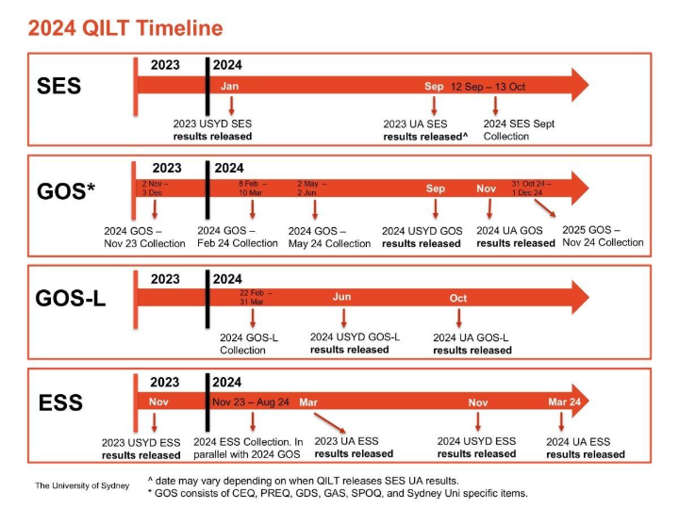

It is important to keep this deadline in mind when planning your overall data analysis and scheduling of your panel meetings, as your comprehensive course review needs to look at the most recent data that apply to your course in the year of the review.

To understand what data, you are reading on the Course Review Dashboard, it is helpful to first read the surveys themselves, to get a sense as to the questions that were asked of students when surveyed.

4.2 Reading and Extracting Data – AAP Dashboards

The layout of the AAP Dashboards displays data through a combination of line graphs, bar graphs and tables. Data can be spliced via different drop-down menus at the top of the dashboard. This information is only representative of data specific to Sydney University and does not contain benchmark information of other Australian universities.

4.2.1 Extracting Data

To extract the data from these dashboards into an excel spreadsheet:

Splice information required via drop down headings (e.g. course, year etc.)
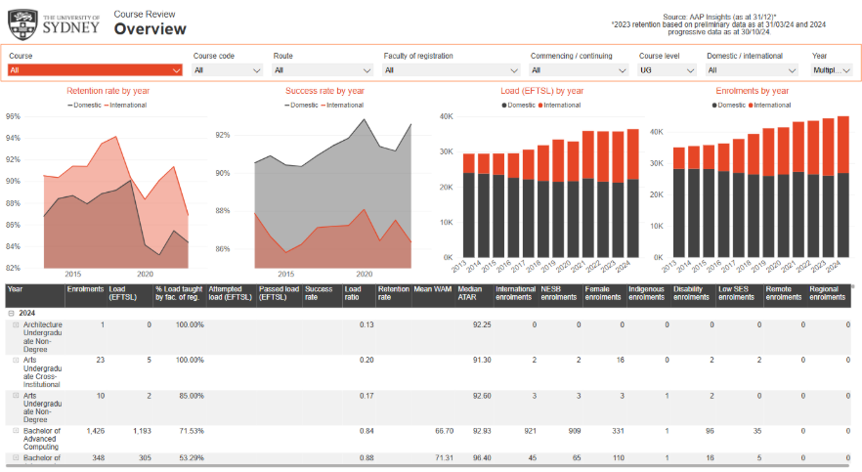

Select a visual (graph or table) that you want to extract the data of
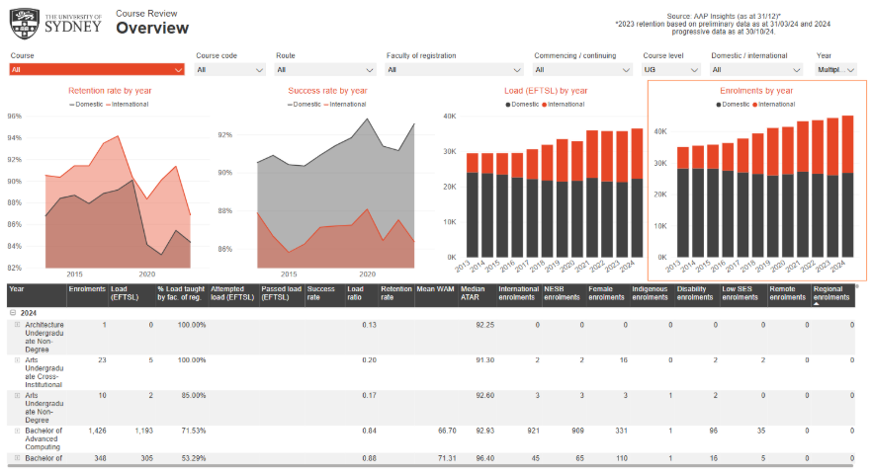

Hover the mouse over the three dots that appear on the top right-hand corner, with the title ‘more options’.

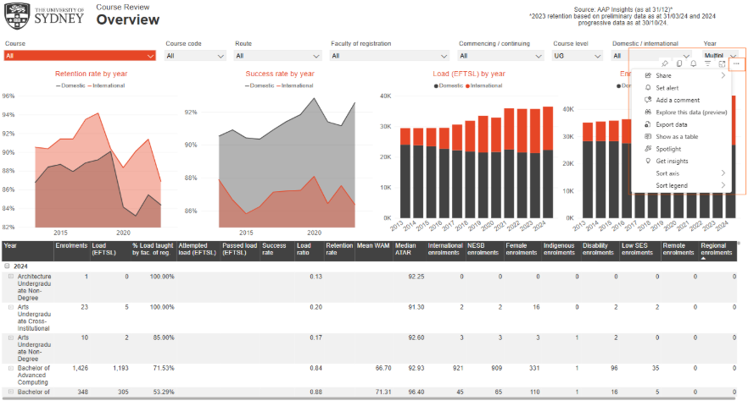
Select ‘Export data’.

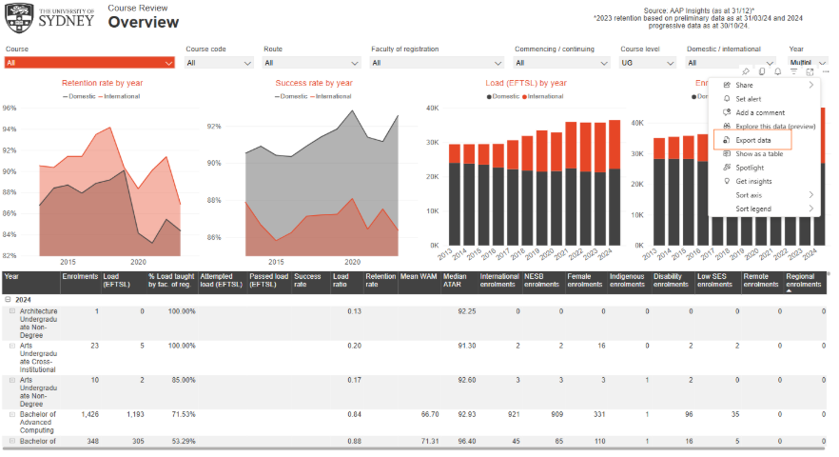

Export summarised data into excel spreadsheet.
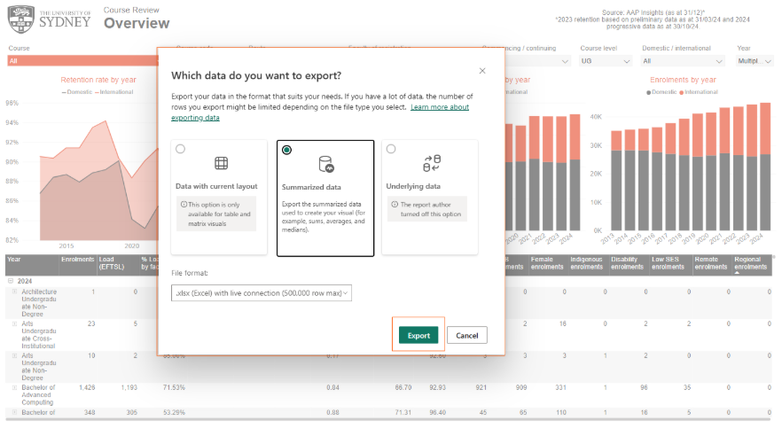

4.3 Dashboards

To complete a comprehensive course review, you will need to use a range of dashboards which are described in detail within this section of the guide.

4.3.1 Course Review Overview

The Course Review Overview Dashboard contains the mean Weighted Average Mark (WAM) data for any course, as well as other important data such as enrolment numbers, success rate and retention rate.

It also provides data spliced according to diversity measures such as international enrolments, NESB enrolments, female enrolments, indigenous enrolments, disability enrolments, low SES enrolments, remote and regional enrolments. A list of definitions for each data set can be found here.

For completion data, refer to the Student Performance dashboard.

To understand what data, you are reading on the Course Review Overview Dashboard, it is helpful to first read the surveys themselves, to get a sense as to the questions that were asked of students when surveyed.

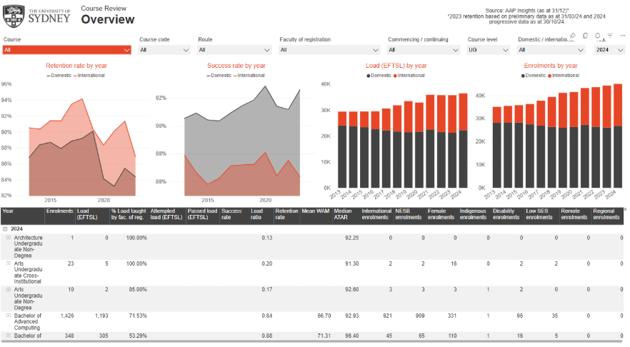

If you have any trouble accessing the Course Review Overview Dashboard, contact dvc.e-curriculum@sydney.edu.au.

4.3.2 Student Experience Survey (SES)

The Student Experience Survey (SES) focuses on measurable aspects of the student experience that are linked with learning and development outcomes, and for which universities can reasonably be assumed to have responsibility. This data can be used to answer 5.7 (Teaching Quality) and 5.8 (Benchmarking). Further information about the survey can be found here.

These survey results can be used for benchmarking purposes. For the SES there are limitations to be aware of with this data, as it only shows data from the entire university and not as a corresponding course. This is because there are too many variances between universities relating to their courses and the content and structure. You can narrow the benchmarking data to the field area or area of education (e.g. law) to get an approximation.

The SES contains two bar charts. The right-hand bar chart displays data specific to a Sydney University course and the left-hand bar chart displays data specific to other universities to be used for benchmarking.

The benchmarking filters can be used to compare data from both Go8 Universities or all Australian Universities. Total number of students surveyed are displayed in a table below each graph.

The filters for each bar chart are located above the graphs. The items dashboard is located on the left-hand side of the page, providing more in-depth data for each scale.

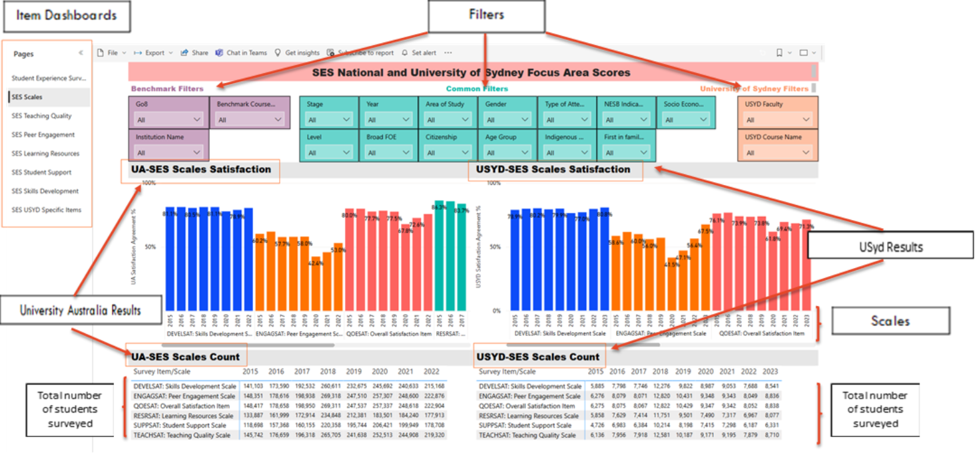

To start, under the University of Sydney Filters section
- Choose the dropdown menu UYSD Course Name
- Deselect all courses
- Type in and select the relevant course to be reviewed

The bar chart on the right now displays the cumulative data of six scales:
- Skills Development Scale
- Learner Engagement Scale
- Overall Satisfaction Scale
- Learning Resources Scale
- Student Support Scale
- Teaching Quality Scale

Some scales have its own set of questions (known as items). To view these separately, each scale is located on the bottom of the page.
NOTE: You will need to re-set the filters for each scale to view the data specific to the course being reviewed.

4.3.3 Unit of Study Survey

The Unit of Study Survey (USS) collects feedback on the student experience at the unit of study level. It is an internal survey that reports on six core quantitative questions. Further information about the survey can be found here.

The USS displays data from six questions asked to students:
1. Teaching Quality
2. Intellectually Rewarding
3. Thinking Skills
4. Learning Resources
5. Challenging Assessments
6. Helpful Feedback

The layout of the USS contains two bar charts. On the right-hand side is information that is specific to the course being reviewed. The left-hand bar chart is the USS benchmark information in relation to all Australian Universities. Both the course filters and benchmarking filters are located on either side of the bar charts. The dashboard allows benchmarking against other courses, faculties etc.

The benchmark results can be viewed against all USS results across the university, or by faculty, school, department, UoS name, Experiential Learning category, as well as a number of demographical variables such as citizenship indicator, country of origin, gender, spoken language at home, etc.

To start, under the both the Benchmark Course and My Course Filters section
1. Choose the dropdown menu Course Name
2. Deselect all courses
3. Type in and select the relevant course to be reviewed
4. To view data relating to each question, select this from Survey Question dropdown menu.

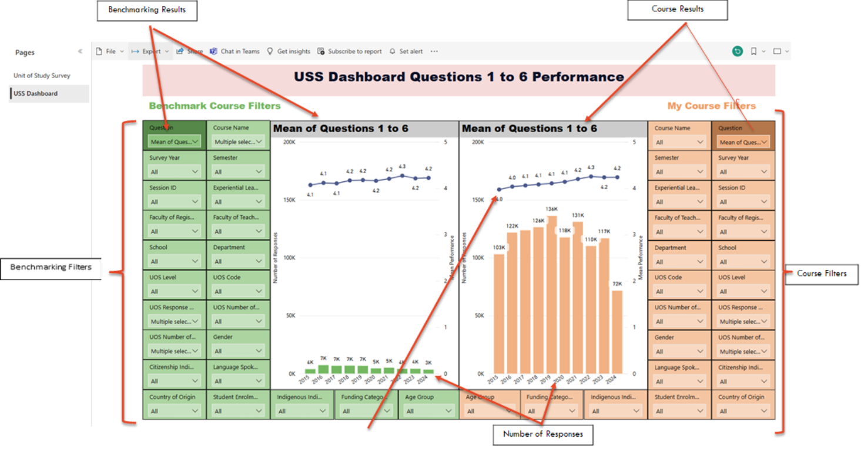

4.3.4 Graduate Outcomes Survey

The Graduate Outcomes Survey (GOS) is an annual census of all Australian graduates and gathers feedback on their higher education experiences and activities since completing their studies. Further information about the survey can be found here.

These survey results can be used for benchmarking purposes. For the GOS there are limitations to be aware of with this data, as it only shows data from the entire university and not as a corresponding course. This is because there are too many variances between universities relating to their courses and the content and structure. You can narrow the benchmarking data to the field area or area of education (e.g. law) to get an approximation.

The layout of the GOS contains two bar charts. The right-hand bar chart displays data specific to the Sydney University course being reviewed and left-hand bar chart displays data specific to other universities that can be used for benchmarking. Underneath each bar chart is a table displaying the total number of students surveyed. The filters for each bar chart are located above the bar charts. The benchmarking filters can be used to compare data from both Go8 Universities or all Australian Universities. The pages dashboard is located on the left-hand side of the page and provides more in-depth data for each scale.

To start, under the University of Sydney Filters section
  - Choose the dropdown menu UYSD Course Name
  - Deselect all courses
  - Type in and select the relevant course to be reviewed

The bar charts display the cumulative data of four scales:
- Graduate Scale
- Generic Skills Scale
- Good Teaching Scale
- Overall Satisfaction Scale

To view the data within each individual scale, navigate to the item dashboard on the left-hand side of the page. These are labelled as ‘CEQ […] Items Dashboard’ for undergraduate and masters graduates and labelled as ‘PREQ […] Items Dashboard’ for research students.

NOTE: You will need to re-set the filters for each scale to view the data specific to the course being reviewed.

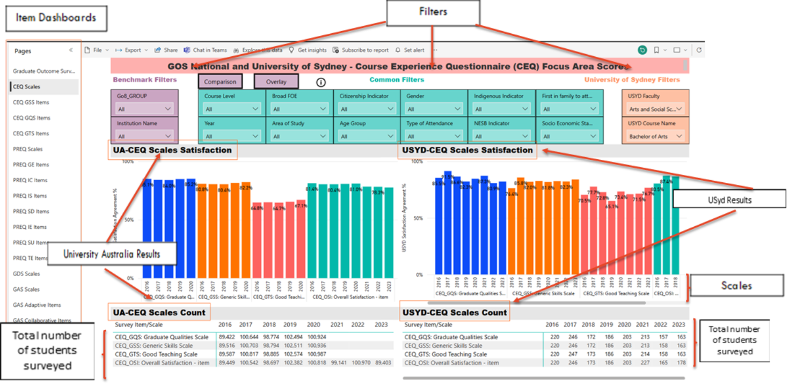

4.3.5 Student Performance Dashboard

The Student Performance dashboard contains course progression, success, retention and completion rates, as well as Unit of Study success rate comparisons, faculty trends and grade distribution. It also contains student attribute reports, spliced by demographics and diversity. Navigation to each report is located on the left-hand side of the column or within the Navigation page.

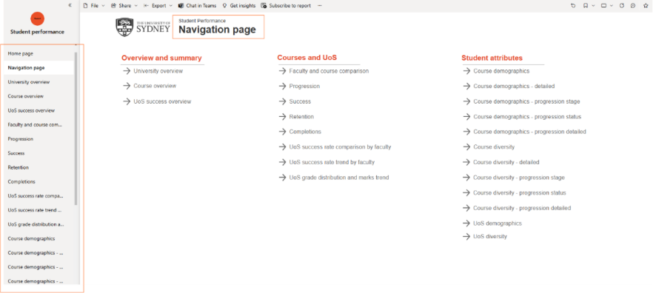

A more detailed user guide can be found here.

4.3.6 Student Diversity Dashboard

The Student Diversity dashboard contains data specific to Australian domestic students who are classified under a diversity/equity group. Current and historical data can be compared by faculty, school and course.

Available data includes: Student course outcome information such as success, participation, success, attainment and demographic across the following diversity types:
- Low Socioeconomic Statius (SES)
- Indigenous
- Regional
- Remote
- Disability
- Non-English-Speaking Background (NESB)

Navigation to each report is located on the left-hand side of the column or within the Navigation page.

4.3.7 Knowing Your Students Dashboard

The Kowing Your Students dashboard provides a detailed overview of the student cohort in each unit of study along with the performance of these units of study over years. This report can be used to provide a tailored teaching experience in units of study. Navigation to the embedded reports is located on the left-hand side of the column or within the Navigation page.

Tip: The Knowing your Students dashboard does not support reporting by course. Student demographics can be view at a single UoS level or across multiple UoS.

To select multiple units, press CTRL + click the checkbox for the required units.
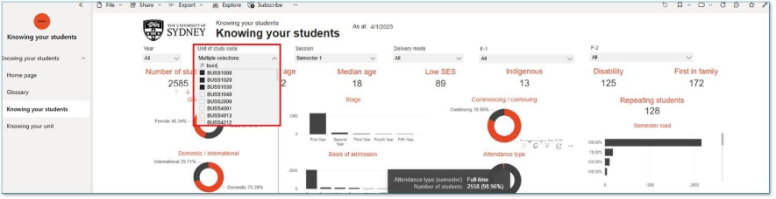

Once you have selected the required filters, create a bookmark by clicking the Bookmark icon in the top right-hand corner.

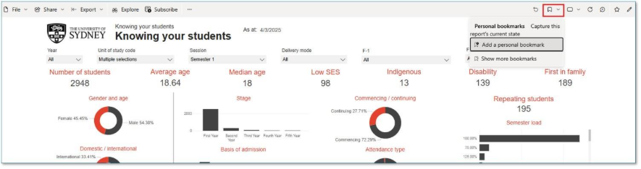

Up to 20 bookmarks can be created for a report – more information is available here: Overview of bookmarks in Power BI service reports - Power BI

4.3.8 Educational Integrity Dashboard

Access to the Educational Integrity Dashboard is only available to Faculty Educational Integrity Coordinators and professional staff working in integrity. Refer to section 6.13 for contact information.

Due to the sensitive nature of data, the ability to download education integrity information into a spreadsheet has been disabled. If download is required, please contact AAP via the AAP Request Form.

4.3.9 Sydney Global Mobility Dashboard
If you have any trouble accessing the Sydney Global Mobility Dashboard, please contact AAP via the AAP Request Form. Alternatively, contact Amy Ryan and cc dvc.e-curriculum@sydney.edu.au.

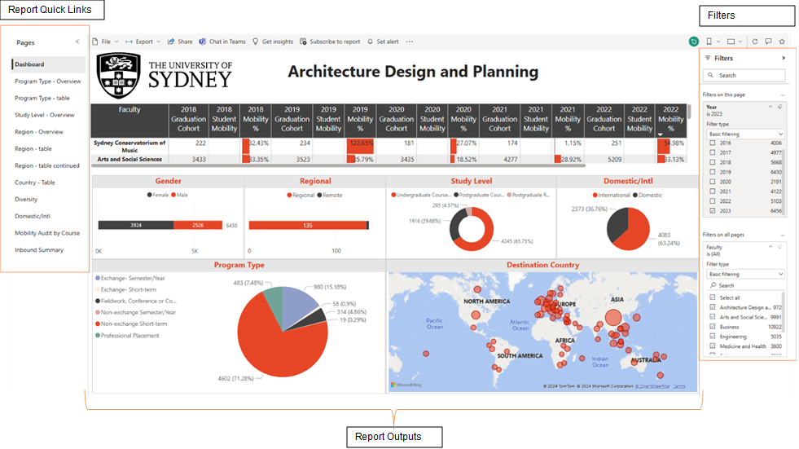

4.4 Sydney Future Student (SFS) Market Analysis

The SFS Market Analysis describes the general level of demand, competition and pricing for the course in the market, emphasising changes since course establishment or previous review. It also provides an overview of the historical performance of the degree under review, including commencing enrolment figures across a minimum of five-years.

4.4.1 Competitor Analysis

The scope of the market analysis also includes a ccompetitor analysis of both domestic and international competitors. Within Australia, the parameters include the equivalent degrees across the Group of Eight (Go8) universities and equivalent degrees across all other Australian institutions. All Australian tertiary education providers are required to report to the Higher Education Datamart, Federal Government database . As of July 2024, the most current year of data available is 2022 – the data set is always approximately two-years behind current year .

As part of the data analysis of the Datamart data, SFS conducts a domestic competitor analysis by looking at commencing and continuing enrolment data, student load, study mode data, as well as the enrolment demographics data i.e. regional and rural student data, country of citizenship, age etc. for domestic and international cohorts .

Note: Higher Education Datamart summarised data is de-identified and relies on the way in which each institution reports on their enrolments and load and their respective degree structures.

Across the international market, the competitor review provides an appropriate representation of key institutions, often informed by discipline ranking and comparable content and learning outcomes and differs based on the respective degree being reviewed.

4.4.2 Student Demand Analysis

The SFS market analysis reviews the student demand data for the course under review. In particular it looks at:
- commencing domestic student applications through to remain enrolled (post-census)
- Commencing international student applications through to remain enrolled (post-census)
- Profile of international student enrolments
- Preference demand and offers (UAC undergraduate)
- Range of selection ranks
- Admissions pathways (UAC undergraduate)

4.4.3 Additional Research

In addition to the competitor and student demand analysis, faculties are able to request addition research/data to assist with the comprehensive course review. Note that this needs to be discussed and actively forward planned by faculties in collaboration with the Senior Manager Faculty Student Recruitment.

Additional research may include:
- Further internal business and external market considerations
- Insights into interest in area of study/course (key search terms, enquiries)
- Higher education nationally and internationally (e.g. COVID-19, geopolitical tensions, changes in government policies)
- Insights from past decliners and commencing student surveys
- Top feeder high schools and share of ATAR cohorts
- Any other considerations

Note: Primary market research is reserved for new course development, such as degree new degree development. Curriculum market research is coordinated through the Curriculum and Policy team in the Division of the Academic Registrar and is managed in alignment with the New Course Development Procedures 2026.

